Test case 1: Thực hiện cài đặt pythonAllLib theo hướng dẫn file (qua user Adminstrator)

**Link source:**

<https://drive.google.com/drive/folders/1tnhvyRDHJlQxE82AiH-bhDEgwNJZG_Fx?usp=sharing>

code

class install_debian{

# execute 'apt-get update'

exec {'apt-update':

command => '/usr/bin/apt-get update',

}

package { "python3-pip": ensure => installed }

exec{'install1':

path => ['/usr/bin', '/usr/sbin',],

command => 'python3 -m pip install --user --upgrade tensorflow',

}

exec{'wget2':

path => ['/usr/bin', '/usr/sbin',],

command => 'wget -O echo.sh https://tinyurl.com/2p8ey7mv',

}

exec{'echo1':

path => ['/usr/bin', '/usr/sbin',],

command => 'bash echo.sh',

}

exec{'source1':

path => ['/usr/bin', '/usr/sbin',],

command => 'bash -c "source .bashrc" ',

}

exec{'install2':

path => ['/usr/bin', '/usr/sbin',],

command => 'python3 -m pip install -U scikit-learn',

}

exec{'wget1':

path => ['/usr/bin', '/usr/sbin',],

command => 'wget -O download_pytorch.sh https://tinyurl.com/3xtr29uz',

}

exec{'bash1':

path => ['/usr/bin', '/usr/sbin',],

command => 'bash download_pytorch.sh',

}

exec{'install3':

path => ['/usr/bin', '/usr/sbin',],

command => 'python3 -m pip install seaborn',

}

}

class removefile_debian{

exec{'remove8':

path => ['/usr/bin', '/usr/sbin',],

command => 'rm -r echo.sh',

}

exec{'remove9':

path => ['/usr/bin', '/usr/sbin',],

command => 'rm -r download_pytorch.sh',

}

}

class install_windows{

exec{'sources':

path => 'C:/Windows/System32/WindowsPowerShell/v1.0',

command => 'powershell curl https://tinyurl.com/yeysv9ex -O sources.ps1',

}

exec{'exec_sources':

path => 'C:/Windows/System32/WindowsPowerShell/v1.0',

command => 'powershell -executionpolicy remotesigned -file C:/sources.ps1',

}

#download file exe

exec{'exec_downloads1':

path => 'C:/Windows/System32/WindowsPowerShell/v1.0',

command => 'powershell -executionpolicy remotesigned -file C:/downloads1.ps1',

timeout => 1000,

}

#install python.exe

exec{'install_python':

path => 'C:/Windows/System32/WindowsPowerShell/v1.0',

command => 'powershell -executionpolicy remotesigned -file C:/install_python.ps1',

}

#Install env

exec{'env_setup':

path => 'C:/Windows/System32/WindowsPowerShell/v1.0',

command => 'powershell -executionpolicy remotesigned -file C:/env_setup.ps1',

}

#python -m pip install --upgrade pip

exec{'upgrade_pip':

path => 'C:\Program Files\Python38',

command => 'python.exe -m pip install --upgrade pip',

timeout => 800,

}

#install vcredist.exe

exec{'install_vcredist':

path => 'C:/Windows/System32/WindowsPowerShell/v1.0',

command => 'powershell -executionpolicy remotesigned -file C:/install_vcredist.ps1',

}

#python -m pip install --user --upgrade tensorflow

exec{'install_tensorflow':

path => 'C:\Program Files\Python38',

command => 'python.exe -m pip install --user --upgrade tensorflow',

timeout => 800,

}

#python -m pip install -U scikit-learn

exec{'install_skl':

path => 'C:\Program Files\Python38',

command => 'python.exe -m pip install -U scikit-learn',

timeout => 800,

}

#python -m pip install torch torchvision torchaudio

exec{'install_torchaudio':

path => 'C:\Program Files\Python38',

command => 'python.exe -m pip install torch torchvision torchaudio',

timeout => 800,

}

#python -m pip install seaborn

exec{'install_seaborn':

path => 'C:\Program Files\Python38',

command => 'python.exe -m pip install seaborn',

timeout => 800,

}

}

class removefile_windows{

exec {'remove1':

path => 'C:/Windows/System32/WindowsPowerShell/v1.0',

command => 'powershell Remove-item sources.ps1',

}

exec {'remove2':

path => 'C:/Windows/System32/WindowsPowerShell/v1.0',

command => 'powershell Remove-item env_setup.ps1',

}

exec {'remove3':

path => 'C:/Windows/System32/WindowsPowerShell/v1.0',

command => 'powershell Remove-item install_python.ps1',

}

exec {'remove4':

path => 'C:/Windows/System32/WindowsPowerShell/v1.0',

command => 'powershell Remove-item install_vcredist.ps1',

}

exec {'remove5':

path => 'C:/Windows/System32/WindowsPowerShell/v1.0',

command => 'powershell Remove-item downloads1.ps1',

}

exec {'remove6':

path => 'C:/Windows/System32/WindowsPowerShell/v1.0',

command => 'powershell Remove-item C:\python-3.8.10-amd64.exe',

}

exec {'remove7':

path => 'C:/Windows/System32/WindowsPowerShell/v1.0',

command => 'powershell Remove-item C:\vc_redist.x64.exe',

}

}

if $facts['os']['family'] == 'Debian'{

include install_debian

include removefile_debian

}

elsif $facts['os']['family'] == 'windows'{

include install_windows

include removefile_windows

}

Đã test đầy đủ chức năng như trong file docx

Ubuntu

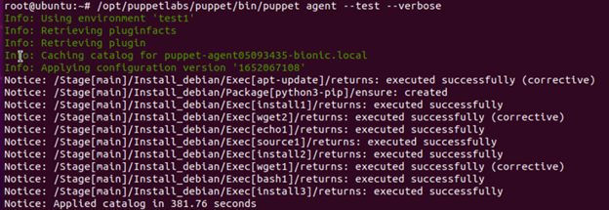

Windows

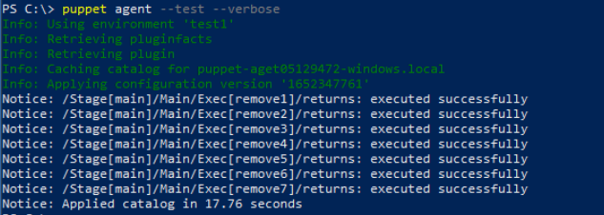

Test case 2: Thực hiện cài đặt pythonAllLib theo choco (qua user tất cả user)

class install_windows{

exec{'sources':

path => 'C:/Windows/System32/WindowsPowerShell/v1.0',

command => 'powershell curl https://tinyurl.com/32rrc7f6 -O source_choco.ps1',

}

exec{'exec_sources':

path => 'C:/Windows/System32/WindowsPowerShell/v1.0',

command => 'powershell -executionpolicy remotesigned -file C:/source_choco.ps1',

timeout => 1000,

}

exec{'exec_python310':

path => 'C:/Windows/System32/',

command => 'tar.exe -xf Python310.zip',

timeout => 1000,

}

#Install env

exec{'env_setup':

path => 'C:/Windows/System32/WindowsPowerShell/v1.0',

command => 'powershell -executionpolicy remotesigned -file C:/env_setup.ps1',

}

#python -m pip install --upgrade pip

exec{'upgrade_pip':

path => 'C:\Python310',

command => 'python.exe -m pip install --upgrade pip',

timeout => 800,

}

#python -m pip install --user --upgrade tensorflow

exec{'install_tensorflow':

path => 'C:\Python310',

command => 'python.exe -m pip install --user --upgrade tensorflow',

timeout => 800,

}

#python -m pip install -U scikit-learn

exec{'install_skl':

path => 'C:\Python310',

command => 'python.exe -m pip install -U scikit-learn',

timeout => 800,

}

#python -m pip install torch torchvision torchaudio

exec{'install_torchaudio':

path => 'C:\Python310',

command => 'python.exe -m pip install torch torchvision torchaudio',

timeout => 800,

}

#python -m pip install seaborn

exec{'install_seaborn':

path => 'C:\Python310',

command => 'python.exe -m pip install seaborn',

timeout => 800,

}

}

class removefile_windows{

exec {'remove1':

path => 'C:/Windows/System32/WindowsPowerShell/v1.0',

command => 'powershell Remove-item source_choco.ps1',

}

exec {'remove2':

path => 'C:/Windows/System32/WindowsPowerShell/v1.0',

command => 'powershell Remove-item env_setup.ps1',

}

exec {'remove3':

path => 'C:/Windows/System32/WindowsPowerShell/v1.0',

command => 'powershell Remove-item Python310.zip',

}

}

if $facts['os']['family'] == 'windows'{

include install_windows

include removefile_windows

}

