Name____Patrick Du_______ Mark _____________________/50

## Brief introduction __/3

My feature in Doki Doki Library Club is User Interface Management, which handles most user input and menu movement.

User input will mostly come from point and click interactions with a mouse on a select menu or UI for different scenes. There will be buttons on the side of the screen users can click to change rooms as well as interact buttons that will appear on screen within certain distance of the love interests in the game.

Each scene in the game will include an interact button for each love interest that is different in each scene that is specific to the different love interest characters.

The start menu will have a few options, a text box button to start the game and send the player to the main starter room. A quit game text button to leave the application, and a BC mode to start the game in BC mode.

If the user presses tab in the game, an overlay will appear on the screen displaying the love interests’ affection points for the main player.

## Use case diagram with scenario __14

### Use Case Diagram 1

### Scenarios

**[Scenario 1]**

**Name:** Interacts with love interest

**Summary:** The player clicks on the interaction button to interact with a love interest

**Preconditions:** Player must be within certain range of love interest.

**Basic sequence:**

**Step 1:** Player moves close enough to love interest.

**Step 2:** Player clicks on interact button.

**Step 3:** Player begins interaction with love interest.

**Exceptions:**

**Step 2:** Love interest is locked out of interaction. Button is grayed out, and love interest is not interactable.

**Post conditions:** Player is now interacting with love interest character.

**Priority:** 1*

**ID:** P01.1

### Use Case Diagram 2

### Scenarios

**[Scenario 2]**

**Name:** Game Over Screen

**Summary:** The player’s user interface gets updated upon game over condition.

**Preconditions:** Player must either be at a point where winning is not possible or they have successfully collected all affection points for a certain love interest.

**Basic sequence:**

**Step 1:** Player finishes an interaction with a love interest

**Step 2:** New menu/screen pops up declaring the game is over

**Step 3:** Player can quit or play again.

**Exceptions:**

**Step 2:** If the player is locked out of all possible love interests (losing condition) a game over loss screen appears. If the player successfully collects enough affection points for a certain love interest, a winning screen will appear.

**Post conditions:** Player is now interacting with love interest character.

**Priority:** 2*

**ID:** P01.2

## Data Flow diagram(s) from Level 0 to process description for your feature _______14

### Data Flow Diagrams

**Context Diagram:**

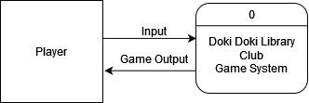

**Diagram 0:**

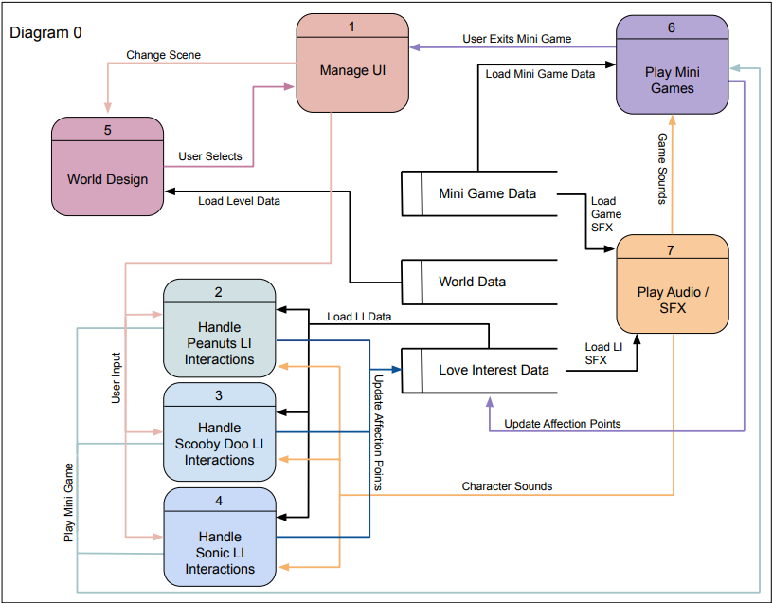

**Diagram 1: Manage UI**

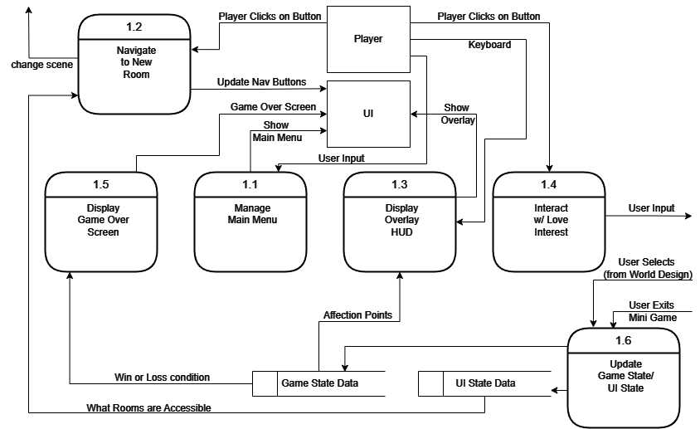

### Process Descriptions

*Really basic pseudo code*

Manage Main Menu:

If user input – show main menu

Pause time

If inGame

Display continue button

Display quit button

Else

Display Start button

Display BC Mode button

Display quit button

//buttons will get input from mouse and execute associated functionality

Navigate to New Room:

Read available rooms

If room to right is available

Display button to right

Else

Block out button

If room to left is available

Display button to left

Else

Block button

If Button right pressed

Change scene to right room

If button left pressed

Change scene to left room

Display Overlay HUD:

If keyboard input (‘tab’ most likely)

Set canvas for overlay active

Displays affection points of each character from data store

//time is not paused for the overlay

Pressing tab again deactivates canvas screen

Interact with love interest:

If character is available to interact with

Display interact button once within certain distance of character

Player clicks button to interact

//not really sure yet how I’ll send this data to the character processes yet

Else

Button is blocked/grayed out

Display Game Over Screen:

If max affection points reached for love interest:

Set canvas active

Pause time

Show love interest icon w/ win message

If all love interests are not interactable

Set canvas active

Pause time

Display loss screen

Update Game/UI state:

Get current scene state from world design

Get minigame exit status from minigames

Update data stores for game state and UI state

//UI state is for available rooms since I’ll use that for displaying navigation

//game state is for player progress

## Acceptance Tests ________9

**Main Menu:**

I want to ensure that the start game, BC mode, and quit game buttons receive input from the mouse and execute their intended functions. Once in game, main menu should appear, except only continue button and quit button should populate the canvas. These buttons will be interactable via mouse click.

**Navigation**:

I need to make sure that the buttons for moving between each room appear properly and are blocked out if a room is inaccessible. Clicking on an available button will need to send the player to a new room.

**Overlay**:

I need to ensure input is received from pressing tab on the keyboard to bring up the overlay, ensuring that time is not paused and all love interests are displayed on screen with their associated affection points.

**Interact button:**

I also need to make sure the interact button appears when it is intended to within a certain radius of a love interest, getting proper input from the mouse upon click. I should also make sure that the interact functionality only happens when the interact button appears on screen.

## Timeline _________/10

[Figure out the tasks required to complete your feature]

Example:

### Work items

|  |  |  |
| --- | --- | --- |
| Task | Duration (Hours) | Predecessor Task(s) |
| 1. Main menu design | 2 | - |
| 2. UIElement Superclass design | 6 | 1 |
| 3. UIElementHandler (is monobehavior but contains instance of UIElement) | 5 | 2 |
| 4. UIButton subclass | 5 | 2 |
| 5. UITextBox subclass | 4 | 2 |
| 6. Overlay subclass | 5 | 2 |
| 7. Programming | 3 | 3,4,5,6 |
| 8. Testing | 3 | 7 |
| 9. Integration | 2 | 7,8 |

### Pert diagram

