IMAGE SCRAPER

**Step 1: Creating Environment**

**Step 2: Install all libraries in requirements.txt file**

**Step3: Set environment in PyCharm**

**Step 4: Run application**

**Using this Application, we can fetch images from google**

**How to execute the code**

**Step 1: pip install selenium, pillow, requests**

**Step 2: make sure you have chrome/Mozilla installed on your machine**

**Step 3: Check your chrome version (go to ‘three dots’ then ‘help’ then ‘about google chrome’)**

**Step 4 : Download the same chrome driver from here** [**https://chromedriver.storage.googleapis.com/index.html**](https://chromedriver.storage.googleapis.com/index.html%20)  **select the folder which is closer to your chrome version for windows download 'cromedrive-win32' click on it once it downloaded then put it inside the same folder where your application is.**

**I fetched Minions 5 images from google**

**Result: -**

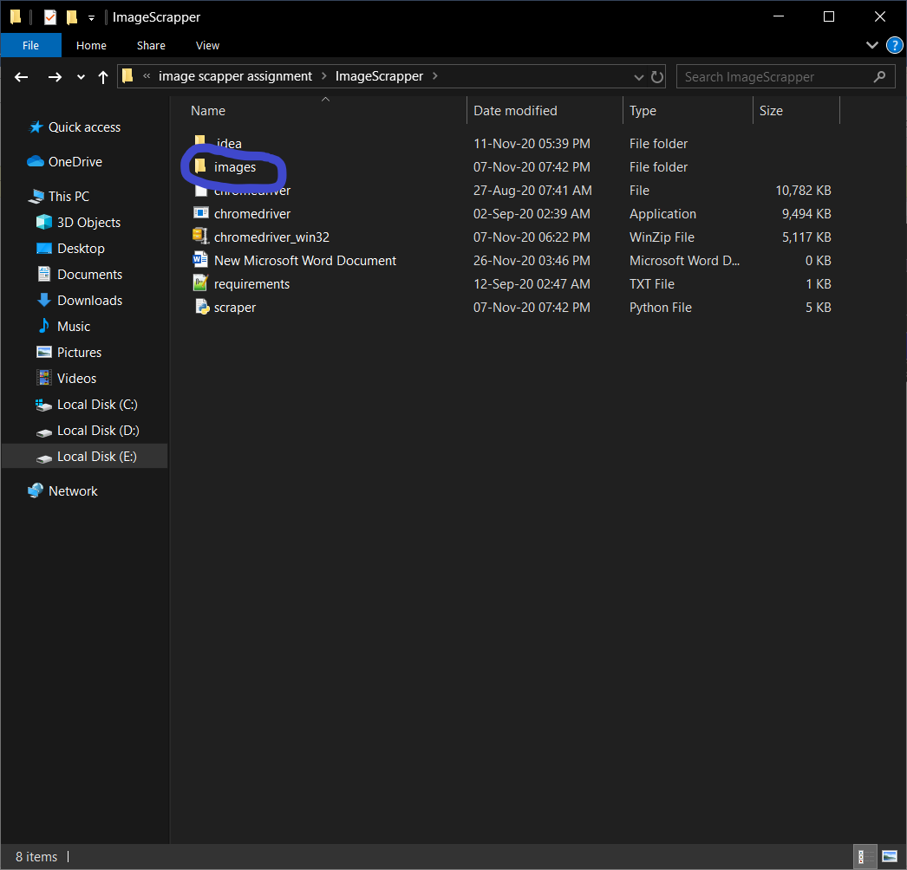

**Inside the Images folder ‘minions folder’ created**

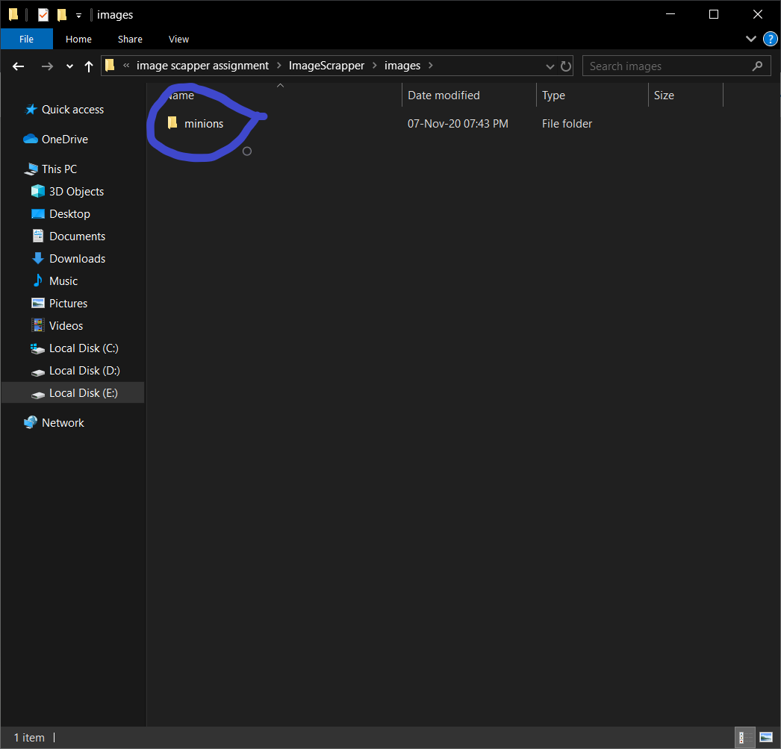

**Five images fetch successfully!**

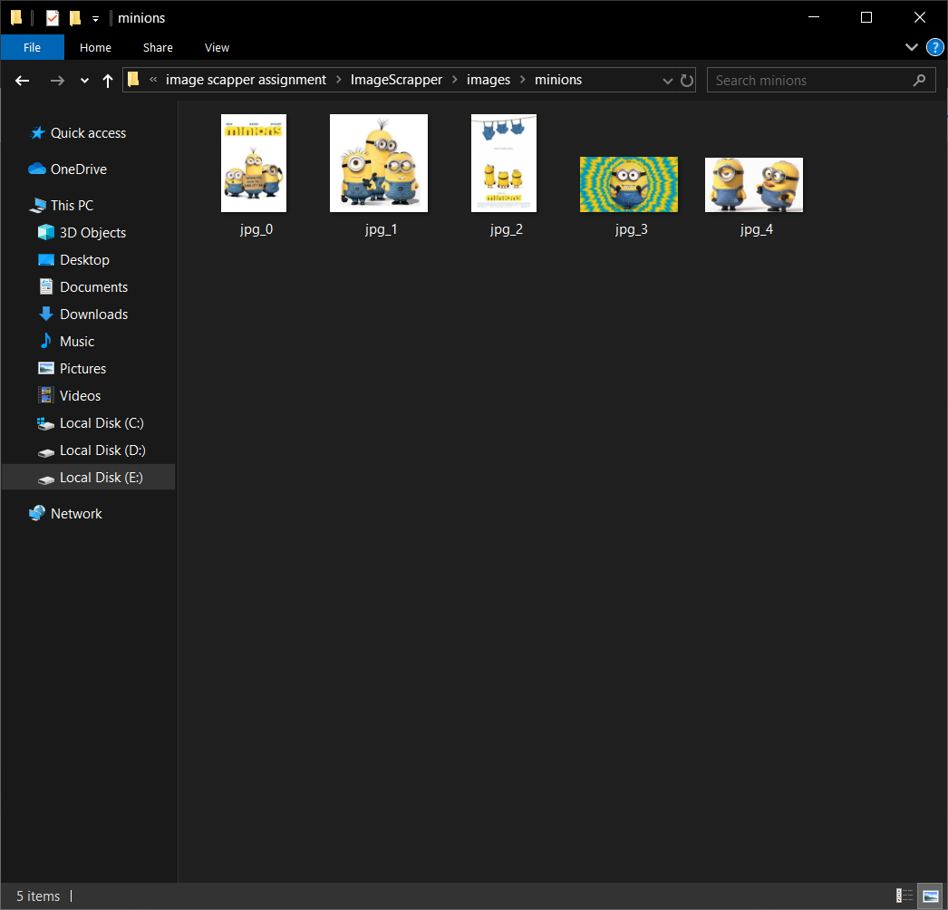

**Application Run successfully!**

