Part 1_slide5

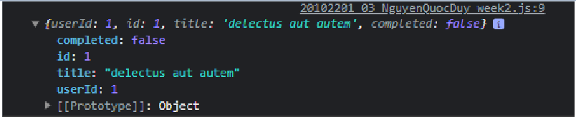

Part2_slide6

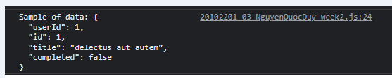

Part3_slide7

Get all user

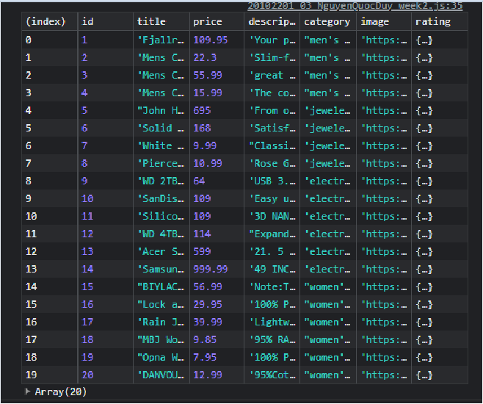

Part4_Slide8

Get a user

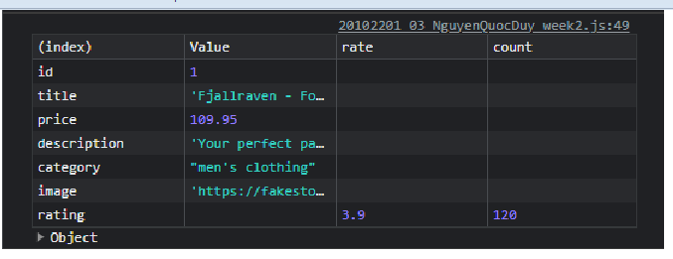

Part5_Slide9

Post a user

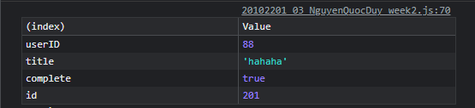

Part6_Slide10

Update a user

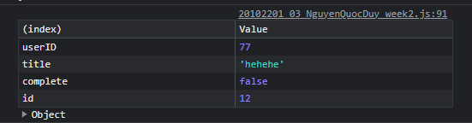

Part7_Slide11

Delete a user and get new user id 12

