

**FLOYD Algorithm Handbook**

**Algorithmic Problem Solving**



**Prakash Hegade**

**Floyd’s Algorithm**

ALGORITHM Floyd (W[1..n,1..n])

// Implements Floyd’s algorithm for all pair shortest path problem

// Input: The weight matrix W of the graph with no negative length cycle

// Output: The distance matrix of the shortest path’s lengths

D 🡨 W

for k 🡨 1 to n do

for i 🡨 1 to n do

for j 🡨 1 to n do

D [i, j] 🡨 min {D[i, j], D[i, k] +D[k, j]}

return D

Example: Apply Floyd’s algorithm on the given graph:

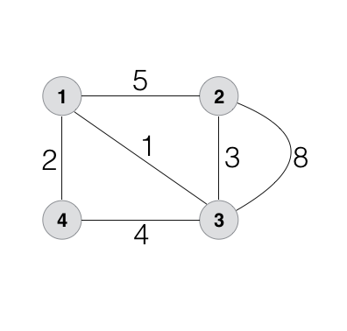

D(0) =

D(1) = D(2) =

D(3) = D(4) =