

**Warshall Algorithm Handbook**

**Algorithmic Problem Solving**



**Prakash Hegade**

**Warshall’s Algorithm**

ALGORITHM Warshall (A[1..n,1..n])

// Implements Warshall’s algorithm for computing transitive closure

// Input: The adjacency matrix A of a diagraph with n vertices

// Output: The transitive closure of the diagraph

R(0) 🡨 A

for k 🡨 1 to n do

for i 🡨 1 to n do

for j 🡨 1 to n do

R(k) [i, j] 🡨 R(k-1) [i, j] or (R(k-1) [i, k] and R(k-1) [k, j])

return R(n)

**Example:**

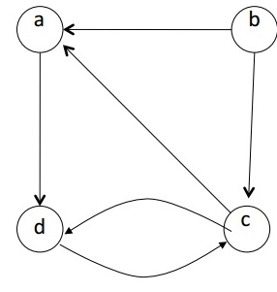

R(0) =

R(1) = R(2) =

R(3) = R(4) =