

**PRIMs Algorithm Handbook**

**Algorithmic Problem Solving**



**Prakash Hegade**

**Prim’s Algorithm**

ALGORITHM Prim(G)

// Prim’s algorithm to construct a minimum spanning tree

// Input: A weighted connected graph G(V, E)

// Output: ET, the set of edges composing of MST of G

VT 🡨 {vo}

ET 🡨 Ø

for i 🡨 1 to |V| - 1 do

find a minimum weight edge e* = (v*,u*) along all the edges (v, u) such that

v is in VT and u is in V – VT

VT 🡨 VT U {u*}

ET 🡨 ET U {e*}

return ET

**Intuition:**

What do you think is the intuition behind this algorithm?

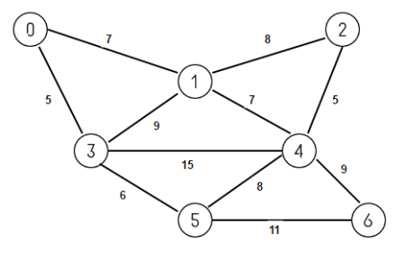Example:

|  |  |  |  |  |  |  |  |
| --- | --- | --- | --- | --- | --- | --- | --- |
|  | **0** | **1** | **2** | **3** | **4** | **5** | **6** |
| **0** |  |  |  |  |  |  |  |
| **1** |  |  |  |  |  |  |  |
| **2** |  |  |  |  |  |  |  |
| **3** |  |  |  |  |  |  |  |
| **4** |  |  |  |  |  |  |  |
| **5** |  |  |  |  |  |  |  |
| **6** |  |  |  |  |  |  |  |

cost[ ][ ] =

Initialization: Step 0

dist path

|  |  |  |
| --- | --- | --- |
| **0** |  |  |
| **1** |  |  |
| **2** |  |  |
| **3** |  |  |
| **4** |  |  |
| **5** |  |  |
| **6** |  |  |

S =

V – S =

u =

dist[u] =

output =

Initialization: Step 1

dist path

|  |  |  |
| --- | --- | --- |
| **0** |  |  |
| **1** |  |  |
| **2** |  |  |
| **3** |  |  |
| **4** |  |  |
| **5** |  |  |
| **6** |  |  |

S =

V – S =

u =

dist[u] =

output =

Initialization: Step 2

dist path

|  |  |  |
| --- | --- | --- |
| **0** |  |  |
| **1** |  |  |
| **2** |  |  |
| **3** |  |  |
| **4** |  |  |
| **5** |  |  |
| **6** |  |  |

S =

V – S =

u =

dist[u] =

output =

Initialization: Step 3

dist path

|  |  |  |
| --- | --- | --- |
| **0** |  |  |
| **1** |  |  |
| **2** |  |  |
| **3** |  |  |
| **4** |  |  |
| **5** |  |  |
| **6** |  |  |

S =

V – S =

u =

dist[u] =

output =

Initialization: Step 4

dist path

|  |  |  |
| --- | --- | --- |
| **0** |  |  |
| **1** |  |  |
| **2** |  |  |
| **3** |  |  |
| **4** |  |  |
| **5** |  |  |
| **6** |  |  |

S =

V – S =

u =

dist[u] =

output =

Initialization: Step 5

dist path

|  |  |  |
| --- | --- | --- |
| **0** |  |  |
| **1** |  |  |
| **2** |  |  |
| **3** |  |  |
| **4** |  |  |
| **5** |  |  |
| **6** |  |  |

S =

V – S =

u =

dist[u] =

output =

Initialization: Step 6

dist path

|  |  |  |
| --- | --- | --- |
| **0** |  |  |
| **1** |  |  |
| **2** |  |  |
| **3** |  |  |
| **4** |  |  |
| **5** |  |  |
| **6** |  |  |

S =

V – S =

Cost of MST is ___________