

**KRuskal Algorithm Handbook**

**Algorithmic Problem Solving**



**Prakash Hegade**

**Kruskal’s Algorithm**

ALGORITHM Kruskal(G)

// Kruskal’s algorithm to construct a minimum spanning tree

// Input: A weighted connected graph G(V, E)

// Output: ET, the set of edges composing of MST of G

sort E in nondecreasing order of the edge weights w(ei1) <= … <= w(ei|E|)

ET 🡨 Ø

ecounter 🡨 0

k 🡨 0

while ecounter < |V| - 1 do

k 🡨 k + 1

if ET U {eik} is acyclic

ET 🡨ET U {eik}

ecounter 🡨ecounter + 1

return ET

**Disjoint-Set:**

For the given array, perform the said union operations:

|  |  |  |  |  |  |  |  |  |
| --- | --- | --- | --- | --- | --- | --- | --- | --- |
| 0 | 1 | 2 | 3 | 4 | 5 | 6 | 7 | 8 |
| 0 | 1 | 2 | 3 | 4 | 5 | 6 | 7 | 8 |

Union (3, 4)

|  |  |  |  |  |  |  |  |  |
| --- | --- | --- | --- | --- | --- | --- | --- | --- |
| 0 | 1 | 2 | 3 | 4 | 5 | 6 | 7 | 8 |
|  |  |  |  |  |  |  |  |  |

Union (1, 4)

|  |  |  |  |  |  |  |  |  |
| --- | --- | --- | --- | --- | --- | --- | --- | --- |
| 0 | 1 | 2 | 3 | 4 | 5 | 6 | 7 | 8 |
|  |  |  |  |  |  |  |  |  |

Union (3, 7)

|  |  |  |  |  |  |  |  |  |
| --- | --- | --- | --- | --- | --- | --- | --- | --- |
| 0 | 1 | 2 | 3 | 4 | 5 | 6 | 7 | 8 |
|  |  |  |  |  |  |  |  |  |

Union (6, 8)

|  |  |  |  |  |  |  |  |  |
| --- | --- | --- | --- | --- | --- | --- | --- | --- |
| 0 | 1 | 2 | 3 | 4 | 5 | 6 | 7 | 8 |
|  |  |  |  |  |  |  |  |  |

Union (6, 5)

|  |  |  |  |  |  |  |  |  |
| --- | --- | --- | --- | --- | --- | --- | --- | --- |
| 0 | 1 | 2 | 3 | 4 | 5 | 6 | 7 | 8 |
|  |  |  |  |  |  |  |  |  |

Example:

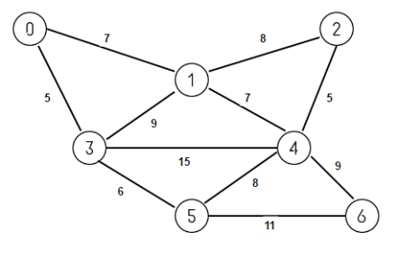

Sorted Edges:

1. 2. 3. 4.

5. 6. 7. 8.

9. 10. 11.

|  |  |  |  |  |  |  |  |  |  |  |
| --- | --- | --- | --- | --- | --- | --- | --- | --- | --- | --- |
| steps | ( u, v ) | i=find(u)  j=find(v) | output | Union( i, j ) | | | | | | |
| 0 | 1 | 2 | 3 | 4 | 5 | 6 |
| init |  |  |  |  |  |  |  |  |  |  |
| 1 |  |  |  |  |  |  |  |  |  |  |
| 2 |  |  |  |  |  |  |  |  |  |  |
| 3 |  |  |  |  |  |  |  |  |  |  |
| 4 |  |  |  |  |  |  |  |  |  |  |
| 5 |  |  |  |  |  |  |  |  |  |  |
| 6 |  |  |  |  |  |  |  |  |  |  |
| 7 |  |  |  |  |  |  |  |  |  |  |
| 8 |  |  |  |  |  |  |  |  |  |  |
| 9 |  |  |  |  |  |  |  |  |  |  |