

**bellman-ford Algorithm Handbook**

**Algorithmic Problem Solving**



**Prakash Hegade**

**Bellman Ford Algorithm**

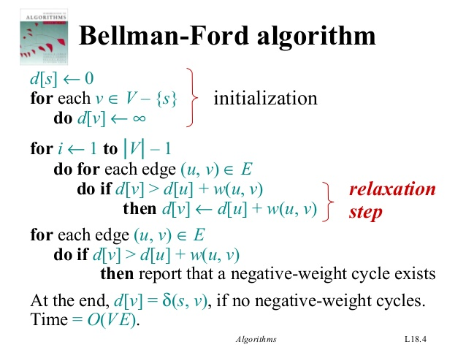

Example:

Edge List: (B, E), (D, B), (B, D), (A, B), (A, C), (D, C), (B, C), (E, D).

C:\Users\Sripad\Desktop\bellmanford1.png

Iteration 01:

C:\Users\Sripad\Desktop\bellmanford1.png

Iteration 02:

C:\Users\Sripad\Desktop\bellmanford1.png

Iteration 03:

C:\Users\Sripad\Desktop\bellmanford1.png