Model plan Model Architecture
Steps to build
Detailed and brief walkthrough
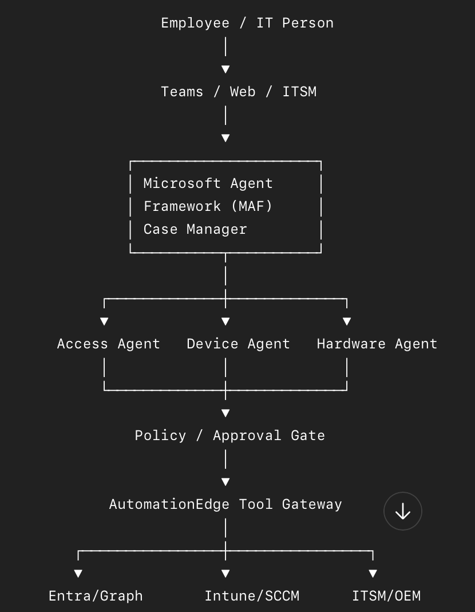
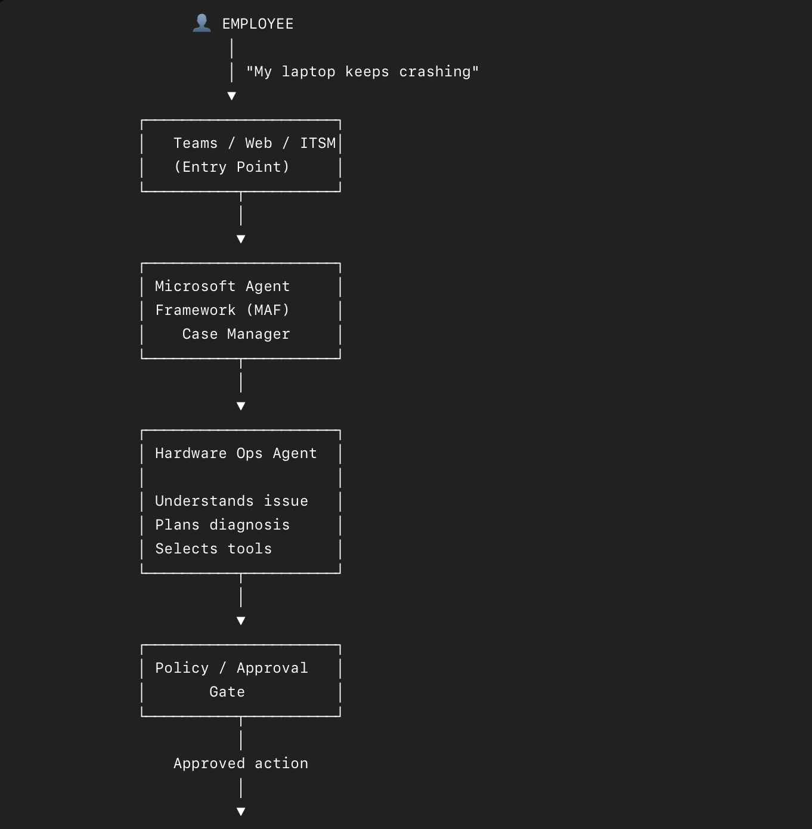
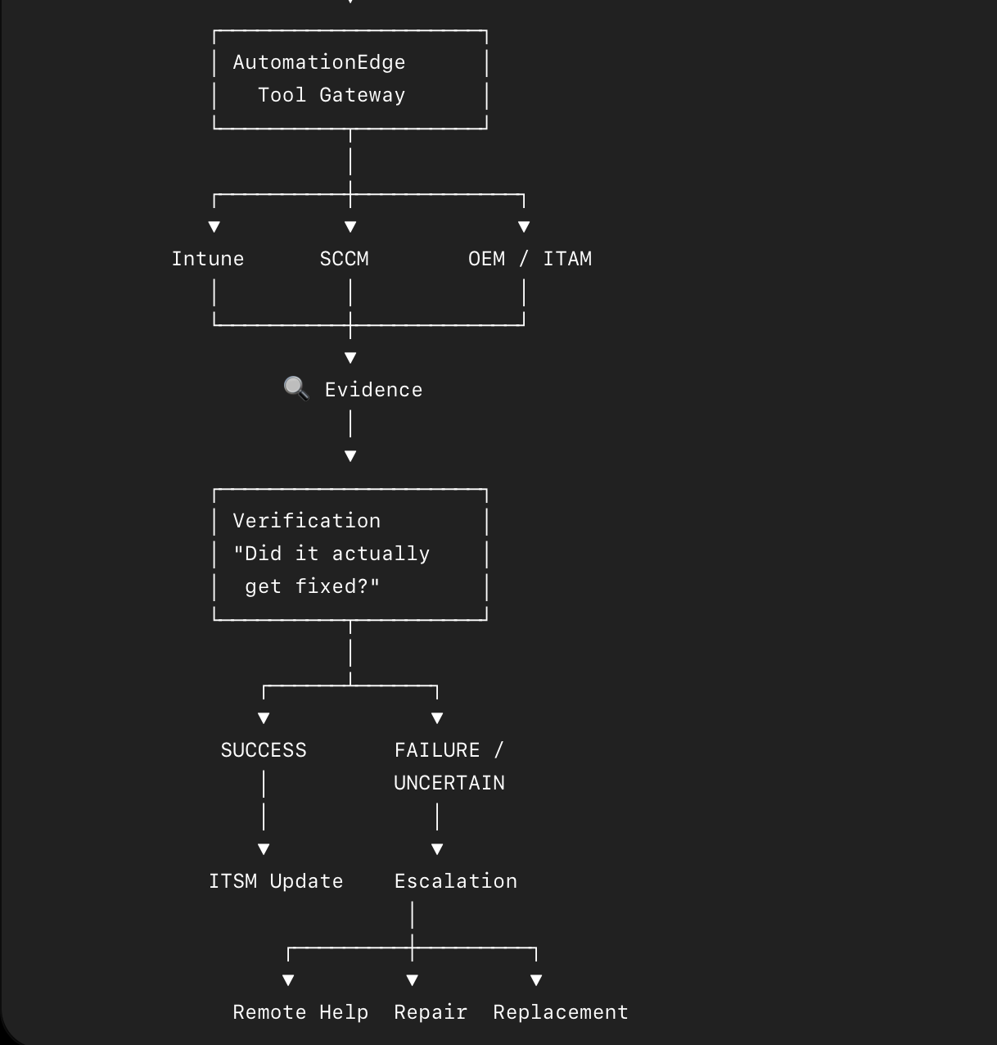

Hardware Ops Engineer Agent - Hardware Endpoint Engineer responsible for diagnosing endpoint hardware and OS-level failures using deterministic diagnostics, evidence-based reasoning, approved remediation workflows, Remote Help, and repair/replacement escalation.

Teams / Web / ITSM
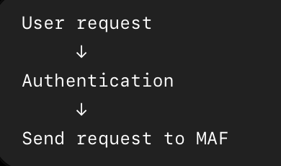

MAF Case Manager - What exactly is happening and which specilisation to call
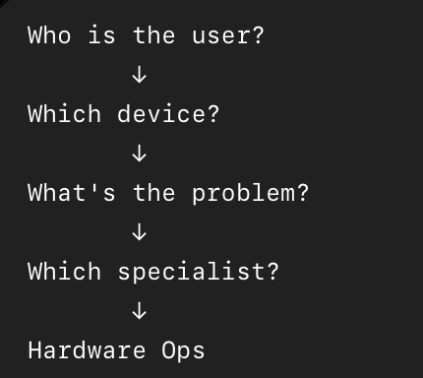

Hardware Ops Agent

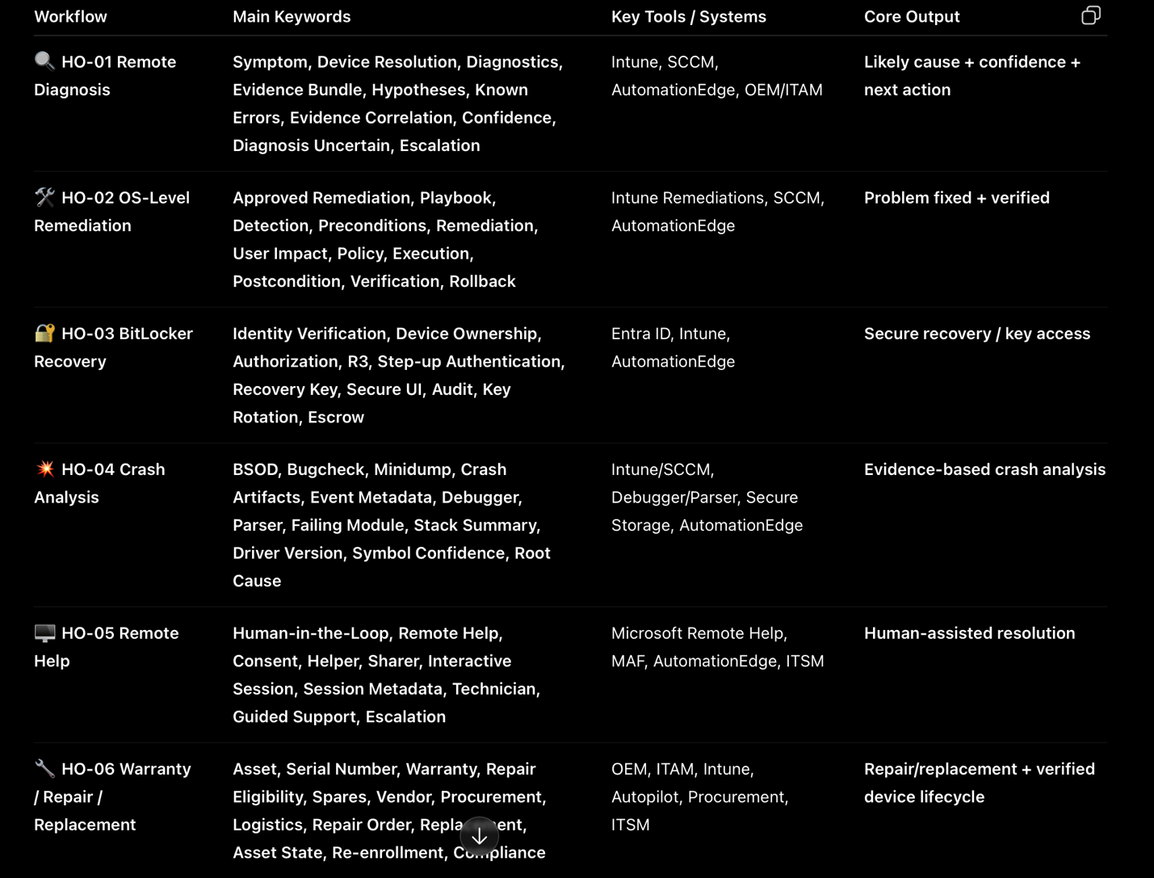
Verfification
