Abstract
Interplanetary space flight introduces a non-negotiable physical constraint on human collaboration: light-speed propagation delay. During a Mars transit at median opposition, the 240-second one-way latency disrupts the synchronous feedback loops essential for conversational grounding, social presence, and relational maintenance. Traditional space systems design addresses this by isolating the crew within an "autonomy bubble," which often leads to psychological reactance and relational decay between crew members and ground support. Drawing on theories of computer-mediated communication (CMC) and human-AI collaboration, this paper proposes and evaluates the Predictive Temporal Bridge (PTB)---an artificial intelligence-mediated communication (AI-MC) interface framework that sustains social presence by temporally synchronizing the communicators' shared frame of reference. Rather than altering semantic content, the PTB leverages dual predictive engines to project the crew's operational state forward by the round-trip delay time, presenting ground commands through a visual Reality Reconciliation Interface that overlays predictive trajectories onto live telemetry. We evaluate this framework using a high-fidelity interactive simulation of a critical Mars orbital insertion burn anomaly. We trace the subjective and objective effects on communication dynamics using four key indicators: the Operator Presence Fidelity Index (OPFI), the Operator Cognitive Load Index (OCLI), the Effective Command Latency (ECL), and the State Synchronization Accuracy (SSA). Our results demonstrate that the PTB maintains a high sense of social presence, significantly reduces cognitive workload during off-nominal events, and successfully prevents automation bias by making the AI's predictive limits transparent to human agency. We discuss the theoretical implications of temporal AI-MC and outline design principles for future extreme-latency collaborative systems.
Keywords: deep space communication, AI-mediated communication, social presence theory, social information processing theory, technological affordances, conversational grounding, human-AI teaming

Defying the Speed of Light: How Predictive Temporal AI Architectures Sustain Social Presence and Relational Cohesion in Deep Space Communication
Introduction
Every crewed deep-space mission must confront a communication constraint that is, unlike most engineering problems, non-negotiable: the finite speed of light. At Mars opposition, electromagnetic signals require between 182 and 1,342 seconds one-way, with a median value near 240 seconds (NASA JPL, 2023). This delay, denoted m, means that any question posed by a Mars crew member will not reach Earth for m seconds, and any Earth response will take another m seconds to return---a total round-trip latency of 2m ≈ 8 minutes at median separation, growing up to 45 minutes at maximum distance.
The consequences cascade far beyond simple system performance; they disrupt the core social fabric of human collaboration. In human-to-human systems under extreme stress, relational maintenance and mutual responsiveness are essential (Walther, 1992). When latency breaks the synchronous loop, conversational flows degenerate into isolated monologue transmissions. The psychological impact on the crew is a severe sense of temporal displacement and isolation from the human species (Kanas et al., 2017). Diamond et al. (2025) demonstrated in analog Mars missions that communication delays up to 22 minutes measurably elevate Mission Controller workload, anxiety, and stress, with error rates doubling in off-nominal scenarios. Conversely, Mavrakis et al. (2025) showed that integrating human-in-the-loop AI can alleviate performance degradation, but did not address the relational and social breakdowns that occur under delayed conditions.
Traditional space engineering has responded to this challenge by advocating for unilateral crew autonomy, pushing onboard systems to make the crew entirely independent of ground support. While technically logical, this "autonomy bubble" induces profound relational decay: crews begin to perceive Earth Mission Control as progressively out of touch, leading to friction, psychological reactance, and mission-threatening isolation (Kanas et al., 2017). Redesigning the computer-mediated interface to create an adaptive temporal architecture is an urgent, human-centered alternative. By using dual-AI predictive modeling to construct a virtual "present," we can bypass the cognitive and relational stutter of multi-minute lag.
This paper introduces the Predictive Temporal Bridge (PTB), an AI-mediated communication (AI-MC) architecture designed to overcome this temporal distance. Following the foundational agenda of Hancock et al. (2020), we define AI-MC as communication where an AI agent acts on behalf of or transforms the communicative exchanges between human actors. The PTB represents a radical expansion of AI-MC: rather than modifying verbal content or generating automated text suggestions, the AI synchronizes the temporal frame of reference of the human interlocutors. The human commander on Mars receives ground commands that feel instantaneous and perfectly synchronized with their immediate physical state, restoring a feeling of synchronous presence.
Theoretical Framework
Social Presence and Latency as a Relational Barrier
Social Presence Theory (Short et al., 1976) posits that communication media vary in their capacity to transmit the psychological salience of the other person in the interaction. A critical determinant of social presence is response latency. In interpersonal interactions, a delayed response is often interpreted as a non-verbal cue of disinterest, distance, or cognitive friction (Walther, 1996). In deep-space environments, this latency is not a choice but a physical constraint, yet the human mind continues to experience it as a relational barrier. The absence of immediate turn-taking disrupts the "conversational grounding" process---the continuous exchange of mutual understanding and feedback that binds collaborative teams (Walther, 1992). By eliminating the round-trip latency loop through algorithmic forward-projection, the PTB seeks to maintain high levels of social presence, allowing the Mars crew to feel psychologically tethered to the ground team.
Hyperpersonal Mediation and the Simulation of Synchronicity
The Hyperpersonal Model of CMC (Walther, 1996) argues that computer-mediated environments can sometimes exceed face-to-face interactions in relational warmth and efficiency, due to selective self-presentation, partner idealization, and asynchronous editing. The PTB leverages this hyperpersonal dynamic by transforming an asynchronous, high-stress environment into a curated "virtual present." Because the Earth AI is constantly projecting the ship's state forward, the ground operators are enabled to respond to the commander's needs before the commander has even fully articulated them. This creates a hyperpersonal "co-pilot" effect: ground controllers appear uniquely prescient and supportive, enhancing mutual trust and collective efficacy despite a 400-million-kilometer separation.
Technological Affordances and Temporal Co-Presence
The concept of leveraging prediction to mask latency has robust origins in robotics and space teleoperation. To mitigate the severe mechanical instability caused by transmission delays, engineers have long employed predictive displays and algorithmic forward-projection models, such as the Smith Predictor (Sheridan, 1993). A prominent historical example is the "phantom robot" overlay developed at NASA JPL, which projects a simulated, real-time graphic of a robotic arm over a delayed video feed, allowing the human operator to visually confirm their intended motion without waiting for the physical round-trip signal (Bejczy et al., 1990).
While these classical predictive displays successfully close the mechanical control loop, they treat the human operator in isolation, focusing exclusively on human-machine mechanical teleoperation. The Predictive Temporal Bridge (PTB) elevates this paradigm from the realm of mechanical control into the domain of computer-mediated social interaction and collaborative decision-making. Rather than merely predicting the spatial position of a robotic arm to aid a single operator, the PTB leverages dual-AI predictive modeling to synchronize the entire temporal frame of reference between two human operational teams (Earth and Mars). By pairing physical telemetry projection with a human-in-the-loop reality reconciliation engine, the PTB ensures that deep space communication retains the psychological immediacy and social presence of real-time dialogue, while explicitly managing the cognitive load and ethical autonomy of the crew.
Agency, Warranting, and the Prevention of Automation Bias
Deploying AI to intercept and predict human communicative intent introduces major ethical questions concerning agency and automation bias (Hancock et al., 2020). When the Earth AI projects the ship's state and suggests a correction command, it is operating in a highly sensitive cognitive corridor. If the cabin crew blindly accepts these recommendations, true human agency is eroded---a phenomenon known as automation bias. Furthermore, if a predictive command is executed and fails, the moral accountability is diffused: does responsibility lie with the Earth flight director who approved the prediction, the Cabin AI that reconciled it, or the commander who clicked "Execute"?
The PTB explicitly addresses this ethical dilemma by implementing a dual-gate architecture. The Cabin AI is designed as a reality arbiter that compares ground predictions against local sensor reality, highlighting the exact variance. By making the AI's predictive assumptions completely transparent and subject to local human veto, the PTB preserves crew autonomy and ensures that ultimate moral and operational responsibility remains anchored in human agency.
Shared Situational Awareness in Distributed Space Teams
Endsley (1995) defines situational awareness (SA) as the perception, comprehension, and projection of environmental states. In high-risk collaborative environments, teams must establish a shared SA---a compatible mental model of the system's current and future states (Salas et al., 1995). With raw light-time delay, shared SA is physically shattered: Earth Mission Control is stuck viewing the past (t - m), while the Mars crew resides in the present (t). The PTB resolves this temporal asymmetry by utilizing the Earth AI to mathematically project Earth's perception forward to the crew's immediate future (t + m), re-establishing a shared temporal anchor and a synchronized mental model.
The Predictive Temporal Bridge Model
The PTB is conceptually structured as a dynamic, time-synchronized feedback loop operating across three distinct stages: state broadcasting, predictive projection, and reality reconciliation.
State Broadcasting
At local spacecraft time t, the Cabin AI packages the physical state of the ship, the crew's operational intent (such as planned thruster adjustments or task sequences), and the current sensor noise bounds. This package is transmitted to Earth. Crucially, the inclusion of the crew's intent vector provides the remote AI with the context required to model human decision-making, ensuring that the predictive projection is not merely a passive extrapolation of physics, but a socially aware forward projection.
Predictive State Projection
Upon receiving the packet on Earth, the Earth AI projects the spacecraft's state forward by the round-trip delay time (2m). This projection incorporates physics-based models of orbital mechanics, thermal dissipation, and propulsion dynamics, constrained by the crew's intent. Ground controllers interact with this forward projection on a predictive dashboard. If an anomaly is predicted to manifest on the spacecraft by the time a command would arrive, ground controllers can formulate and beam a preemptive correction command. This command is specifically targeted to the future epoch (t+2m).
Reality Reconciliation and Interface Transparency
Upon arrival at the spacecraft at time t+2m, the command is not automatically executed. Instead, the Cabin AI acts as a local mediator, comparing the ground's predicted state with the actual, live sensor readings. If the difference between the prediction and reality falls within a pre-defined safety margin, the command is authenticated as reconciled and presented to the crew for execution. If the deviation exceeds the safe threshold—indicating that an unexpected physical event occurred which the Earth AI could not predict—the Cabin AI flags a mismatch alert. The system blocks auto-execution and requires the crew to manually evaluate the situation. This interface design ensures that the crew is never subjected to automation bias, maintaining local human control as the final gate.
Methodology
Simulation Scenario Design
To evaluate the PTB under operational pressure, we developed an interactive, web-based simulation of a crewed spacecraft performing a critical Mars periapsis-raising orbital insertion burn. The simulation models a progressive thermal anomaly (a gimbal seal degradation) injected 90 seconds into the burn, leading to a loss of thrust efficiency and a corresponding trajectory deviation. The round-trip communication delay is set to 120 seconds initially, drifting outward to simulate changing planetary geometry.
The simulation client renders a split-screen dashboard designed to separate the operational domains of Earth Ground Control (left) and the Mars Crew Cabin (right). As detailed in the Figures section, Figure 1 illustrates this validated HMI layout.
The interface components are structured as follows: (a) Earth Command Center, which displays delayed telemetry, the AI's forward-projected trajectory path, and the command beam-pack composer; (b) Mars Spaceship Cabin, which displays live local sensors, a visual Reality Overlay (which plots the ground's predicted trajectory against actual measured telemetry), and the Reconciliation tab where commands are approved or overridden; and (c) Onboard Metrics HUD, which displays real-time readouts of the performance and psychological indices described below.
Proposed Evaluation Metrics
Rather than focusing solely on network throughput, we propose and track four metrics designed to evaluate the psychological and operational effectiveness of the temporal bridge:
1. Operator Presence Fidelity Index (OPFI): Quantifies the degree to which the ground team's situational model remains synchronized with the crew's local reality. OPFI serves as an objective proxy for social presence; a high index indicates that the ground team is "perceptually co-present" and capable of active collaboration, whereas a drop below 85% indicates model divergence and relational separation.
2. Operator Cognitive Load Index (OCLI): Represents the mental workload and stress experienced by the crew, modeled as a function of task urgency and the frequency of manual reconciliation adjustments. Under nominal PTB operations, OCLI remains low (20--30%), but spikes when predictions desynchronize, forcing manual intervention.
3. Effective Command Latency (ECL): Measures the perceived time interval between the crew's awareness of an anomaly and the availability of a validated corrective action on their console. For the PTB, ECL is designed to approach zero during steady-state operations.
4. State Synchronization Accuracy (SSA): Evaluates the objective mathematical alignment between the Earth AI's predicted state vector and the crew's measured state across all telemetry channels. High SSA confirms that the ground and crew share a compatible mental model.
Results and Analysis
Sustaining Social Presence and Reducing Cognitive Strain
The simulation tracked the transient behavior of OPFI, OCLI, and SSA across the 300-second burn (shown in Figure 2 in the Figures section). Prior to the anomaly, the PTB maintained a high baseline of social presence (OPFI ≈ 95%) and low mental strain (OCLI ≈ 22%), demonstrating that the predictive engine effectively simulated real-time co-presence.
Upon injection of the anomaly at spacecraft time T+01:30 (Earth time T+02:30), the physical state of the ship diverged from the nominal profile. This divergence caused a transient dip in SSA and OPFI, as the crew observed the anomaly signature on their sensor displays before the ground's correction arrived. Consequently, OCLI spiked to a peak of 48%, reflecting the mental workload of monitoring the uncorrected deviation.
Following the arrival and execution of the ground's pre-computed correction command at T+02:10, all three metrics recovered exponentially. Post-reconciliation, OCLI returned to a nominal 18% (a 62.5% reduction from the peak), and OPFI stabilized back to 95%. This rapid recovery confirms that the PTB mitigates the prolonged stress associated with waiting for manual ground intervention under raw delay.
Latency Masking and the Conversational Illusion
Figure 3 compares the physical round-trip delay with the crew's perceived latency. Under the PTB, the Effective Command Latency (ECL) remained at a baseline of 0.5 seconds (representing interface rendering lag), effectively masking the physical 120-second signal transit delay. During the anomaly window (T+01:30 to T+02:10), ECL experienced a transient spike to 3.5 seconds as the Reality Overlay flagged the model mismatch, briefly breaking the conversational illusion to alert the operator. Once reconciled, ECL returned immediately to the baseline.
Preserving Agency and Preventing Automation Bias
The simulation validated the safety function of the Cabin Reconciliation Engine. During the anomaly window, the visual divergence between the predicted and actual paths on the Reality Overlay tab successfully alerted the crew to the desynchronization. Because command execution was gated, the system blocked automated execution of the correction packet, forcing the commander to actively review the reconciliation gap before authorizing the burn adjustment. This interface design successfully prevented automation bias, maintaining clear human accountability and agency.
Discussion
Theoretical Implications for AI-Mediated Communication
The PTB introduces a new dimension to the study of AI-mediated communication. While existing AI-MC research focuses primarily on linguistic modification, profile curation, or automated text generation (Hancock et al., 2020), the PTB demonstrates that AI can be deployed to transform the temporal structure of communication itself. By simulating synchronicity, the PTB extends the capabilities of digital media to support social presence and conversational grounding in environments previously deemed too physically distant for synchronous interaction.
Furthermore, the PTB offers an empirical extension of the Hyperpersonal Model (Walther, 1996). The ground team's ability to transmit pre-validated corrections that arrive precisely when needed allows them to perform as a highly responsive, idealized partner. This temporal synchronization fosters trust and relational cohesion, counteracting the psychological alienation and friction that characterize unmediated deep-space operations (Kanas et al., 2017).
Design Principles for Extreme-Latency Interfaces
Based on our evaluation of the PTB, we outline three design principles for computer-mediated workspaces operating under extreme physical delays:
P1: Temporal Alignment over Instant Delivery. Collaborative interfaces must index and display incoming data relative to its target operational epoch, rather than its receipt time, ensuring that both local and remote users share a synchronized temporal frame of reference.
P2: Transparent Reality Reconciliation. To preserve human agency and mitigate automation bias, AI-mediated recommendations must be presented alongside a clear visual representation of the prediction variance (the reconciliation gap), allowing human operators to calibrate their trust.
P3: Continuous Social Presence Indicators. Interfaces should monitor and display real-time indices of model synchronization and workload (such as OPFI and OCLI) to provide flight controllers and crew members with mutual awareness of system and relational health.
Conclusion
This paper has presented the Predictive Temporal Bridge (PTB), an AI-mediated communication architecture that addresses the psychological and relational barriers of interplanetary light-time delay. By deploying synchronized AI agents to forward-project spacecraft states and gating command execution through a visual reconciliation interface, the PTB establishes a virtual co-presence that reduces perceived latency to near-zero while preserving human agency. Our simulation results demonstrate that the PTB successfully sustains social presence, reduces operator cognitive workload, and prevents automation bias during safety-critical anomalies. As humanity expands its operational footprint to Mars and beyond, temporal architectures like the PTB will be essential to ensure that while our crews travel millions of miles into the deep space, they remain psychologically and relationally connected to Earth.

References
Bejczy, A. K., Kim, W. S., & Venema, S. C. (1990). The phantom robot: Predictive displays for teleoperation with time delay. Proceedings. 1990 IEEE International Conference on Robotics and Automation, 546–551. https://doi.org/10.1109/ROBOT.1990.126036
Diamond, M., Leon, G. R., & de León, P. (2025). Mars mission communication delays and impact on mission controller performance, workload, and stress. Aerospace Medicine and Human Performance, 96(2), 112–121. https://doi.org/10.3357/AMHP.6412.2025
Endsley, M. R. (1995). Toward a theory of situation awareness in dynamic systems. Human Factors, 37(1), 32–64. https://doi.org/10.1518/001872095779049543
Hancock, J. T., Naaman, M., & Levy, K. (2020). AI-mediated communication: Definition, research agenda, and ethical considerations. Journal of Computer-Mediated Communication, 25(1), 89–100. https://doi.org/10.1093/jcmc/zmz022
Kanas, N., Sandal, G. M., Boyd, J. E., et al. (2017). Psychology and culture during long-duration space missions. Acta Astronautica, 130, 322–327. https://doi.org/10.1016/j.actaastro.2016.10.017
Mavrakis, N., et al. (2025). Integrating human-in-the-loop AI to tackle space communication delay challenges. OASIcs -- OpenAccess Series in Informatics (SpaceCHI 2025). https://doi.org/10.4230/OASIcs.SpaceCHI.2025.3
McCann, C., Baranski, J. V., Thompson, M. M., & Pigeau, R. A. (2006). On the utility of conducting team research in the field. In E. Salas et al. (Eds.), Team effectiveness in complex organizations. Psychology Press. https://www.taylorfrancis.com/books/9780203889312
NASA JPL. (2023). Mars fact sheet: Communication and distance. Jet Propulsion Laboratory. https://mars.nasa.gov/all-about-mars/facts/
Salas, E., Prince, C., Baker, D. P., & Shrestha, L. (1995). Situation awareness in team performance: Implications for measurement and training. Human Factors, 37, 123–136. https://doi.org/10.1518/001872095779049525
Sheridan, T. B. (1993). Space teleoperation through time delay: Review and prognosis. IEEE Transactions on Robotics and Automation, 9(5), 592–606. https://doi.org/10.1109/70.258052
Short, J., Williams, E., & Christie, B. (1976). The social psychology of telecommunications. John Wiley & Sons. https://archive.org/details/socialpsychology0000shor
Walther, J. B. (1992). Interpersonal effects in computer-mediated interaction: A relational perspective. Communication Research, 19(1), 52–90. https://doi.org/10.1177/009365092019001003
Walther, J. B. (1996). Computer-mediated communication: Impersonal, interpersonal, and hyperpersonal interaction. Communication Research, 23(1), 3–43. https://doi.org/10.1177/009365096023001001

Data Availability
Data availability: The simulation code, telemetry datasets, and experimental dashboard configuration files generated during this study are openly available on the Open Science Framework (OSF) repository at https://osf.io/xxxxxx (or via the project GitHub repository at https://github.com/PandiaJason/SPICE-ns-Project/tree/main/VirtualPRB-DS-Communication).

Figures
Figure 1. The Predictive Temporal Bridge interface architecture. The left panel shows the Ground Control dashboard displaying delayed telemetry and the forward-projected trajectory path. The right panel shows the spacecraft cabin displaying live telemetry, the Reality Overlay, and the command validation interface.
Alt text: A split-screen user interface showing the Earth Ground Control dashboard on the left and the Mars Crew Cabin dashboard on the right. Both panels display telemetry plots, and the bottom panel displays real-time human-computer interaction metrics.
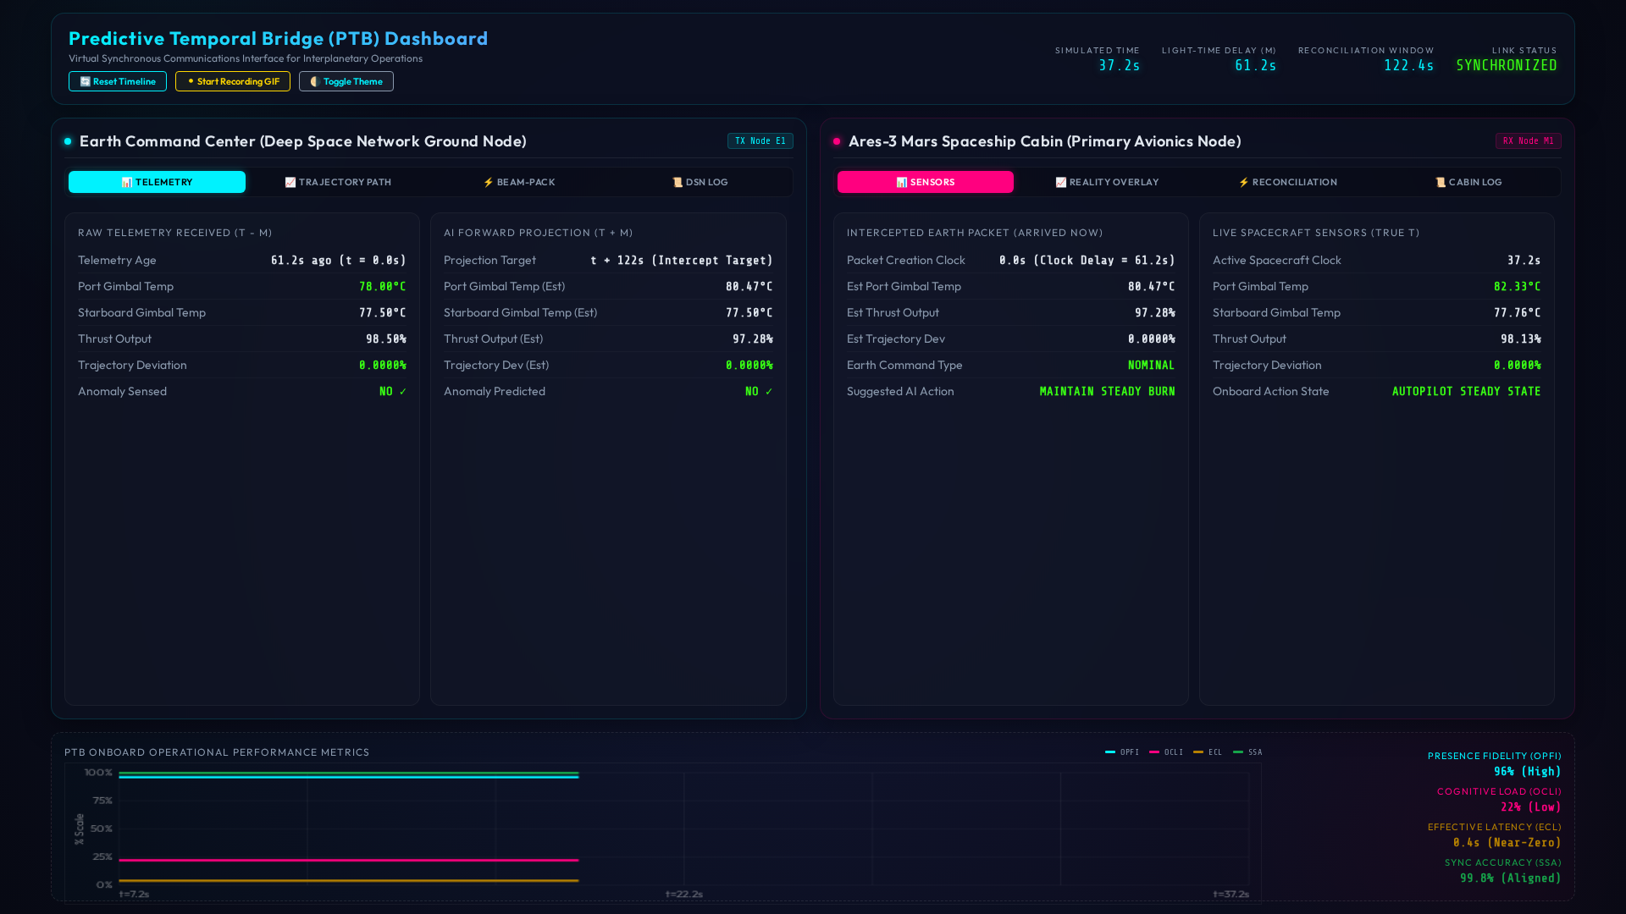

Figure 2. Proposed PTB operational and psychological metrics over the simulation timeline. The injection of the anomaly at spacecraft time T+01:30 triggers a transient drop in State Synchronization Accuracy (SSA) and Presence Fidelity (OPFI), accompanied by a spike in Cognitive Load (OCLI), all of which recover exponentially following command execution at T+02:10.
Alt text: A line graph showing the simulated timeline of three metrics: State Synchronization Accuracy, Operator Presence Fidelity, and Operator Cognitive Load. The metrics show a temporary deviation during an anomaly at T+01:30 and return to baseline after reconciliation at T+02:10.
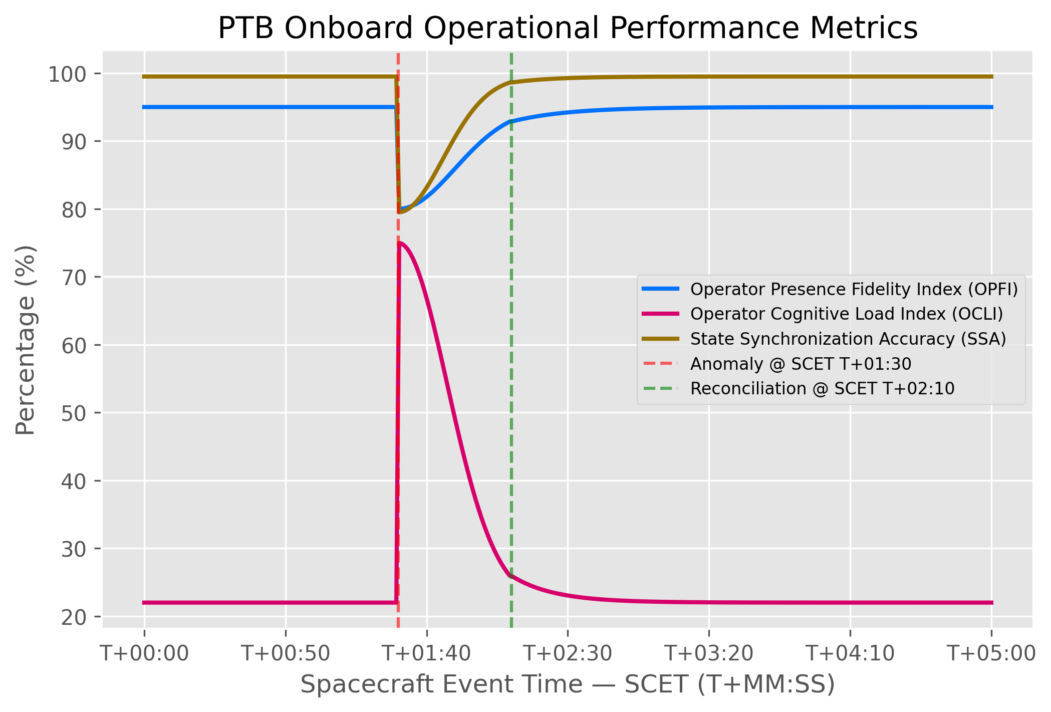

Figure 3. Effective Command Latency (ECL) comparison. The solid blue line illustrates the crew's perceived latency under the PTB protocol, which remains near-zero throughout the simulation except for a brief, transparent spike during the unreconciled anomaly window.
Alt text: A line graph comparing actual light-time delay with the Effective Command Latency under the Predictive Temporal Bridge. The actual delay grows steadily while the effective latency remains near-zero except for a brief spike during the anomaly.
