1. Do the below programs in anonymous function & IIFE
   1. Print odd numbers in an array

const arr = [0,1,2,3,4,5,6,7,8,9,10];

const oddNumbers = []

for(let i = 0; i < arr.length; i++){

arr[i] % 2 === 0 && oddNumbers.push(arr[i]);

}

console.log("this is oddNumbers:", oddNumbers);

**output:**

**___**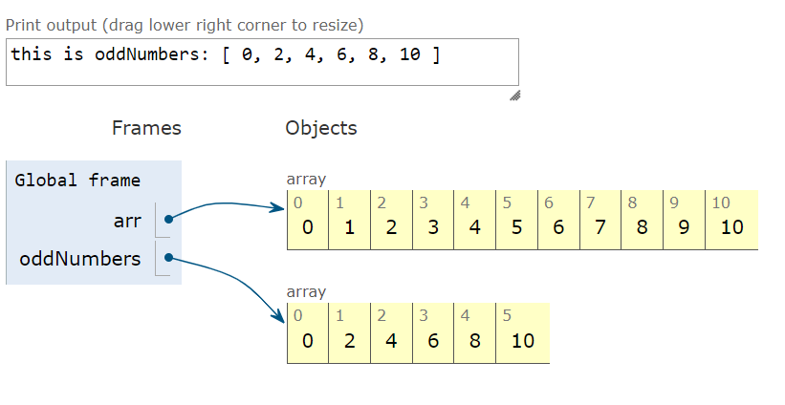

______________________________________________________________

* 1. Convert all the strings to title caps in a string array

function titleCase(str) {

str = str.toLowerCase().split(' ');

for (let i = 0; i < str.length; i++) {

str[i] = str[i].charAt(0).toUpperCase() + str[i].slice(1);

}

return str.join(' ');

}

console.log(titleCase("full stack development"));

**output:** 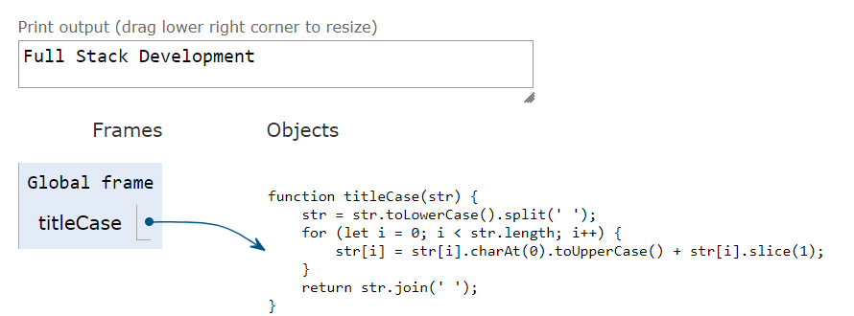

________________________________________________________________________________

* 1. Sum of all numbers in an array

let arr = [5,15,30,50]

let sum = 0;

for (let i = 0; i < arr.length; i++) {

sum += arr[i];

}

console.log("Sum is:",sum)

**Output**

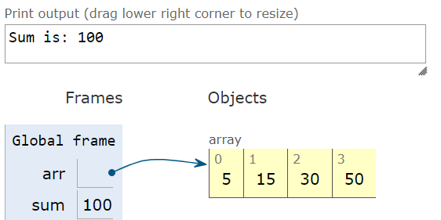

______________________________________________________________

* 1. Return all the prime numbers in an array

function inputArray(num) {

if (num < 2) {

return false;

}

for (let i = 2; i <= Math.sqrt(num); i++) {

if (num % i === 0) {

return false;

}

}

return true;

}

function findPrimes(n) {

const primes = [];

for (let i = 2; i <= n; i++) {

if (inputArray(i)) {

primes.push(i);

}

}

return primes;

}

console.log("This is the Primes Numbers:",findPrimes(20))

**Output**

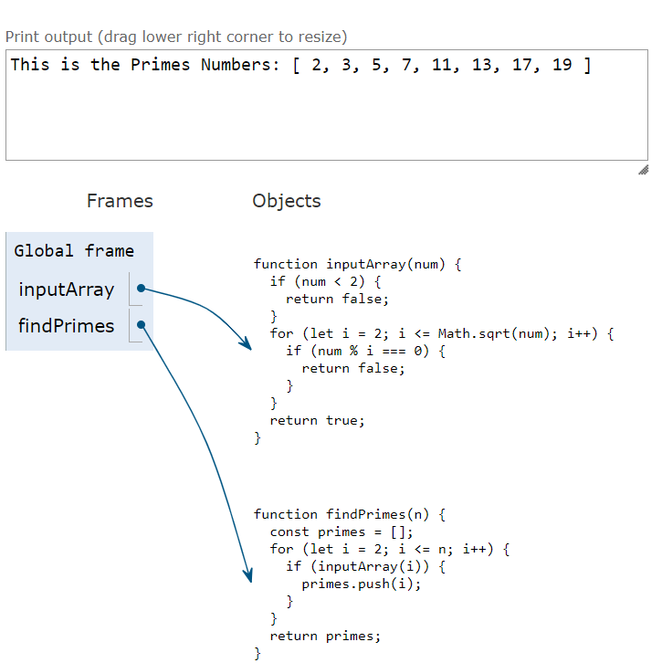

_______________________________________________________________

* 1. Return all the palindromes in an array

let str1 = "rotator";

let str2 = "deed";

let str3 = "wow";

function isPalindrome(str) {

let rev = "";

for (let i = str.length - 1; i >= 0; i--) {

rev += str[i];

}

if (rev == str) {

return true

} else {

return false;

}

}

console.log("rotator is Palindrome:",isPalindrome(str1));

console.log("deed is Palindrome:",isPalindrome(str2));

console.log("wow is Palindrome:",isPalindrome(str3));

**Output**

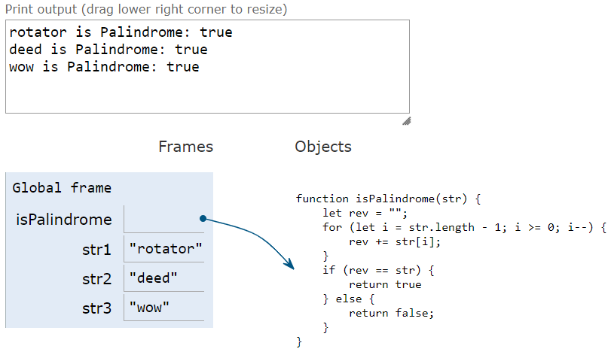

____________________________________________________________

* 1. Return median of two sorted arrays of the same size.
  2. Remove duplicates from an array

let arr = [10,20,30,20,10];

function removeDuplicates(arr) {

return [...new Set(arr)];

}

console.log(removeDuplicates(arr));

**Output**

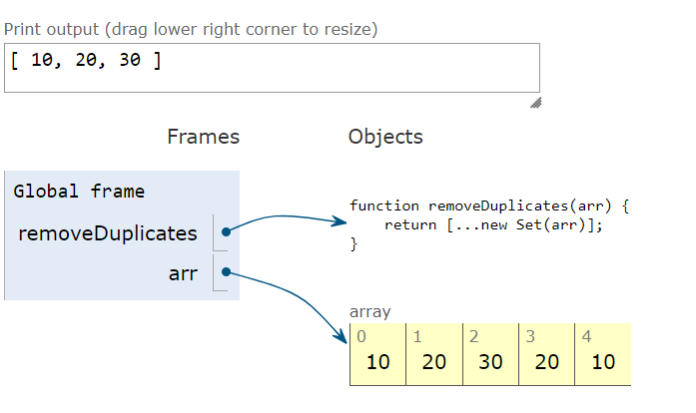

_________________________________________________________________

* 1. Rotate an array by k times

let arr = [1,2,3,4,5,6,7,8,9,10];

let n = arr.length;

let k = 5; //No. of rotations

k = k % n;

let i, j;

for (i = n - k, j = n - 1; i < j; i++, j--) {

let temp = arr[i];

arr[i] = arr[j];

arr[j] = temp;

}

for (i = 0, j = n - k - 1; i < j; i++, j--) {

let temp = arr[i];

arr[i] = arr[j];

arr[j] = temp;

}

for (i = 0, j = n - 1; i < j; i++, j--) {

let temp = arr[i];

arr[i] = arr[j];

arr[j] = temp;

}

for (let i = 0; i < n; i++) {

console.log(arr[i]+ " ");

}

**Output:**

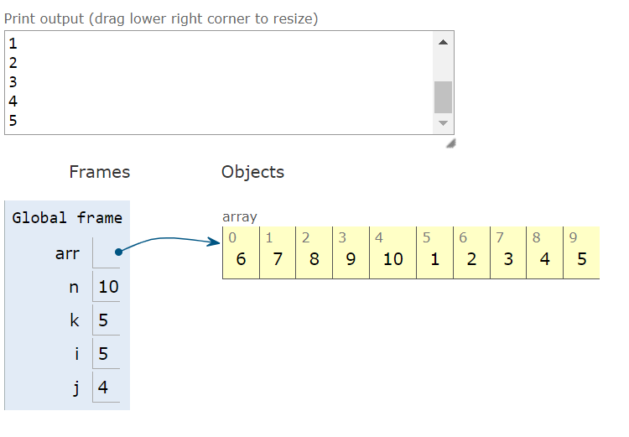

**____________________________________________________________________________**

1. Do the below programs in arrow functions.
   1. Print odd numbers in an array.

const arr = [1 , 2, 4, 9, 12, 13, 20];

const oddNumbers = arr.filter((num) => num%2 === 1);

console.log(oddNumbers);

**Output:**

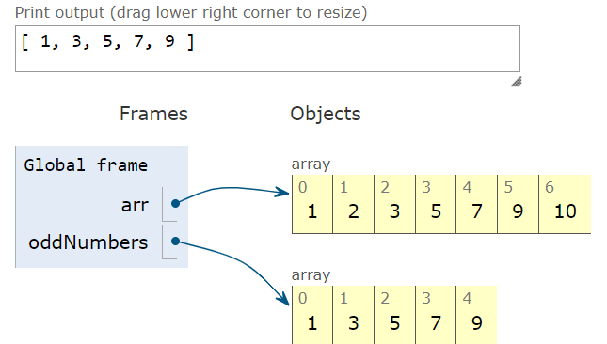

________________________________________________________________

* 1. Convert all the strings to title caps in a string array

const str = "full stack development";

let titleCase = "";

str.split(" ").forEach(word => {

const capitalizedWord = word.charAt(0).toUpperCase() + word.slice(1).toLowerCase();

titleCase += capitalizedWord + " ";

});

console.log(titleCase);

**Output:**

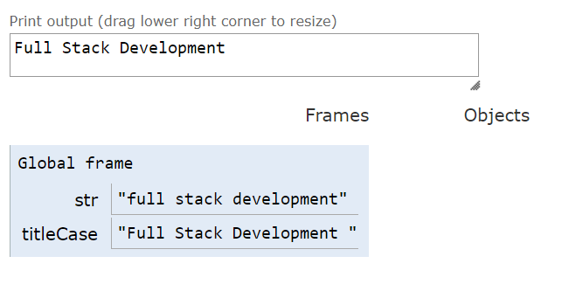

_________________________________________________________________________________

* 1. Sum of all numbers in an array.

let addition = (a, b) => a + b;

let num1 = 15;

let num2 = 15;

let sum = addition(num1, num2);

console.log("Sum of given numbers is :", sum);

**Output:**

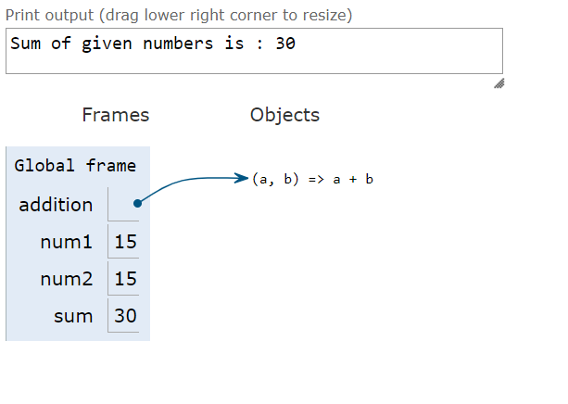

_______________________________________________________________________________

* 1. Return all the prime numbers in an array

function isPrime(number) {

if (number <= 1) return false;

for (let i = 2; i <= Math.sqrt(number); i++) {

if (number % i === 0) return false;

}

return true;

}

function displayPrimes(start, end) {

for (let i = start; i <= end; i++) {

if (isPrime(i)) {

console.log(i);

}

}

}

let num1 = 500;

let num2 = 600;

displayPrimes(num1, num2);

**Output:**

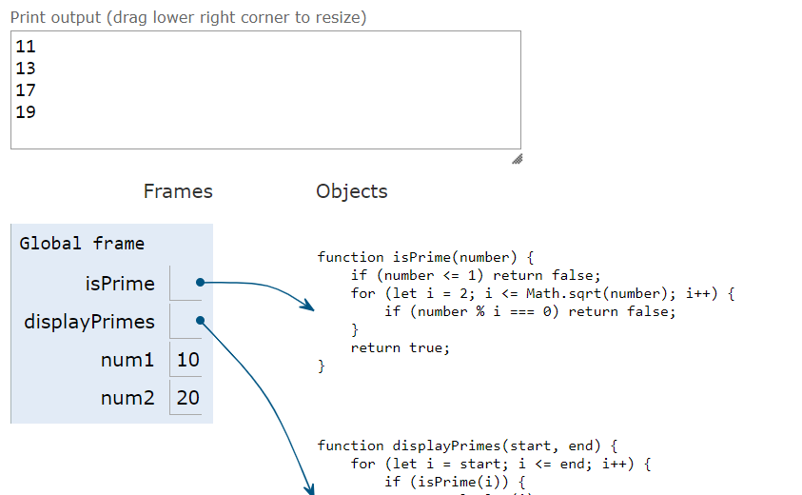

_________________________________________________________________________________

Return all the palindromes in an array .

const getAllPalindromes = function (words) {

return words.filter(function (word) {

return word.split("").reverse().join("") === word;

});

};

console.log(getAllPalindromes(["hello", "noon","rotator","deed"]));

**Output:**



