1.Write a “person” class to hold all the details

class Person {

constructor(name, age, country) {

this.name = name;

this.age = age;

this.country = country;

}

displayDetails() {

console.log(`Name: ${this.name}`);

console.log(`Age: ${this.age}`);

console.log(`Country: ${this.country}`);

}

}

const person1 = new Person('Vel', 25, 'USA');

const person2 = new Person('Murugan', 30, 'Netherlands');

console.log('Person-1 Details:');

person1.displayDetails();

console.log('\nPerson-2 Details:');

person2.displayDetails();

**OutPut:**

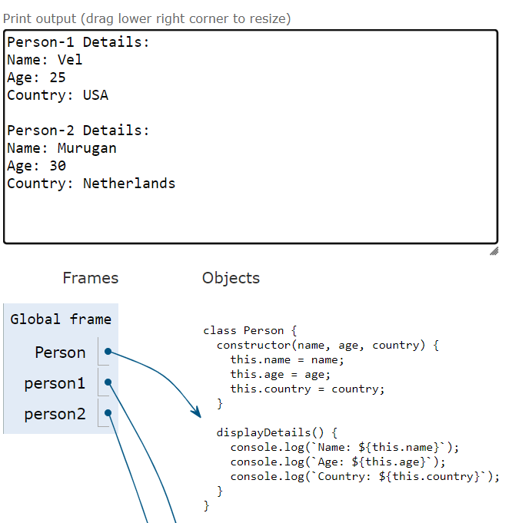

2. write a class to calculate the Uber price

|  |  |
| --- | --- |
|  | /** |
|  | * 1. Go to <https://riders.uber.com/trips> |
|  | * 2. Open developers console |
|  | * 3. Paste next code |
|  | */ |
|  |  |
|  | class UberPrice { |
|  | constructor() { |
|  | this.interval = null; |
|  | this.prices = []; |
|  | this.pages = 0; |
|  | this.lastTrip = null; |
|  | } |
|  |  |
|  | getNextButton() { |
|  | return $('.btn.pagination__next'); |
|  | } |
|  |  |
|  | getLastTrip() { |
|  | return $('#trips-table tbody tr:nth-last-child(2)') |
|  | .children() |
|  | .map((i, e) => e.innerHTML) |
|  | .toArray() |
|  | .join(); |
|  | } |
|  |  |
|  | getSum(currency = 'UAH') { |
|  | return this.prices.filter(p => p.indexOf(currency) !== -1) |
|  | .map(p => p.slice(3)).map(parseFloat) |
|  | .reduce((acc, x) => acc + x, 0); |
|  | } |
|  |  |
|  | parse() { |
|  | const currentPrices = $('td.text--right') |
|  | .map((i, e) => e.innerHTML) |
|  | .filter((k,e) => e.indexOf('Canceled') === -1) |
|  | .toArray() |
|  | .map(price => price.match(/[A-Z]{3}.*/g)) |
|  | .filter(e => e) |
|  | .map(p => p[0]); |
|  |  |
|  | this.lastTrip = this.getLastTrip(); |
|  | this.prices = this.prices.concat(currentPrices); |
|  | } |
|  |  |
|  | nextPage() { |
|  | const page = window.location.href; |
|  | const $button = this.getNextButton(); |
|  |  |
|  | $button.click(); |
|  |  |
|  | console.log('PAGE: ', page); |
|  |  |
|  | this.interval = setInterval( |
|  | () => { |
|  | if (window.location.href !== page) { |
|  | clearInterval(this.interval); |
|  | setTimeout(() => { |
|  | this.run(); |
|  | }, 1000); |
|  | } |
|  | }, 300); |
|  | } |
|  |  |
|  | incrementPages() { |
|  | this.pages += 1; |
|  | } |
|  |  |
|  | run() { |
|  | this.parse(); |
|  | this.incrementPages(); |
|  | this.nextPage(); |
|  | } |
|  | } |
|  |  |
|  | const p = new UberPrice(); |
|  |  |
|  | p.run(); |
|  |  |