TABLE OF CONTENTS
Page | Section / Title
1 | Table of Contents
2 | Abstract
3 | Chapter 1 – Introduction / Project Overview
3 | Objectives, Scope and Motivation
4 | Chapter 2 – System Analysis / Existing System
4 | Proposed System and Feasibility Study
5 | Chapter 3 – System Design / Architecture
5 | Technology Stack and Dataset
5 | Text Preprocessing and TF-IDF
5 | Model Development and Implementation
7 | Chapter 4 – System Testing
8 | Results and Output Screenshots
10 | GitHub Repository
11 | Chapter 5 – Conclusion
11 | Future Enhancement
12 | References
13–16 | Appendix / Sample Code

The contents are arranged according to the chapter sequence of this mini-project report.

ABSTRACT
Customer reviews are an important source of feedback about products and services. They contain opinions about quality, price, delivery, usability, customer support and overall satisfaction. However, manually reading and categorizing a large number of reviews requires considerable time and effort. This project presents a Customer Review Sentiment Classification system that applies Natural Language Processing techniques to process review text and predict the sentiment expressed by customers.
The proposed system uses Python-based text processing to clean and normalize review data. The cleaned text is converted into numerical features using Term Frequency–Inverse Document Frequency (TF-IDF). A supervised machine-learning classifier, with Logistic Regression as the baseline, learns patterns from labelled examples and predicts sentiment classes. The workflow is designed to be modular so that dataset preparation, vectorization, model training and prediction can be tested independently.
The workflow includes dataset loading, data inspection, text preprocessing, feature extraction, model training, prediction and evaluation. Performance is assessed using accuracy, precision, recall, F1-score and a confusion matrix. The report also discusses system feasibility, testing, limitations and possible future improvements such as multi-class sentiment, aspect-based analysis and transformer models. Actual metric values must be added only after executing the model on the selected dataset; no unverified performance result is claimed.
Keywords: Natural Language Processing, Sentiment Analysis, Customer Reviews, TF-IDF, Tokenization, Logistic Regression, Text Classification.

CHAPTER 1: INTRODUCTION

1.1 Project Overview
The Customer Review Sentiment Classification system is designed to identify the opinion expressed in customer feedback. E-commerce websites and digital service platforms generate large volumes of textual reviews every day. These reviews contain useful information, but reading every comment manually becomes difficult as the dataset grows.
Natural Language Processing provides methods for processing human language and extracting meaningful patterns. Sentiment analysis is one such task. It classifies text according to the opinion expressed, commonly as positive, negative or neutral. The exact categories depend on the dataset used in the project.
The proposed system accepts a labelled review dataset, performs text preprocessing, converts text into numerical features and applies a supervised classifier. The output is a predicted sentiment label for each review, together with evaluation information.

1.2 Need for the Project
Organizations need to understand customer satisfaction and identify recurring complaints. A sentiment classifier can help summarize large review collections and highlight broad patterns. It does not replace human judgement, but it can support faster first-level analysis.

1.3 Objectives
- To understand and apply Natural Language Processing techniques to customer reviews.
- To inspect and prepare a labelled review dataset for supervised learning.
- To clean and normalize textual data while preserving sentiment-bearing words.
- To convert text into numerical features using TF-IDF.
- To train a machine-learning model for sentiment classification.
- To evaluate the classifier using standard metrics.
- To demonstrate a practical application of NLP in opinion mining.

1.4 Project Scope
The minimum project scope is an offline application that reads a labelled CSV dataset containing review text and sentiment labels. It performs text preprocessing, feature extraction and model training, then produces predictions for unseen test examples. The report focuses on English-language reviews and a traditional machine-learning baseline.

1.5 Motivation
The motivation comes from the increasing volume of online feedback and the need for consistent analysis. This project also provides practical experience in text preprocessing, vectorization, supervised learning, evaluation and reproducible documentation.

CHAPTER 2: SYSTEM ANALYSIS

2.1 Existing System
In a manual review-analysis process, a person reads customer comments and decides whether each review is positive, negative or neutral. Some platforms display average star ratings or use simple keyword-based methods to summarize opinions.

Limitations of the Existing System
- Manual reading takes time when the number of reviews is large.
- Different people may interpret the same review differently.
- Keyword matching may fail to understand negation and context.
- Large datasets are difficult to summarize consistently.
- Manual categorization may become repetitive and difficult to scale.

2.2 Challenges in Review Text
Customer reviews are not always written in a formal style. They may contain spelling mistakes, abbreviations, repeated punctuation, emojis, mixed opinions and domain-specific words. A review can also express both positive and negative points. These characteristics make text preprocessing and evaluation important parts of the system.

2.3 Proposed System
The proposed system uses NLP and supervised machine learning to classify review sentiment. It processes review text through cleaning, tokenization and TF-IDF feature extraction, then uses a trained classifier to predict the sentiment label.

Key Features
- Accepts review data from a CSV file.
- Checks missing values and prepares text for analysis.
- Uses TF-IDF to create numerical text features.
- Trains a Logistic Regression baseline classifier.
- Predicts sentiment for unseen reviews.
- Provides evaluation metrics and an output file for further analysis.

2.4 Feasibility Study
Type | Description
Technical | Python and open-source libraries such as Pandas and Scikit-learn support the required processing and model training.
Economic | The project can be developed using free, open-source software and a standard student computer.
Operational | The workflow is straightforward: provide a dataset, run the notebook/script and inspect predictions.
Academic | The project demonstrates NLP concepts including preprocessing, vectorization and text classification.

CHAPTER 3: SYSTEM DESIGN AND IMPLEMENTATION

3.1 System Architecture
The system follows a sequence of connected modules. The dataset is first loaded and validated. Review text is then cleaned and normalized. The processed text is transformed into numerical features using TF-IDF. A supervised classifier is trained using labelled examples and evaluated on held-out data.
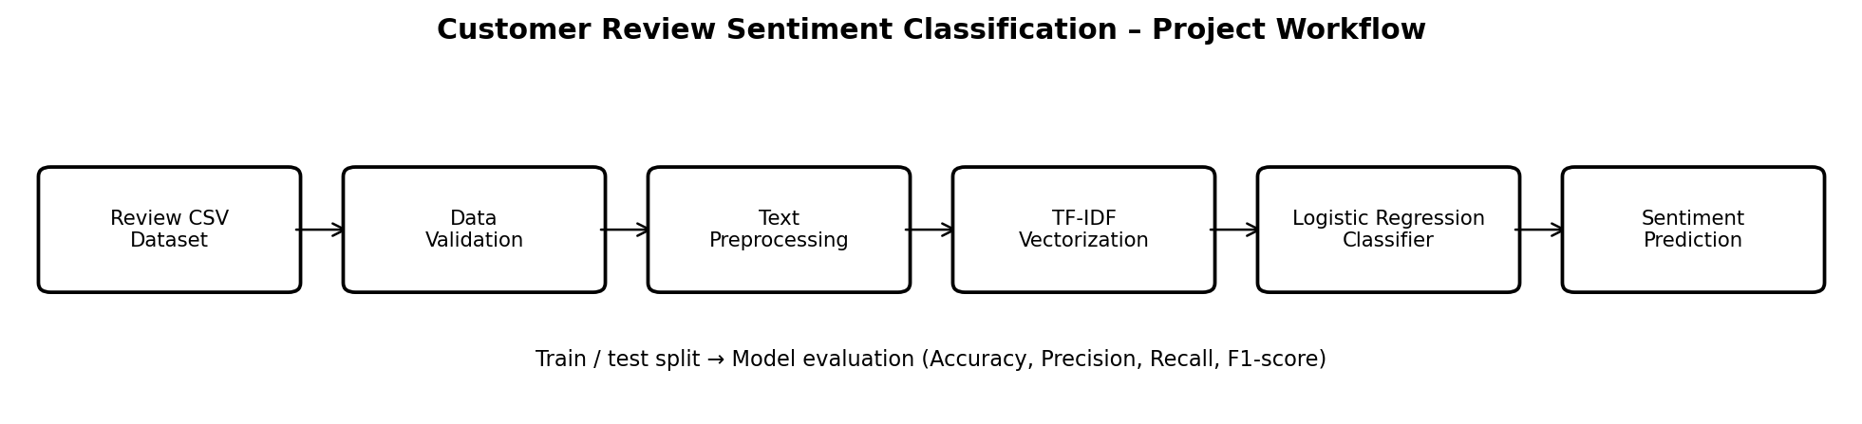
Figure 3.1: Project workflow (proposed system)
REVIEW DATASET → PREPROCESSING → TF-IDF → CLASSIFIER → SENTIMENT OUTPUT
Module | Function
Input / Dataset | Loads labelled customer reviews from a CSV file.
Preprocessing | Handles missing values, normalization and unwanted text noise.
Feature Extraction | Transforms text into TF-IDF numerical vectors.
Classification Model | Learns sentiment patterns from training examples.
Prediction and Evaluation | Predicts labels and calculates classification metrics.

3.2 System Flow
- User or analyst provides a labelled review dataset.
- The system checks the dataset structure and required columns.
- Text preprocessing prepares review content.
- TF-IDF converts the text into numerical vectors.
- The classifier learns from the training portion.
- The trained pipeline predicts sentiment for test or new reviews.
- The system displays or saves predictions and evaluation results.

3.3 Technology Stack
Technology | Purpose
Python 3.x | Core programming language.
Pandas | Loading and manipulating review datasets.
NLTK / regular expressions | Text preprocessing and tokenization.
Scikit-learn | TF-IDF, train/test split, Logistic Regression and evaluation.
Matplotlib | Charts and confusion matrix visualization.
Jupyter Notebook / VS Code | Development and execution environment.
Git / GitHub | Version control and source-code hosting.

3.4 Dataset Description
A labelled customer/product review dataset is required for supervised learning. The dataset should contain a review-text column and a sentiment label, or a rating field that can be converted into sentiment classes. The label conversion rule must be recorded clearly.
Dataset detail | Fill from the actual dataset
Dataset name | ________________________
Source / URL | ________________________
Review text column | ________________________
Sentiment label column | ________________________
Number of records | ________________________
Class labels and counts | ________________________

The exact dataset source, version, license and record count are not established by the supplied sample report. These details must be completed from the dataset actually selected.

3.5 Text Preprocessing
Text preprocessing prepares raw customer comments for feature extraction. The objective is to reduce irrelevant variation while retaining information that helps determine sentiment.

Common Preprocessing Steps
- Lowercasing: convert text to a consistent case where appropriate.
- Noise removal: remove HTML fragments and unwanted formatting characters.
- Whitespace normalization: replace repeated spaces and line breaks with standard spacing.
- Tokenization: split text into words or tokens.
- Stop-word handling: remove only words that do not contribute useful information.
- Optional stemming or lemmatization: reduce related word forms to a common base.

Important Consideration
Negation words such as “not” and “never” can change the meaning of a review. They should not be removed blindly during stop-word removal. For example, “good” and “not good” express different sentiment. Preprocessing choices should therefore be tested against actual examples.

3.6 TF-IDF Feature Extraction
Term Frequency–Inverse Document Frequency converts text into numerical features. Term Frequency represents how often a term appears in a document. Inverse Document Frequency reduces the influence of terms that occur in many documents. TF-IDF produces a sparse numerical representation suitable for traditional text-classification algorithms.

3.7 Model Development and Implementation
Logistic Regression is selected as the baseline classifier because it is efficient for sparse text features and provides a useful reference for comparison. The dataset is divided into training and testing subsets. The vectorizer is fitted only on training text, preventing information from the test set from influencing feature construction.

Implementation Steps
- Load the CSV file using Pandas.
- Remove or handle records with missing review text or labels.
- Separate the review text (X) and sentiment label (y).
- Split the data into training and testing subsets.
- Create a pipeline containing TF-IDF and Logistic Regression.
- Train the pipeline using training data.
- Generate predictions for test reviews.
- Calculate classification metrics and save predictions.

Reproducibility
A fixed random seed should be used for the train/test split. The report should also record the dataset version, library versions, label mapping and model parameters. These details make the experiment easier to repeat and verify.

CHAPTER 4: SYSTEM TESTING AND RESULTS
System testing verifies that each stage of the sentiment-classification workflow operates correctly and that the final model produces consistent outputs. Testing should cover dataset loading, preprocessing, feature extraction, model training and prediction.

4.1 Types of Testing

1. Functional Testing
- The dataset is loaded successfully.
- Required text and label columns are available.
- Missing or invalid review records are handled.
- Text preprocessing returns valid cleaned text.
- The model generates a sentiment prediction for valid input.

2. Unit Testing
Individual modules such as data loading, text cleaning, vectorization and prediction should be tested separately. This makes it easier to identify errors at the stage where they occur.

3. Integration Testing
Integration testing verifies that preprocessed text is transformed by the fitted vectorizer and passed correctly to the classifier, and that predictions are saved in the expected output format.

4.2 Test Cases
Test Case | Expected Outcome
Valid CSV file | Dataset loads without error.
Missing review text | Record is removed or handled using the documented rule.
Valid review text | Preprocessing returns normalized text.
Training data | TF-IDF and classifier fit successfully.
New review | Model returns a sentiment prediction.
Export predictions | Output file is saved with review and predicted label.

4.3 Evaluation Metrics
Metric | Purpose
Accuracy | Overall proportion of correct predictions.
Precision | Among predictions for a class, proportion that are correct.
Recall | Among actual examples of a class, proportion correctly identified.
F1-score | Balances precision and recall.
Confusion Matrix | Shows correct and incorrect predictions for each class.

4.4 Results
Enter the actual values generated by running the project. Do not report sample or estimated values as real experimental results.
Result | Actual value
Dataset records used | ______________________
Train/test split | ______________________
Accuracy | ______________________
Precision (macro) | ______________________
Recall (macro) | ______________________
F1-score (macro) | ______________________

4.5 Output Screenshots
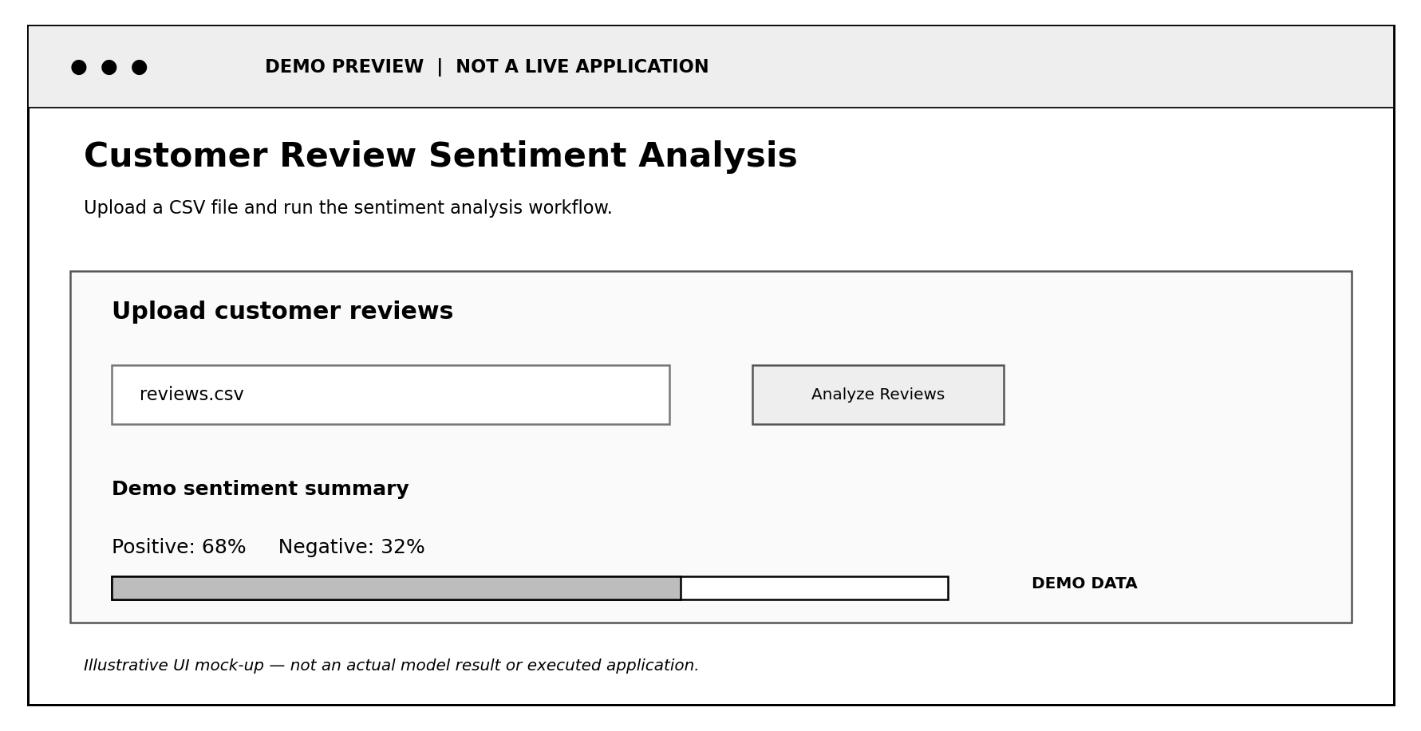
Illustrative demo screenshot – replace with actual project output.
Dataset preview / review records
Illustrative demo screenshot – replace with actual project output.
Cleaned text and preprocessing output
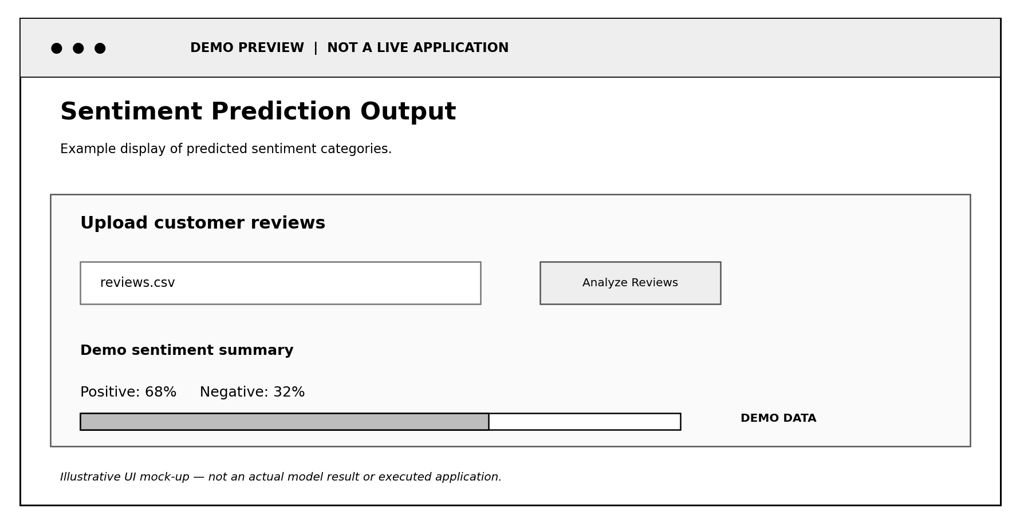
Illustrative demo screenshot – replace with actual project output.
Model evaluation / confusion matrix
Illustrative demo screenshot – replace with actual project output.
Sentiment prediction output

4.6 GITHUB REPOSITORY
The project source code should be maintained in a GitHub repository. The repository makes the project files accessible for review and supports version control. A clear README file should explain the project objective, dataset requirements, installation steps and execution instructions.

Recommended Repository Structure
customer-review-sentiment/
data/ # dataset instructions or sample data
notebooks/ # NLP analysis notebook
src/ # preprocessing and training scripts
outputs/ # metrics and prediction files
requirements.txt # Python dependencies
README.md # project documentation
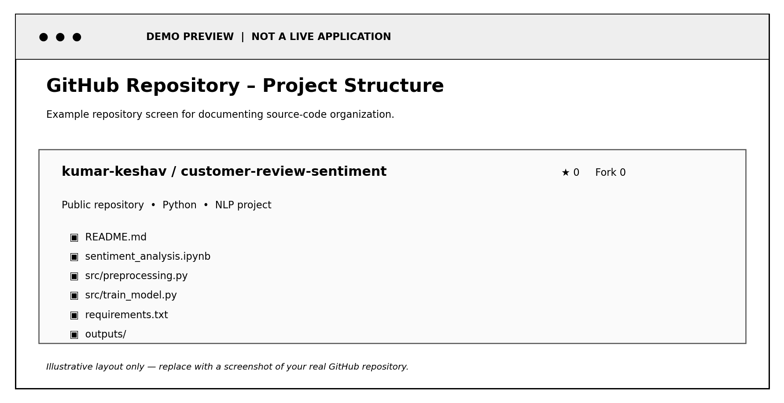
Illustrative GitHub screenshot – not a live repository.
Figure: GitHub repository overview and file list
Repository URL: ______________________________________________
Important: The GitHub image above is a visual demo only. It is not evidence of an existing repository. Insert a real screenshot from your GitHub account and add the repository URL before final submission.

CHAPTER 5: CONCLUSION AND FUTURE WORK

5.1 Conclusion
The Customer Review Sentiment Classification project demonstrates how Natural Language Processing and machine learning can be used to analyze customer opinions. The proposed workflow includes dataset preparation, text preprocessing, TF-IDF feature extraction, sentiment classification and evaluation.
The project provides practical experience in transforming unstructured text into numerical features and using a supervised classifier to predict sentiment. It also highlights the importance of dataset quality, label consistency and correct evaluation methodology.
The final performance of the system must be established through execution on the selected dataset. Actual test metrics and screenshots should be included so that the implementation can be verified.

5.2 Future Enhancement
- Add a neutral sentiment class and support multi-class classification.
- Compare Logistic Regression with Naive Bayes and Support Vector Machine.
- Explore LSTM or transformer-based models for contextual language understanding.
- Add aspect-based sentiment analysis for product quality, price, delivery and support.
- Develop a web interface for uploading reviews and viewing sentiment summaries.
- Extend the system to additional languages using suitable labelled datasets.
- Add model monitoring and periodic retraining when new labelled data becomes available.

Potential Applications
- Summarizing customer feedback for online stores.
- Identifying recurring product complaints.
- Monitoring broad satisfaction trends across review collections.
- Supporting service teams in prioritizing review categories.

REFERENCES
- Bird, S., Klein, E., & Loper, E. (2009). Natural Language Processing with Python. O’Reilly Media.
- Pedregosa, F., et al. (2011). Scikit-learn: Machine Learning in Python. Journal of Machine Learning Research, 12, 2825–2830.
- Jurafsky, D., & Martin, J. H. Speech and Language Processing. https://web.stanford.edu/~jurafsky/slp3/
- NLTK Documentation. https://www.nltk.org/
- Scikit-learn Documentation. https://scikit-learn.org/stable/
- Pandas Documentation. https://pandas.pydata.org/docs/
- Matplotlib Documentation. https://matplotlib.org/stable/
- Add the exact citation, URL and access date for the customer-review dataset actually used.
The references above identify general NLP and software documentation. The selected dataset must be cited separately after it has been chosen.

APPENDIX: SAMPLE DATASET (CSV)
The accompanying file reviews.csv is a small illustrative dataset provided to demonstrate the required input format. It contains two columns: review_text (the customer review) and sentiment (the target class: positive or negative). These example records are for testing the program structure only; they are not collected research data and must not be used to claim model performance. For final evaluation, replace or extend this file with a properly sourced and cited real dataset.
APPENDIX: SAMPLE IMPLEMENTATION CODE
Install required libraries: pip install pandas scikit-learn joblib
Save the dataset as reviews.csv in the same folder as the Python file, then run: python sentiment_classifier.py
Complete Python Implementation
print("Saved: sentiment_model.joblib and sentiment_predictions.csv")
results.to_csv("sentiment_predictions.csv", index=False)
})
"predicted_sentiment": predictions
"actual_sentiment": y_test,
"review_text": X_test,
results = pd.DataFrame({
# 10. Export test predictions for inspection

print(f"Predicted sentiment: {sentiment}\n")
print(f"Review: {review}")
for review, sentiment in zip(new_reviews, new_predictions):
new_predictions = model.predict(new_reviews)

]
"The item is damaged and customer support was very poor."
"The product quality is excellent and delivery was fast.",
new_reviews = [
# 9. Predict sentiment for a new customer review

joblib.dump(model, "sentiment_model.joblib")
# 8. Save the trained model for future predictions

print(confusion_matrix(y_test, predictions))
print("\nConfusion Matrix:")
print(classification_report(y_test, predictions, zero_division=0))
print("\nClassification Report:")
print("Accuracy:", round(accuracy_score(y_test, predictions), 4))

predictions = model.predict(X_test)
# 7. Evaluate using unseen test data

model.fit(X_train, y_train)
# 6. Train the model

])
))
class_weight="balanced"
max_iter=1000,
("classifier", LogisticRegression(
)),
min_df=2
ngram_range=(1, 2),
max_features=5000,
("tfidf", TfidfVectorizer(
model = Pipeline([
# 5. Build TF-IDF + Logistic Regression pipeline

)
stratify=y
random_state=42,
test_size=0.20,
y,
X,
X_train, X_test, y_train, y_test = train_test_split(
# 4. Split data into training and testing sets

raise ValueError("The dataset must contain at least two sentiment classes.")
if y.nunique() < 2:

y = df[LABEL_COLUMN]
X = df[TEXT_COLUMN]
# 3. Separate input reviews and target sentiment labels

df = df[df[TEXT_COLUMN].str.len() > 0]
df[TEXT_COLUMN] = df[TEXT_COLUMN].apply(clean_review)

return text
text = re.sub(r"\s+", " ", text).strip()
text = re.sub(r"[^a-zA-Z0-9\s']", " ", text)
text = re.sub(r"http\S+|www\.\S+", " ", text) # Remove URLs
text = re.sub(r"<[^>]+>", " ", text) # Remove HTML tags
text = text.lower()
def clean_review(text):
# 2. Basic text cleaning

df[LABEL_COLUMN] = df[LABEL_COLUMN].astype(str).str.strip().str.lower()
df[TEXT_COLUMN] = df[TEXT_COLUMN].astype(str)
df = df.dropna(subset=[TEXT_COLUMN, LABEL_COLUMN]).copy()

raise ValueError(f"Missing required columns: {missing_columns}")
if missing_columns:
missing_columns = required_columns - set(df.columns)
required_columns = {TEXT_COLUMN, LABEL_COLUMN}

df = pd.read_csv(DATA_FILE)

LABEL_COLUMN = "sentiment"
TEXT_COLUMN = "review_text"
DATA_FILE = "reviews.csv"
# 1. Load and validate the dataset

)
confusion_matrix
classification_report,
accuracy_score,
from sklearn.metrics import (
from sklearn.linear_model import LogisticRegression
from sklearn.feature_extraction.text import TfidfVectorizer
from sklearn.pipeline import Pipeline
from sklearn.model_selection import train_test_split

import pandas as pd
import joblib
import re

# Example labels: positive / negative
# Expected CSV columns: review_text, sentiment
# Customer Review Sentiment Classification
The implementation below loads a labelled CSV dataset, cleans review text, trains a TF-IDF and Logistic Regression model, evaluates it, saves the trained model and exports predictions. The code is a working template; use the actual dataset file and confirm its label values before execution.
Note: Fit the TF-IDF vectorizer only on training data. The Scikit-learn Pipeline above ensures that the vectorizer is fitted as part of model training. Verify that negation words such as “not” are not unintentionally removed.
Submission checklist: include the dataset citation, actual evaluation values, screenshots of the real application output and a genuine GitHub repository screenshot.
review_text | sentiment
The product quality is excellent and delivery was fast. | positive
Very happy with this purchase. It works perfectly. | positive
Amazing value for money and easy to use. | positive
The packaging was neat and the item arrived on time. | positive
Customer support was helpful and resolved my issue. | positive
Good quality, exactly as described. | positive
I love this product and would recommend it. | positive
The battery life is great and performance is smooth. | positive

