Dr. Pandit,  
  
We received two evaluations of your study. The two reviewers, and I, are supportive of your research. Nevertheless, there are several points to be addressed before publication. Please answer carefully to all the comments but do not feel obliged to follow them all in the revised version of your manuscript.  
  
Sincerely,  
  
Leonardo Montagnani

Reviewer: Pietro Kiyoshi Maruyama

**Basic reporting**

In this manuscript, Pandit and colleagues make use of long-term data on hummingbird admission to wildlife rehabilitation centers from California-USA to assess the main causes associated with hummingbird admission and the effect of different treatments that may lead to successful recuperation and release of hummingbirds to nature.

I found this manuscript very interesting, presenting solid data and with potential to make an important contribution to the literature on the anthropogenic effects on this relevant group of charismatic pollinators. I must admit that my training is of a field ecologist, with experience in hummingbird behavior and their interaction with plants, thus I may not have the necessary expertise to comment on the more clinical aspects of the data and study. Nevertheless, the investigation on the anthropogenic effect, especially urbanization, on hummingbirds (and other animals, pollinators) is a really important topic that has been deserving attention from many researchers from different backgrounds. Said that, this is the only point that I must say this study could be improved: to make a wider connection with topics such as urbanization and its effects on hummingbirds and other animals, the importance of hummingbirds as pollinators in the urban context. This would make this important contribution more easily found by researchers from different backgrounds. These points could at least be better mentioned for context. I would suggest the below two studies (and references therein) so that authors can improve this “context”:  
  
- Greig, E. I., Wood, E. M., & Bonter, D. N. (2017). Winter range expansion of a hummingbird is associated with urbanization and supplementary feeding. Proceedings of the Royal Society B: Biological Sciences, 284(1852), 20170256.  
- Maruyama, P. K., Bonizário, C., Marcon, A. P., D'Angelo, G., da Silva, M. M., da Silva Neto, E. N., et al. (2019). Plant-hummingbird interaction networks in urban areas: Generalization and the importance of trees with specialized flowers as a nectar resource for pollinator conservation. Biological conservation, 230, 187-194.  
  
But please feel free to choose others that are equally applicable.

**Line numbers represent lines in untracked version or with “simple markup” in tracked version.**

**Our response**: We appreciate the reviewer comments on our manuscript and value the opinion on emphasizing the issues related effects of urbanization on hummingbirds and other synanthropic wildlife. We highlight early in the manuscript the value of hummingbirds and pollinators in urban environments and also the fact that urbanization has significantly affected ecology and behavior of these species.  
**Changes to the manuscript****:** Lines 66-73: Hummingbirds, found only in the Americas, are commonly presented to wildlife rehabilitation centers (Greenewalt 1990; Heyden 2005). Commonly found in urban settings due to the use of man-made feeders, hummingbirds are key pollinator species in urbanized areas (Maruyama et al. 2019). Hummingbird distribution (Greig et al. 2017), population composition, and intra- and inter species interactions (Bandivadekar et al. 2018; Carpenter 1987; Ditchkoff et al. 2006; Lowry et al. 2013; Ng et al. 2004; Thomas et al. 2014) all have been significantly affected due to increased artificial food-resource provisioning, and urbanization. Empirical studies describing disease and health risks in hummingbird found in urban habitats are still needed.

I would also change the title to include the term “urbanization” or a related term, somehow. Besides, I have some minor but relevant points that needs revision, including comments, questions and points that needs attention for better clarity, especially regarding some numbers reported and possible correlation among variables.  
**Our response**: Updated the title to include “urban”

**Changes to the manuscript:** Title: Retrospective study on admission trends of California hummingbirds found in urban habitats (1991-2016)  
See these below.  
  
I hope my comments are useful.  
Pietro  
---  
Title and key words -> Emphasize the “urban” aspect of the study.

**Our response:** Updated the title to include “urban”

**Changes to the manuscript:** Title: Title: Retrospective study on admission trends of California hummingbirds found in urban habitats (1991-2016)

Abstract  
Line 49: Clarify the “found inside” here.

**Our response**: Updated the text clarify the reason for admission.

**Changes to the manuscript:** Lines 47-50: Reasons for hummingbird admissions to three California wildlife rehabilitation centers were anthropogenic in nature (i.e., being associated with domestic animals, window collisions, and found inside a man-made structure) and constituted 25% of total admissions.

Lines 66-80. Please gives a wider context on urban ecology, conservation of hummingbirds/pollination and impacts of urbanization on wildlife. Importance of hummingbird as pollinators, including in urban settings.

**Our response**: Included wider context to urban ecology and importance hummingbirds for pollination in urban habitats. Reviewer 2 suggested to condense the introduction, hence here is the first paragraph updated which focuses briefly on states effects of urbanization of hummingbird populations.

**Changes to the manuscript:** Lines 66-73: Hummingbirds, found only in the Americas, are commonly presented to wildlife rehabilitation centers (Greenewalt 1990; Heyden 2005). Commonly found in urban settings due to the use of man-made feeders, hummingbirds are key pollinator species in urbanized areas (Maruyama et al. 2019). Hummingbird distribution (Greig et al. 2017), population composition, and intra- and inter species interactions (Bandivadekar et al. 2018; Carpenter 1987; Ditchkoff et al. 2006; Lowry et al. 2013; Ng et al. 2004; Thomas et al. 2014) all have been significantly affected due to increased artificial food-resource provisioning, and urbanization. Empirical studies describing disease and health risks in hummingbird found in urban habitats are still needed.  
Line 184. Add “model2” after “second model” as you did for model1

**Our response**: Done, included “model 2” in a parenthesis.

**Changes to the manuscript:** Lines 175-177:A second model predicting survival was developed that included only a subset of individuals whose records indicated that they received preliminary treatment at rehabilitation centers (model 2).

Line 204-205. You mention in line 132 that nestlings were not assigned to species. But the sum of 5,723 and 1,185 is 6908 (total number of reported hummingbirds). So, nestlings were at least were classified into these two large groups? Please make this clear in M&M.

**Our response**: Nestlings were not classified into species but were classified into two species groups similar to adult-like birds. We have updated sections on the methods related to classification of nestlings into species groups (*Selasphorus spp.*, *Non-Selasphorus spp.*). Nestlings were classified into either of these two groups based on known breeding ranges and seasons and associated information reported by rescuers. For example, if a nestling was found in the month of November in Northern California was assigned *Non-Selasphorus spp.* tagas it is most likely an Anna’s Hummingbird nestling.

**Changes to the manuscript:** Lines 121-124: All nestlings were considered unknown for sex and were classified into species groups (*Selasphorus spp.* and *Non-Selasphorus spp.*) based on known breeding ranges and seasons of hummingbird species in California, and associated information reported by rescuers.

Line 205-207. These 1645 nestlings that died were within the total of 6908 hummingbirds, right? Could you also report the numbers separately for the adults likewise? These numbers need revising.

**Our response**: 1,645 were total number of nestlings reported within those 587 died. As per the reviewer’s suggestion, we now also proportion of adults that died in our manuscript.

**Changes to the manuscript:** Lines 198-200: Out of 1,645 nestlings, 35.7 % (n = 587) either died or were euthanized, with higher nestling deaths reported between March and June (Fig 2c). Similarly, within 5,263 adult birds, 72.89% either died or were euthanized.  
Line 209-212. The order of reporting needs revising. How come 12.9% was followed by 13.7%? This makes no sense.

**Our response**: Changed the order of reporting percentages.

**Changes to the manuscript:** Lines 201-205: For the study period, the most common reason for admission was ‘found on the ground’ at 42.7% (n= 2,950) and at 2.0% (n=135) the least common was “torpor-like state” (Fig 3). Of the total cases, 13.7% of rescue were “nest-related”. This was followed by 12.9 % of hummingbirds that were admitted after being caught by a domestic animal, with most of them being associated with cats except for three instances (2 dogs and 1 companion chicken). Finally, 9.6% of cases were associated with “window collisions” (Fig 3).

Line 230-231. Is this result regarding higher survival of nestlings related to the fact that nestlings were usually found in nest related reasons, which also relate to higher survival? Is there a correlation between these fixed factors: nestling and nest related reasons?

**Our response**: As reviewer suggests, based on data exploration, there is a correlation between nestling and nest related reason with more 45.7% nestlings and only 3.62% adult-like birds admitted due to nest related reason. Since, both age and reason for admission affect the survivability and are associated with each other, they are thought to act as confounders for each other. Hence, inclusion of both variables in the model is warranted. We add a brief statement describing this association in the manuscript.

**Changes to the manuscript:** Lines 248-253:“Nest-related” birds had the highest predicted probability for successful release compared to other admission reasons (mean = 0.65, SD±0.117, n = 575). 45.7% of total nestlings contrary to only 3.62 adult-like birds were admitted due to ‘nest-related’ reasons. Since both the age and reason for admission affect survivability and are associated with each other, they are thought to act as confounders for each other. Hence, the inclusion of both variables in the model was warranted.

Line 234-236. In lines 192-194 you state that these probabilities were calculated only for model 2. It is possible that I misunderstood. Please clarify.

**Our response**: Yes, probabilities are calculated only for model 2. We made slight changes to the text both in methods and results sections to clearly state that.

**Changes to the manuscript:**

**Lines** 183-185**:** Ten thousand simulations, only of the best fitting model 2, were used to predict the probability of survival for all the birds and outcomes were plotted against risk factors categories.

Lines 223-225: Predicted probability of successful release for nestlings based on model with treatment options (model 2) was also significantly higher than adult-like birds (Nestlings: [mean = 0.69, SD±0.056, n = 1,026], adult-like birds: [mean = 0.33, SD±0.178, n = 2,753], Figure 7).

Line 252. Change to: admission related to domestic...

**Our response**: Included missing preposition.

**Changes to the manuscript:** lines 244-248**:** Similarly, within model 1, hummingbirds with a reason for admission related to domestic animals (odds ratio: 0.65, CI: 0.53-0.79, p <0.001), window hit (odds ratio: 0.65, CI: 0.52-0.82, p <0.001), and those which were found on the ground (odds ratio: 0.76, CI: 0.65-0.89, p <0.001) also showed significantly lower odds of release compared to hummingbirds with an unknown reason for admission (Figure 5).

Line 263. Is this not non-significant (0.064)?

**Our response**: Updated the wording around the result.

**Changes to the manuscript:** Lines 257-262:Model 1 indicated that provision of supportive treatment, in general, was not found to be significantly associated with improving the odds of successful hummingbird release (odds ratio: 0.90, CI: 0.80-1.01, p = 0.064, Figure 5), but when explored further by parsing out treatments into broad treatment options for select birds that received treatment, model 2 identified treatment options that increased the odds of successful hummingbird release (Figure 6).  
Line 275. Not only a popular backyard species, but also a charismatic pollinator group

**Our response**: Noted, and sentence is now updated.

**Changes to the manuscript:** Lines 271-273: This is the first study to evaluate the survival of hummingbirds, found in urban settings, undergoing rehabilitation and factors that affect survival for this popular group of backyard species and key pollinator group.

Line 398. Remove “in California” as hummingbird “charisma” is much more widespread than in California only, I would say (but I am biased…)

**Our response**: Noted and sentence updated.

**Changes to the manuscript:** Line: 388-390: With increasing urbanization of wildlife habitats and human interactions with hummingbirds, analyzing rehabilitation trends of hummingbirds provides insights to better manage the rehabilitation of one of the most charismatic avian groups.  
Figure 7. Both nest-related and nestling factors have positive trends for hummingbird release, but one would expect naturally for these

**Our response**: Right, this comment is also related to reviewer’s previous comment related to a possible correlation between nestlings a nest-related reason. As discussed in previous comment, both age and reason for admission affect the survivability and are associated with each other, they are thought to act as confounders for each other. Hence, inclusion of both variables in the model is warranted. We add a brief statement describing this association in the manuscript. The model predicted probabilities for individual hummingbirds that are either nestlings or are admitted due to nest-related reasons both show higher chances of survival which is expected.

**Changes to the manuscript:** Lines 248-253: “Nest-related” birds had the highest predicted probability for successful release compared to other admission reasons (mean = 0.65, SD±0.117, n = 575). 45.7% of total nestlings contrary to only 3.62 adult-like birds were admitted due to ‘nest-related’ reasons. Since both the age and reason for admission affect survivability and are associated with each other, they are thought to act as confounders for each other. Hence, the inclusion of both variables in the model was warranted.

**Experimental design**

no comment

**Validity of the findings**

no comment

### Reviewer: Aniruddha Belsare

#### Basic reporting

PeerJ policy states that the authors should make code, data, and associated protocols available to readers. I think it would be a good idea to provide the protocol/code used for processing the data sourced from the WRMD online database. This could be in the Supplemental Information or consider an outlet like ‘Data-in-Brief’. The model equations provided in the Supplemental files do not provide sufficient details to ensure transparency and reproducibility of the results.

**Line numbers represent lines in untracked version or with “simple markup” in tracked version.**

**Our response**:

We apologize for not clearly indicating and directing our readers to data and code repositories. The data used for the study, python and R code used for pre-processing the data, creating models and generating figures are openly stored in a Zenodo repository. <https://zenodo.org/record/4311820> . Within the repository there are Jupyter code notebooks each for descriptive data analysis, model 1, model 2 and for plotting predictions from model 2. Further, in a separate folder within the same repository consists the main data file, and two derivative data files for model building. We completely support the open-source format of science and want to ensure that study results can be reproduced precisely. We have included specific statements in our methods to direct readers to the repository.

Reviewer has also raised a point related to the protocol for accessing/downloading the data from WRMD. Unfortunately, currently the within WRMD only users (rehabilitation centers) can access their data. There is no API/or protocol established yet to query the database for the public. We accessed the data directly from rehabilitation centers that contributed their data to WRMD. We describe the process in detail in our manuscript.

**Changes to the manuscript: Lines:** 196-198: The data used for the study, python and R code used for pre-processing the data, creating models and generating figures are openly stored in a Zenodo repository https://zenodo.org/record/4311820.

#### Experimental design

No comment, but see General comments for the author.

#### Validity of the findings

Some conclusions are unsupported or inaccurate given the methods used. See General comments for the author.

#### Comments for the author

Review of ‘Retrospective study on admission trends of Californian Hummingbirds (1991-2016)’ by Pandit & Bandivadekar et al.  
The paper describes a retrospective study that evaluates hummingbird medical records obtained from three California wildlife rehabilitation centers over a period of 26 years. The objectives of this study as stated by the authors (lines 110-115) were to analyze demographics, reasons and seasonal patterns of admission, and rehabilitation outcomes. The authors use mixed-effects logistic regression models to assess risk factors and predict probability of release post-treatment.  
Overall, the manuscript is well-written although I felt there were several areas that could be condensed. In particular, the Introduction (1st 4 paragraphs) is unnecessarily drawn out. For example, lines 69-79 could be easily removed without affecting the readability and message of this paper. The second paragraph can be similarly condensed. Also, do check line 97 for readability (replace ‘, ‘ with a period and capitalize the first letter of the next sentence).

**Our response**: We have significantly condensed the first two paragraphs as per reviewer’s suggestions. Further as per the suggestion of reviewer 1, we highlight the importance of hummingbirds as pollinators in urban habitats. Finally, changed the sentence previously at line number 97 for better readability.

**Changes to the manuscript:** Lines 66-87: Hummingbirds, found only in the Americas, are commonly presented to wildlife rehabilitation centers (Greenewalt 1990; Heyden 2005). Commonly found in urban settings due to the use of man-made feeders, hummingbirds are key pollinator species in urbanized areas (Maruyama et al. 2019). Hummingbird distribution (Greig et al. 2017), population composition, and intra- and inter species interactions (Bandivadekar et al. 2018; Carpenter 1987; Ditchkoff et al. 2006; Lowry et al. 2013; Ng et al. 2004; Thomas et al. 2014) all have been significantly affected due to increased artificial food-resource provisioning, and urbanization. Empirical studies describing disease and health risks in hummingbird found in urban habitats are still needed.

Wildlife centers play a vital role in rehabilitation efforts and provide valuable data for wildlife commonly found in urban habitats (Griffith et al. 2013; Kelly & Bland 2006; Molina-López & Darwich 2011) through standardized medical records documenting success or failure for each wildlife rescue (Heyden 2005; Kelly & Bland 2006; Mazaris et al. 2008; Molina-López & Darwich 2011; Wimberger & Downs 2010). Evaluation of rehabilitation centers’ medical records can identify admission trends, key reasons for admission, anthropogenic threats (Deem et al. 1998; Griffith et al. 2013), and pathogen prevalence (Harris & Sleeman 2007) for a wide variety of wildlife species. This vast availability of data brings a greater understanding of human-wildlife interactions in our urbanized world, as well as determines the overall impacts and outcomes of rescued wildlife following rehabilitation efforts (Molina-López & Darwich 2011). With increasing numbers of birds are rescued daily and brought to rehabilitation centers (Deem et al. 1998; Molina-López & Darwich 2011; Molina-López et al. 2011), the analysis of data collected by rehabilitation centers provide a unique opportunity to understand and mitigate anthropogenic threats to hummingbirds.

My main concern relates to the approach used by the authors to evaluate factors affecting the survival of hummingbirds admitted to rehabilitation centers. I think the initial triage/assessment at the respective rescue centers has a strong influence on the treatment course and therefore the outcome. But such assessments are subjective, and accurate clinical status of the bird cannot be ascertained using ‘reason for admission’. Such assumptions underpinning the models should therefore be clearly discussed. This is particularly important for the conclusions/discussions section of the paper. For instance, in the Discussion section (lines 362-364), the authors state that their ‘results indicated that some simple supportive measures, such as the provision of oral commercial nectar solutions, and as appropriate, antibiotics, can improve survivability during the rehabilitation process.’ This statement is not supported by the study and should be rephrased.

**Our response**: We agree to reviewer’s comment related to subjective assessment of clinical status of the bird and the proxy of “reason for admission” cannot completely represent it, hence warrants discussion. We include these assumptions upfront in our discussion and limit our discussion only to model related specifics. Further, throughout the discussion, inference related supportive treatment results has been limited to model findings.

**Changes to the manuscript:** Lines 354-361: Initial clinical assessment of rescued hummingbirds by rehabilitation centers can be subjective and can change over the years. Hence, the clinical status of these birds cannot be ascertained solely on the reasons for admission. Still, our results indicated that some simple supportive measures, such as the provision of oral commercial nectar solutions, and as appropriate, antibiotics, improve survival odds of hummingbirds. The difficulty in providing medical care to small avian species, such as hummingbirds, lies in the fact that much is unknown regarding medication pharmacokinetics and pharmacodynamics and varying metabolic requirements for hummingbirds of varying stages of life (Bucher & Chappell 1989).

278-280: The data also indication that the provision of supportive treatments such as commercial nectar solution can significantly increase the odds of survival of rescued hummingbirds.

The discussion section should also be condensed keeping in mind the method used for this study. Several ‘conclusions’ are unsupported or are inaccurate given the methodology: for instance, the authors state (lines 277-280) that ‘…several admission categories…were found to be anthropogenic’ This is not a novel finding, given that anthropogenic threats to urban hummingbirds have been well documented (e.g. references provided in line 102). This is also not a ‘finding’ of this study.

**Our response**: Changes made to statement previously at (lines 277-280). Same anthropogenic threats have been identified as threats for hummingbirds previously, hence we limit out discussion only to odds ratios from the model for reasons for admission, which is a newer finding.

Further, the discussion is condensed by removing several unsupported conclusions, especially while discussing model results related to treatment options. Please see response to previous comment.

**Changes to the manuscript:** Lines 271-280: This is the first study to evaluate the survival of urban hummingbirds undergoing rehabilitation and factors that affect survival for this popular group of backyard species and key pollinator group. We identified key anthropogenic threats and reasons that hummingbirds found in urban settings were to be admitted to wildlife rehabilitation centers. Reasons for admissions associated with anthropogenic pressures such as being associated with domestic animals, window collisions, and found inside human structures, which together constituted 25% of the total admissions were frequent but did not show any differences in influencing the odds of successful rehabilitation. The data also indicated that the provision of supportive treatments such as commercial nectar solution can significantly increase the odds of survival for rescued hummingbirds.  
Lines 305-308: “We observed an increased number of window collisions during early spring….” Given the nature of this study I recommend rephrasing such sentences - ‘The data indicates that the number of window collisions increase during early spring …’.

**Our response**: Agree to reviewer’s suggestion. Following sentences have been updated in the main text.

**Changes to the manuscript:**

Lines 301-304: The data showed an increased number of window collisions during early spring that can be associated with the territorial nature of breeding hummingbirds (Graham 1997; Stiles 1982) and the infusion of hummingbird gardens with more aggressive migratory hummingbird species (Dearborn 1998; Klem Jr 1989).

278-280: The data also indication that the provision of supportive treatments such as commercial nectar solution can significantly increase the odds of survival of rescued hummingbirds.

Data availability: PeerJ policy states that the authors should make code, data and associated protocols available to readers. I think it would be a good idea to provide the protocol/code used for processing the data sourced from the WRMD online database. This could be in the Supplemental information, or consider an outlet like ‘Data-in-Brief’. The model equations provided in the Supplemental files do not provide sufficient details to ensure transparency and reproducibility of the results.

**Our response**: We apologize for not clearly indicating our data and code repositories. The data used for the study, python and R code used for pre-processing the data, creating models and generating figures are openly stored in a Zenodo repository. <https://zenodo.org/record/4311820> . Within the repository there are Jupyter code notebooks each for descriptive data analysis, model 1, model 2 and for plotting predictions from model 2. Further, in a separate folder within the same repository consists the main data file, and two derivative data files for model building. We completely support the open-source format of science and want to ensure that study results can be reproduced precisely. We have included specific statements in our methods to direct readers to the repository.

Reviewer has also raised a point related to the protocol for accessing/downloading the data from WRMD. Unfortunately, currently the WRMD is only users (rehabilitation centers) can access their data and as per my understanding there is not API/or protocol established yet to query the database for the public. We accessed the data directly from rehabilitation centers that were contributing to WRMD. We describe the process in detail in our manuscript.

**Changes to the manuscript: Lines:** 185-187: The data used for the study, python and R code used for pre-processing the data, creating models and generating figures are openly stored in a Zenodo repository https://zenodo.org/record/4311820.  
Figure 4. Please confirm that the y axis labels for plots in Figure 4 are accurate. Also, the scales are different and make visual comparisons difficult. Either have a uniform Y axis range, or add a horizontal marker line to facilitate visual comparisons.

**Our response**: Yes, y-axis labels for plot 4 are accurate. We have taken into consideration the issues related to scale for figure 4. To address those, we tried generating the plot with same y-axis scale. Since some reasons have low frequencies in the data adjusting the plot to same scale results in a plot where seasonal pattern (if present) is not visually noticed. Please see the trial plot below. This plot is not included in the manuscript.

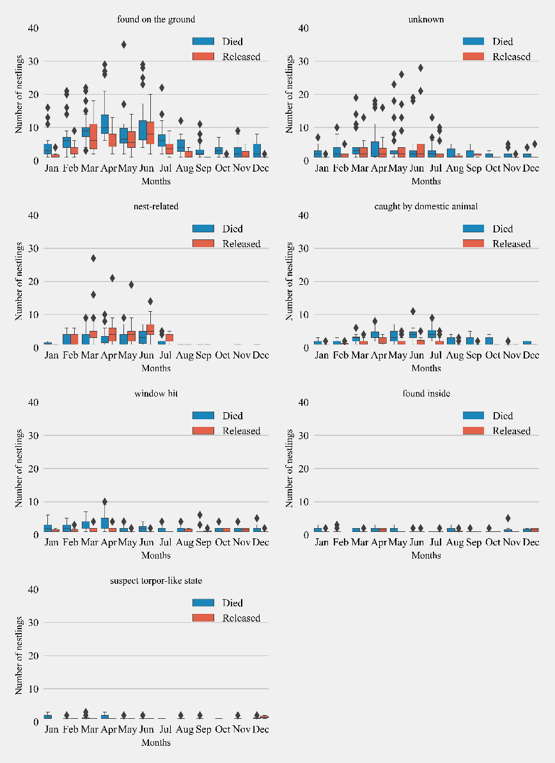

We hence made a couple of changes to address scale related concerns raised by the reviewer. 1. We standardized y-axis scale across column, and now subplots next each other have same y-axis scales. Further we added a horizontal line at y=10 as suggested by the reviewer to facilitate visual comparison.

**Changes to the manuscript: Please see the updated figure 4.**

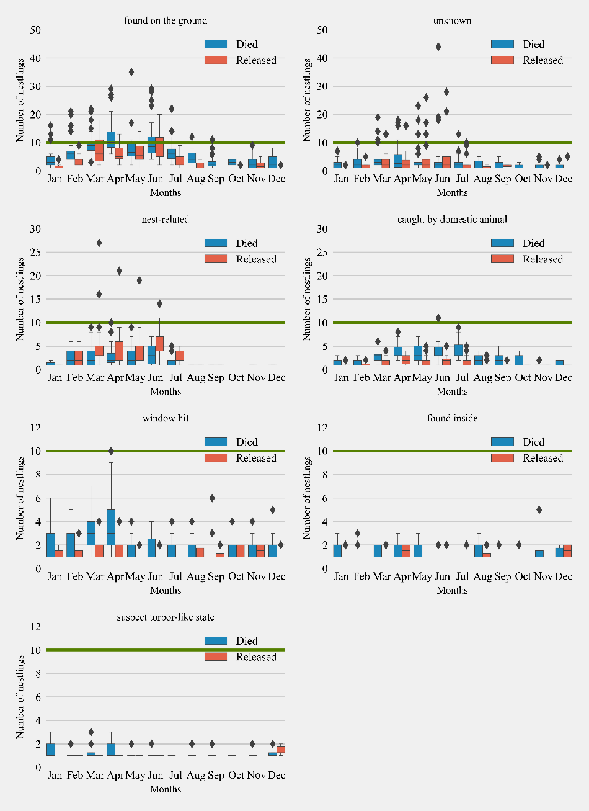

Figure 4: Monthly distribution of hummingbirds admitted to California wildlife rehabilitation centers and their disposition for each admission category (n = 7). Boxplots show the median, first, and third quartiles of the data. Whiskers extend to the data range and outliers are presented as separate diamonds. Green horizontal line represents 10 monthly cases for visual comparisons across subplots.

Figure 5 and 6: The legend should be outside – it is distracting.

**Our response**: The legend box has been moved outside the plot area. Please see updated Figures 5 and 6 below and in the manuscript.

**Changes to the manuscript:**

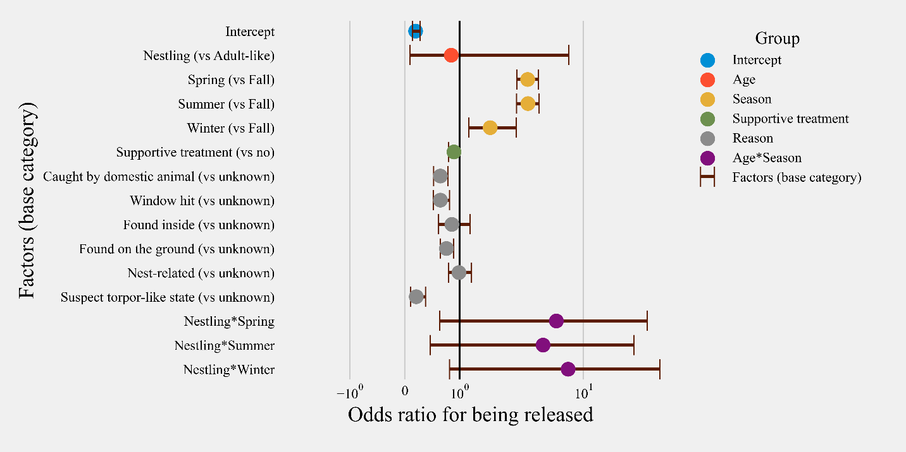

Figure 5: Odds ratios for all risk factors and their confidence intervals for rescued hummingbirds (n = 6,908) with available treatment information. Categories are color-coded according to the group of independent variables.

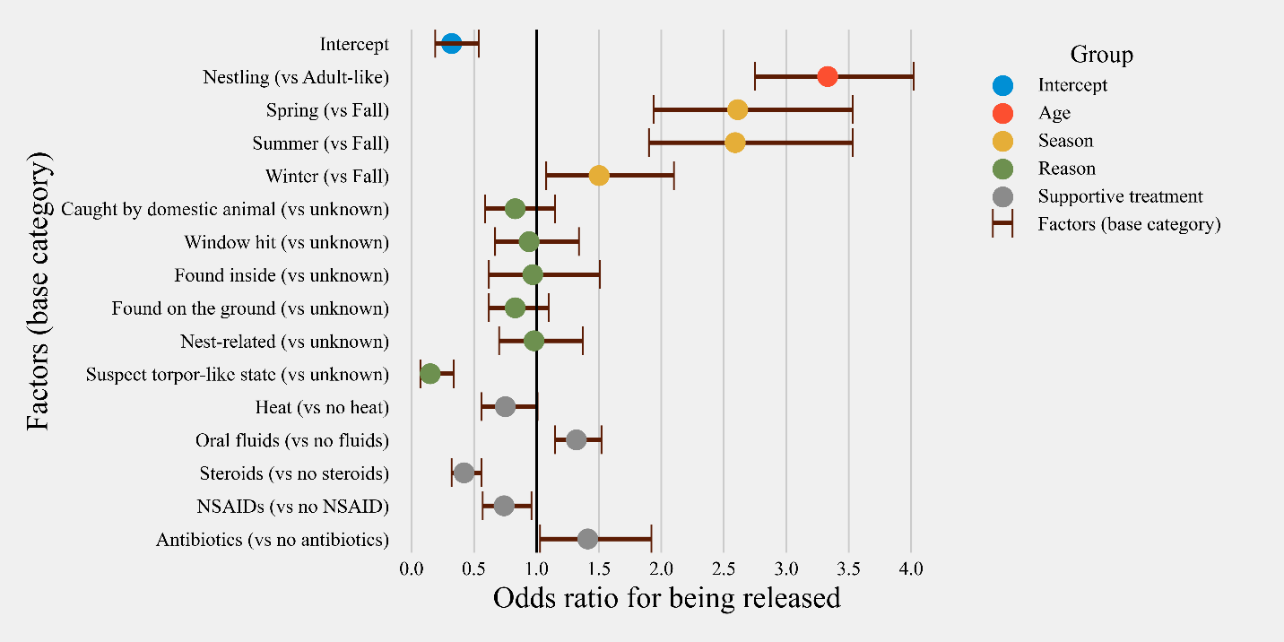

Figure 6: Odds ratios for all risk factors and their confidence intervals for the subset of hummingbirds with treatment information available in the database (rescued hummingbirds’ n = 3,779). Categories are color-coded according to the group of independent variables. [Heat= supportive care and/or shock treatment; Oral Fluids= hydration and/or energy supplementation; NSAID= Non-steroidal anti-inflammatory drug; Steroids = Anti-inflammatory and antipyretics]