GenAI LOC Tracker — User Guide
Source: USER_GUIDE.md

GenAI LOC Tracker — User Guide

> **Version:** 1.0.0 | **Date:** April 20, 2026 | **Author:** CTS Internal

---

Contents
1. Solution Overview 2
2. Architecture 3
2.1 High-Level Architecture 3
2.2 Component Diagram 3
2.3 Data Flow 5
3. Component Details 6
3.1 intellij-plugin-claude-ij — IntelliJ Plugin 6
3.2 intellij-plugin-loc-service — Backend Service 7
4. Prerequisites 7
5. Installation Guide 8
Step 1 — Install & Start MongoDB 8
Step 2 — Build & Start the Backend Service 9
Step 3 — Build the IntelliJ Plugin 11
Step 4 — Install the Plugin in IntelliJ IDEA 11
Step 5 — Configure the Plugin 12
6. Configuration Reference 13
Plugin — `genai-loc.properties` 13
Backend Service — `application.yml` 15
7. REST API Reference 16
Event Endpoints 16
Summary Endpoints 17
Sample Request — Single Event 17
Sample Response 18
Sample Request — Batch Events 18
8. Offline / CSV Fallback 19
CSV Columns 19
Auto-Recovery Flow 19
9. Logging & Diagnostics 20
View Plugin Logs in IntelliJ IDEA 20
Enable DEBUG Logging 20
Log Level Reference 21
View Backend Service Logs 21
10. Troubleshooting 21
Quick Start Summary 22

1. Solution Overview

GenAI LOC Tracker is a two-component system that measures how much code in a software project is generated by AI coding assistants (GitHub Copilot, Claude, ChatGPT, Gemini, etc.) versus typed manually by developers.

Component | Technology | Role
IDEs Plugins | Java / Kotlin, IntelliJ Platform SDK, Gradle | IntelliJ IDEA plugin — detects and captures LOC events
LOC Microservice | Java 21, Spring Boot 3.3, MongoDB | Backend REST service — stores and queries LOC events
UI application | React and web technologies | User interface for review and report generation

---

2. Architecture

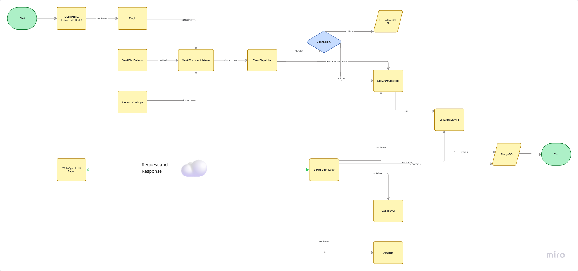

2.1 High-Level Architecture

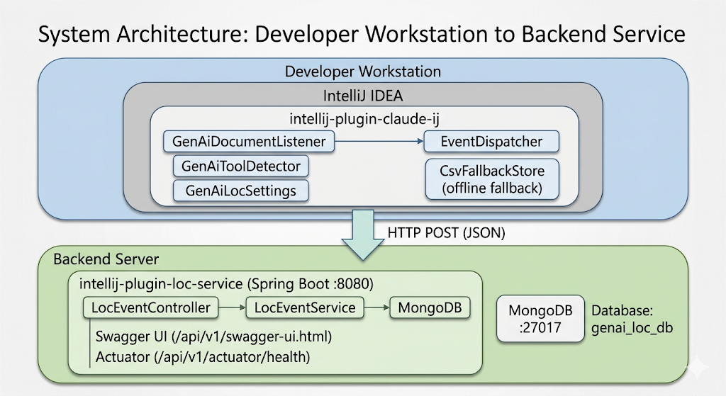

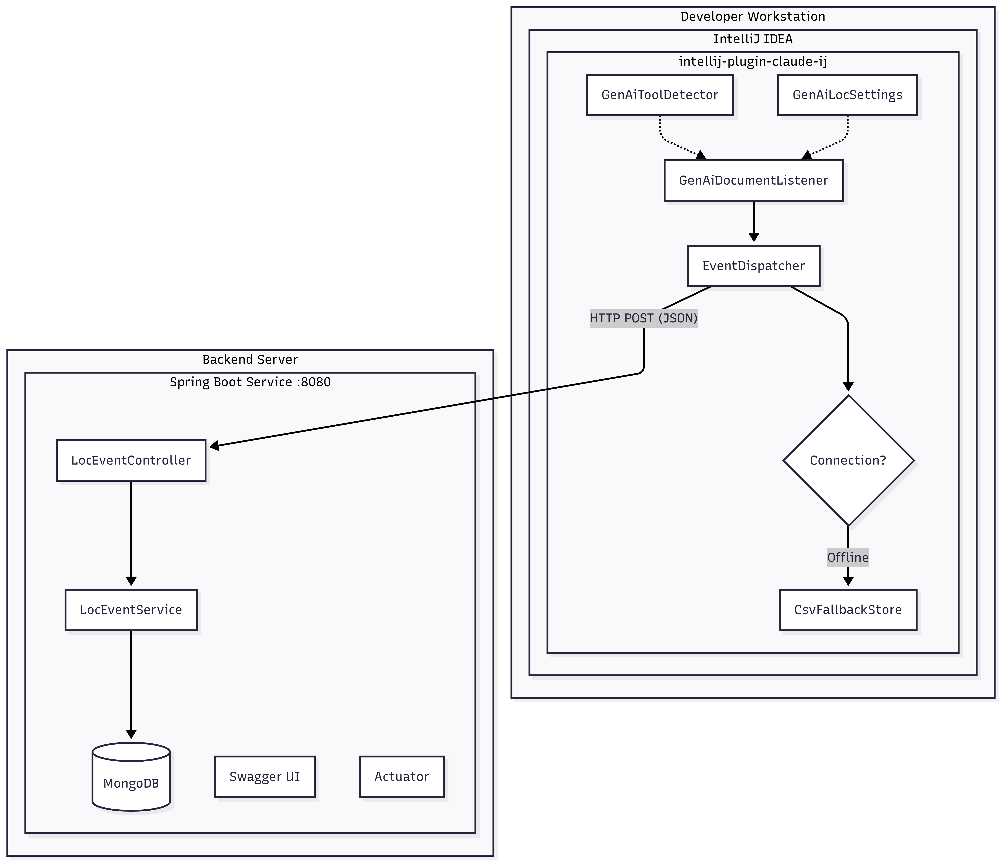

2.2 Component Diagram

This diagram represents the package structure and functional responsibilities of the IntelliJ Plugin.
Package | Component | Responsibility
listeners | GenAiDocumentListener | Hooks into editor events to detect line changes and classify source (GenAI vs Manual).
service | GenAiLocProjectService | Manages the plugin lifecycle (init/dispose) per IntelliJ project.
service | EventDispatcher | Buffers captured events and flushes them to the REST API; handles CSV replay.
settings | GenAiLocSettings | Acts as a persistent singleton for user configuration.
settings | GenAiLocConfigurable | Provides the graphical UI panel for the Settings menu.
model | CodeEventRequest | Defines the JSON payload structure for backend communication.
util | GenAiToolDetector | Automatically identifies installed AI plugins (e.g., Copilot, Claude).
util | CsvFallbackStore | Manages local CSV file operations when the backend is offline.

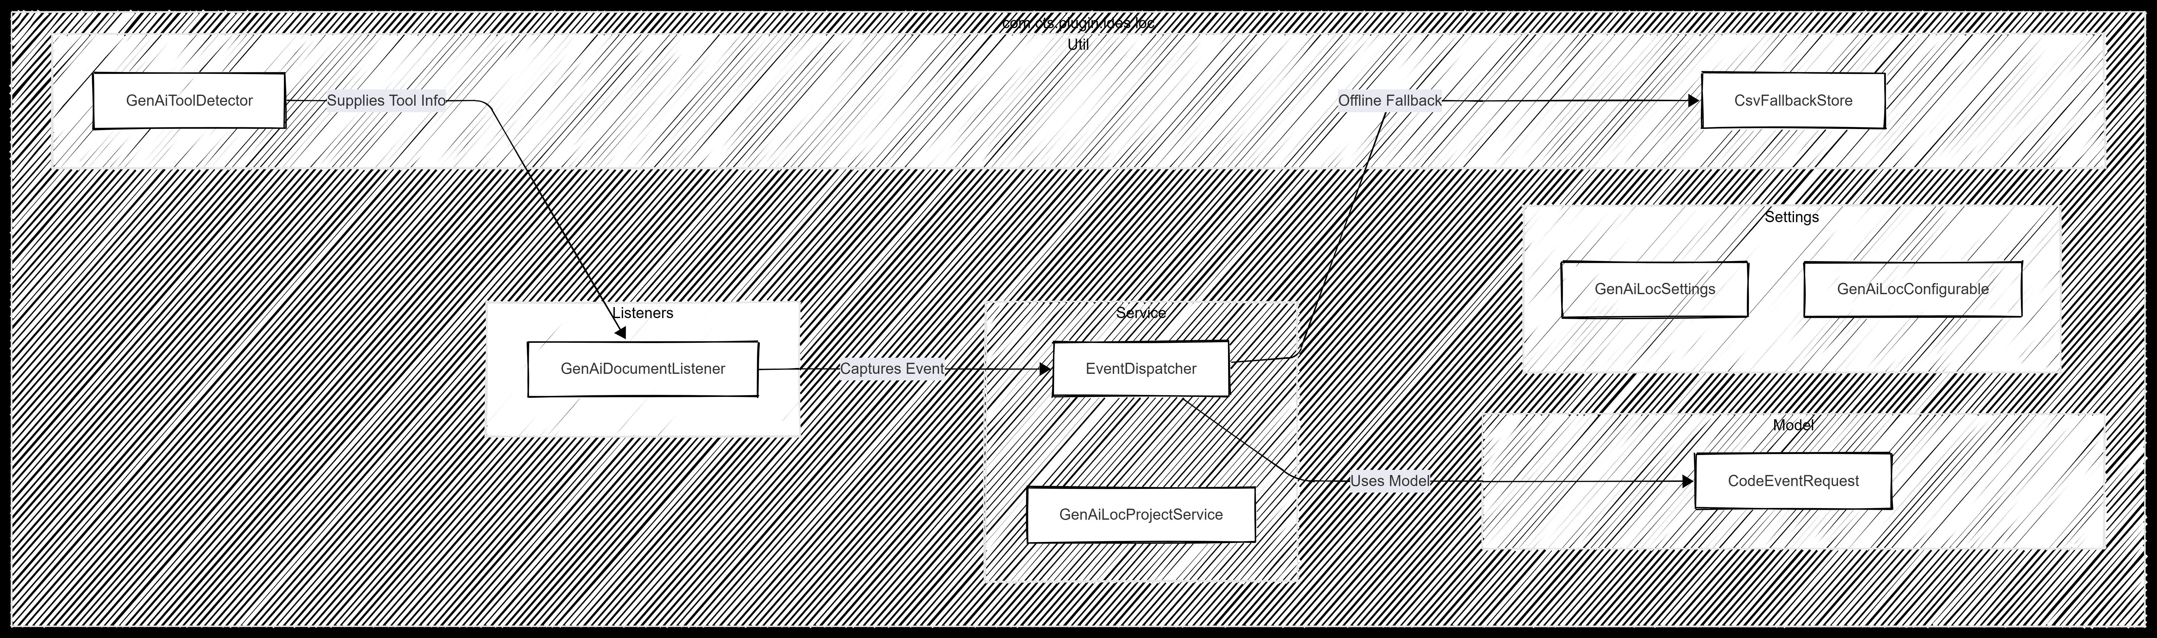

Microservice Code
Package | Component | Responsibility
controller | LocEventController | Exposes REST endpoints for CRUD operations and summary statistics.
service | LocEventService | Contains core business logic and data aggregation routines.
dto | LocEventRequest / Response | Defines the structure for inbound and outbound JSON payloads.
dto | BatchLocEventRequest | Handles multiple events in a single request for optimized data transfer.
dto | LocSummary | DTO used for returning aggregated statistical data.
model | LocEvent | The primary MongoDB document entity annotated with @Document.
model | FileChange | An embedded sub-document within the main LocEvent.
repository | LocEventRepository | Interface for Spring Data MongoDB to handle database persistence.
exception | Global Handlers | Manages centralized exception handling across the API.
config | OpenApiConfig | Configures Swagger/SpringDoc for API documentation and UI.

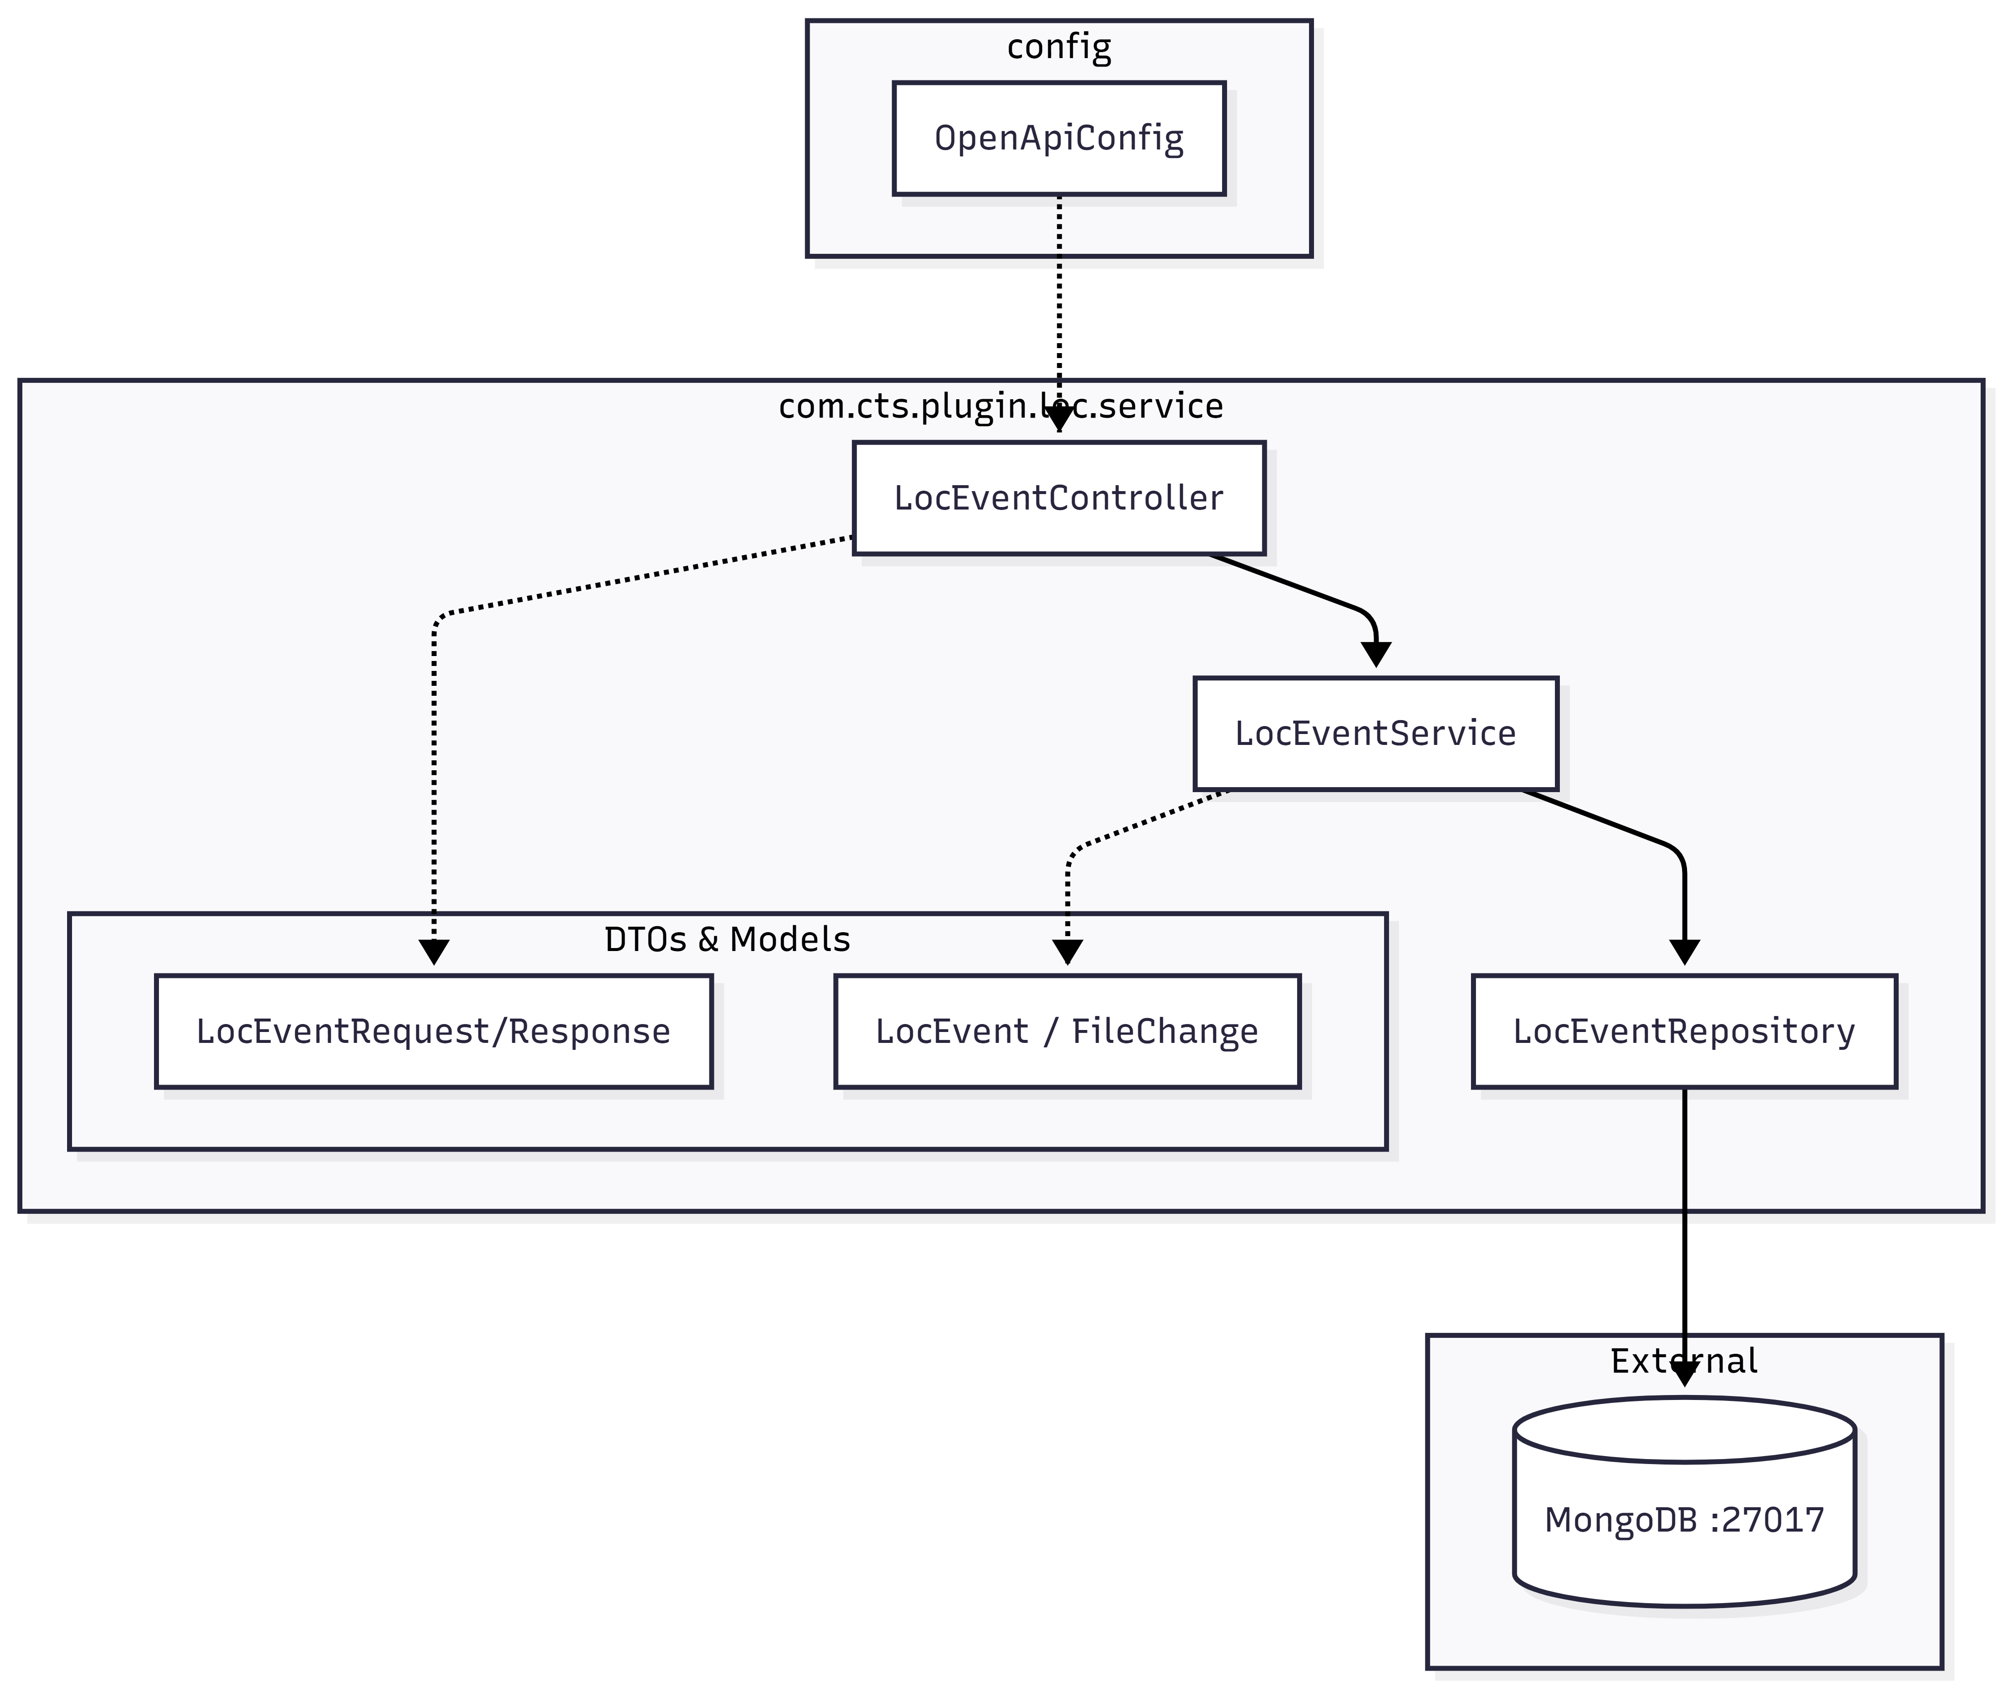

2.3 Data Flow
Step 1: Capture & Classification
As a developer codes in IntelliJ IDEA, the GenAiDocumentListener triggers on every document change to perform the following:
- Metric Counting: Tracks linesAdded, linesModified, and linesDeleted.
- AI Classification: Automatically sets genAiGenerated to true if the linesAdded count meets or exceeds the configured threshold.
- Identity Resolution: Captures the developerId and developerName via Windows login or Git configuration.
- Tool Detection: Identifies which GenAI tool (e.g., Copilot, Claude) is being used based on active IDE plugins.
- Payload Building: Assembles all metadata into a CodeEventRequest.
Step 2: Buffering & Dispatching
To optimize performance and network usage, the EventDispatcher manages a memory queue:
- Queueing: Events are held in a local buffer.
- Flush Triggers: A flush to the backend occurs when the batch.size is reached or the flush.interval.seconds timer expires.
Step 3: Delivery & Resilience
The system dynamically adapts to the state of the backend server:
- Success Path (Backend UP): The dispatcher sends an HTTP POST to /api/v1/genai-loc/events. Upon receiving an HTTP 201 Created response, it checks for and replays any existing offline CSV files.
- Fallback Path (Backend DOWN): If the backend is unreachable, the CsvFallbackStore writes the events to a local file at ~/.genai-loc/fallback-YYYYMMDD.csv.

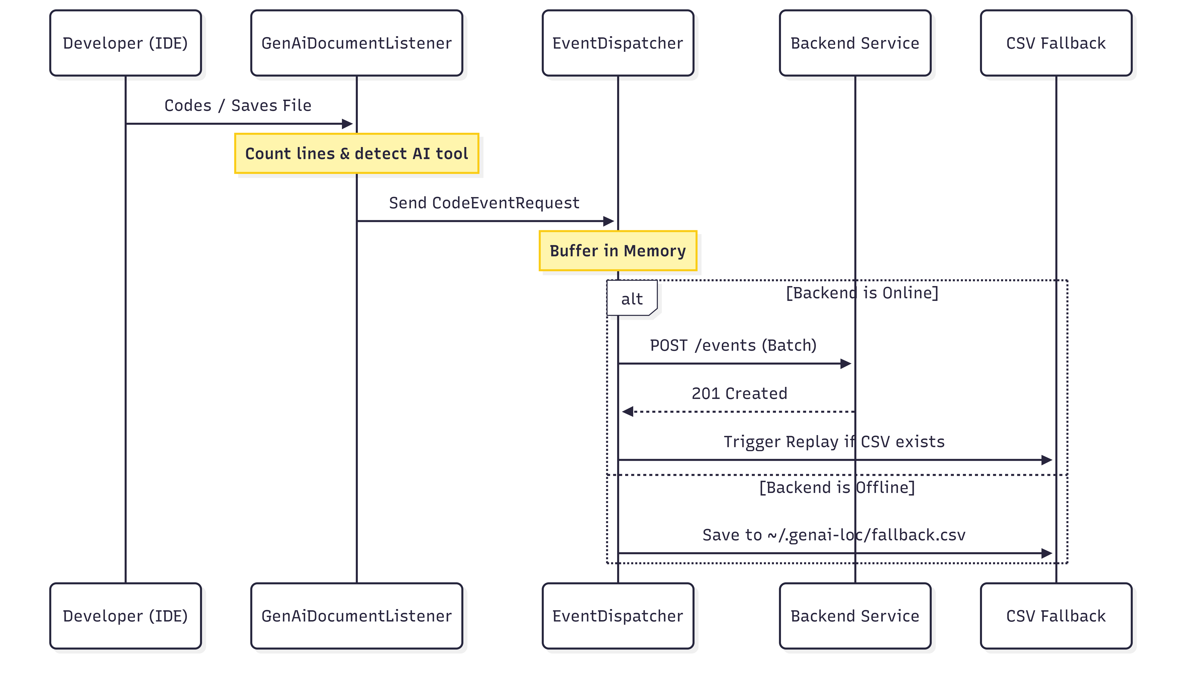
Data Flow Quick-Reference
Stage | Key Component | Data State
Capture | GenAiDocumentListener | Raw IDE Event
Buffer | EventDispatcher | In-Memory Queue
Transmission | REST API | JSON Payload
Persistence | MongoDB | Stored Document
Reliability | CsvFallbackStore | Local CSV File

3. Prerequisites

Ensure the following are installed before proceeding:

Software | Version | Notes
Java JDK | 21+ | Required by both components
Gradle | 8.x | Via wrapper (gradlew.bat) — no manual install needed
Apache Maven | 3.9+ | Required to build the backend service
MongoDB | 6.0+ | Must be running on localhost:27017
IntelliJ IDEA | 2025.1+ | Community or Ultimate edition
OS | Windows / macOS / Linux | Plugin runs cross-platform

---

5. Installation Guide

Step 1 — Install & Start MongoDB

• Start MongoDB: Ensure the service is running (net start MongoDB on Windows).
• Deploy Backend: * Navigate to service directory.
- Run .\mvnw.cmd clean package -DskipTests.
- Execute java -jar target\intellij-plugin-loc-service-1.0.0.jar.
• Build Plugin: * Navigate to plugin directory.
- Run .\gradlew.bat clean buildPlugin.
• Install in IDE: * Go to File → Settings → Plugins.
- Select Install Plugin from Disk and choose the .zip from the build/distributions folder.

Step 2 — Build & Start the Backend Service
• Start MongoDB: Ensure the service is running (net start MongoDB on Windows).
• Deploy Backend: * Navigate to service directory.
- Run .\mvnw.cmd clean package -DskipTests.
- Execute java -jar target\intellij-plugin-loc-service-1.0.0.jar.
• Build Plugin: * Navigate to plugin directory.
- Run .\gradlew.bat clean buildPlugin.
• Install in IDE: * Go to File → Settings → Plugins.
- Select Install Plugin from Disk and choose the .zip from the build/distributions folder.

7. REST API Reference

Base URL http://localhost:8080/api/v1/genai-loc`

Swager : http://localhost:8080/api/v1/swagger-ui/index.html#/
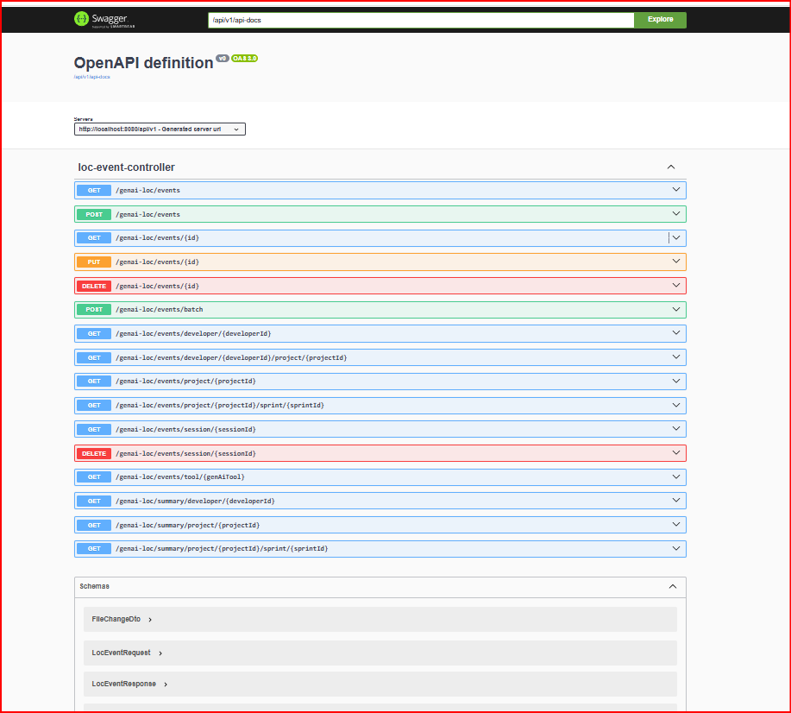

Event Endpoints

Method | Endpoint | Description
POST | /events | Submit a single LOC event
POST | /events/batch | Submit multiple LOC events
GET | /events | List all events (paginated)
GET | /events/{id} | Get event by MongoDB ID
PUT | /events/{id} | Update an event
DELETE | /events/{id} | Delete an event by ID
GET | /events/developer/{developerId} | Events by developer (supports ?from=&to=)
GET | /events/project/{projectId} | Events by project (supports ?from=&to=)
GET | /events/developer/{devId}/project/{projId} | Events by developer + project
GET | /events/tool/{genAiTool} | Events by AI tool
GET | /events/session/{sessionId} | Events by session
GET | /events/project/{projectId}/sprint/{sprintId} | Events by sprint
DELETE | /events/session/{sessionId} | Delete all events in a session

Summary Endpoints

Method | Endpoint | Description
GET | /summary/developer/{developerId}?from=&to= | Aggregated stats for a developer
GET | /summary/project/{projectId}?from=&to= | Aggregated stats for a project
GET | /summary/project/{projectId}/sprint/{sprintId} | Aggregated stats for a sprint

Sample Request — Single Event
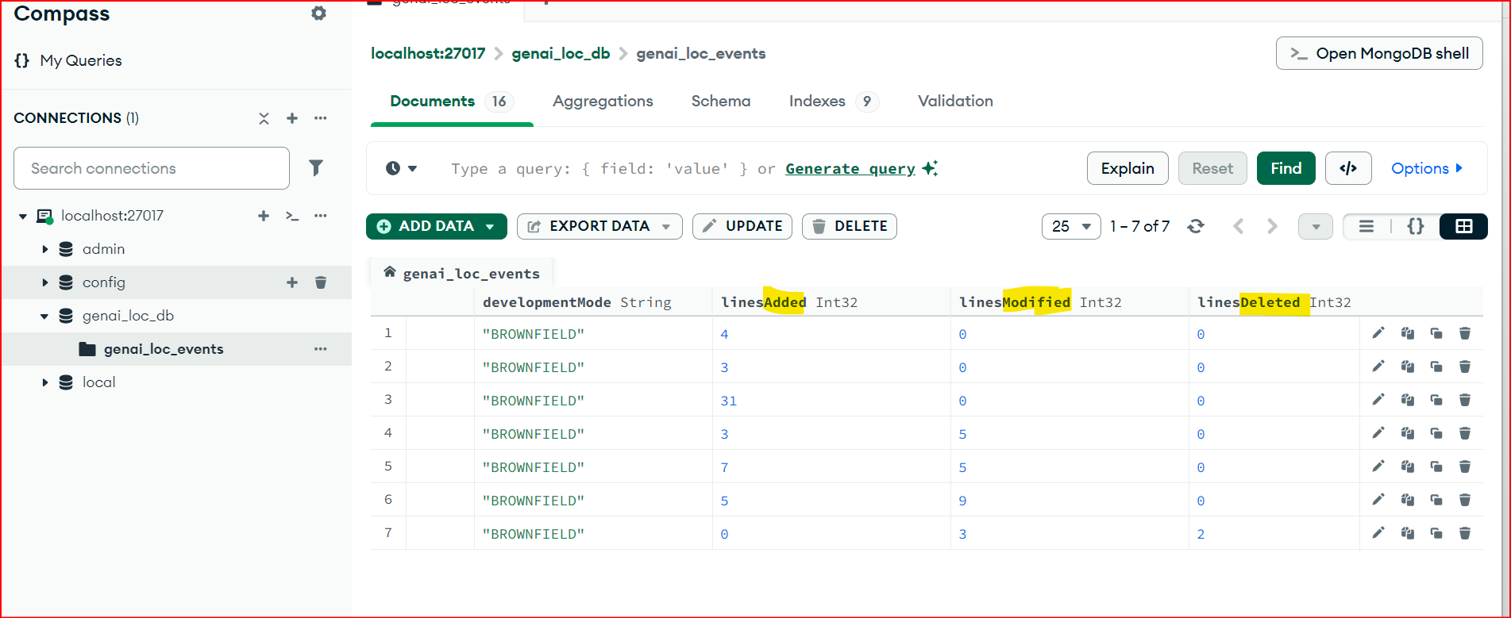

Sample Request — Batch Events

```

---

8. Offline / CSV Fallback

When the backend service is **unreachable**, the plugin automatically saves events to a local CSV file:

```
~/.genai-loc/fallback-YYYYMMDD.csv
```

CSV Columns

```
developerId, developerName, projectId, sprintId, filePath, fileName,
ideType, genAiTool, developmentMode,
linesAdded, linesModified, linesDeleted,
genAiGenerated, genAiConfidenceScore, eventTimestamp, sessionId
```

Auto-Recovery Flow

```
Backend UNREACHABLE Backend RECOVERS
───────────────────────────────── ──────────────────────────────
Plugin flush() fails Plugin flush() succeeds (HTTP 2xx)
└─► Events written to CSV └─► replayFallback() triggered
└─► All CSV rows POSTed
└─► CSV file deleted ✅
```

> If replay also fails, the CSV is **retained** and automatically retried on the next successful flush.

---

9. Logging & Diagnostics

View Plugin Logs in IntelliJ IDEA

> **Help → Show Log in Explorer** → open `idea.log`

Enable DEBUG Logging

> **Help → Diagnostic Tools → Debug Log Settings**

Add any of these class names:

```
com.cts.plugin.intelij.loc.listeners.GenAiDocumentListener
com.cts.plugin.intelij.loc.service.EventDispatcher
com.cts.plugin.intelij.loc.service.GenAiLocProjectService
com.cts.plugin.intelij.loc.settings.GenAiLocSettings
com.cts.plugin.intelij.loc.util.GenAiToolDetector
com.cts.plugin.intelij.loc.util.CsvFallbackStore
```

Log Level Reference

| Level | When Used |
|---|---|
| `DEBUG` | Per-event details, field values, plugin detection checks |
| `INFO` | Lifecycle events — init, flush, settings applied, replay |
| `WARN` | Recoverable issues — backend down, Git config unavailable |
| `ERROR` | Unrecoverable — events lost after all retry attempts |

View Backend Service Logs

10. Troubleshooting

Problem | Cause | Solution
Plugin not tracking events | plugin.enabled=false | Enable in Settings → Tools → GenAI LOC Tracker
Events not reaching backend | Wrong backend.url | Verify URL in settings; check backend is running on port 8080
Backend returns 500 | MongoDB not running | Start MongoDB: net start MongoDB
CSV fallback not replaying | Backend still down during flush | Wait for backend to recover; replay triggers automatically
GenAI tool shows OTHER | No supported AI plugin installed | Manually set default.genai.tool in settings
Build fails — SSL error | Zscaler proxy / corporate firewall | Run import-zscaler-cert.bat in the plugin project root
gradlew.bat runIde is slow | First-time IntelliJ SDK download | Normal; subsequent runs are fast (cached in ~/.gradle)
Swagger UI not loading | Service not started | Start the backend service on port 8080 first
MongoDB connection refused | MongoDB not installed | Install from mongodb.com/try/download/community

---

Quick Start Summary

Source Code:

