Megan Wheeler

CSD 310

Assignment 1.2

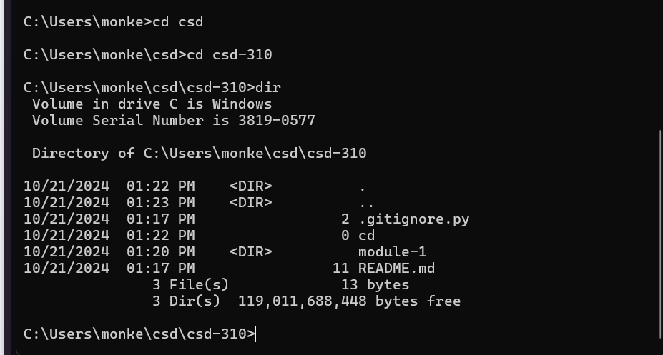

https://github.com/Pandma13/csd-310/tree/62eefe005222436171b927e2be2351f2124331fd/module-1