Megan Wheeler

Assignment 3

VS Code

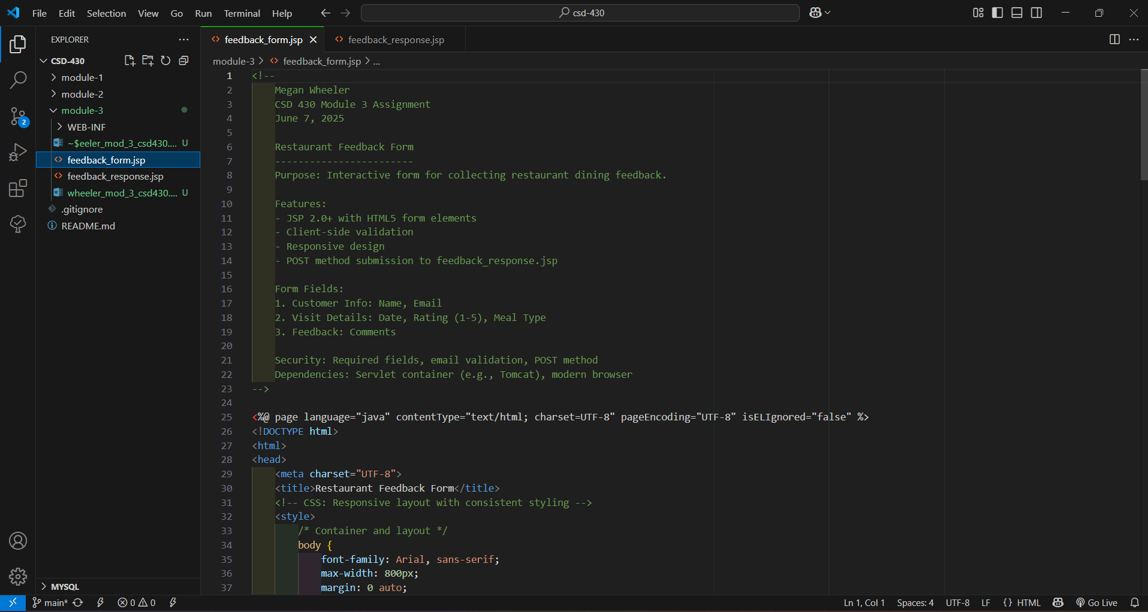

Tomcat

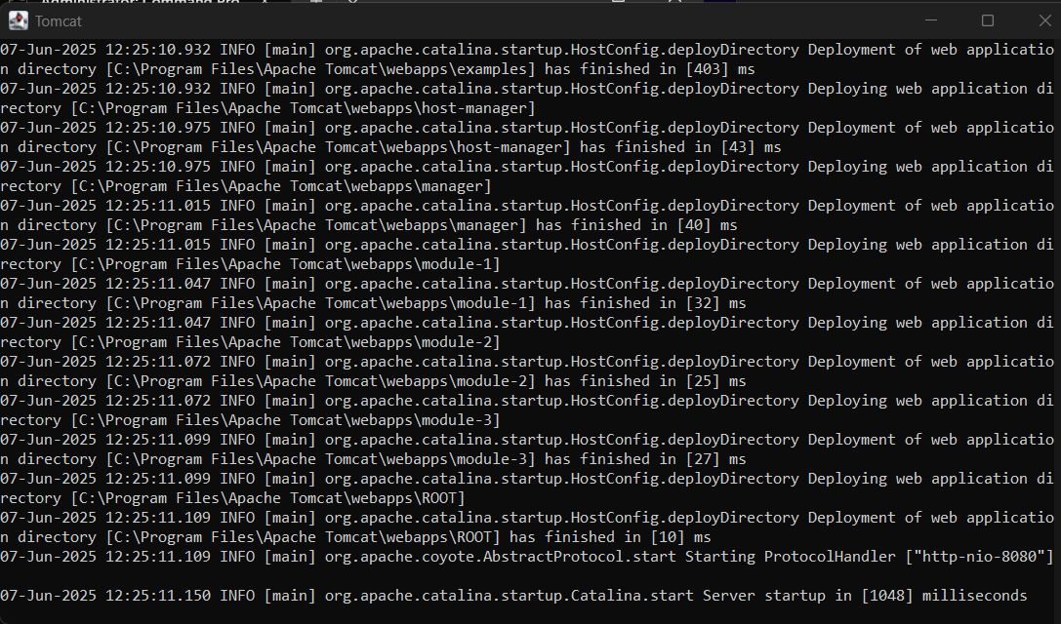

startup.bat

Apache Tomcat work folder contents for module-3

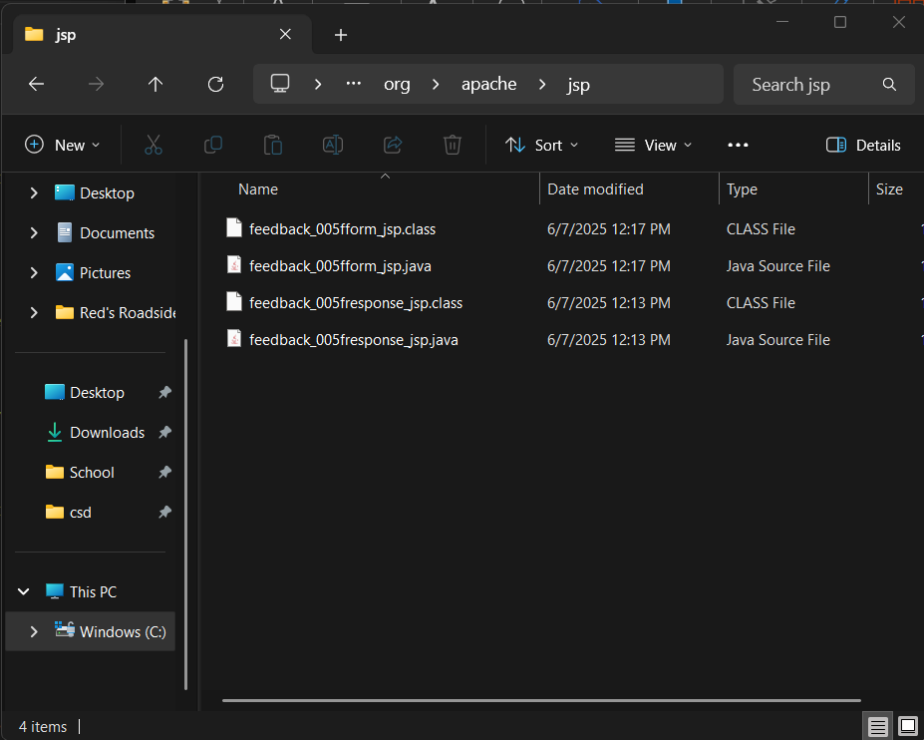

<http://localhost:8080>

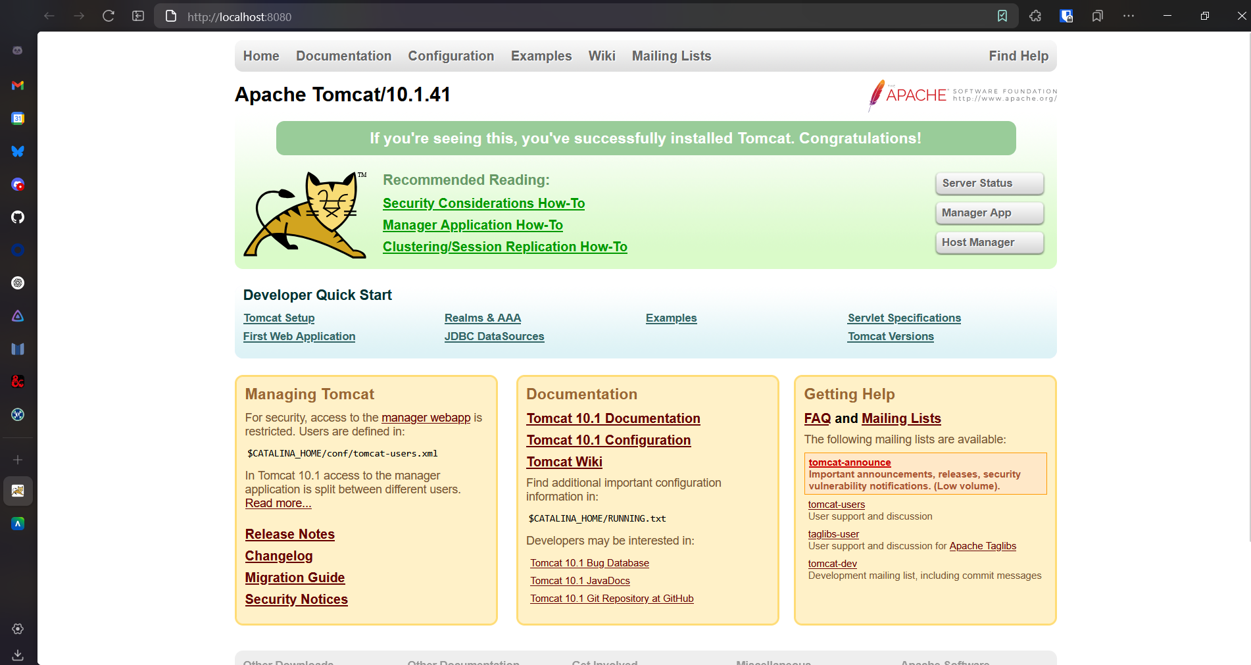

<http://localhost:8080/module-3/feedback_form.jsp>

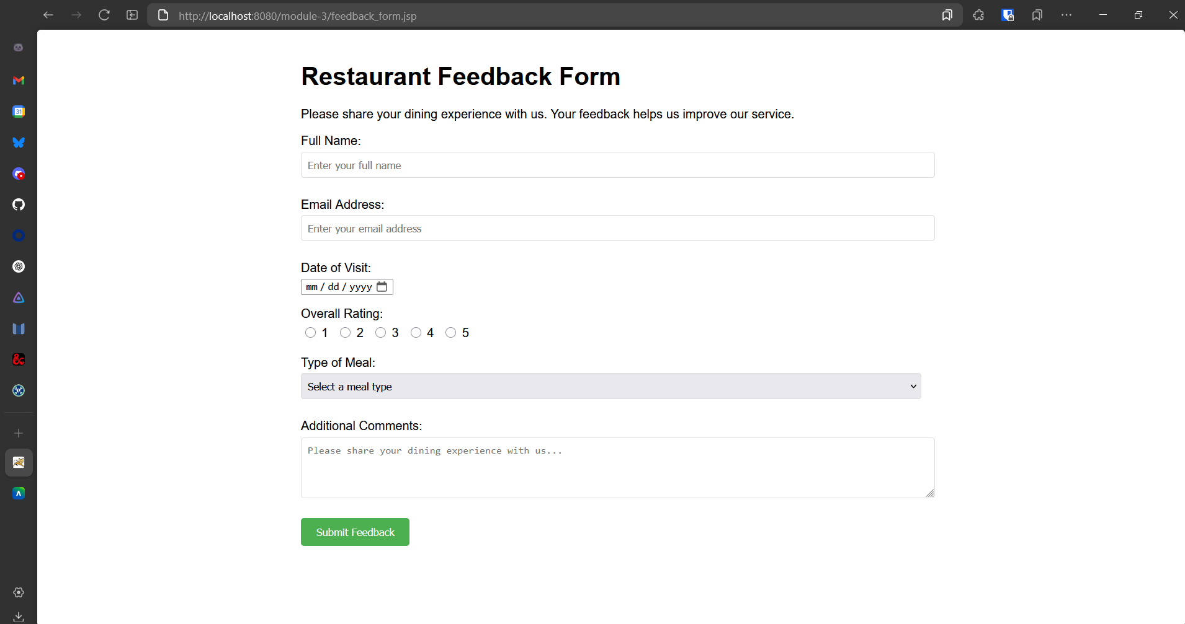

<http://localhost:8080/module-3/feedback_response.jsp>

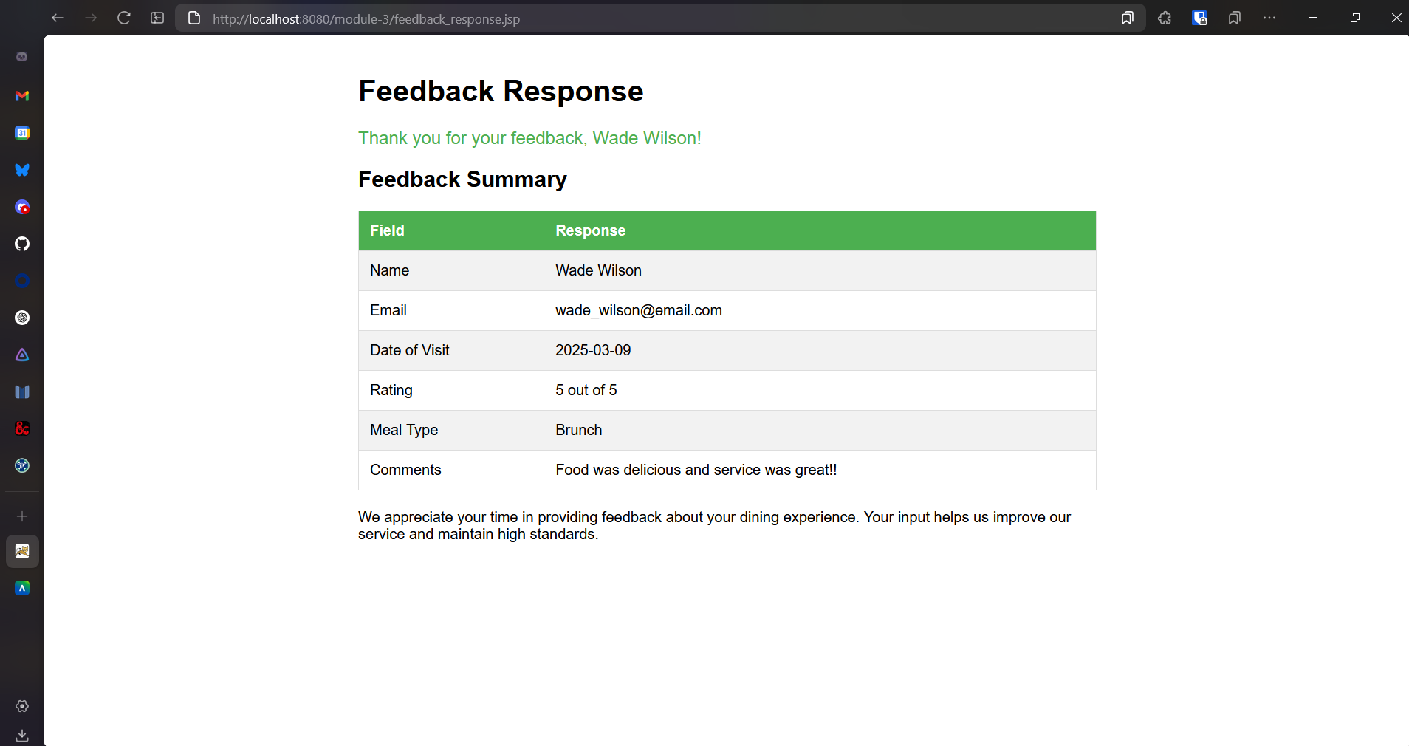

shutdown.bat

