Megan Wheeler

20 June 2025

Assignment 6.2

**VS Code**

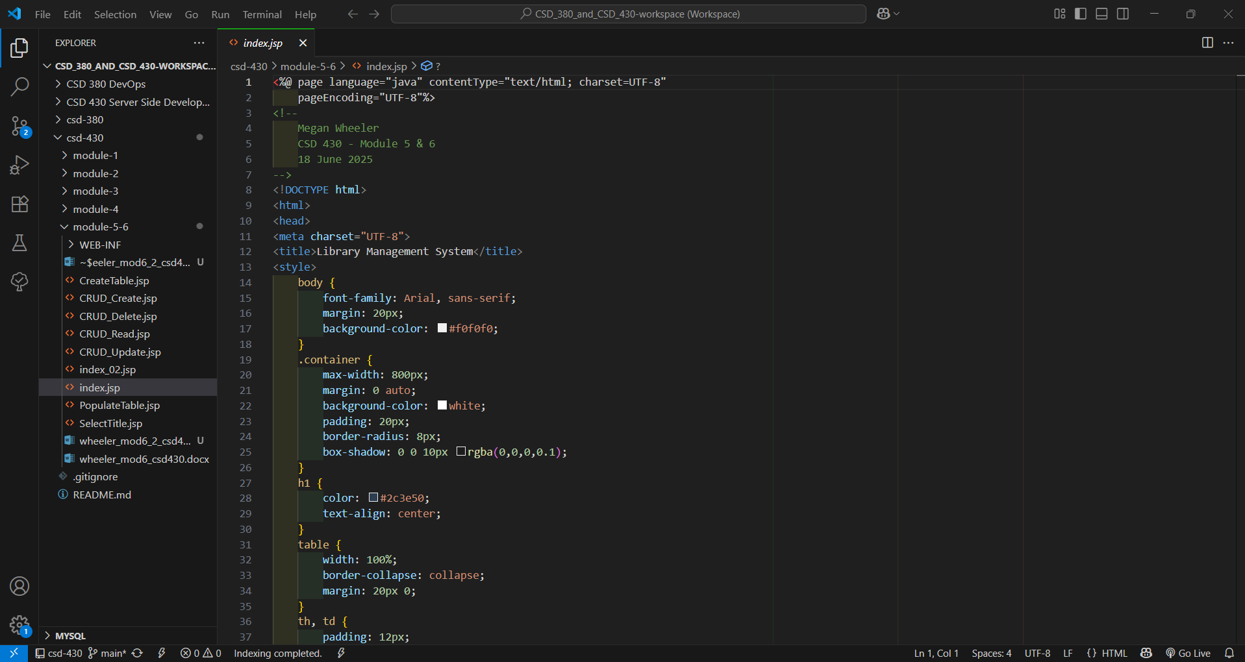

**startup.bat**

**Tomcat**

**Tomcat work folder contents for module-5-6**

[**http://locathost:8080**](http://locathost:8080)

[**http://locathost:8080/module-5-6/index.jsp**](http://locathost:8080/module-5-6/index.jsp)

[**http://localhost:8080/module-5-6/index_02.jsp**](http://localhost:8080/module-5-6/index_02.jsp)

[**http://localhost:8080/module-5-6/CRUD_Read.jsp**](http://localhost:8080/module-5-6/CRUD_Read.jsp)

**After submitting query**

**shutdown.bat**

