1. **Examine the first stage of the assignment:   
   2.1. List the major components you believe you will need to build to achieve this.** 
   1. a PLAY/PAUSE button
   2. VOL+ and VOL- buttons
   3. track skip buttons: <-(prev) and->(next)
   4. an 8-LED bar graph indicating 8 volume settings
   5. a 2-digit decimal display, using the Logisim Hex display, that indicates the track number
   6. one LED, which indicates PLAY mode is on and PAUSE mode (flashing 1Hz) OR Two LEDs, one for each mode.

**2.2. What resources (lecture slides, previous labs, online links etc) do you have that are relevant to these components ?**

1. **Start sketching your solution - either free-hand drawings or logisim circuits are fine. You might want to focus on specific components and consider their design in isolation. Discuss with your lab mates, and your demonstrator (but remember your work has to be your own !)**

**I have work a little bit on the On/Off and the Play/Pause button so that the all the light will be turned off when the circuit is off.**

**Play state:**

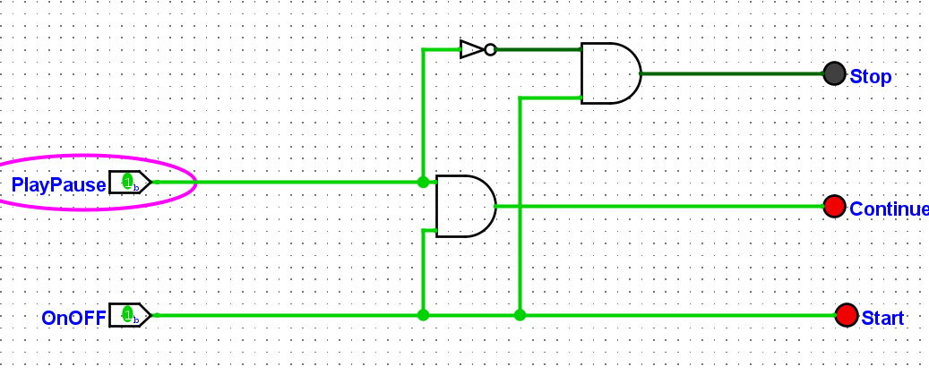

**Pause state:**

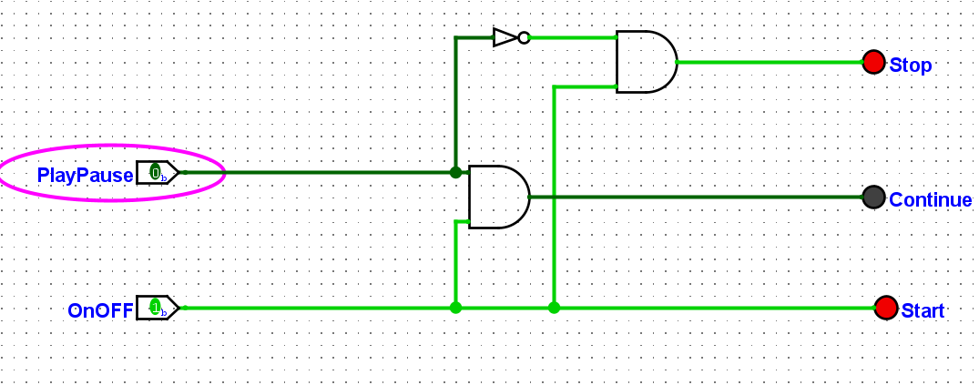

**Off State:**

