**SHORT SCREEN TEST 02 OF ITP**

Student ID: 103809048 MARKs

Student Name: Tran Thanh Minh

Email: minhttsws00016@fpt.edu.vn

Closed Date: 13h00 (GMT+), 08 – NOV – 2022 WEEK 10

1. QUIZ 1

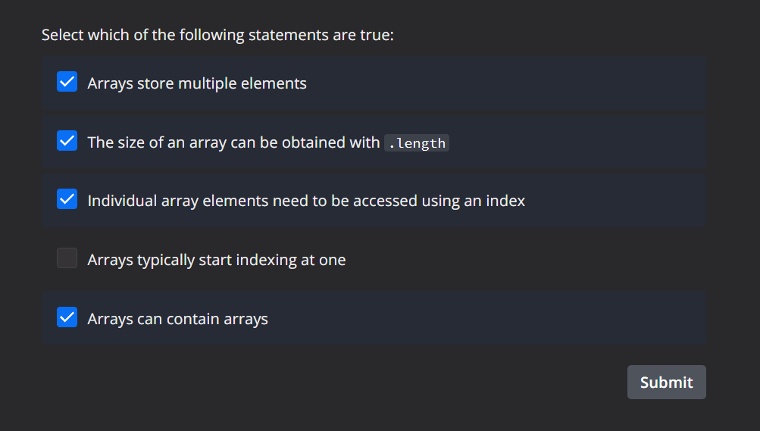

1. QUIZ 2

1. QUIZ 3

1. QUIZ 4

1. PROGRAM 1

def main()

# put your code here

print('Enter your name: ')

name = gets.chomp

puts('Hello, ' + name + "!")

end

main

1. PROGRAM 2

def main()

# put your code here.

i = 0

total = 0

while i < 10

i += 1

print('Enter integer ' + i.to_s + ': ')

number = gets.chomp

total += number.to_i

end

puts('Total is: ' + total.to_s)

end

main()

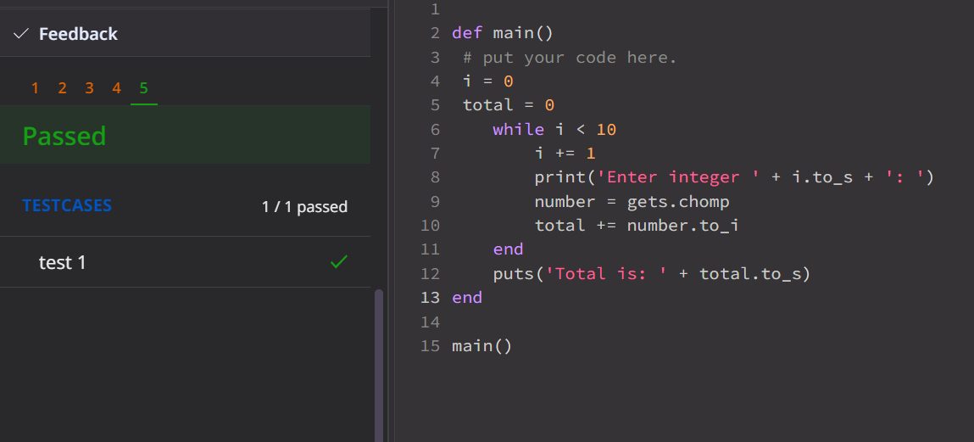

1. PROGRAM 3

def read_array()

# put code here

print('How many lines are you entering? ')

num_line = gets.chomp.to_i

i = 0

lines = []

while i < num_line

i += 1

print('Enter text: ')

str = gets.chomp.to_s

lines << str

end

return lines

end

def print_array(a)

# put code here

puts('Printing lines:')

num = a.length

i = 0

while i < num

puts(i.to_s + ' ' + a[i])

i += 1

end

end

def main()

# put code here

a = read_array()

print_array(a)

end

main()

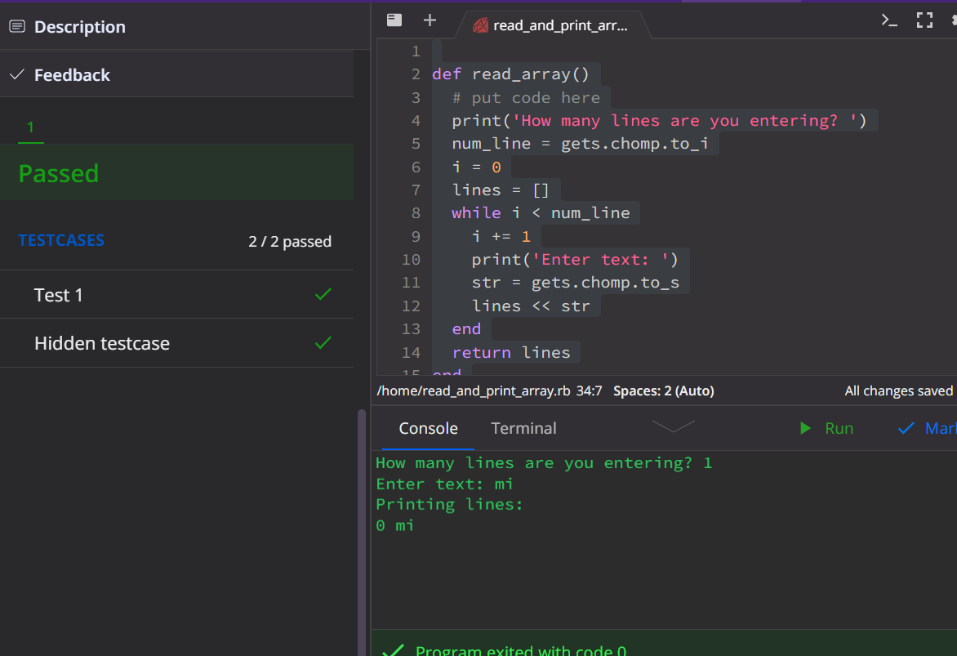

1. PROGRAM 4