
SE4030 – Secure Software Development

Lab Sheet 7 - Vulnerability Detection and Remediation

Student NO: IT22555380
Student Name: Wijesinghe LP.P.

1. Initial QApug Analysis
The initial QApug analysis identified several security and reliability issues in the application.
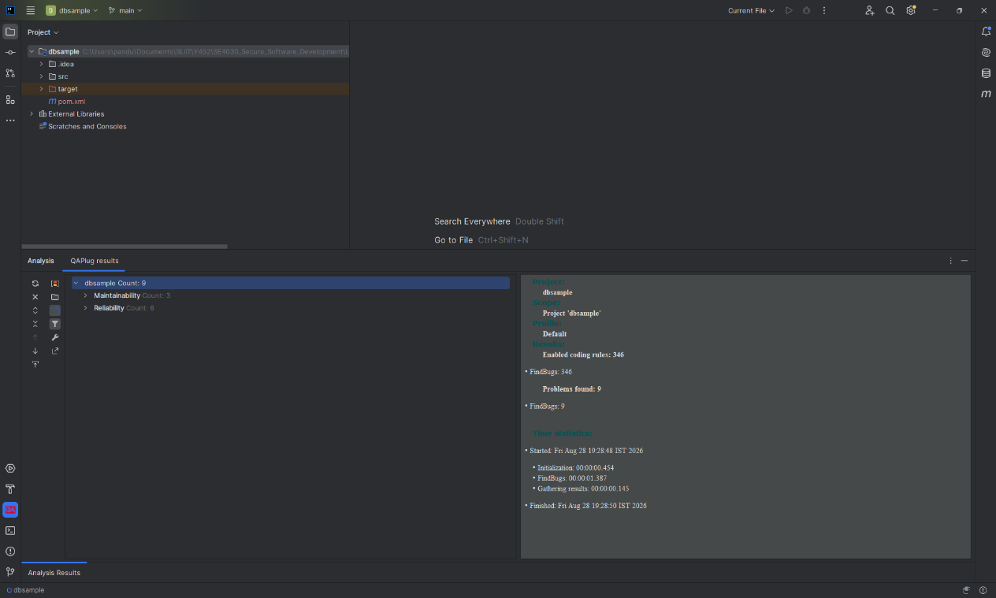
Problems Found: 9
Figure 1: Initial QApug Analysis

2. Identified Vulnerabilities
2.1 Login.java
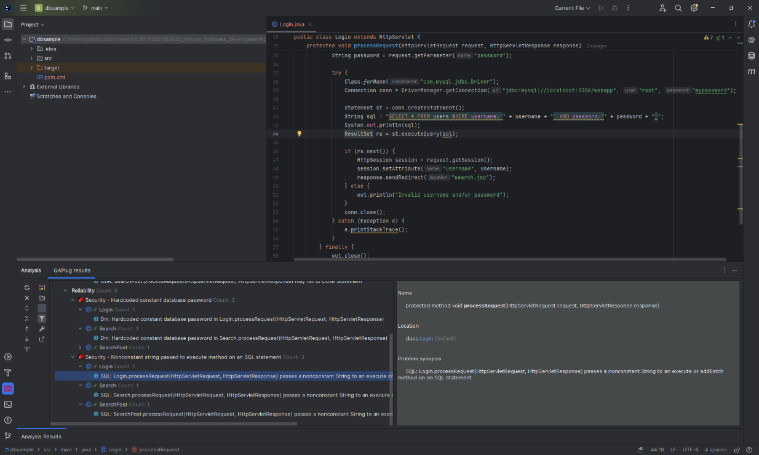
The initial Login.java contained SQL Injection and hardcoded database password issues.
Figure 2 : Vulnerabilities in Login.java
2.2 Search.java
The initial Search.java contained similar SQL and database security issues.
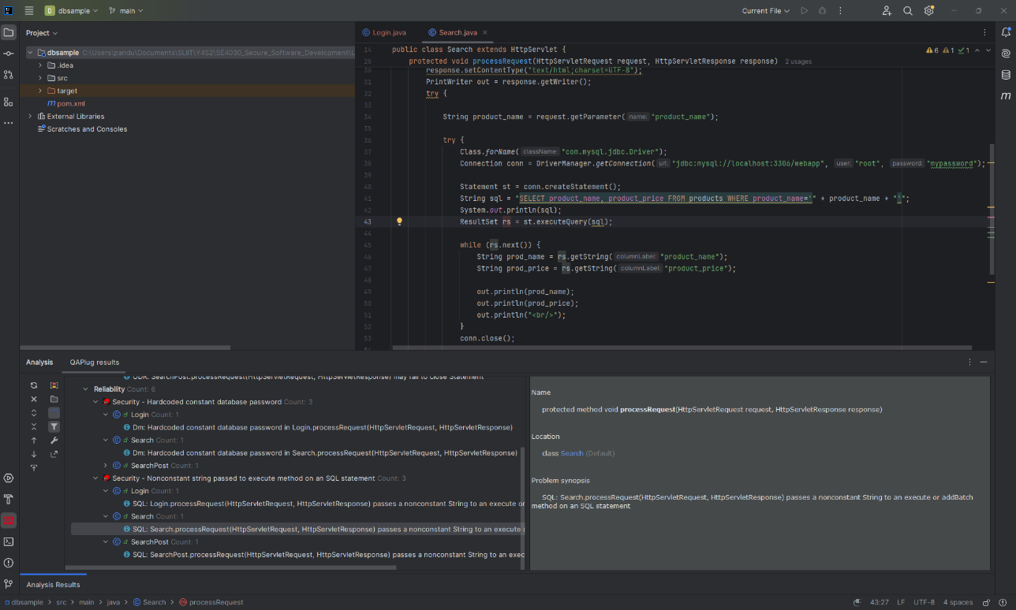
Figure 3 : Vulnerabilities in Search.java

2.3 SearchPost.java
The initial SearchPost.java also contained SQL and database security issues.
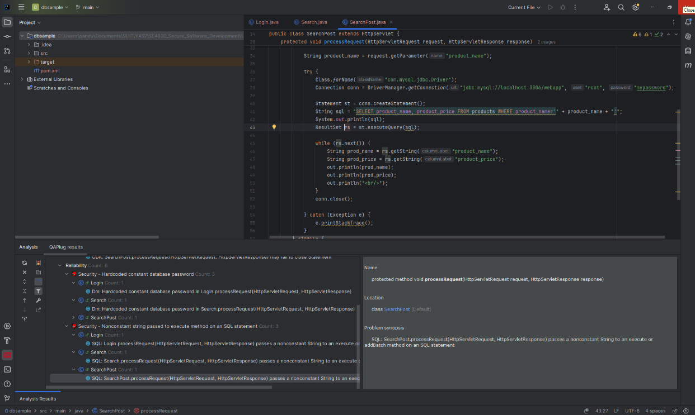
Figure 4 – Vulnerabilities in SearchPost.java
Figure 4 : Vulnerabilities in SearchPost.java
3. Vulnerability Fixes
3.1 Fixed Login.java
The SQL query and database password handling were improved.
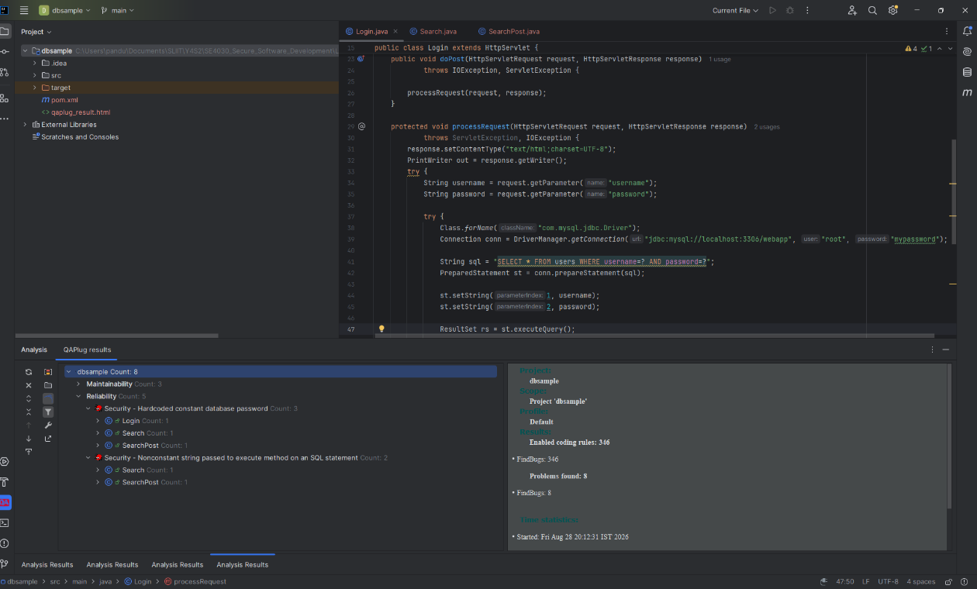
Figure 5: Fixed Login.java
3.2 Fixed Search.java
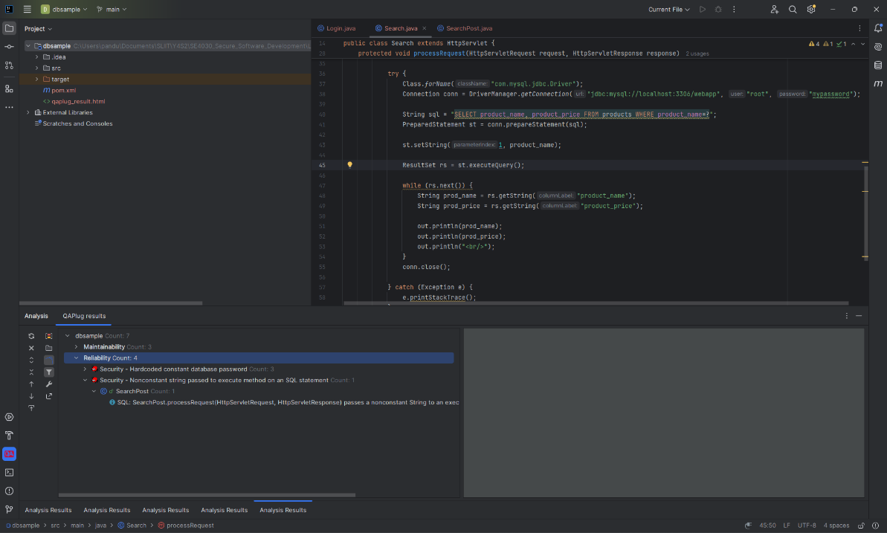
The SQL query and database resource handling were improved.
Figure 6 : Fixed Search.java

4. Final QApug Analysis
After applying the security fixes, QApug analysis was performed again.
The final analysis reported:
Problems Found: 0
FindBugs: 0
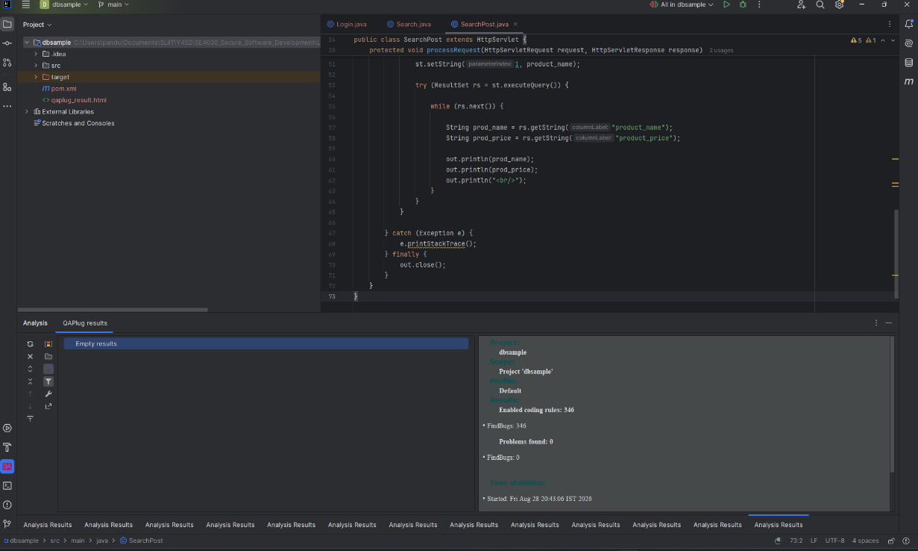
Figure 7: Final QApug Analysis

