User Manual of the Proposed System

User Login

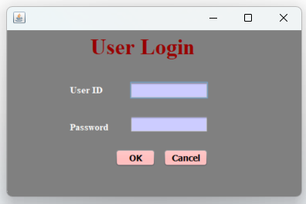

In the above **LoginUI**, Some users are capable of handling different facilities, those facilities will be mentioned in this user manual.

Test plan for the LoginUI,

|  |  |  |  |
| --- | --- | --- | --- |
| User ID | Password | Login Success | Login Unsuccessful |
| Admin | 123 | ✓ |  |
| Admin | 555 |  | ☓ |
| HR_Manager | 111 | ✓ |  |
| HR_Manager | 222 |  | ☓ |
| HR_Assistant | 222 | ✓ |  |
| HR_Assistant | 333 |  | ☓ |

Login with **Admin** by entering Password **123**

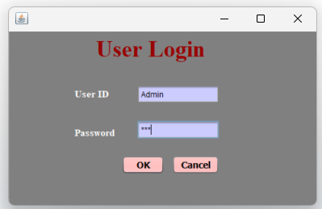

After Login with **Admin**, the **MainUI** will be appear

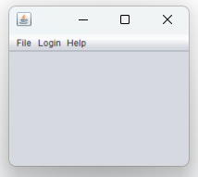

When Login using Admin in the **File** menu, the **Employee** menu item will not be available

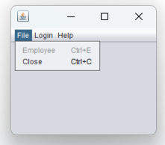

For the **Admin** in the **Login** menu, **New Employee Login** menu item will be available

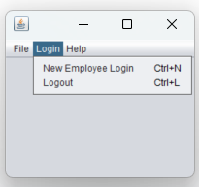

**NewUserLoginUI** will appear when the **New Employee Login** menu item clicked

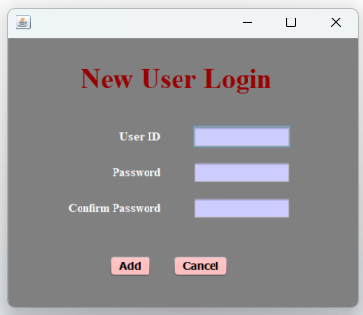

After entering the new **User ID** and **Password** to this **NewUserLoginUI,** when the Add button is clicked, the **User ID** and **Password** will be written into the **loginemp.txt.**

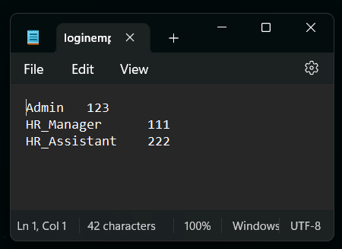

Login with **HR_Manager** by entering Password **111**

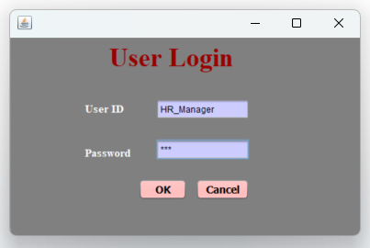

After Login with **HR_Manager**, the **MainUI** will be appear



When Login using Admin in the **File** menu, the **Employee** menu item be available

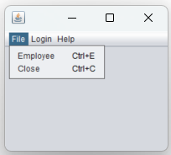

When Login using **HR_Manager** in the **File** menu, the **New Employee Login** menu item will not be available

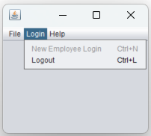

For Any User the **Guide** menu item that is under the **Help** Menu can be referred, **Guide** menu item that refers to an MS Word File named **Guide.docx** that contains a user manual.

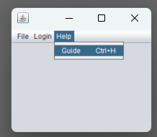

**Add** button action

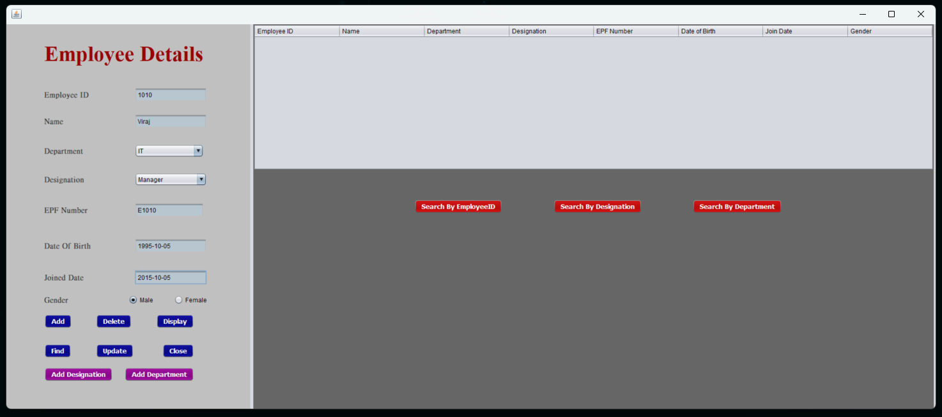

When a record is added, a message dialog box will appear by showing “**The record is added**”

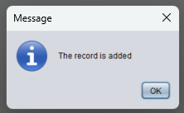

The values that we added will be written to a text file named **employee.txt**

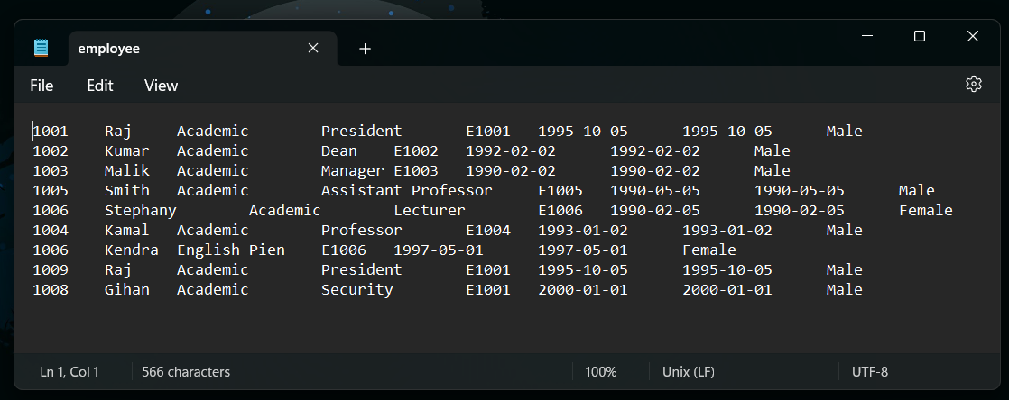

**Delete** button action

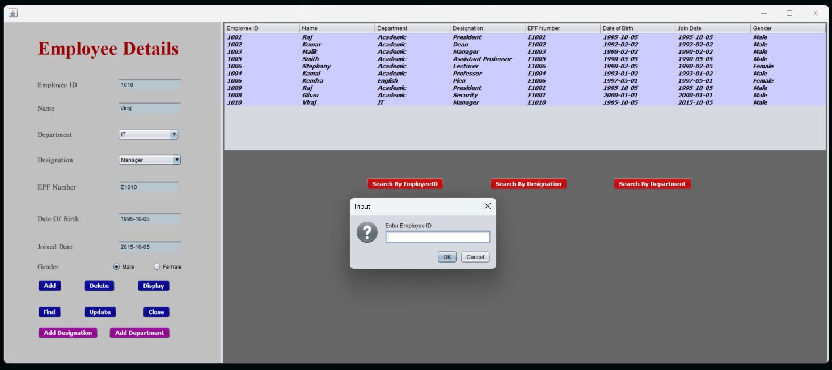

When clicking the **Delete** button, a message dialog box will appear by showing “**Enter Employee ID**” to enter the Employee ID that you want to delete.

Then you can check if the record was deleted or not by clicking the **Display** button.

The record will also delete from the **employee.txt** file

**Display** button action

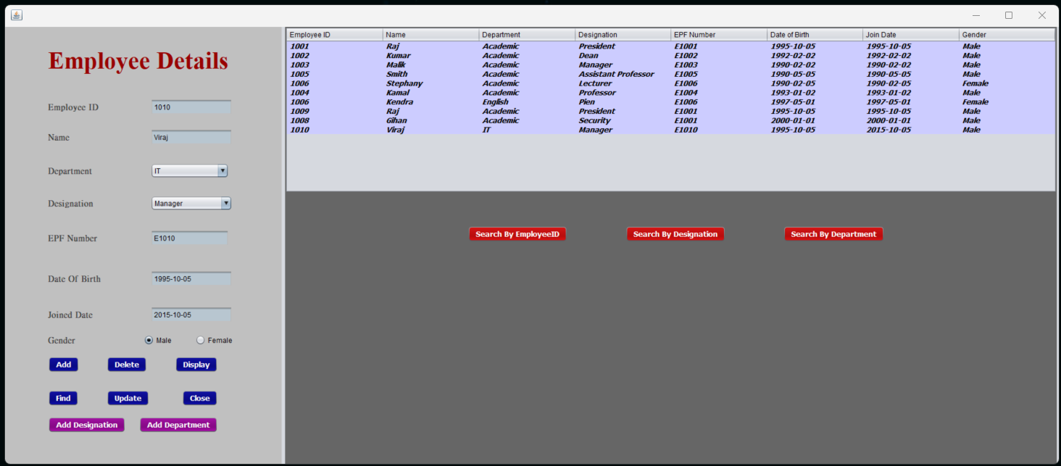

All the records that were added before will be shown in the table.

The records are read by using the text file **employee.txt.**

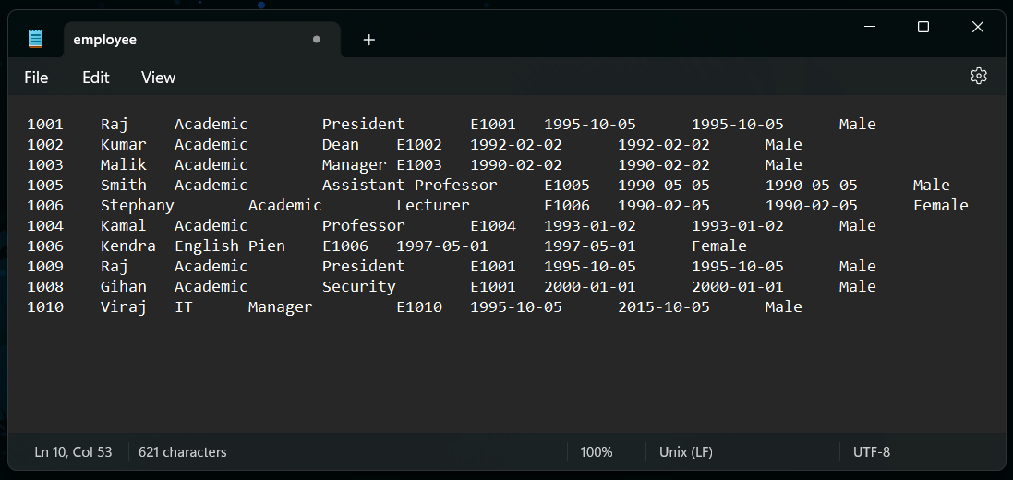

**Find** button action

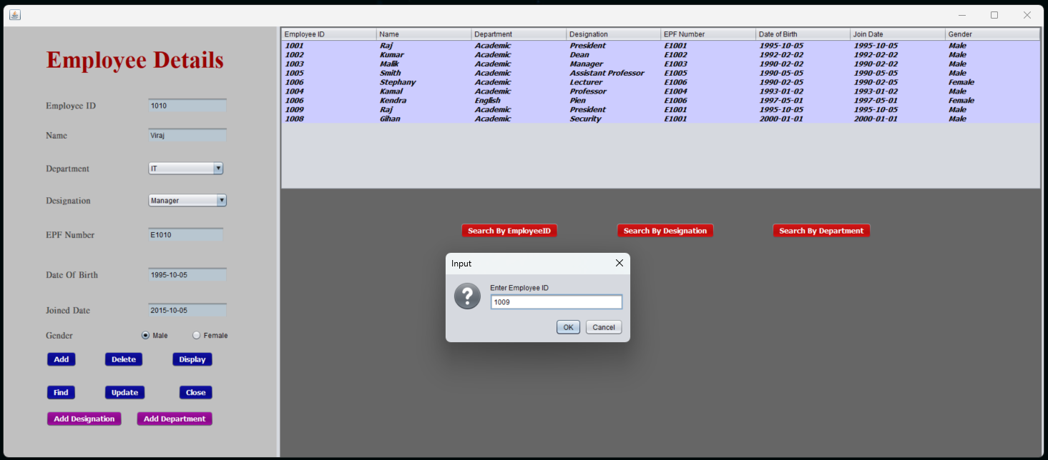

When clicking the **Find** button, a message dialog box will appear by showing “**Enter Employee ID**” to enter the Employee ID that you want to find.  
The data will be shown in the **EmployeeUI**’s text fields.

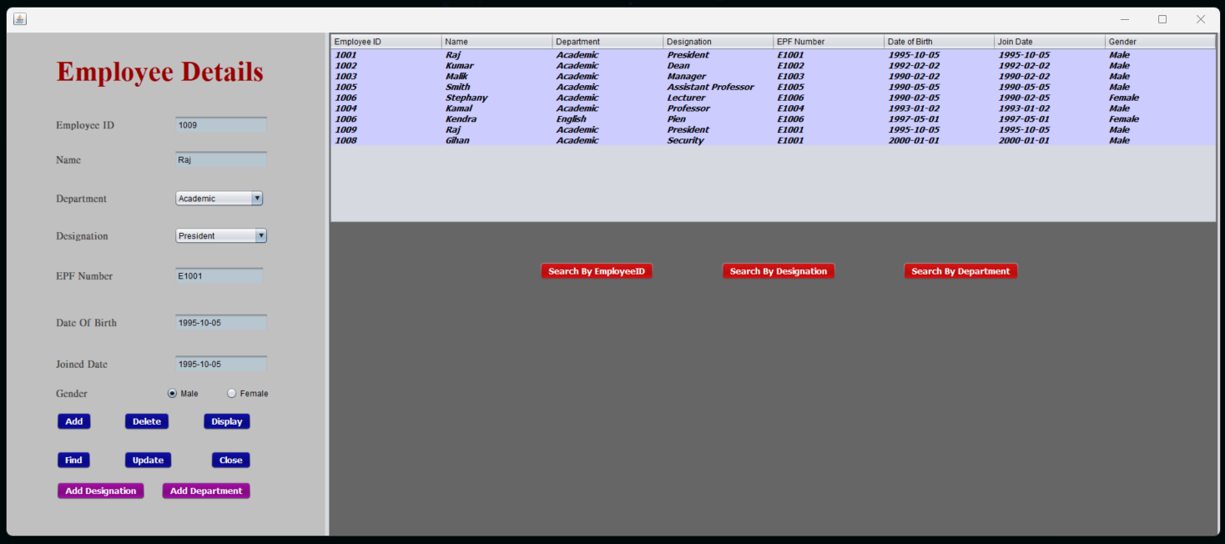

**Update** button action

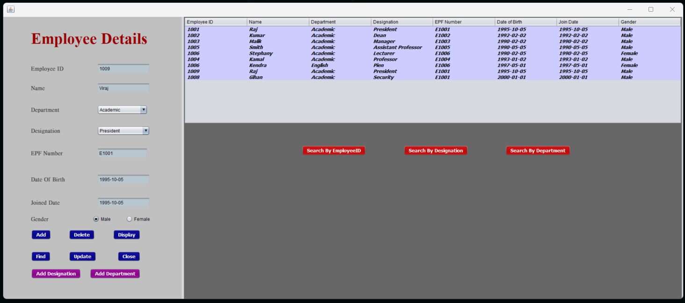

To perform the update function First you need to find the record by using the **Find** button.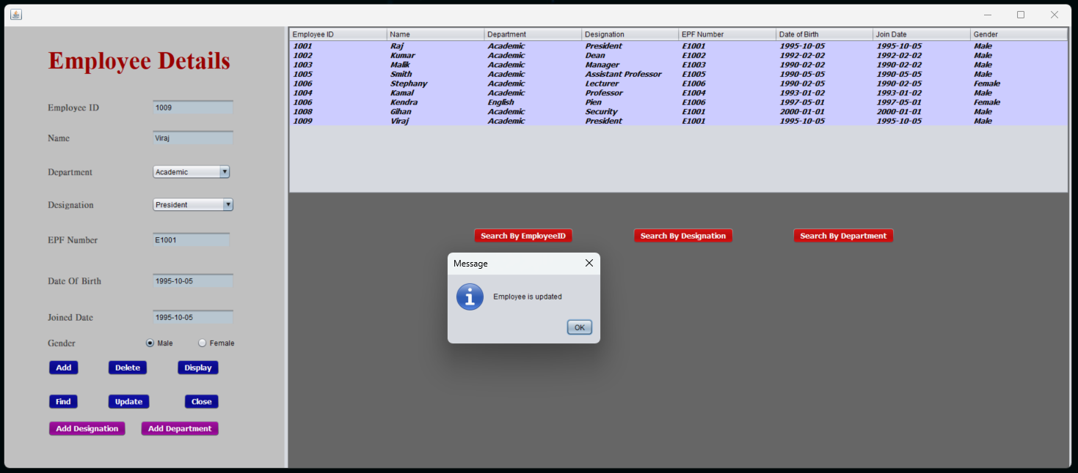

After changing the values you want, when the Update button is clicked, a message dialog box will appear showing “**Employee is updated**”.

Then you can check if the record was updated or not by clicking the **Display** button.

The values in the **employee.txt** also changed.

**Add Designation** button action

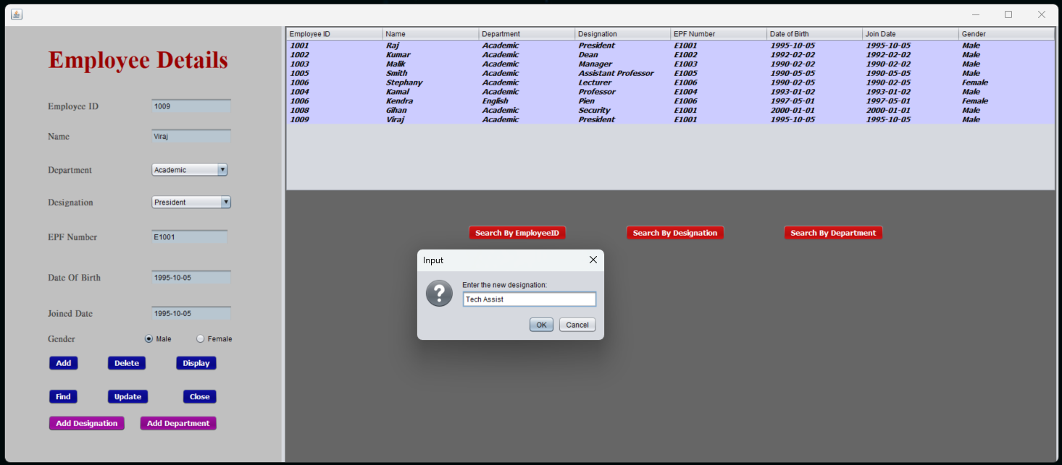

When clicking the **Add Designation** button, a message dialog box will appear by showing “**Enter the new designation**” to enter a designation that you want to add.

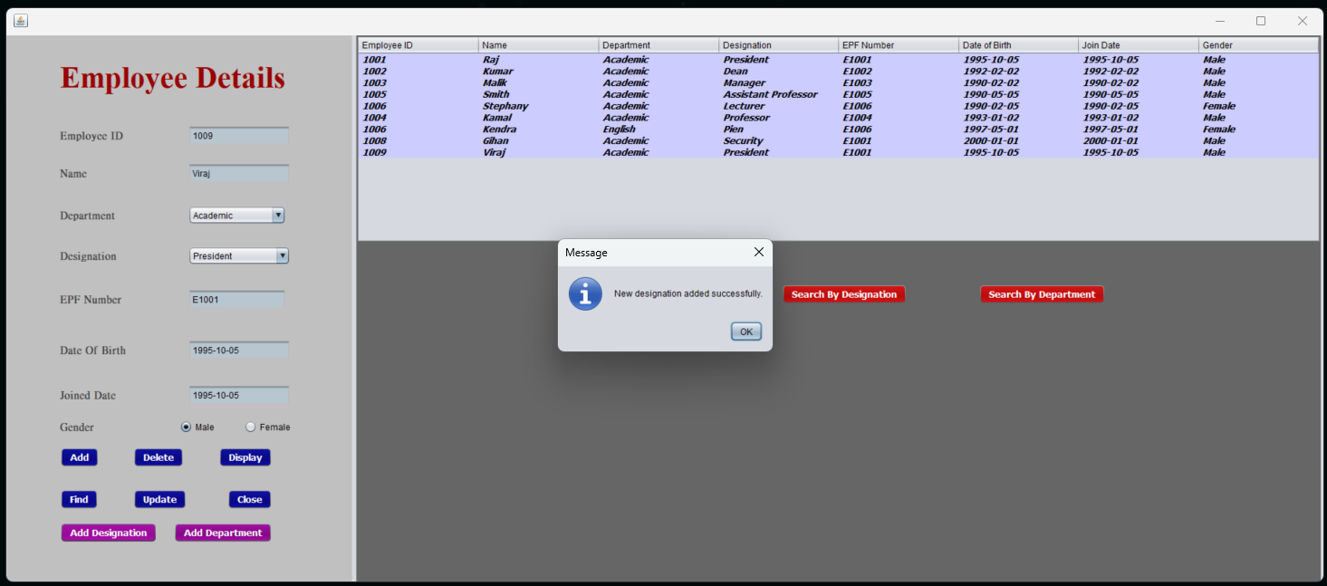

When a new designation is added, a message dialog box will appear by showing “**New designation added successfully**”.

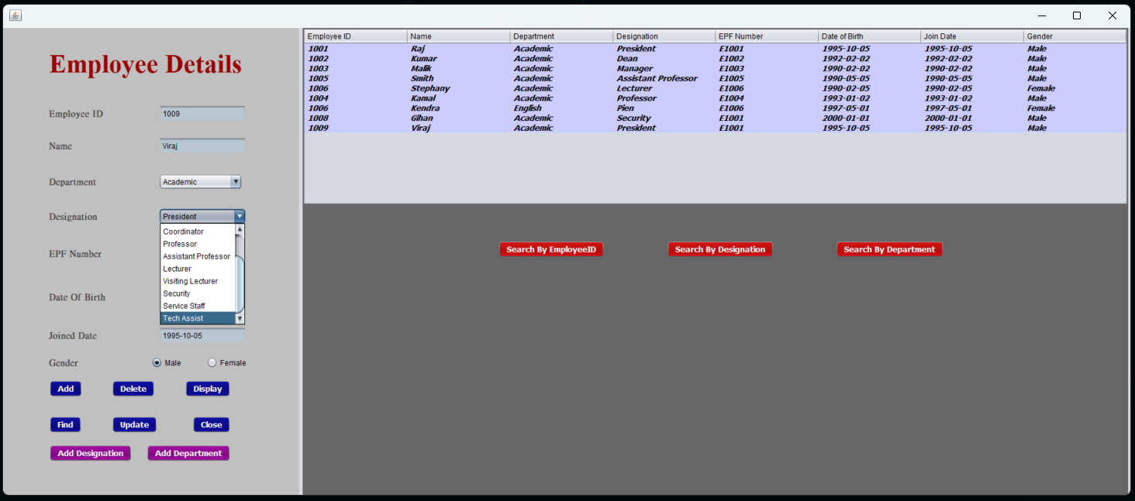

The added designations will be written to a text file named **designations.txt** and those designations will appear in the combo box after the inbuilt added designations.

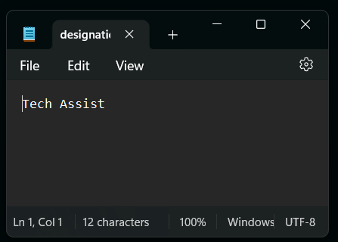

**Add Department** button action

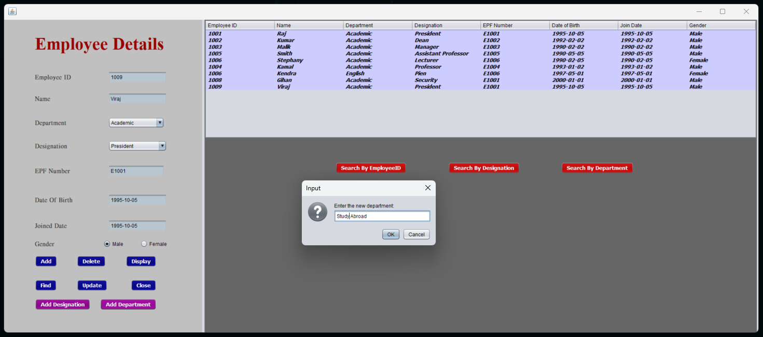

When clicking the **Add Department** button, a message dialog box will appear by showing “**Enter the new department**” to enter a designation that you want to add.

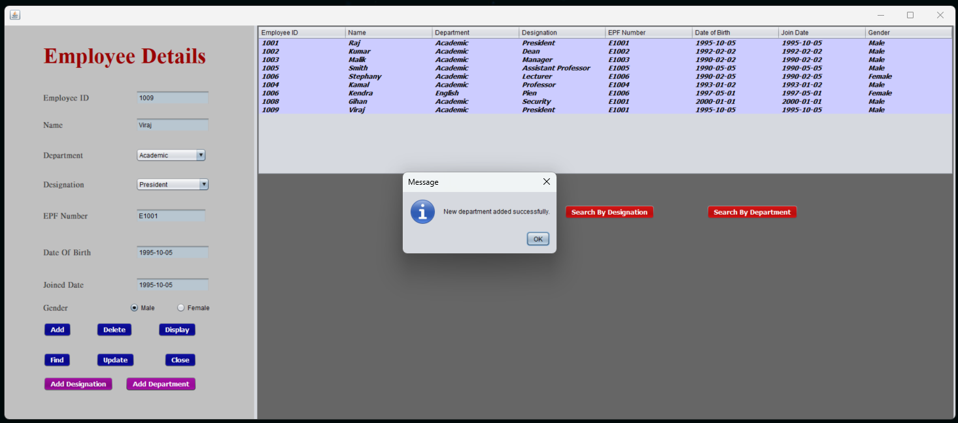

When a new designation is added, a message dialog box will appear by showing “**New department added successfully**”.

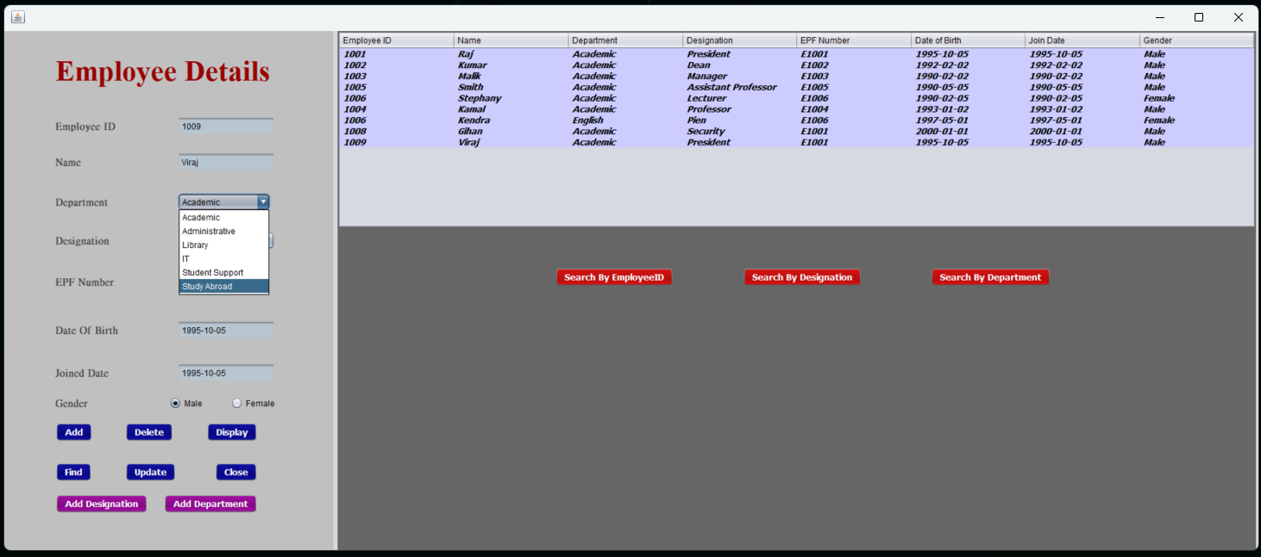

The added designations will be written to a text file named **departments.txt** and those designations will appear in the combo box after the inbuilt added designations.

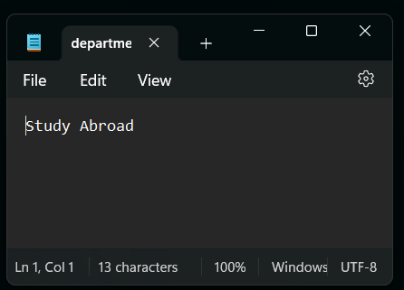

**Search by EmployeeID** button action

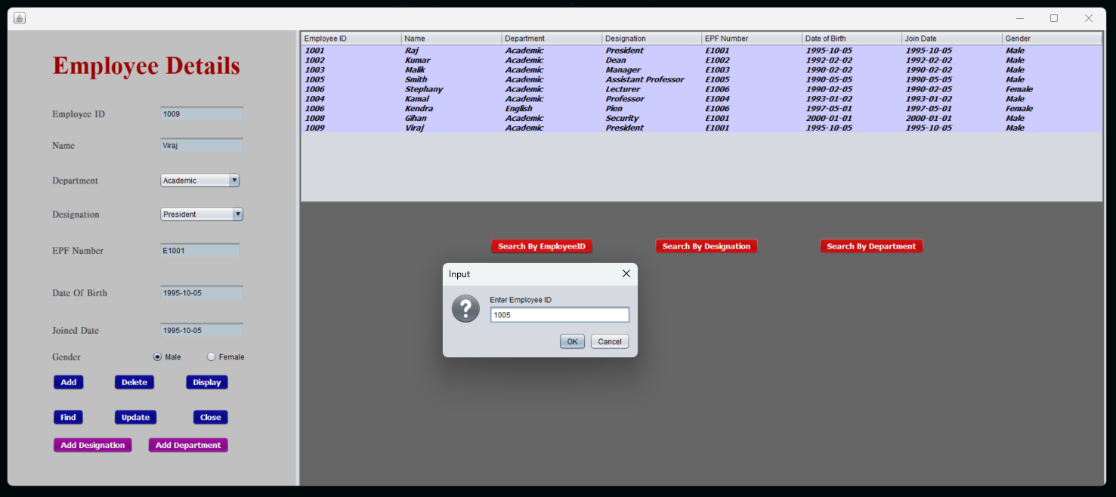

When clicking the **Search by EmployeeID** button, a message dialog box will appear by showing “**Enter Employee ID**” to enter and to find the record relevant to the entered Employee ID.

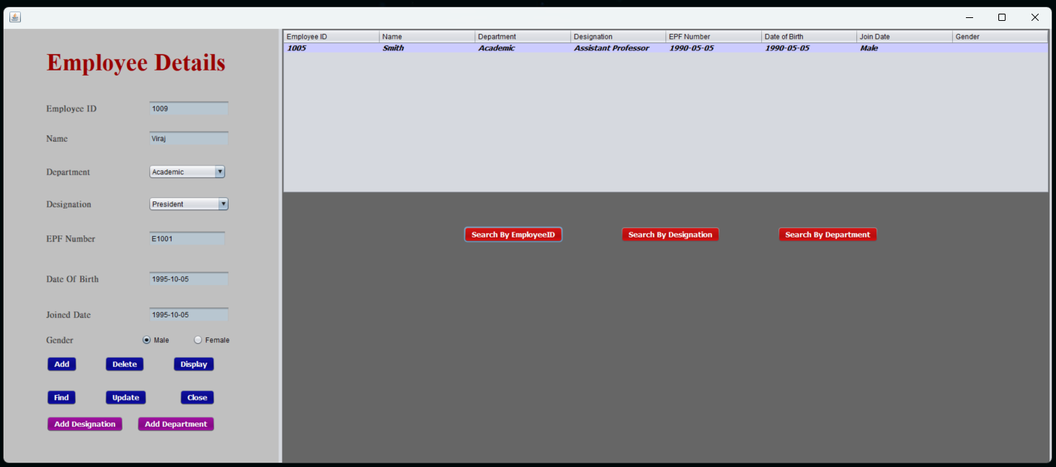

The result will be displayed in the employee table.

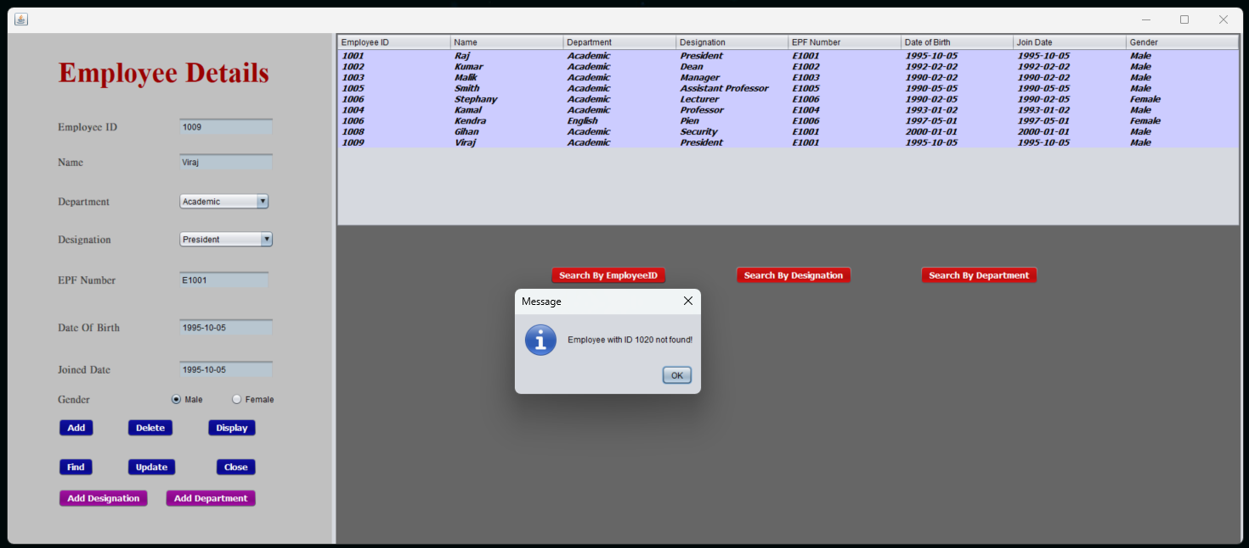

If a wrong Employee ID was entered, a message dialog box will appear by showing “**Employee with ID (Employee ID number) not found**”.

**Search by Department** button action

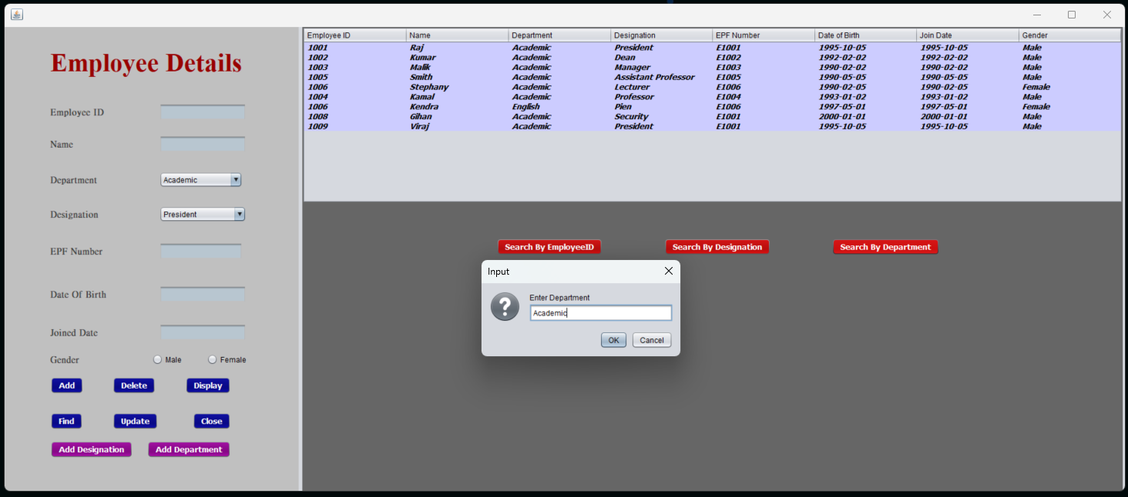

When clicking the **Search by Department** button, a message dialog box will appear showing “**Enter Department**” to enter and to find the records relevant to the entered Department.

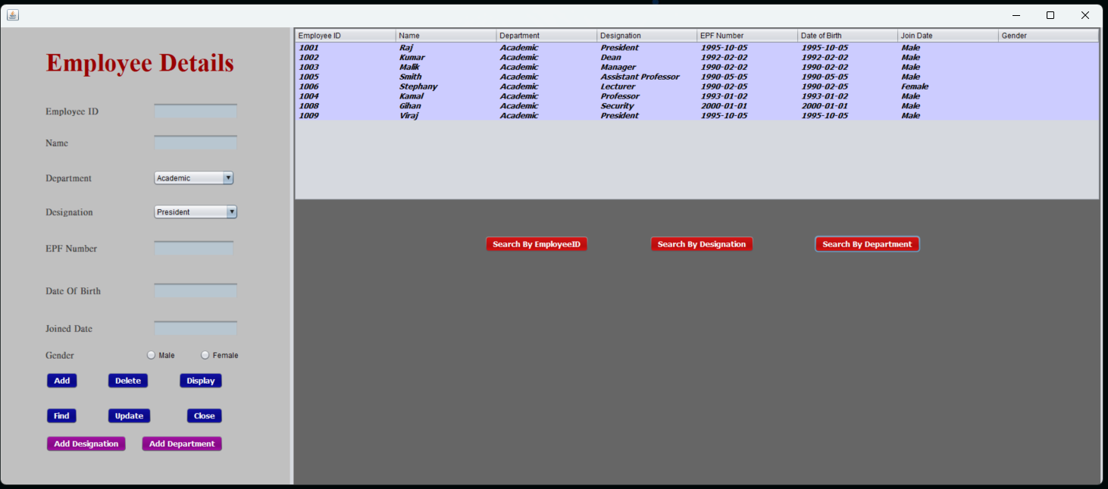

The result will be displayed in the employee table.

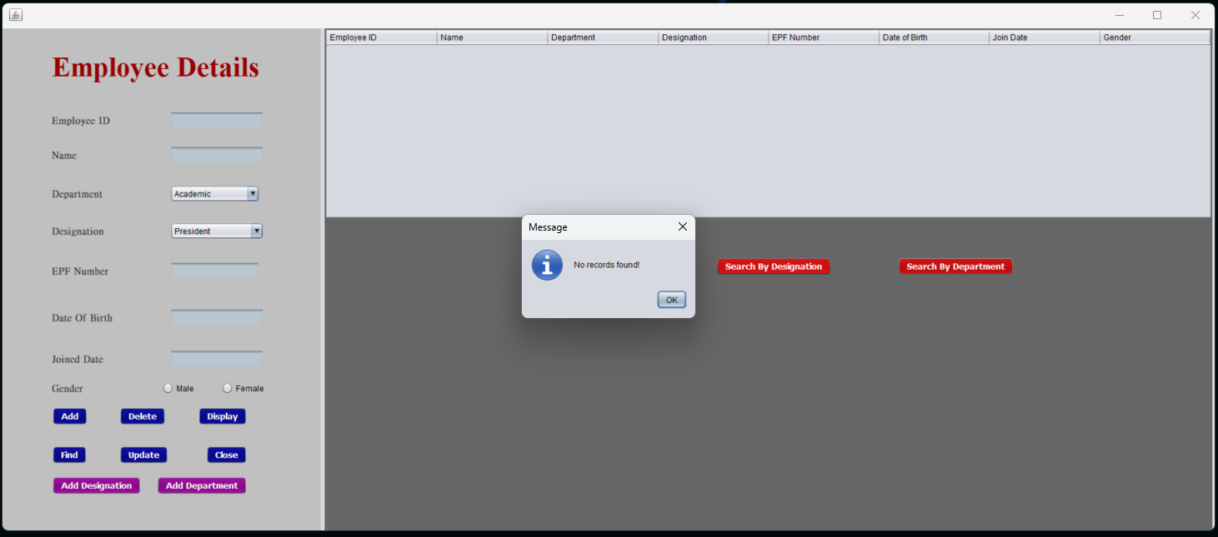

If there are no records found relevant to the searched department name, a message dialog box will appear showing “**No records found**”.

**Search by Designation** button action

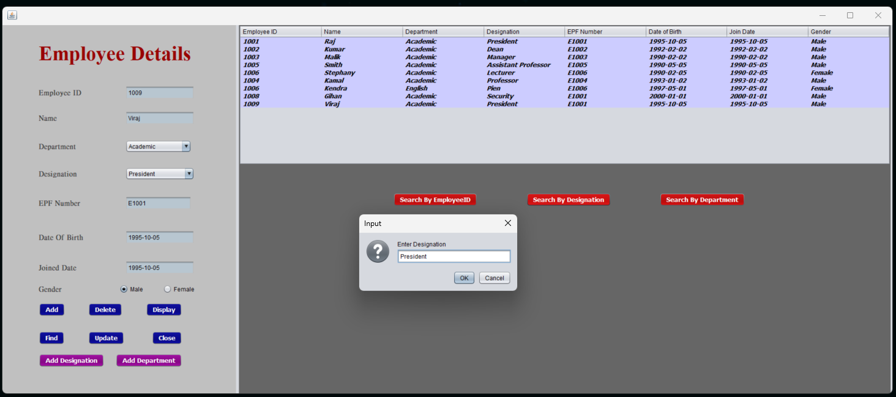

When clicking the **Search by Designation** button, a message dialog box will appear showing “**Enter Designation**” to enter and to find the records relevant to the entered Designation.

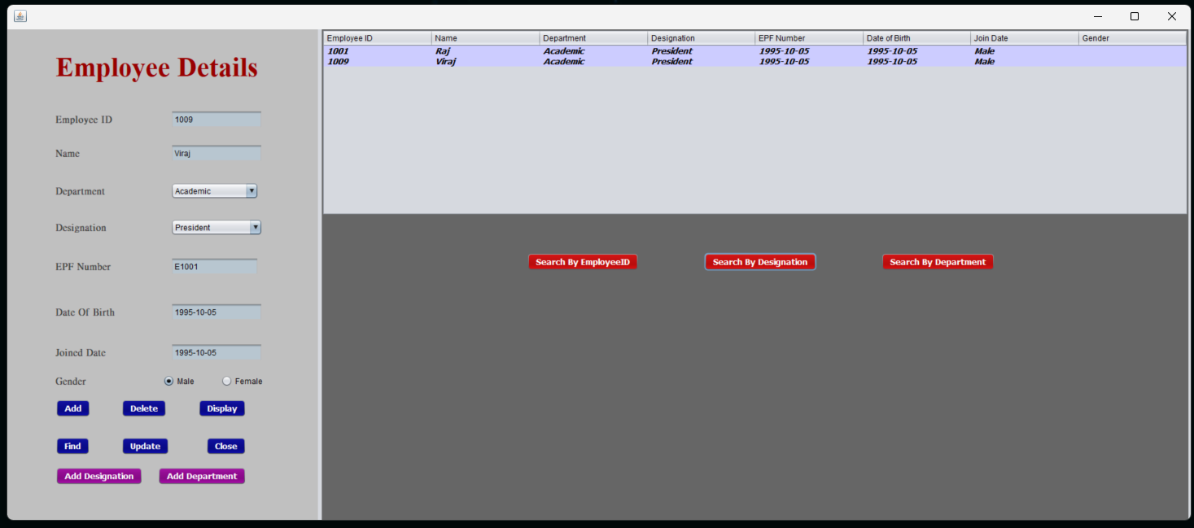

The result will be displayed in the employee table.



If there are no records found relevant to the searched department name, a message dialog box will appear showing “**No records found**”.