Nama : Pandu wiguna ruswandi (20240040258)
Kelas : TI24F
Matkul : OOP (praktikum)
- Buatlah akun di https://www.hackerrank.com/
- Kerjakan soal latihan bagian https://www.hackerrank.com/domains/java?filters%5Bsubdomains%5D%5B%5D=oop
- Screenshot masing - masing challenge lewat tab leader board
- Kumpulkan semua screenshot dalam bentuk pdf
- Upload file pdf ke edlink
Jawab
Java interance I
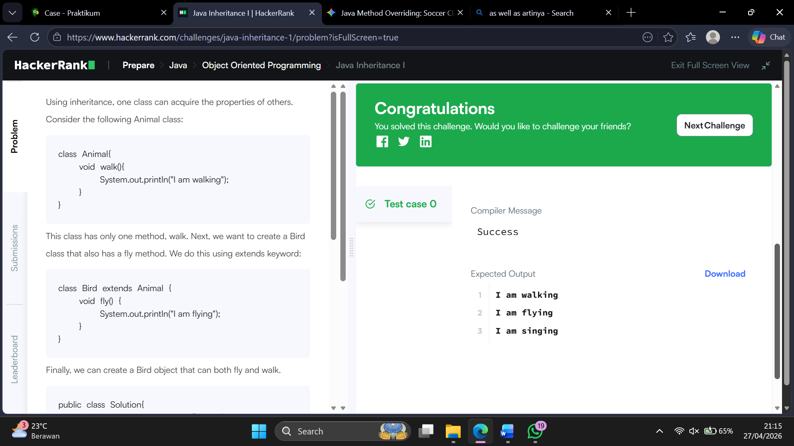
Java intherance II
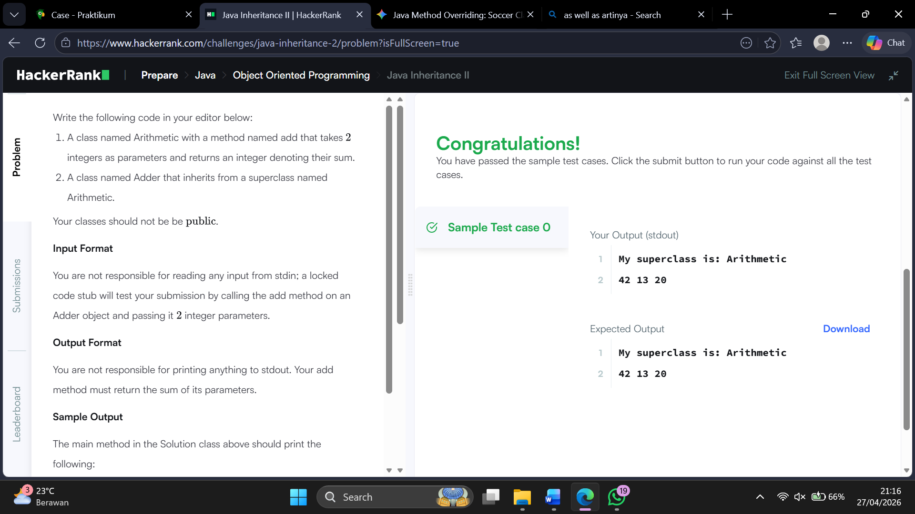

Java abstract class
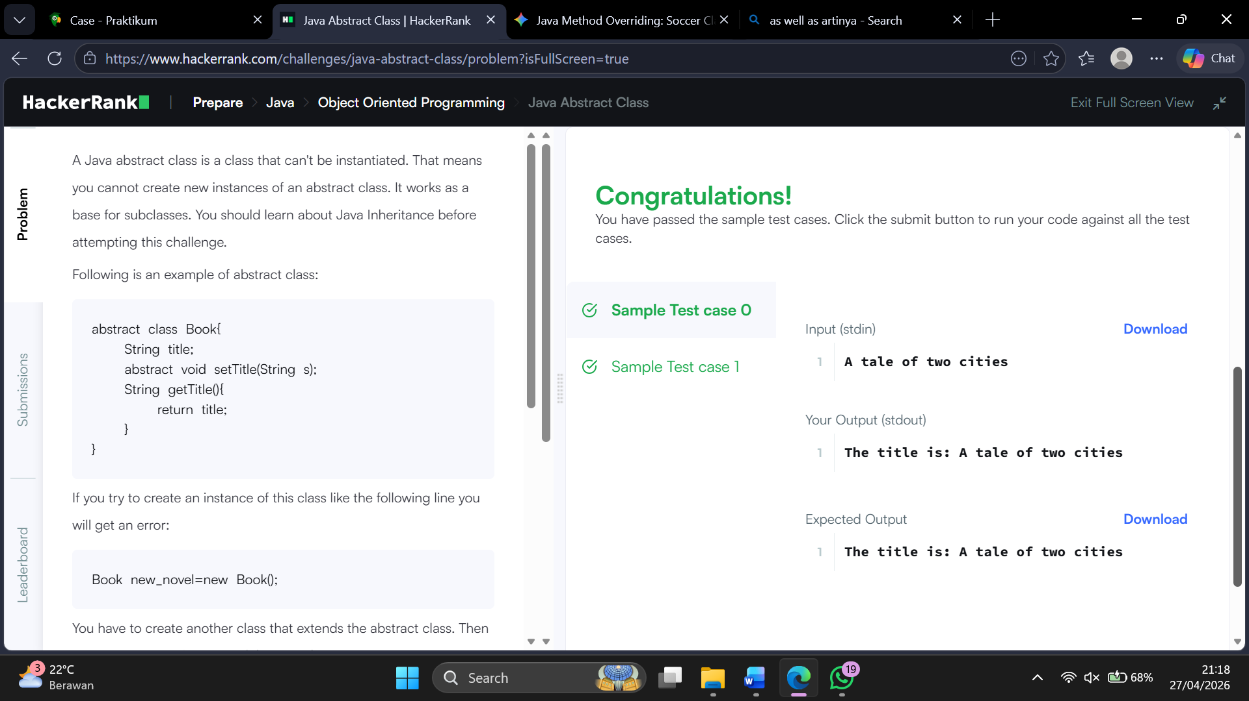
Java interface
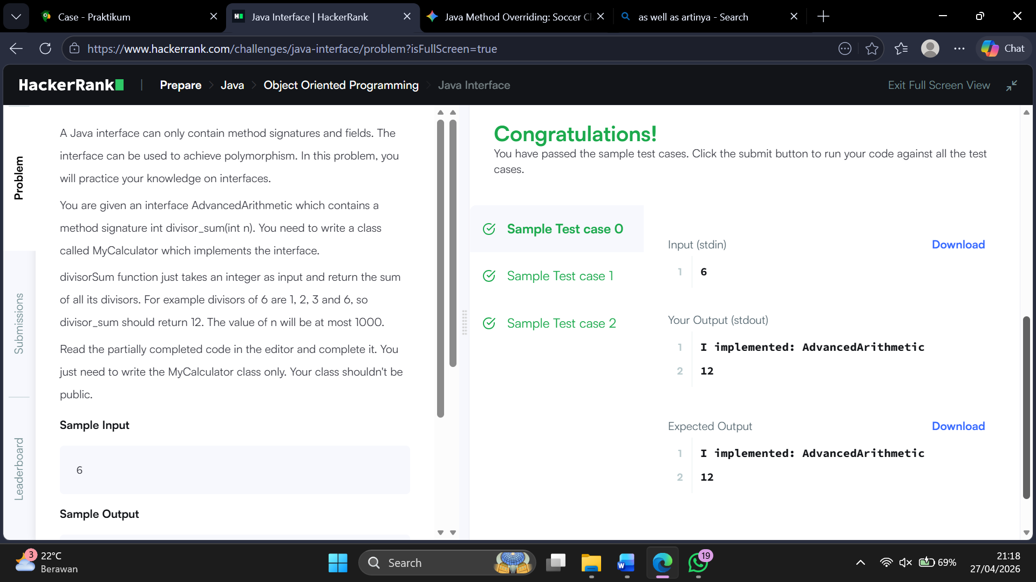
Java method overriding
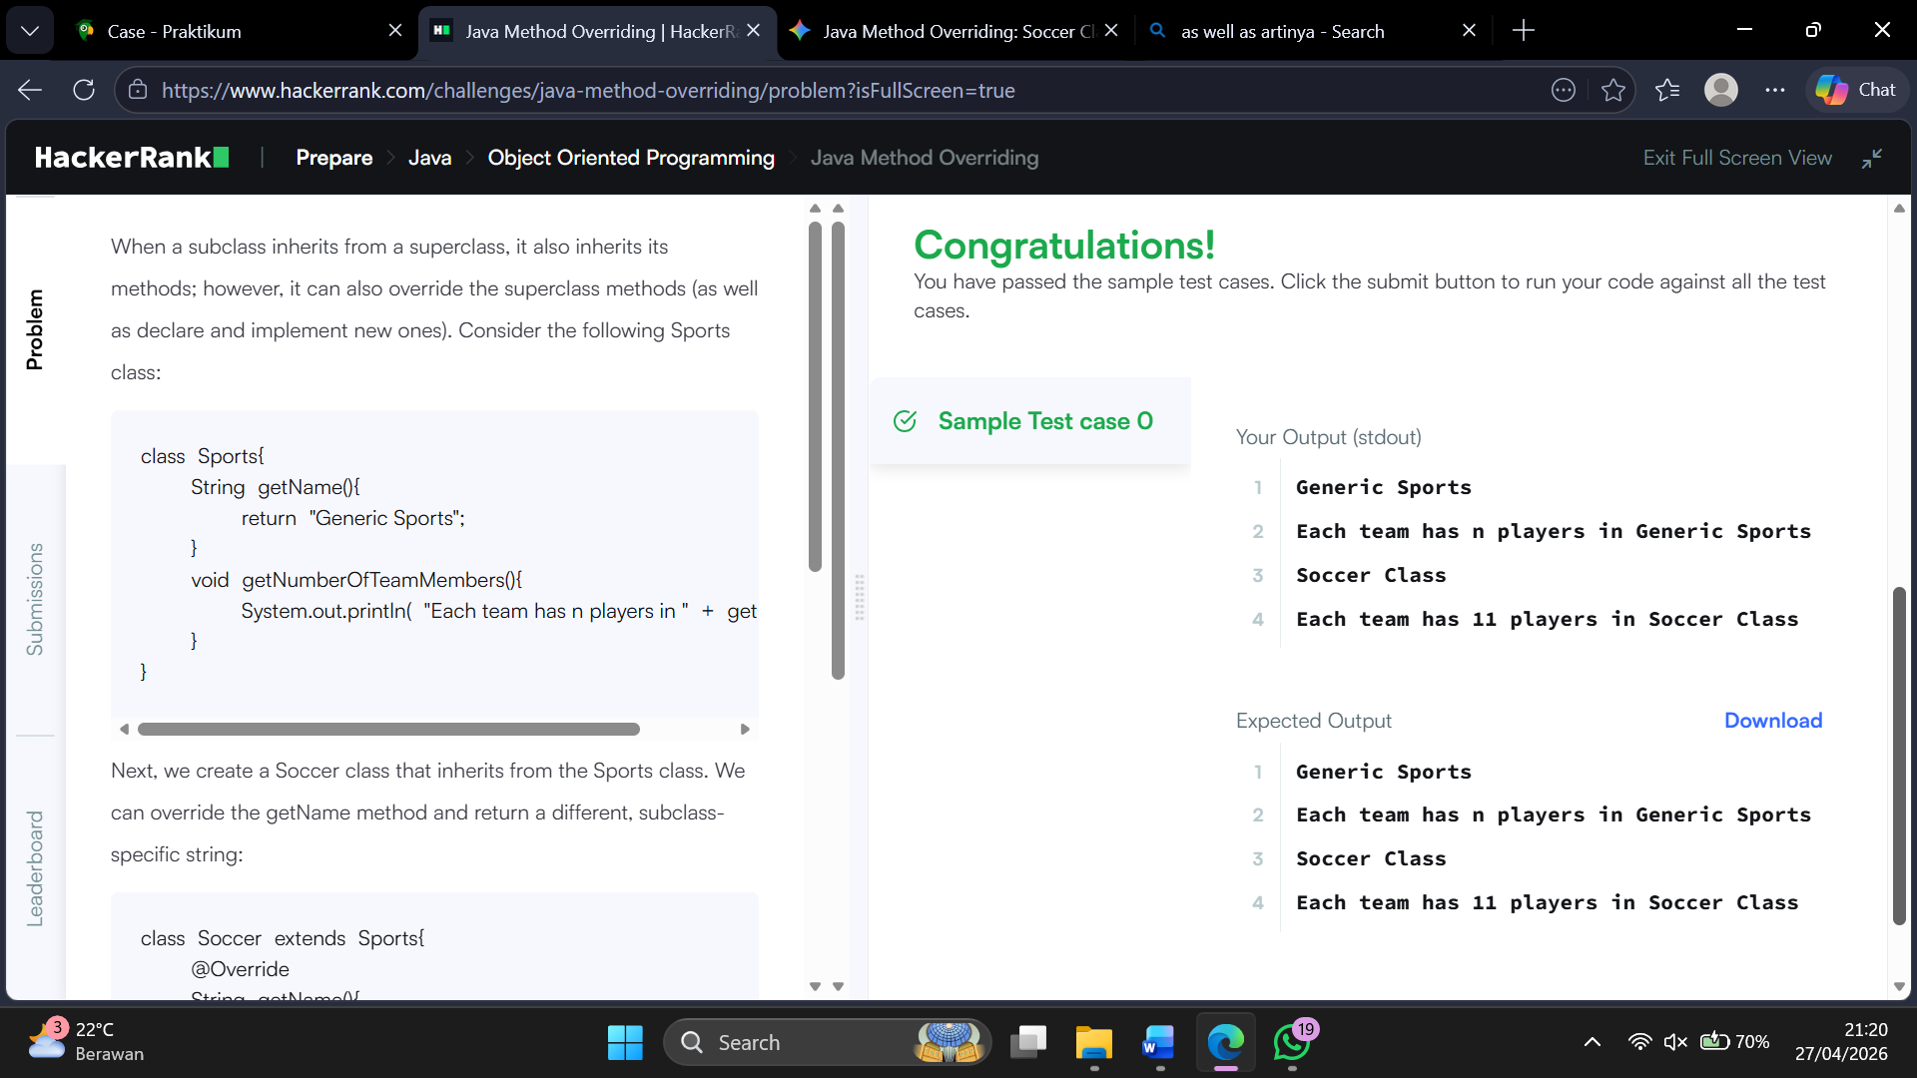

Java method overriding II
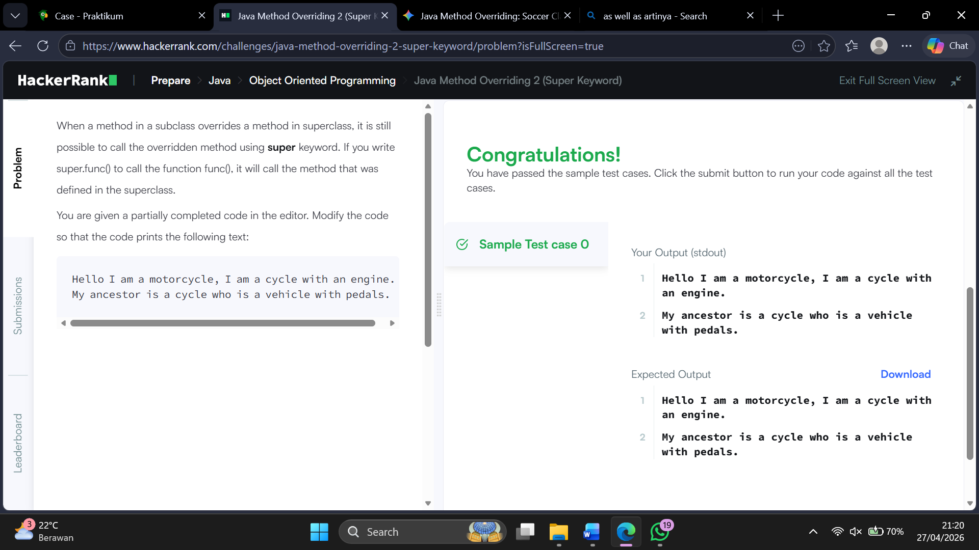
Java instanceof keyword
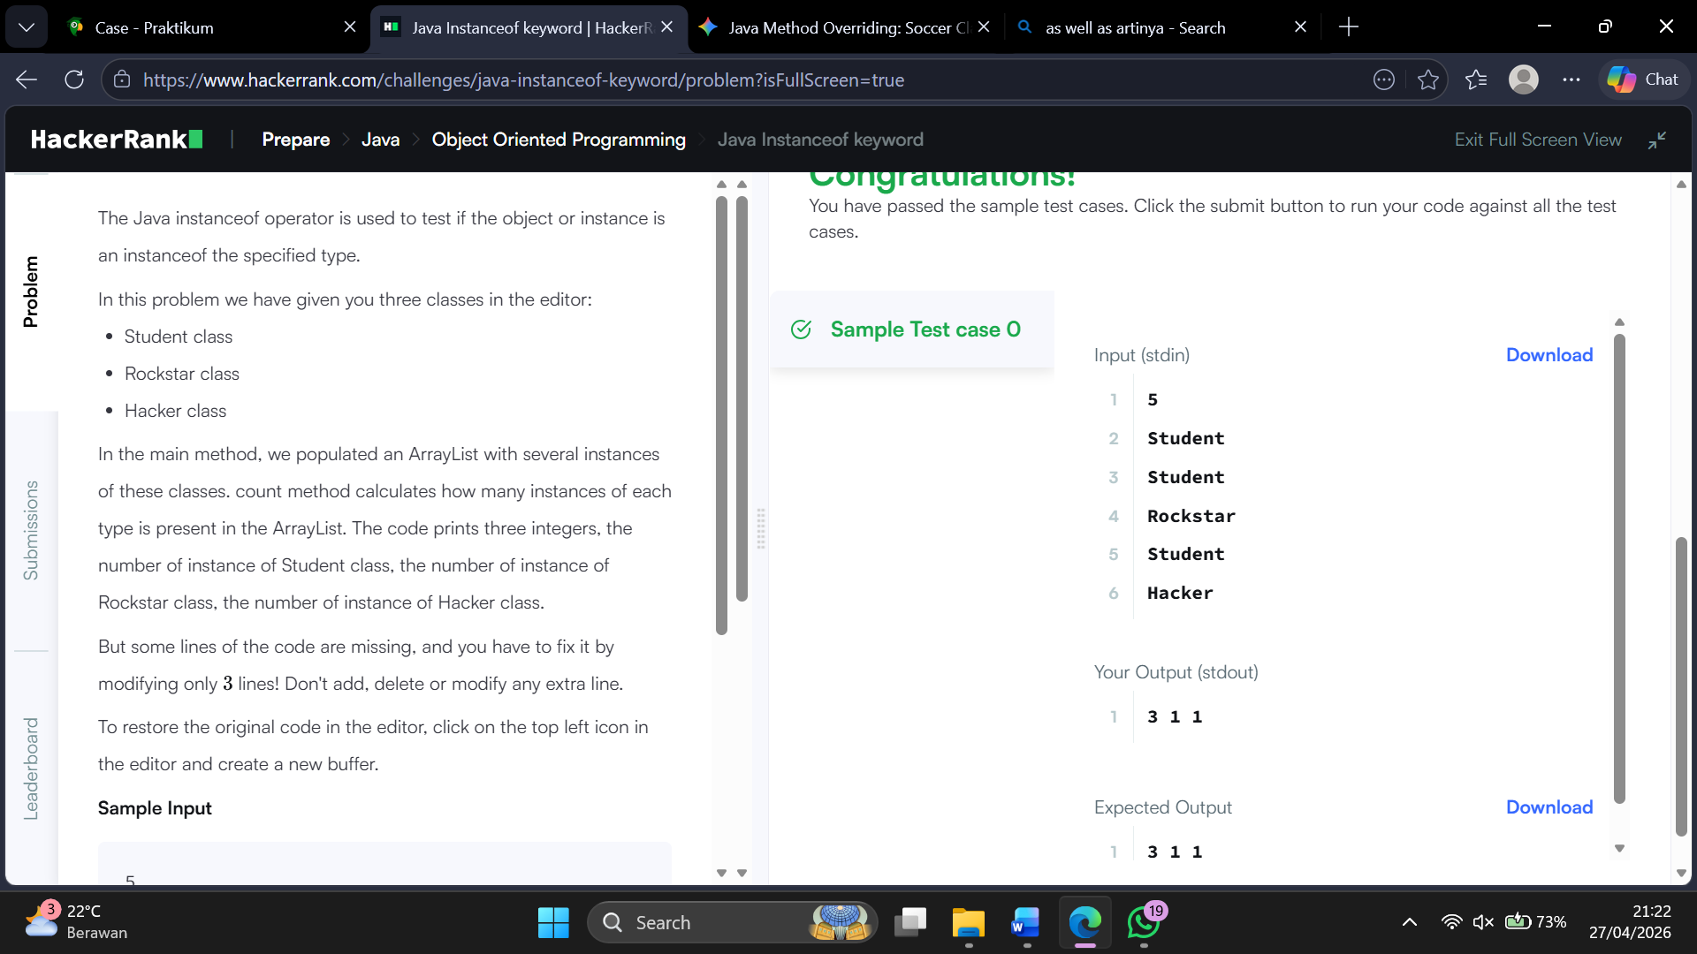
Java iterator
