**Bamazon – Basic**

This is the basic version of the Bamazon application.

Run the application “bamaznCustomer.js”. You will be prompt with the list of items that are currently available.

Go through the list, select your item.

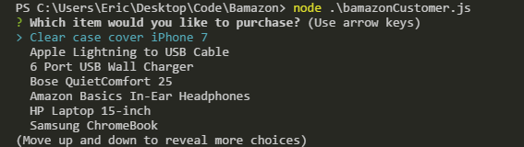

Once you have selected your item, you will then be asked about the quantity of the item you want to purchase.

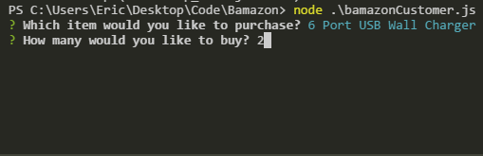

Depending on the number of items you want to purchase, the application will check against the quantity of the item in the database. If your order is less than the quantity in the database the order will placed. It will also log out the price of your order as well as the remaining items/quantity in the inventory.

If your input order exceeds the number in the database it will log out that there is insufficient number of items in stock.

