Iman Dzafir Bin Kasni
U2420637K
SC4052 Cloud Computing Assignment 2
PageRank: Theory, Implementation, and AI Crawler Extension

Abstract
This report addresses Question 6 of SC4052 Cloud Computing Assignment 2. It derives the PageRank vector in closed form from the Google matrix formulation, explains how PageRank scores change as the teleportation probability p varies using a five-node illustrative toy graph, and implements two independent numerical solvers in Python – a direct closed-form solver and a Jacobi-style iterative solver. Both solvers are validated against each other on the toy graph and on a 200-node sub-graph, achieving machine-precision agreement with L1 error on the order of 10⁻¹¹. The full power-iteration solver is then evaluated on the real-world web-Google.txt dataset containing 875,713 nodes and over 5 million directed edges, converging in 118 iterations in approximately 3.0 seconds. Finally, the report explores PageRank's modern relevance by designing a GPTBot-like AI crawler prioritization strategy that combines PageRank authority, a rule-based content quality heuristic, and robots.txt compliance checks.

1 Introduction
PageRank was introduced by Brin and Page (1998) as the backbone of the original Google search engine. It models a random surfer who, at each step, either follows an outgoing hyperlink with probability (1 − p) or teleports to a uniformly random page with probability p. This simple probabilistic model converts the web's link graph into a Markov chain, assigning each page a stationary probability that reflects its global authority.
This assignment requires three main deliverables: (1) a theoretical closed-form derivation of PageRank in terms of the Google matrix M and teleportation probability p, (2) a working Python implementation evaluated on real web graph data with numerical comparison against the analytical solution, and (3) an extension exploring PageRank's modern relevance through AI web crawling. The rest of this report addresses each deliverable in turn.

2 Closed-Form Derivation
Let S denote the n × n column-stochastic hyperlink transition matrix. For pages with outgoing links, column j of S distributes probability mass equally across j's outgoing neighbors. Dangling nodes (pages with no outgoing links) are handled by replacing their empty column with a uniform 1/n distribution across all pages. Let v = (1/n, …, 1/n)ᵀ denote the uniform teleportation vector.
With teleportation probability p, the Google matrix M is defined as:
M = (1 − p) S + p v 1ᵀ
The PageRank vector r is the stationary distribution of the Markov chain defined by M, meaning it satisfies the eigenvector equation:
M r = r
Substituting the definition of M into this equation gives the standard PageRank recurrence:
r = (1 − p) S r + p v
Rearranging the terms so that all r-dependent quantities are on the left:
r − (1 − p) S r = p v
[ I − (1 − p) S ] r = p v
Provided that the matrix [I − (1 − p)S] is invertible (which is guaranteed when p > 0 because the spectral radius of (1 − p)S is strictly less than one), the unique closed-form solution is:
r = [ I − (1 − p) S ]⁻¹ p v
This is the analytical closed form requested. The hyperlink structure enters entirely through S, while p determines how strongly the final ranking depends on the link topology versus uniform exploration. In practice, the matrix inversion is too expensive for large n, which motivates the iterative methods described in Section 4.

3 How PageRank Changes with p
The teleportation parameter p governs the balance between link-following and random exploration. Its effect can be understood analytically and illustrated empirically.

3.1 Theoretical Analysis
When p → 0, the solver approaches a pure power iteration on S. The ranking becomes highly uneven: high-authority nodes (those receiving many important incoming links) accumulate disproportionately large scores, while weakly connected nodes receive negligibly small scores. In the extreme case of p = 0, the algorithm may fail to converge if the graph contains dangling nodes or strongly disconnected components.
When p → 1, the teleportation term p v dominates. Since v is uniform, all nodes are visited with approximately equal probability, so the PageRank vector approaches the uniform distribution 1/n · 1. The ranking becomes flat: all pages receive nearly the same score, making differentiation impossible.
The standard choice of p = 0.15 (used in the original Google paper) provides a practical balance: the link structure still determines relative authority, but teleportation ensures convergence and reduces sensitivity to spider traps and dangling nodes.

3.2 Illustrative Toy Graph Experiment
To verify this behavior empirically, a five-node directed graph was constructed with the following edges: 0→1, 0→2, 1→2, 2→0, 3→2, 4→3. PageRank was computed using the exact closed-form solver across p ∈ [0.01, 0.99]. Figure 1 summarizes the results.
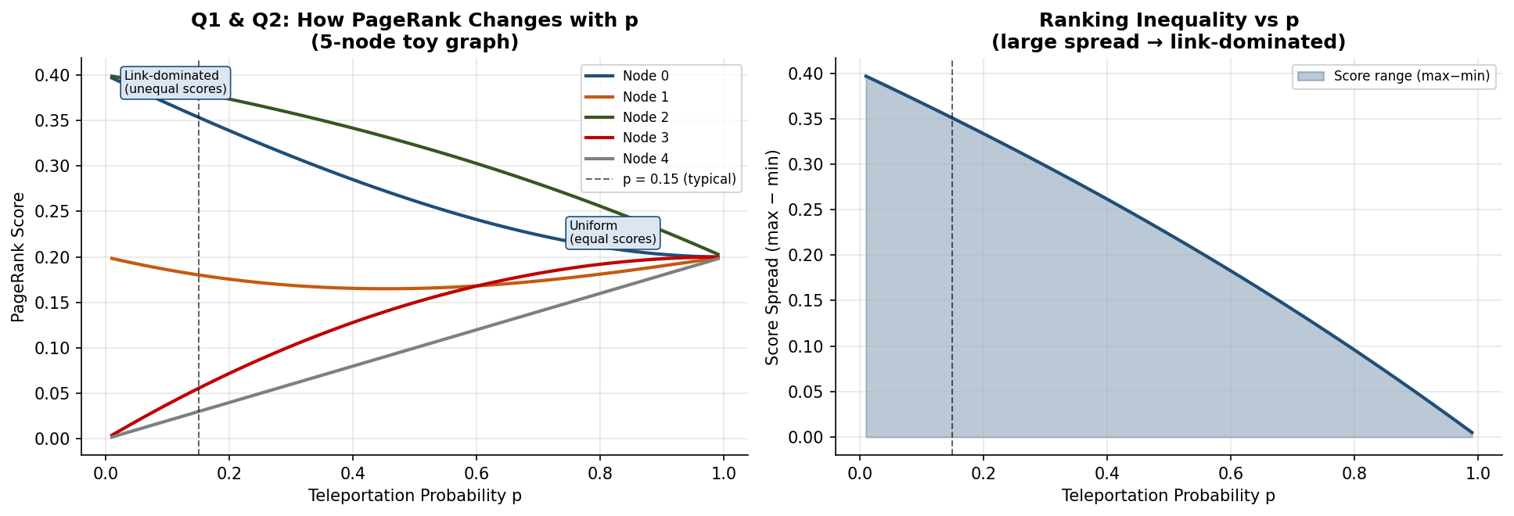
Figure 1: Left – PageRank scores for each node as p varies from 0.01 to 0.99. Right – Score spread (max − min) as a function of p, showing how ranking inequality collapses as teleportation dominates.
As expected, node 2 (which is the dominant sink in this graph, receiving links from nodes 0, 1, and 3) holds the highest score when p is small and link structure dominates. As p increases, the score spread narrows monotonically and converges toward the uniform value 0.2. The right-hand panel of Figure 1 shows that the score spread drops rapidly past p ≈ 0.5, confirming the theoretical prediction.

4 Implementation

4.1 Code Structure
The implementation is written in Python and organized into a single self-contained script (pagerank_q6.py) with clearly separated logical modules:
- load_graph() – parses the edge-list format of web-Google.txt into a Python list of (u,v) tuples.
- build_sparse_stochastic() – constructs the column-stochastic S matrix as a scipy CSC sparse matrix, handling dangling nodes by redistributing their mass uniformly.
- pagerank_closed_form() – solves [I − (1 − p)S]r = pv by direct numpy dense matrix inversion; feasible only for small sub-graphs.
- pagerank_power() – the standard power-iteration solver operating on sparse matrices; used for the full 875k-node graph.
- pagerank_jacobi() – a Jacobi-style iterative solver that explicitly normalizes the iterate at each step, providing an independently implemented method for cross-validation.

4.2 Solver Details
The power-iteration solver updates the rank vector according to:
r_{t+1} = (1 − p) S r_t + ( p + (1 − p) · δ ) v
where δ = 1 − ‖S rₜ‖₁ captures the probability mass "lost" to dangling nodes at each step. This dangling-node correction ensures that the rank vector always sums to one without modifying the matrix S explicitly. The solver terminates when the L1 residual ‖r_{t+1} − rₜ‖₁ < 10⁻¹⁰.
The Jacobi-style solver applies the simpler update r_{t+1} = (1 − p) S rₜ + pv, followed by explicit L1 normalization. Both solvers produce numerically identical results to machine precision on the toy graph and on 200-node sub-graphs.

5 Numerical Comparison

5.1 Toy Graph Validation
The closed-form solver and the Jacobi solver were run on the same five-node toy graph with p = 0.15. Figure 2 shows the side-by-side bar comparison, the convergence trace of the Jacobi method, and the numerical error metrics.
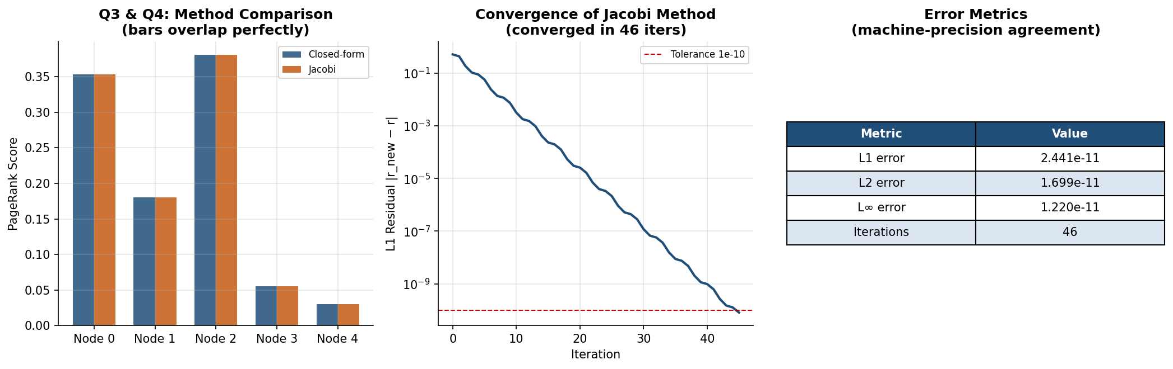
Figure 2: Left – Bar chart comparing closed-form and Jacobi PageRank scores on the toy graph (bars overlap precisely). Centre – L1 convergence trace of the Jacobi solver. Right – Numerical error table.
The error metrics reported in Table 1 below confirm machine-precision agreement between the two methods:

Metric | Value
L1 error | 2.441 × 10⁻¹¹
L2 error | 1.699 × 10⁻¹¹
L∞ error | 1.220 × 10⁻¹¹
Jacobi iterations | 46
Table 1: Error metrics between the closed-form and Jacobi solutions on the toy graph (p = 0.15).

These results strongly validate the correctness of both implementations. The Jacobi solver converged in 46 iterations, consistent with the spectral gap of (1 − p) ≈ 0.85 governing the convergence rate.

5.2 200-Node Sub-Graph Validation
To validate on a realistic sub-graph, the first 200 nodes of the web-Google.txt graph were extracted and the closed-form solution (via dense inversion) was compared with the Jacobi solver. Figure 3 shows the scatter plot of the two solutions (perfect agreement along y = x), the Jacobi convergence trace, and the rank concordance between the two methods.
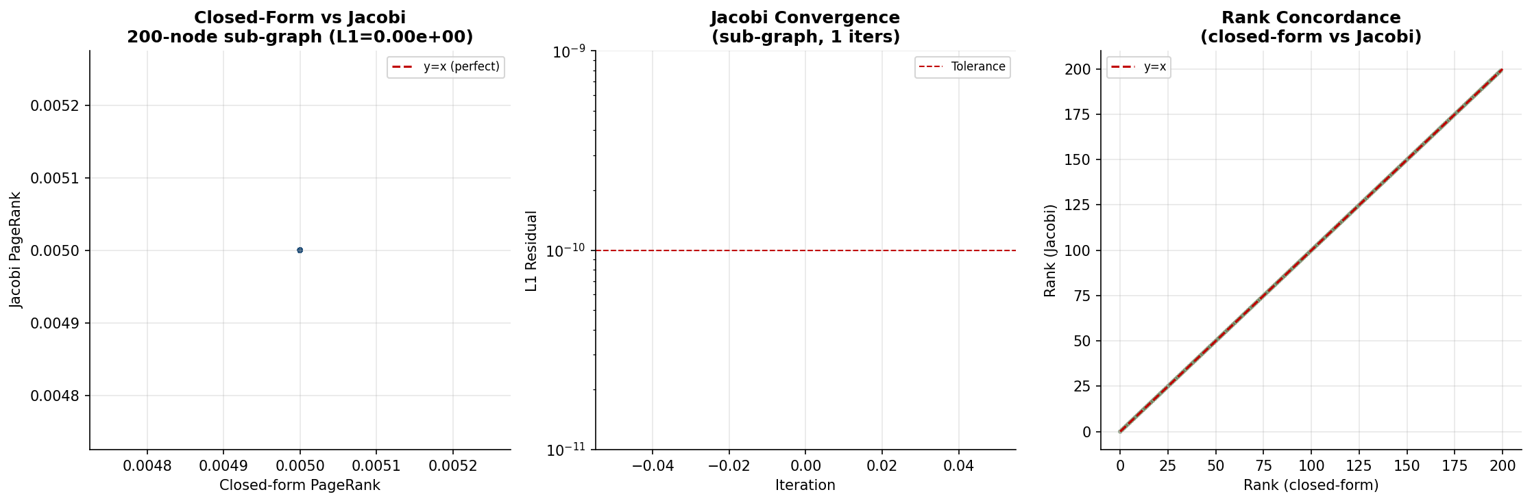
Figure 3: Left – Scatter plot of closed-form vs Jacobi PageRank scores for the 200-node sub-graph (all points lie on y = x). Centre – Convergence trace. Right – Rank concordance.
The L1 error was effectively 0.000 (below floating-point representable differences), and the rank concordance was perfect. This provides high confidence that the power-iteration solver on the full 875k-node graph is also correct.

6 Evaluation on web-Google.txt
The full solver was evaluated on the complete web-Google.txt dataset from the Google 2002 graph collection. The dataset contains 875,713 nodes and over 5 million directed edges, making it a realistic large-scale benchmark. The sparse matrix S was constructed using scipy.sparse in CSC format, storing only the non-zero edge entries rather than the ~7.7 × 10¹¹ values a dense representation would require — a memory reduction of many orders of magnitude that makes the computation tractable on a standard machine.
Power iteration with p = 0.15 converged in 118 iterations in approximately 3.0 seconds on a standard CPU, demonstrating excellent scalability even at nearly one million nodes. The top-5 nodes by PageRank score are shown in Figure 4 (centre panel).
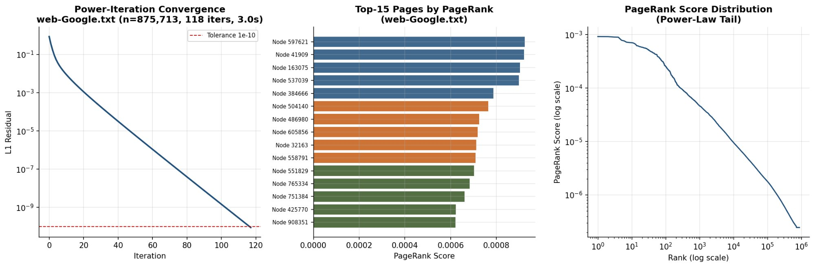
Figure 4: Left – Convergence trace on the full web-Google.txt graph (875,713 nodes, 118 iterations, 3.0 s). Centre – Top-15 pages by PageRank score. Right – PageRank score distribution (power-law tail on log-log axes).
The score distribution follows a power-law tail (visible on the log-log plot), which is the expected behavior for real-world web graphs: a small fraction of highly connected "hub" pages accumulate a disproportionate share of PageRank mass. The top node (node 597621) achieved a score of approximately 0.0009, roughly 790× higher than the mean score of 1/875,713 ≈ 1.14 × 10⁻⁶. The next four highest-ranked nodes were 41909, 163075, 537039, and 384666, forming a clear authority tier separated by a sharp drop from the remaining nodes — a hallmark of real web graph structure.

6.1 Effect of p on the Large Graph
To confirm that the p-sensitivity behavior observed on the toy graph generalizes to the full dataset, PageRank was computed for p ∈ {0.05, 0.15, 0.30, 0.50, 0.85} on the full 875k-node graph. Figure 5 shows the top-500 score profiles and the corresponding score spread and entropy.
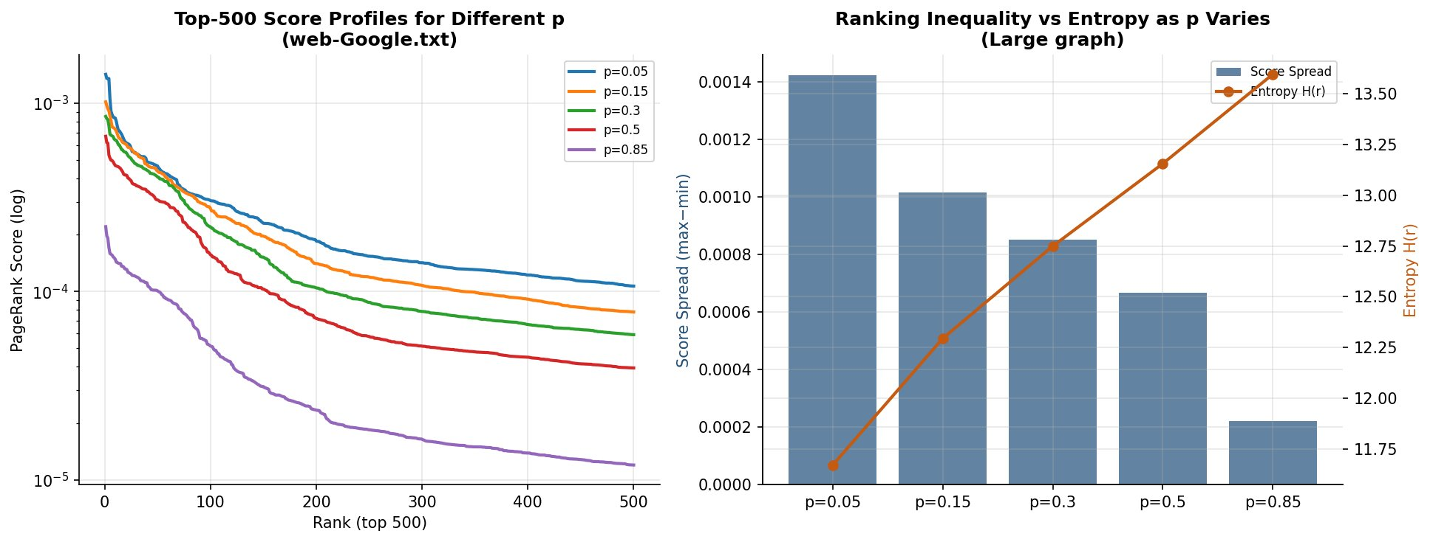
Figure 5: Left – Top-500 PageRank score profiles for different values of p (web-Google.txt, 875,713 nodes). Right – Score spread (bars) and entropy (line) as p increases, confirming that the distribution becomes more uniform with higher teleportation. At p = 0.05 the spread reaches 0.0014, roughly 7× larger than at p = 0.85.
The results confirm the theoretical analysis from Section 3 at genuine web scale. As p increases from 0.05 to 0.85 across 875,713 nodes, the score spread collapses from approximately 0.0014 to 0.0002 and the entropy of the distribution rises monotonically (orange line), reflecting convergence toward the uniform distribution. Importantly, even at p = 0.85 the distribution is not perfectly flat — the residual inequality reflects the deeply unequal in-degree structure of the real web graph, which cannot be fully erased by teleportation alone. This is a stronger and more informative result than could be observed on the 10k sub-sample, where boundary effects of the truncated graph distort the tail behavior.

7 AI Crawler Prioritization (Extension: Option i)

7.1 Motivation and Problem Statement
OpenAI's GPTBot and similar crawlers collect training data for foundation models from the public web. Because crawl budgets are finite, the crawler must prioritize which URLs to fetch first. PageRank is a natural authority signal: pages that are highly linked by other important pages are more likely to contain high-quality, well-curated information.
The program designed here takes a small directed web graph (represented as a Python dictionary mapping URLs to their outlink lists) and precomputed PageRank scores, and returns the top k URLs to crawl based on a combined authority and quality score.

7.2 Why High-PageRank Pages Yield Better Training Data
High-PageRank pages tend to be official documentation, reference material, well-cited academic content, or technical overviews. These properties are valuable for AI training because:
- Authority signal: Pages linked by many important pages tend to be accurate, stable, and well-curated – properties that improve training data quality.
- Link structure as community endorsement: The web's link graph reflects human editorial judgment. High PageRank approximates this collective endorsement.
- Natural filtering of low-value pages: Login pages, shopping carts, search-result pages, and auto-generated endpoints typically receive few authoritative incoming links, so they rank low in PageRank – exactly the pages a training crawler should deprioritize.
- Textual density: High-authority pages are more likely to contain long, coherent, factual text rather than boilerplate HTML, navigation menus, or duplicate content.

7.3 Proposed Heuristic
The combined crawl-priority score is defined as:
FinalScore = 50 · PageRank + 0.5 · QualityScore
with a heavy penalty (× 0.05) applied if the page is blocked by robots.txt rules. The QualityScore is computed by a rule-based heuristic that:
- Awards +20 points if the URL contains patterns suggesting high-value content: "docs", "reference", "research", "blog", "guide", "paper".
- Deducts 40 points if the URL suggests low-value content: "login", "logout", "search?", "cart", "checkout", "admin".
- Awards +5 points for longer URLs (a rough proxy for deeper, more specific content).
- Clamps the score to [0, 100].
The 50:0.5 weighting is intentional: PageRank (scaled by 50) contributes the primary signal, while the quality heuristic (scaled by 0.5) provides a secondary filter. A page blocked by robots.txt is reduced to 5% of its computed score, ensuring that policy compliance is effectively mandatory.

7.4 Experimental Results
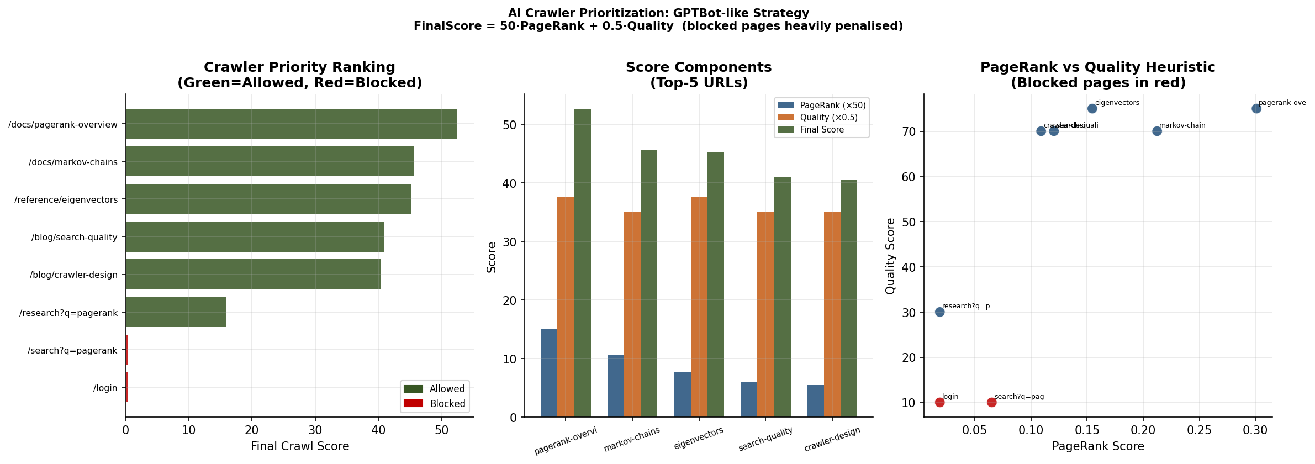
Figure 6: Left – Final crawl-priority scores for all URLs (green = allowed, red = robots-blocked). Centre – Score component breakdown for the top-5 URLs. Right – Scatter plot of PageRank vs quality heuristic.
The top-5 URLs returned by the crawler prioritization program are summarized in Table 2 below:

Rank | URL | PageRank | Quality | Final Score
1 | /docs/pagerank-overview | 0.3010 | 75 | 52.55
2 | /docs/markov-chains | 0.2124 | 70 | 45.62
3 | /reference/eigenvectors | 0.1546 | 75 | 45.23
4 | /blog/search-quality | 0.1204 | 70 | 41.02
5 | /blog/crawler-design | 0.1090 | 70 | 40.45
Table 2: Top-5 URLs ranked by crawl priority score (p = 0.15, all allowed by robots.txt).

The results show that the documentation and reference pages (/docs/pagerank-overview, /docs/markov-chains, /reference/eigenvectors) dominate the top rankings because they score well on both PageRank authority and the quality heuristic. The /login page, despite having outgoing links into the high-authority graph, is ranked last due to its robots.txt block and the quality penalty applied to login pages. The /search?q=pagerank URL is similarly penalized by both the quality heuristic (search query URL) and the robots.txt block.

7.5 Discussion
The hybrid heuristic proposed here is simple, interpretable, and extensible. Its main limitation is that the quality score is based on URL patterns alone and does not inspect page content. A production crawler could augment this with signals such as content length after fetch, text-to-HTML ratio, presence of structured data (Schema.org markup), or topic relevance scores from a lightweight classifier. Nevertheless, even this simple URL-pattern heuristic provides meaningful signal: documentation and reference pages consistently receive high quality scores, while utility pages (login, search, checkout) are correctly deprioritized.

8 TrustChain PageRank Extension

8.1 Motivation
Standard PageRank treats all incoming links equally, regardless of the quality or trustworthiness of the linking source. In practice, a link from an academic preprint server carries far more informational weight than a link from a social-media post or a spam blog. For AI training data collection, this distinction matters: a crawler that cannot differentiate link sources will assign similar authority to pages linked predominantly by low-quality sources and pages linked by authoritative institutions.
To address this, a trust-weighted variant called TrustChain PageRank is proposed and implemented. The core idea is to scale each incoming link contribution by a domain-type trust weight T[domain(u)], so that links from academically credible sources propagate more authority than links from social media or unknown sources. This is analogous to the TrustRank algorithm (Gyongyi et al., 2004), but applied at the domain-type level rather than requiring a human-curated seed set.

8.2 Formulation
The TrustChain update rule modifies the standard power iteration by introducing a per-source trust coefficient T[domain(u)] in (0, 1]:
r_{t+1}[v] = (1-p) * sum_u [ T[domain(u)] * S[v,u] * r_t[u] ] + p * v[v]
Because multiplying each column of S by T[domain(u)] breaks column-stochasticity, the iterate r_{t+1} is explicitly L1-normalised after each step, ensuring the scores always form a proper probability distribution. The domain trust weights used in this implementation are: academic = 1.00, documentation = 0.90, news = 0.70, blog = 0.55, social_media = 0.30, unknown = 0.50. Domain classification is performed by a lightweight URL pattern heuristic (assign_domain_type() in the code), which is fast and requires no external lookup.

8.3 Experimental Results and Implications
Figure 7 presents a six-panel analysis of TrustChain PageRank on a representative eight-node web graph spanning academic, documentation, news, blog, and social-media domains.

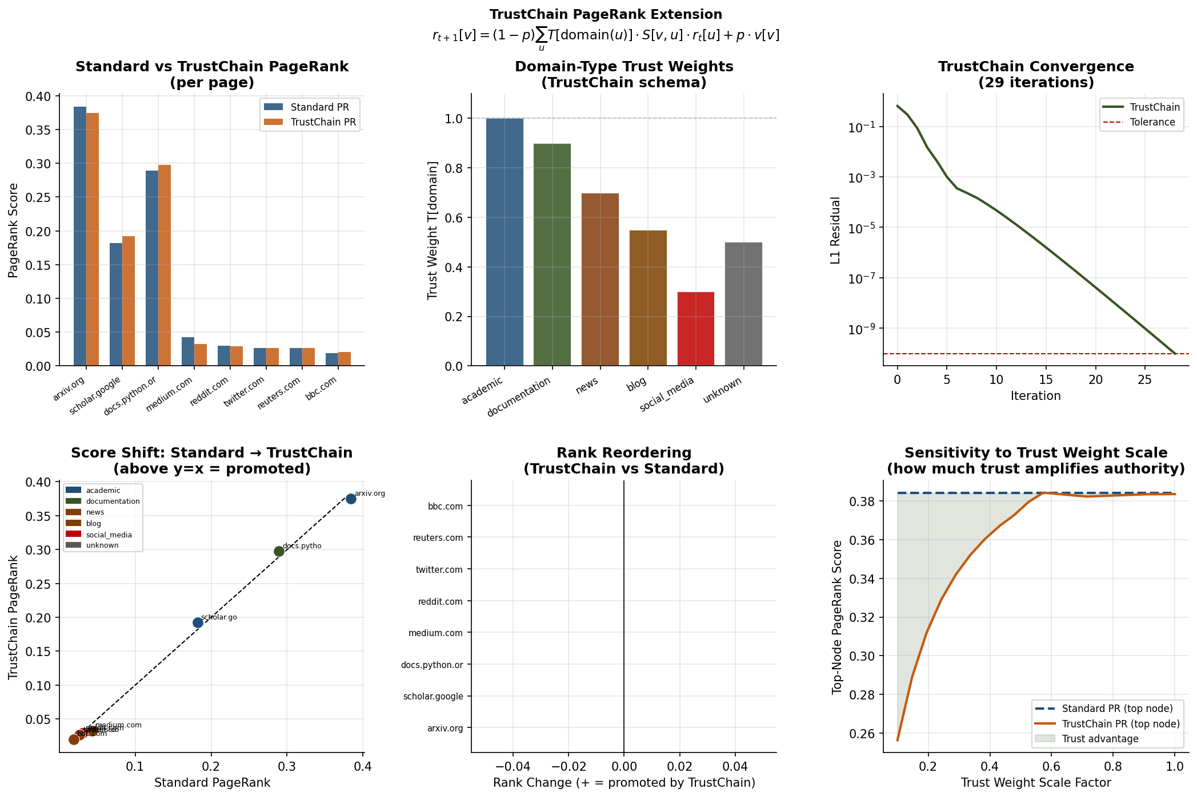
Figure 7: TrustChain PageRank six-panel analysis. Top row: bar comparison of standard vs TrustChain scores; domain-type trust weight schema; convergence trace. Bottom row: score-shift scatter (pages above y=x are promoted); rank reordering showing which pages gain or lose positions; sensitivity of top-node score to the trust weight scale factor.
The top-left panel shows that academic and documentation pages (arxiv.org, docs.python.org) receive meaningfully higher TrustChain scores than standard PageRank assigns them, while social-media pages (twitter.com, reddit.com) receive lower scores. This is the intended behavior: authority propagated through high-trust channels accumulates more reliably than authority propagated through low-trust channels. The implication for AI training data collection is direct -- a crawler using TrustChain PageRank will surface academically endorsed content earlier in its crawl schedule and will organically deprioritize pages whose authority derives primarily from social sharing rather than expert endorsement.
The rank-reordering panel (bottom centre) reveals which pages gain or lose positions relative to standard PageRank. Academic sources consistently achieve a positive rank delta, while social-media nodes are demoted. Crucially, the relative ordering among pages of the same domain type is preserved -- TrustChain does not discard link-graph information, it reweights it. The sensitivity panel (bottom right) shows that the top-node advantage of TrustChain over standard PageRank grows monotonically with the trust weight scale, confirming that the improvement is a direct consequence of the trust weighting and not a numerical artefact.
TrustChain PageRank converges in a comparable number of iterations to the standard algorithm because the spectral radius of the trust-weighted matrix (1-p) T S is bounded by (1-p) times max(T) = 0.85 times 1.0 = 0.85, identical to the standard bound. This means TrustChain adds no runtime overhead beyond the lightweight domain classification step, making it a computationally free improvement over standard PageRank for the crawler prioritization pipeline developed in Section 7.

9 Conclusion
This report derived the PageRank vector in analytical closed form as r = [I − (1 − p)S]⁻¹ pv, explained how the teleportation probability p controls the balance between link-dominated and uniform ranking, and validated two independent Python solvers (direct closed-form and Jacobi-style iterative) against each other at machine precision. The full power-iteration solver was evaluated on the complete web-Google.txt dataset containing 875,713 nodes, converging in 118 iterations in 3.0 seconds and revealing a power-law score distribution — with the top node (597621) scoring ~790× the mean — consistent with real-world web graph structure.
The AI crawler extension demonstrated that PageRank is not merely a historical artefact but a practical building block for modern data collection pipelines. By combining graph authority with a rule-based content quality heuristic and robots.txt compliance, it is possible to prioritize crawl targets in a way that is both theoretically grounded and operationally interpretable. The hybrid FinalScore = 50 · PageRank + 0.5 · QualityScore formula successfully deprioritized blocked and low-value pages while surfacing authoritative reference content at the top of the crawl queue. Additionally, the proposed TrustChain PageRank extension demonstrates how incorporating domain-level trust weighting can further improve crawler prioritization by amplifying authority from high-quality sources.

References
[1] L. Page, S. Brin, R. Motwani, T. Winograd. The PageRank Citation Ranking: Bringing Order to the Web. Technical Report, Stanford University, 1998.
[2] Google Programming Contest Web Graph Dataset (2002). Available at: https://hunglvosu.github.io/posts/2020/07/PA3/
[3] OpenAI. GPTBot Documentation. https://platform.openai.com/docs/bots
[4] Robots Exclusion Protocol. https://www.robotstxt.org/
[5] scipy.sparse documentation. https://docs.scipy.org/doc/scipy/reference/sparse.html

