The following Safe Work Procedure is mandatory to follow when Cleaning Rubber Lined Dams with a Combination Vacuum Truck.

This Safe Work Procedure (SWP) is designed to be used in conjunction with the following Paneltec Safe Work Method Statements (SWMS):

- No.63 Kroll Recycler Vacuum Truck
- No.37 Safe working in a confined space (if relevant)
- No.24 Manual Handling

In addition to the above, other documents that may or may not be required before work can begin on the cleaning project are:

- Relevant Project - Work Health & Safety & Construction Environmental Management Plans
- Customer Permit(s)
- Lock Out and Tag Procedure

This procedure outlines the bare minimum safety procedures to be implemented by Paneltec operatives when working in Rubber Lined Dams.
Personal Protective Equipment (PPE)

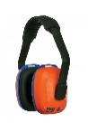
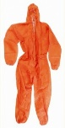

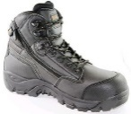
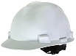

- Gloves (Viton/nitrile/PVC)
- Disposable Coveralls (ensure hair and body is completely covered)
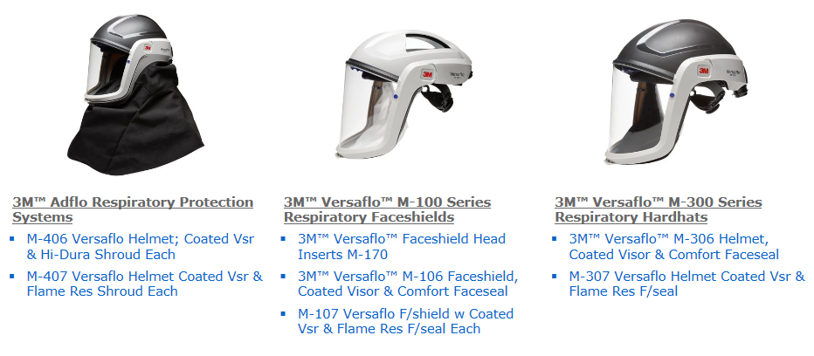
- Protective footwear & hardhat
- Hearing Protection

- Positive Pressure Protection Masks & Hoods

Gas Alarms, Analysers & Detectors

As Required

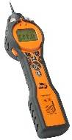
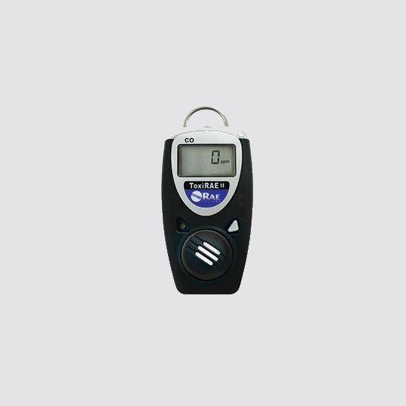
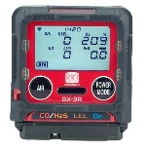
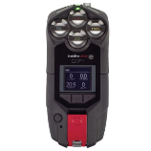
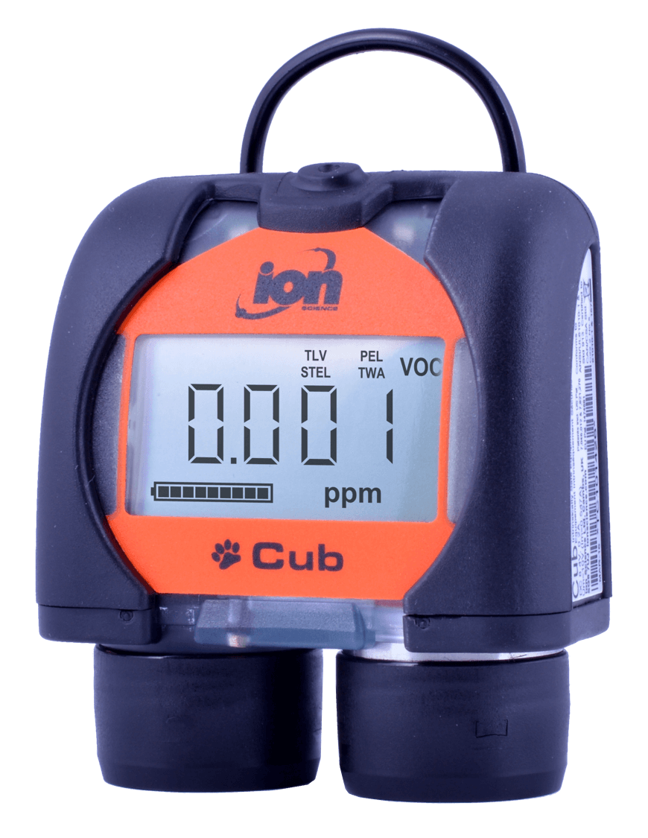
Cub Alarm 50ppm Tiger Analyser Toxi Ray II RKI GX-R3 Blackline G7c
VOC’s Only VOC & Cyanide Hydrogen Cyanide Hydrocarbons LEL Hydrogen Cyanide & Toluene
Does not analyse! CO, O2, & H2S (HCN) CO, O2, & H2S (VOC) & (HCN)

ANALYSER, DETECTOR, GAS & ACRONYM LEGEND

HCN = Hydrogen Cyanide

CO = Carbon Monoxide VOC = Volatile Organic Compound LEL = Lower Explosive Limit (Hydrocarbons - NG & LPG)

O2 = Oxygen H2S = Hydrogen Sulphide (Sewer) UEL = Upper Explosive Limit (Hydrocarbons - NG & LPG)

STEL = Short Term Exposure Level TWA = Time Weighted Average PEL = Permissible Exposure Limit

Safe Work Procedure (SWP)

- Check the wind direction and designate an area upwind as an emergency evacuation zone, make this area clear to all site personnel, set up windsock if the wind direction appears to be variable.

- Complete Paneltec SSRA/JSEA on WHS Monitor identify all aforementioned SWMS and take pictures of the proposed project site

- Verify vacuum truck hose and hydro excavation lance are in safe working order prior to use

- Verify all mechanical plant and small plant is in safe working order in accordance with the SWMS and daily pre-starts if this has not been facilitated earlier

- Ensure you and all your work crews have the skills, training and knowledge appropriate for the hazards/dangers involved when undertaking cleaning of rubber lined dams

- Check that all gas alarms, analysers and detectors (devices) are working and suitable for the detection of VOC’s/ and or cyanide (as above section)

- Check the devices are within their calibration dates (refer to the sticker on the device)

- The devices need to be turned on, battery levels must be checked and verified as sufficient for the anticipated duration of the works, charge device if necessary

- All devices need to be affixed to each operator at all times

- Make sure all PPE as detailed in the above section is in place and adorned by all operatives involved with the project

- If alarms sound whilst cleaning, work must cease immediately and all exposed operatives are to relocate to the emergency evacuation point

- Once all elements from the JSEA, SWMS, relevant permits and the above SWP are satisfied cleaning can begin and regular safe monitoring can be conducted

- All cleaning that is to take place should now be in accordance with the relevant SWMS outlined above

- All effort is to be first made to remove as much silt/build up in accordance with SWMS No. 63 prior to entering the dam

- Entering and Exiting the dam will involve the utilisation of a certified man cage and a licensed crane driver

- Prior to entering the cage operatives must adorn a harness and lanyard and affix the lanyard to the man cage

- The harness must remain fixed and adjusted on the operatives whilst in the dam at all times

- Work cleaning dam floor can now be in accordance with SWMS No. 63 and SWMS No. 24

Please refer to allowable exposure level table in conjunction with this SWP and throughout all testing process’s

Chemical name | Synonym | CAS No. | TWA |  | STEL |  | Peak limit
 |  |  | ppm | mg/m³
Carbon Monoxide | CO | 630-08-0 | 30 | 34 | - | -
Hydrogen Cyanide | HCN | 74-90-8 | 10 | 11 | - | - | 10
VOC (Toluene) | VOC | 108-88-3 | 50 | 191 | 150 | 574
Hydrogen Sulphide | H₂S | 7783-06-4 | 10 | 14 | 15 | 21

