

PANELTEC PTY LTD
A.B.N. 12 128 689 412

SWP-06

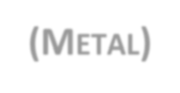

SAFE WORK PROCEDURE
COLD SAW (METAL)
2025 - 2027
DO NOT use this machine unless you have been instructed in its safe use and operation.

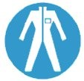
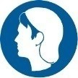
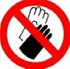

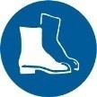

Personal Protective Equipment

Safety glasses must be worn at all times  in work areas. | Long and loose hair must be contained.
Sturdy footwear must be worn at all times in work areas. | Close fitting/protective clothing must be worn.
Hearing protection must be used when using this machine. | Gloves must not be worn when using this machine.
Rings and jewellery must not be worn.

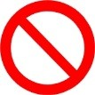
Only one person may operate this machine at any one time.

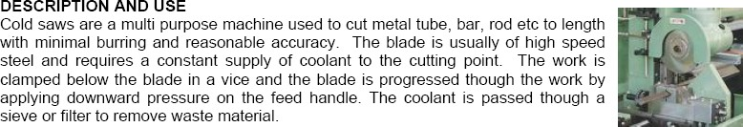

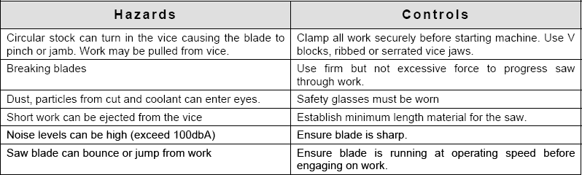

SWP-Coldsaw (Metal) Authorised & Approved by Management Page 1 of 2
This SWP does not necessarily cover all possible hazards associated with the machine/equipment.
It is designed to act as a reminder to users/operators prior to machine/equipment use.



Pre-Operational Safety Checks
PANELTEC PTY LTD
A.B.N. 12 128 689 412
SWP-06

- Check workspace and walkways to ensure that no slip/trip hazards are present.
- Ensure saw blade is in good condition.
- Locate and check the operation of the ON/OFF starter.
- Check that all safety guards are in working order and fitted.
- Check the operation of the work vice.
- Check coolant delivery system to allow for sufficient flow of coolant.
- Faulty equipment must not be used. Immediately report suspect equipment.

Operational Safety Checks
- Ensure that the work piece is securely held in the work vice.
- Support overhanging work and signpost if it presents a hazard.
- Never leave the machine running unattended.
- Attention must be paid to unusual noises during the sawing process.
- Never force the saw into the workpiece. Use a slow and even feed rate.
- Before making adjustments or before cleaning swarf accumulations switch off and bring the machine to a complete standstill.
- Immediately absorb any coolant spills.

Housekeeping
- Switch off the machine.
- Leave the machine in a safe, clean and tidy state.

Potential Hazards
- Hair/clothing entanglement
- Eye injuries
- Flying swarf/chips
- Sharp edges & burrs, metal splinters.
- Ejection of work pieces.
- Shattering of the saw blade.

A Cold Saw MUST NOT BE USED FOR:
- Attempting to cut very small items
- Attempting to cut materials other than metal.

SWP-Coldsaw (Metal) Authorised & Approved by Management Page 2 of 2
This SWP does not necessarily cover all possible hazards associated with the machine/equipment.
It is designed to act as a reminder to users/operators prior to machine/equipment use.

