SAFE WORK PROCEDURE – SWP 30
Personal Protective Equipment (PPE)


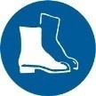


Safety glasses must be worn at all times  in work areas. |   Long and loose hair must be contained.
Sturdy footwear (steel cap boots) must be worn at all times in work areas. |   Close fitting/protective, Hi vis, long sleeve long pant clothing must be worn.
Hard hat required. |   Wear Construction Safety Gloves.  (Eg: Razor shield 5)
Rings and jewellery must not be worn.

Gas Alarms, Analysers & Detectors

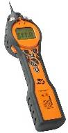
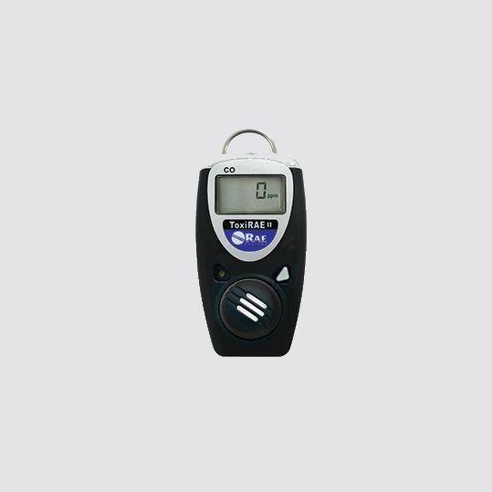
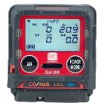
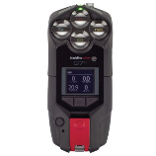
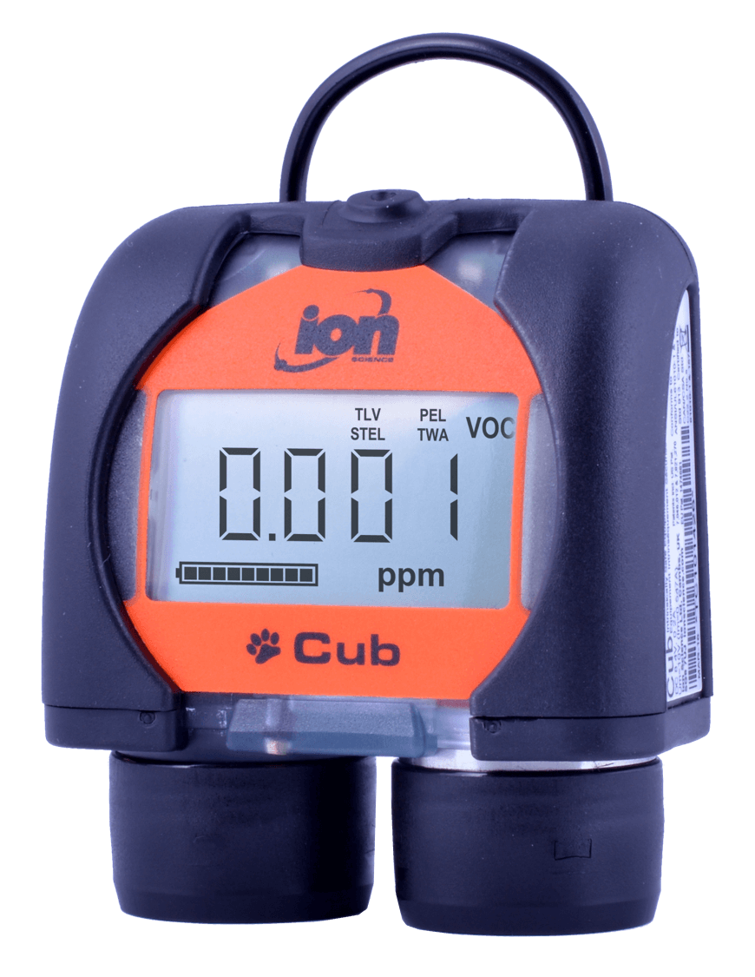

Cub Alarm 50ppm Tiger Analyser Toxi Ray II RKI GX-R3 Blackline G7c
VOC’s Only VOC & Cyanide Hydrogen Cyanide Hydrocarbons LEL Hydrogen Cyanide & Toluene
Does not analyse! CO, O2, & H2S (HCN) CO, O2, & H2S (VOC) & (HCN)

ANALYSER, DETECTOR, GAS & ACRONYM LEGEND

HCN = Hydrogen Cyanide

CO = Carbon Monoxide VOC = Volatile Organic Compound LEL = Lower Explosive Limit (Hydrocarbons - NG & LPG)

O2 = Oxygen H2S = Hydrogen Sulphide (Sewer) UEL = Upper Explosive Limit (Hydrocarbons - NG & LPG)

STEL = Short Term Exposure Level TWA = Time Weighted Average PEL = Permissible Exposure Limit

Please refer to allowable exposure level table in conjunction with this SWP and throughout all testing process’s
Safe Work Procedure – 30 (SWP)

Chemical name | Synonym | CAS No. | TWA |  | STEL |  | Peak limit
 |  |  | ppm | mg/m³
Carbon Monoxide | CO | 630-08-0 | 30 | 34 | - | -
Hydrogen Cyanide | HCN | 74-90-8 | 10 | 11 | - | - | 10
VOC (Toluene) | VOC | 108-88-3 | 50 | 191 | 150 | 574
Hydrogen Sulphide | H₂S | 7783-06-4 | 10 | 14 | 15 | 21

POTENTIAL HAZARDS AND ASSOCIATED RISKS
Slip, Trips, Falls
- Slip, trip, fall due to cluttered, uneven or slippery work surfaces
- Slip, trip, fall due to steep working surfaces

Manual Task Injury
- Manual task/musculoskeletal injury from incorrect manual handling
- Manual task/musculoskeletal injury from repetitive movements

Exposure to Dust/Fumes
- Exposure to hydrogen sulphide/low oxygen atmospheres/harmful gases

PRE-OPERATIONAL SAFETY CHECKS
- Complete, Site-Specific Risk Assessment (SSRA)
- Ensure all workers are trained in “Manual Handling”

OPERATING PROCEDURES
- Centre lift manholes should only be lifted using the Centre-to-side Gatic Lifter(Lifter)
- Place lifter on lid with main body facing in preferred direction of lift
- Locate lifting lug into the centre lifting slot turning it 90 degrees to the slots orientation
- Tighten locking nut ensuring that lifting lug remains 90 degrees to the slot
- Fix lifting handles to both sides of Lifter Body for a 2 person lift or to the required side of lifter body for single person lift
- Always use correct manual handling techniques, lifting the lid
- For a solo worker, lift then drag the lid towards yourself ensuring that it is free of the surround after the initial lift.
- For a two-person lift, lift the lid up together and move to the side resting the lid on the lid surround
- For both single and two person lifts, reposition yourself to be able to move the lid clear of the manhole
- Persons doing a 2-person lift should be careful not to swivel or reach away from their bodies
- Secure manhole opening as appropriate (operational grate, barricades)
- Gas Test the Manhole’s atmosphere utilising a calibrated 4-gas detector and drop test the atmospheric conditions, if alarms sound, stand clear and ventilate the man hole for 5 minutes. Repeat test, proceed only when no alarm sounds
- Side lift manhole lifts should only be lifted using the attachment on the Centre-to-Side Lifter or with a Lid Lifter with the following details –
- Lengths of horizontal bar – 915mm
- Diameter of horizontal bar – 33mm outer diameter pipe
- Material of horizontal bar – galvanised iron pipe

  - Height of lid lifter – 570mm (minimum) 680mm (maximum)
  - Diameter of lid lifter – 12mm
  - Material of the lid lifter – stainless steel rod
  - Lid lifter key shall be compatible to all types of side lift manhole lids
  - The lid lifter shall be certified by an engineer for lifting light duty manhole lids not exceeding 75kg

If height disparity becomes a major concern for carrying out a 2 person lift of manhole lid, a specially made lid lifter (already supplied to work crew) with an eye hole at the top of the lid lifter in conjunction with a non-slip horizontal bar shall be used to lift manhole lid.

Manhole lids should generally be lifted as a two-man lift, if for any reason (e.g. on call situation, limited space around manhole etc.) lifting has to be carried out as a one person lift, then no more than 8 lifts (4 manhole) lids shall be lifted by a single person, followed by a compulsory 10 minutes break.

Where the 2 person lifting operation of a concrete manhole becomes impossible due to the condition of terrain or the space restriction around the manhole, a recommendation is to be made to the asset owner for the concrete manholes replacement with a plastic or steel lid . Employees identifying the condition in the field must report the matter to the Management who will inform the relevant asset owner.

Manhole lids exceeding 75kg (heavy duty lid) shall not be lifted manually. Heavy duty lids shall be lifted by crane or other lifting devices only by using short handled Gatic lifting key for both types of lids (centre lift and side lift).

All manhole lid lifting lugs/points must be inspected prior to any lift being carried out to determine their serviceability and condition. All defects to be reported Management and or the asset owner representative immediately.

ENDING OPERATIONS
- To replace lid for single person, lift fix handle opposite end of lifter body
- Lift or drag manhole lid back into position in stages as per removal.
- Loosen centre lug locking nut and remove the Manhole Lifter
- Ensure all plant is in good working order and stored back in the appropriate location

DO NOT

- Do not use if plant is faulty. Attach an Out of Service tag and report to management immediately
- Do not lift manhole lids with a weight exceeding 75kg
- Do not swivel or lift weight away from your body
- Do not hold your breath when lifting
- Do not use mobile phones while operating plant

Manhole Safety Grates

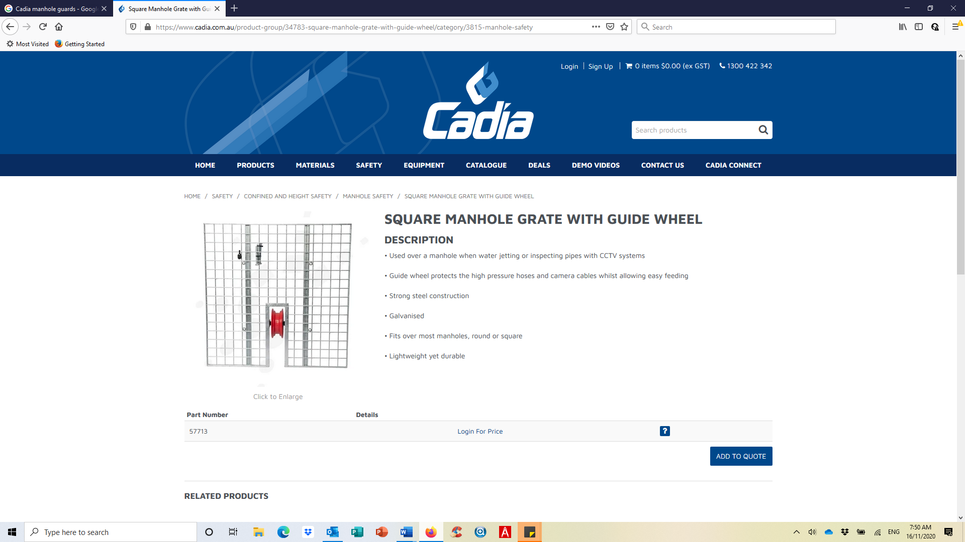
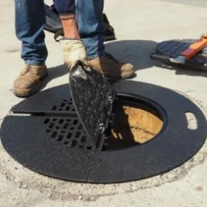
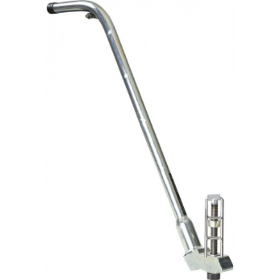
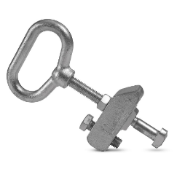
Gatic Lifter Types
Long Handled
D - Handled

