The following Safe Work Procedure is mandatory to follow when cleaning Spirotainers internally with a Combination Vacuum Truck.

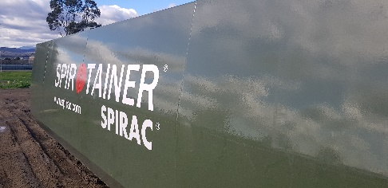
This Safe Work Procedure (SWP) is designed to be used in conjunction with the following Paneltec Safe Work Method Statements (SWMS):

- No.63 Combination Recycler Vacuum Truck
- No.37 Safe working in a confined space
- No.24 Manual Handling

In addition to the above, other documents that may or may not be required before work can begin on the cleaning project are:

- Relevant Project - Work Health & Safety & Construction Environmental Management Plans
- Customer Permit(s) & Authority to Work Forms
- Lock Out and Tag Procedure (where required)

This procedure outlines the bare minimum safety procedures to be implemented by Paneltec Combination vacuum truck operators when working in Spirotainers.
Personal Protective Equipment (PPE)


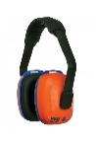
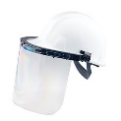
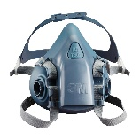

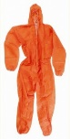


- Chemical Gloves (Viton/nitrile/PVC)
- Disposable Coveralls (ensure hair and body is completely covered)
- Face Shield/Visor & Safety Glasses
- Organic Respirator/6057 Cartridges Organic Gas/Vapour
- Protective Gumboots
- Hearing Protection

As Required
Gas Alarms, Analysers & Detectors

G7 Alarm 50ppm Toxi Ray II Gas Alert Micro Clip XT MX4


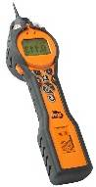
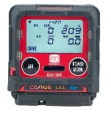
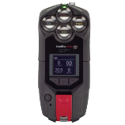
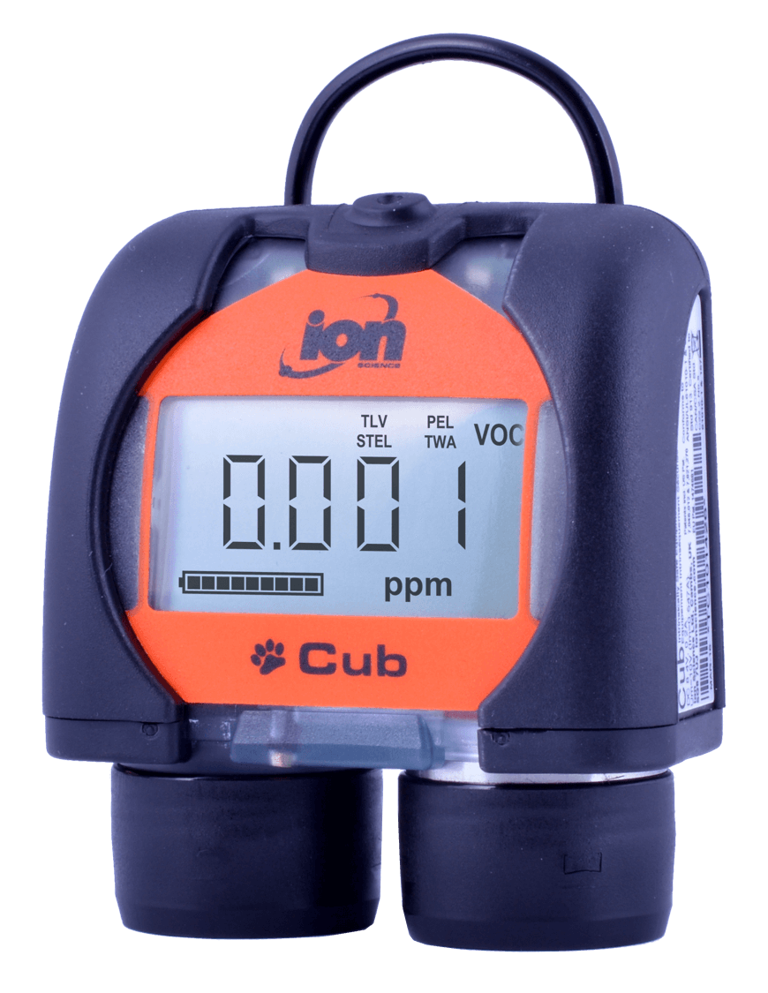
Cub Alarm 50ppm Tiger Analyser Toxi Ray II RKI GX-R3 Blackline G7c
VOC’s Only VOC & Cyanide Hydrogen Cyanide Hydrocarbons LEL Hydrogen Cyanide & Toluene
Does not analyse! CO, O2, & H2S (HCN) CO, O2, & H2S (VOC) & (HCN)

ANALYSER, DETECTOR, GAS & ACRONYM LEGEND

HCN = Hydrogen Cyanide

CO = Carbon Monoxide VOC = Volatile Organic Compound LEL = Lower Explosive Limit (Hydrocarbons - NG & LPG)

O2 = Oxygen H2S = Hydrogen Sulphide (Sewer) HEL = Higher Explosive Limit (Hydrocarbons - NG & LPG)

STEL = Short Term Exposure Level TWA = Time Weighted Average PEL = Permissible Exposure Limit

Safe Work Procedure (SWP)

- Check the wind direction and designate an area upwind as an emergency evacuation zone, make this area clear to all site personnel

- Complete Paneltec SSRA/JSEA on Lucidity, identify all aforementioned SWMS and take pictures of the proposed project site

- Complete Paneltec or TasWater Confined Space Permit (TasWater if requested)

- Ensure the two top openings at either end of the tank are fully open to atmosphere and will not shut in mid operations
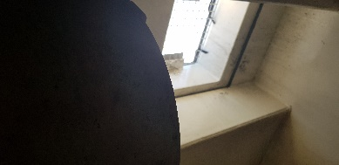

- Fix the main tank door to fully open position with failsafe mechanical/ fixed interlock to prevent it from closing

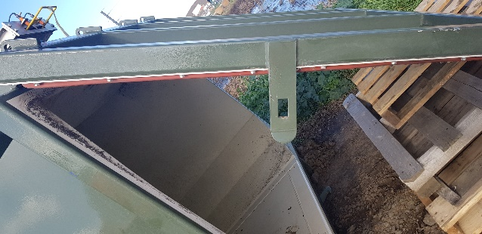

Tank Door needs to be fixed fully open, not halfway as pictured.

- Verify vacuum truck hose and hydro excavation lance are in safe working order prior to use

- Verify all mechanical plant and small plant is in safe working order in accordance with the SWMS and daily pre-starts if this has not been facilitated earlier

- Ensure you and all your work crews have the skills, training and knowledge appropriate for the hazards/dangers involved when undertaking cleaning of Spirotainers

- Check that all gas alarms, analysers and detectors (devices) are working and suitable for the detection of VOC’s/ and or cyanide (as above section)

- Check the devices are within their calibration dates (refer to the sticker on the device)

- The devices need to be turned on, battery levels must be checked and verified as sufficient for the anticipated duration of the works, charge device if necessary

- All devices need to be affixed to each operator at all times

- Make sure all PPE as detailed in the above section is in place and adorned by all operatives involved with the project

- If alarms sound whilst cleaning, work must cease immediately, exit tank and all exposed operatives are to relocate to the emergency evacuation point

- Once all elements from the JSEA, SWMS, confined space permit and the above SWP are satisfied cleaning with disinfectant can begin and regular safe monitoring can be conducted

- All cleaning that is to take place should now be in accordance with the relevant SWMS outlined above, only one person should ever be in the tank at a time

- All effort is to be first made to remove as much silt/build up in accordance with SWMS No. 63 prior to entering the tank

- Entering and Exiting the tank will be done in accordance with the Confined Space Permit, after atmospheric testing with the 4Gas device proves that entry to the atmosphere is safe

- Prior to entering the tank operatives must adorn all PPE outlined above

- The PPE must remain fixed and adjusted on the operatives whilst in the tank at all times

- Work cleaning the tank walls can now be in accordance with SWMS No. 63 and SWMS No. 24

Please refer to allowable exposure level table in conjunction with this SWP and throughout all testing process’s

Chemical name | Synonym | CAS No. | TWA |  | STEL |  | Peak limit
 |  |  | ppm | mg/m³
Carbon Monoxide | CO | 630-08-0 | 30 | 34 | - | -
Hydrogen Cyanide | HCN | 74-90-8 | 10 | 11 | - | - | 10
VOC (Toluene) | VOC | 108-88-3 | 50 | 191 | 150 | 574
Hydrogen Sulphide | H₂S | 7783-06-4 | 10 | 14 | 15 | 21

