This Safe Work Procedure (SWP) is designed to be used in conjunction with the following Paneltec Safe Work Method Statements (SWMS) when undertaking vacuum excavation around suspected Silica Dust in concentrations perceived to be greater than 75%

- No.54 Water Jetting Safe Operation
- No.57 Vacuum Truck
- No.63 Combination Vacuum Truck
- No.73 RSP Suction Excavator Safe Operation

In addition to the above, other documents that are required and have been reviewed by all workers on the removal project are:

- Relevant Project - Work Health & Safety & Construction Environmental Management Plans

This procedure outlines the bare minimum safety procedures to be implemented by Paneltec operatives when working in areas where spoils, dust or slurry is potentially contaminated with Silica Dust concentrations greater than 75% - See Table Below
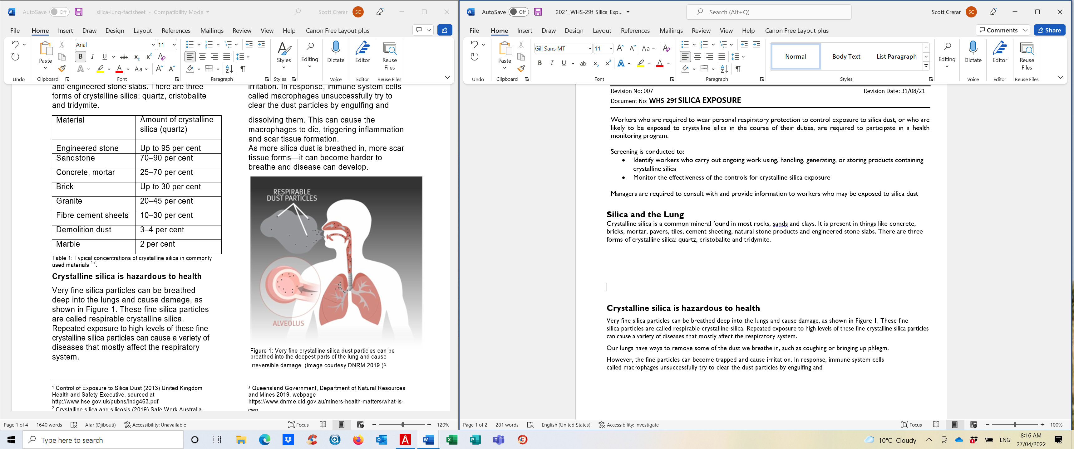

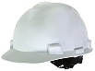
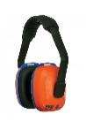
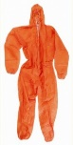
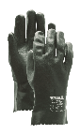
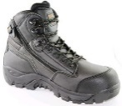
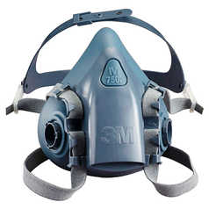
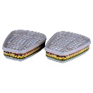
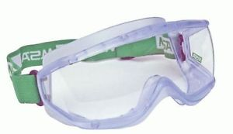
Personal Protective Equipment (PPE)

- Gloves (Viton/nitrile/PVC)
- Chemical goggles
- Disposable Coveralls (ensure hair and body is completely covered)
- Protective footwear & hardhat
- Half-face respirator, (VOC -3M 6035- cartridges for chemical exposure)
- Hearing Protection

Safe Work Procedure (SWP)

- Check the wind direction and designate an area upwind as an emergency evacuation zone, make this area clear to all site personnel, set up wind sock if the wind direction appears to be variable.

- Complete Paneltec JSEA on WHS Monitor identify any relevant aforementioned SWMS and take pictures of the proposed excavation site, removal sites, traffic management and storage containers

- Check that all Traffic Management is in Place and in accordance with the Traffic Management Plan (TMP) and Paneltec SWMS No.48 (Where relevant)

- Verify vacuum truck hose and hydro excavation lance are in safe working order prior to excavation

- Verify all mechanical plant and small plant is in safe working order in accordance with the SWMS and daily pre-starts if this has not been facilitated earlier

- Ensure you and all your work crews have the skills, training and knowledge appropriate for the hazards/dangers involved when vacuuming around dust potentially contaminated with Silica

- Make sure all PPE as detailed in the above section is in place and adorned by all operatives involved within the proposed removal site (above PPE to be worn if within 10 Metres from centre of the closest part of the removal site)

- Triple check that all half face respirators are fitted with the correct 6035 3M cartridges as per the table above, triple check that all other PPE is properly fitted, and that the coverall’s hood is covering the head adequately

- Plan and position all required bunding sediment traps to prevent any water run off (vac hoses or rain) from entering sensitive areas or drains

- Once all elements from the JSEA, SWMS and the above SWP are satisfied vacuuming can begin and regular safe monitoring can be conducted

- All excavations that are to take place should now be in accordance with the relevant SWMS outlined above and wearing all aforementioned PPE. Use as much water from the lance that is required to keep the dust from clouding or escaping from the site.

- Prior to leaving site all contaminated material, PPE and contaminated liquids need to be locked away in the site contaminated waste storage bin or in the tray/tank section of the vehicle that is transporting the waste to the depot for plastic wrapping.

- All workers are to wash thoroughly prior to leaving site or taking meal breaks work boots are also to be decontaminated or placed in a bag for decontamination back at the depot.

- Travel back to depot.
Disposal Procedure

- On arrival back at the depot, set up a 15m exclusion zone around the vacuum truck

- Roll out a 6m length of the 100um (100-micron) 4m roll behind the unloading area

- Add enough fresh water to the tank to ensure the elimination of dust when opening rear door of truck.

- Operators to wear all PPE as specified in point 7

- Place weights around the black 100um black plastic to ensure it does not blow away

- Empty the vacuum tank contents onto the black plastic and roll up edges to prevent liquid escaping

- Hose out the tank and ensure all residue falls onto black plastic if you need to add more soil to solidify the liquid do so with a shovel from the spoils pile

- Roll up the Plastic around the slurry and tape closed with duct tape

- Label the roll with an A3 Sized label clearly indicating “Danger Silica Dust” and tape to the roll

- Take the sealed roll straight to landfill and advise operators of its contents they will direct you to the landfill site where it can be disposed

- Ensure all disposable PPE is disposed of in another wrapped plastic parcel, also labelled and disposed of at the landfill site. All non-disposable PPE shall be decontaminated at the depot.

