This procedure is designed to be used in conjunction with Paneltec Safe Work Method Statements (SWMS) No:61 Combination Vacuum Truck, No:41 Sewage Waste – Collection of , No:21 Liquid Waste Collection & No:24 Manual Handling.

This procedure outlines the bare minimum safety procedures to be implemented by Paneltec operatives when working in a presumed or known location where wastewater may be contaminated with VOC’s or Hydrocarbons.

In these circumstances the contents of the pipe must be previously tested by an accredited third party, an accredited NATA laboratory and an approved analysis report be provided to Paneltec.
Personal Protective Equipment (PPE)


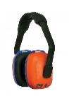


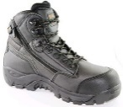
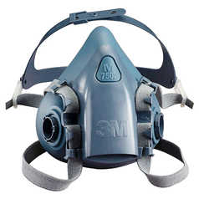
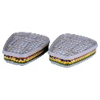
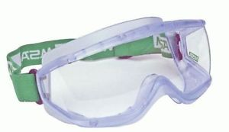

- Gloves (Viton/nitrile/PVC)
- Chemical goggles
- Disposable Coveralls (ensure hair and body is completely covered)
- Protective footwear & hardhat
- Half-face respirator, (VOC -3M 6057- cartridges for chemical exposure) if cyanide is not present
- Hearing Protection
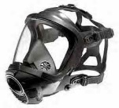
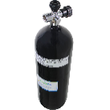

- Full SCBA is required to be on site in case of worker rescue
Gas Alarms, Analysers & Detectors

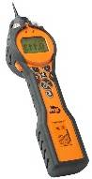

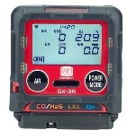

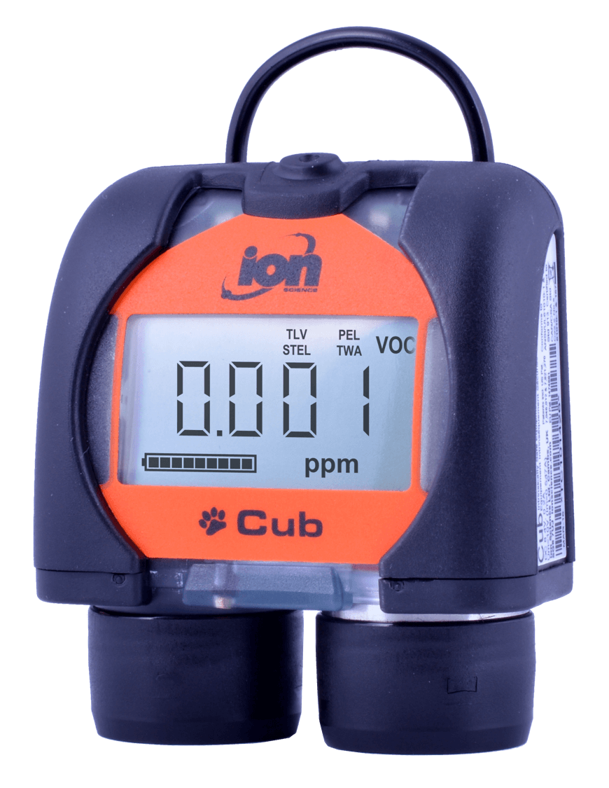
Cub Alarm 50ppm Tiger Analyser Toxi Ray II RKI GX-R3 Blackline G7c
VOC’s Only VOC & Cyanide Hydrogen Cyanide Hydrocarbons LEL Hydrogen Cyanide & Toluene
Does not analyse! CO, O2, & H2S (HCN) CO, O2, & H2S (VOC) & (HCN)

ANALYSER, DETECTOR, GAS & ACRONYM LEGEND

HCN = Hydrogen Cyanide

CO = Carbon Monoxide VOC = Volatile Organic Compound LEL = Lower Explosive Limit (Hydrocarbons - NG & LPG)

O2 = Oxygen H2S = Hydrogen Sulphide (Sewer) UEL = Upper Explosive Limit (Hydrocarbons - NG & LPG)

STEL = Short Term Exposure Level TWA = Time Weighted Average PEL = Permissible Exposure Limit
Safe Work Procedure (SWP) – Set Up

- Implement the Traffic Management Plan/Traffic Guidance Scheme for the site

- Set up Combination Vacuum Truck as per Paneltec SWMS 61 - Combination Vacuum Truck

- Check the wind direction and designate an area upwind as an emergency evacuation zone, make this area known and clear to all site personnel

- Conduct Tailgate Meeting, Complete Paneltec SSRA/ JSEA and take pictures of the proposed drain cleaning route include all manholes requiring access

- Complete any customer/asset owner permits, checklists or pre-starts

- Ensure all required manholes have a manhole guard and cover adjacent to them ready for implementation

- Verify vacuum truck hose and jetting hose are in safe working order prior to the commencement of jetting operations

- Ensure you and all your work crews have the skills, training and knowledge appropriate for the hazards/dangers involved when jetting potentially contaminated drains/sewers

- Check that all gas alarms, analysers and detectors (devices) are working and suitable for the detection of VOC’s/ and or Hydrocarbons (as above section) – if monitoring is being undertaken by a third party ensure they are clear on the scope of works and have signed onto our SSRA/JSEA

- Check the devices are within their calibration dates (refer to the sticker on the device)

- The devices need to be turned on and clipped onto the jetting operators after initial testing of the atmosphere within the pipe has been conducted

- Make sure all PPE as detailed in the above section is in place and adorned by all operatives involved within the Manhole Zone/Jetting areas

- Triple check that all half face respirators are fitted with the correct chemical/gas cartridges as per the section above, triple check that all other PPE is properly fitted and that the coverall’s hood is covering the head adequately, ensure chemical goggles are clean and ready for use

- If detector or alarms sound whilst jetting, work must cease immediately and the trained persons using the analysers should take air quality samples, all exposed operatives are to relocate to the designated emergency assembly point (upwind) as stated in item 4 above

- Ensure a 9kg fire extinguisher is within close proximity to each manhole being lifted and worked around
Safe Work Procedure (SWP) – Operations

- Ensure the exclusion zones are set up to prevent inadvertent access from members of the public to the jetting zones

- Open all required manholes at the required starting time (This maybe dependent on pre- planned discharge times, high tides, low tides, operational jetting tactics etc.)

- Install yellow manhole guard frames around manholes

- Ensure all PPE is adorned by all operators in the jetting zone – Turn on all Gas Alarms & Check Battery

- Begin atmospheric testing of the drain at each manhole, record all test times and results in the end table

- If any alarm sounds or exposure limits are indicated alarm/detector, positive mechanical ventilation will be required to flood the drain/sewer to disperse the accumulation of any potential LEL’s HEL’s

- If positive ventilation is required set up the fan and ducting at the opposite end to the jetting direction

- Retest Atmospheres if required – if atmosphere unsafe or alarm sounds a second time – HOLD POINT STOP WORK – Contact Management

- When satisfied the atmosphere is safe, place steel manhole inserts over manholes and insert jetting hose and attachment into drain

- When the correct amount of hose has been inserted begin jetting procedures at a ¼ of normal pressure

- Jet for two minutes and retest atmosphere at each manhole (Repeat E to H Above)

- When the correct amount of hose has been inserted begin jetting procedures at ½ of normal pressure

- Continue monitoring atmospheric levels at each manhole throughout operations with the detectors

- When the combination vacuum truck is ready for unloading, cease operation, close all manholes and take the truck to the approved disposal area in accordance with SWMS 41, 21 & 61 and wash the truck out at the site. On return to the site (Repeat E to H Above)

- If levels of VOC’s, Hydrocarbons or PAH’s rise above the allowable thresholds as advised by the monitoring company, cease all work, liaise with the Operations Manager and the Customers Supervisor.

- In the event of an incident or accident occurring contact the emergency services if relevant followed by the Operations or Compliance Manager who may contact WorkSafe Tasmania on 1300 366 322.

- On completion of the operations at the end of each shift The Trucks Tank and all non-disposable PPE should be washed thoroughly at the approved disposal area utilising Paneltec’s Environmental Management Plan and associated Procedures.

Record of VOC/Hydrocarbon Readings Throughout the Job
(Please record Times in 24HR Format (00:12 = 12:12AM)

Highest  Reading | Man Hole  1 Reading | TIME | Man Hole  2 Reading | TIME | Man Hole  3 Reading | TIME | Man Hole  4 Reading | TIME | Man Hole  5 Reading | TIME | Man Hole  6  Reading | TIME | DATE
HCN
VOC
O2
CO
LEL
HEL
H2S

Highest  Reading | Man Hole  1 Reading | TIME | Man Hole  2 Reading | TIME | Man Hole  3 Reading | TIME | Man Hole  4 Reading | TIME | Man Hole  5 Reading | TIME | Man Hole  6  Reading | TIME | DATE
HCN
VOC
O2
CO
LEL
HEL
H2S

Highest  Reading | Man Hole  1 Reading | TIME | Man Hole  2 Reading | TIME | Man Hole  3 Reading | TIME | Man Hole  4 Reading | TIME | Man Hole  5 Reading | TIME | Man Hole  6  Reading | TIME | DATE
HCN
VOC
O2
CO
LEL
HEL
H2S

Highest  Reading | Man Hole  1 Reading | TIME | Man Hole  2 Reading | TIME | Man Hole  3 Reading | TIME | Man Hole  4 Reading | TIME | Man Hole  5 Reading | TIME | Man Hole  6  Reading | TIME | DATE
HCN
VOC
O2
CO
LEL
HEL
H2S

Highest  Reading | Man Hole  1 Reading | TIME | Man Hole  2 Reading | TIME | Man Hole  3 Reading | TIME | Man Hole  4 Reading | TIME | Man Hole  5 Reading | TIME | Man Hole  6  Reading | TIME | DATE
HCN
VOC
O2
CO
LEL
HEL
H2S

Highest  Reading | Man Hole  1 Reading | TIME | Man Hole  2 Reading | TIME | Man Hole  3 Reading | TIME | Man Hole  4 Reading | TIME | Man Hole  5 Reading | TIME | Man Hole  6  Reading | TIME | DATE
HCN
VOC
O2
CO
LEL
HEL
H2S

Highest  Reading | Man Hole  1 Reading | TIME | Man Hole  2 Reading | TIME | Man Hole  3 Reading | TIME | Man Hole  4 Reading | TIME | Man Hole  5 Reading | TIME | Man Hole  6  Reading | TIME | DATE
HCN
VOC
O2
CO
LEL
HEL
H2S

Highest  Reading | Man Hole  1 Reading | TIME | Man Hole  2 Reading | TIME | Man Hole  3 Reading | TIME | Man Hole  4 Reading | TIME | Man Hole  5 Reading | TIME | Man Hole  6  Reading | TIME | DATE
HCN
VOC
O2
CO
LEL
HEL
H2S

Highest  Reading | Man Hole  1 Reading | TIME | Man Hole  2 Reading | TIME | Man Hole  3 Reading | TIME | Man Hole  4 Reading | TIME | Man Hole  5 Reading | TIME | Man Hole  6  Reading | TIME | DATE
HCN
VOC
O2
CO
LEL
HEL
H2S

Highest  Reading | Man Hole  1 Reading | TIME | Man Hole  2 Reading | TIME | Man Hole  3 Reading | TIME | Man Hole  4 Reading | TIME | Man Hole  5 Reading | TIME | Man Hole  6  Reading | TIME | DATE
HCN
VOC
O2
CO
LEL
HEL
H2S

Please refer to allowable exposure level table if testing is conducted by Paneltec in conjunction with this SWP and throughout all testing process’s

Chemical name | Synonym | CAS No. | TWA |  | STEL |  | Peak limit
 |  |  | ppm | mg/m³
Carbon Monoxide | CO | 630-08-0 | 30 | 34 | - | -
Hydrogen Cyanide | HCN | 74-90-8 | 10 | 11 | - | - | 10
VOC (Toluene) | VOC | 108-88-3 | 50 | 191 | 150 | 574
Hydrogen Sulphide | H₂S | 7783-06-4 | 10 | 14 | 15 | 21

