OBJECTIVE
This document describes the preparation and welding procedures for safe and efficient work practices when using electro-fusion welding equipment.

HAZARD MANAGEMENT

Hazard management
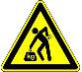 | Manual handling | Lifting pipes and bending | Follow safe manual handling procedures
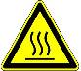 | Hot | Hot welding equipment | Wear appropriate P.P.E when required

WELDING PROCEDURE

Prepare pipe for welding

    - Use rotary scraper to scrape end of pipe :
    - Fit end of pipe into rotary scraper – photo 1
    - Tighten scraper and adjust to required setting – photos 1 & 2
    - Turn handle of rotary scraper until scraped area is clear of length required for specific joiner (check inside joiner to determine appropriate length) – photos 3 & 4
    - Use handheld scraper:
- Hold pipe firmly – photo 5
- Mark pipe with white marker – photo 6
- Scrape manual scraper toward end of pipe until no sign of white marker remains and scraped area is clear of length required for specific joiner – photos 7 & 8
    - Scrape any ‘dags’ from end of pipe if necessary – photo 8

Photos 1 & 2: Fit pipe into rotary scraper and adjust Photo 3: Turn handle to scrape

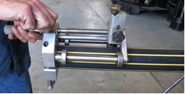 | 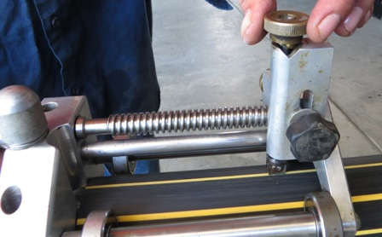 | 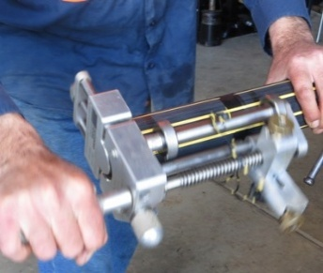

Photo 4: Pipe scraped with rotary scraper Photo 5: Manual scraper Photo 6: Mark with white marker

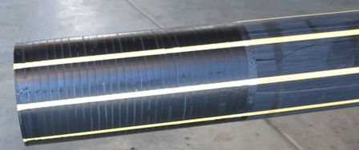 |  | 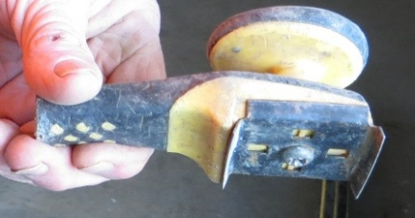 |  | 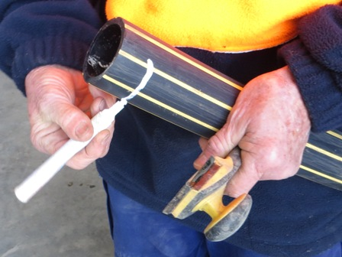
Photos 7 & 8: Scrape toward end of pipe and remove ‘dags’ Photos 9 & 10: Clean end of pipes and fit joiner

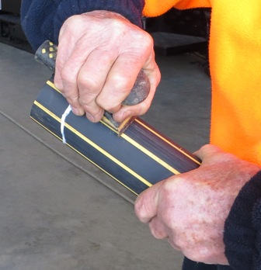 | 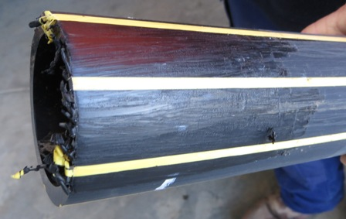 |  | 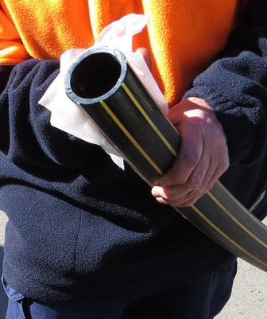 |  | 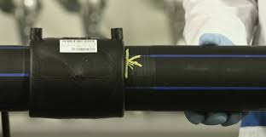
Check all sign of white marker are removed

    - Clean inside and outside end of pipe with alcohol wipes to ensure all dirt is removed, ensuring that final wipe is directed toward end of pipe – photo 9
    - Fit appropriate joiner to both ends of pipe, ensuring fitting is very straight on pipes and secure – photo 10
    - Mark each side of joiner with white marker (to check it doesn’t move during welding)

Welding Pipes

    - Attach welder fittings to joiner – photos 11, 12, 13, 14 & 15

NOTE: Fitting may have to be colour coded to joiner depending on type of joiner used

    - Plug welder into generator – photo 16
    - Turn generator on – photo 16
    - Check weld times and temperature on joiner packet – photo 17
    - Use arrows on welder console to manually adjust time and temperature – photo 18
    - Follow instructions on console screen to push green button three (3) times – photos 18 & 19
    - Screen will count down weld time and indicate process is complete, by displaying “OK” – photo 19
    - Wait for appropriate cooling time, before checking weld or removing fittings (check joiner packet).

Photo 11, 12 & 13: One type of joiner and fittings (not colour coded)

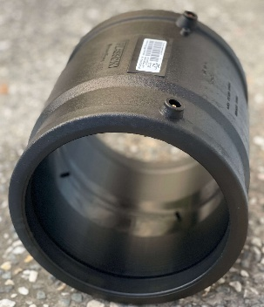 | 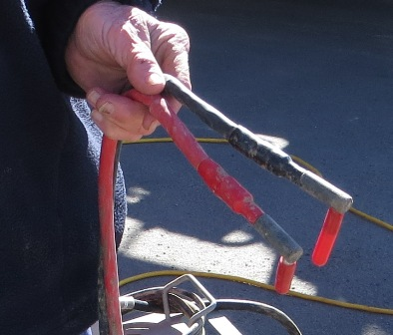 | 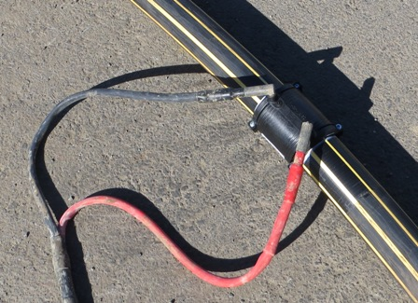
Photos 14 & 15: Colour coded joiner and fittings Photo 16: Generator

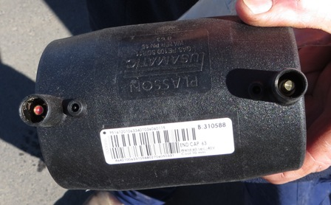 | 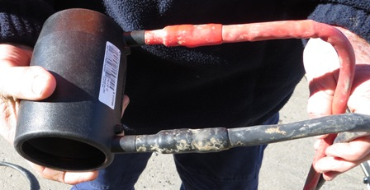 | 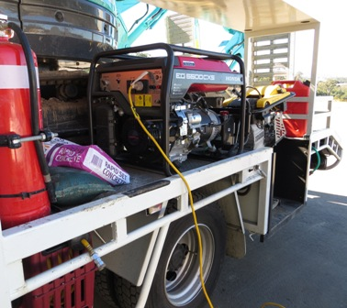
Red Black

Photo 17: Check time and temp Photos 18 & 19: Welder console and screen
on packaging Green button Arrows “OK”

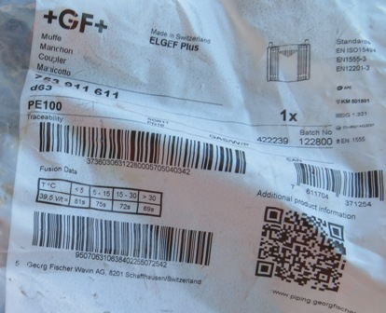 | 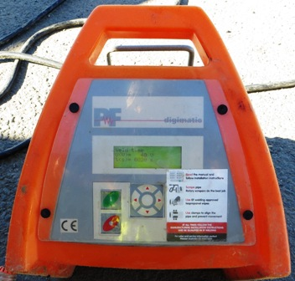 | 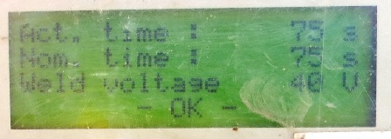

    - Check white lines to ensure joiner did not move during weld time – photo 20
    - Turn welder off
    - Remove fittings from joiner
    - Check indicator nipples have risen to confirm successful weld (where appropriate) – photo 20
    - Turn generator off
    - Unplug welder from generator and pack up
    - Record relevant information on pipe with permanent marker – photo 21:
- Time weld was completed
- Date
- Initials of person responsible for weld (or persons individual number as required for service such as TasGas)

Photo 20: Check white lines and indicator nipples | Photo 21: Write relevant information in permanent marker
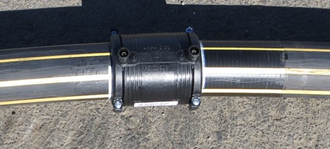 | 