

PANELTEC PTY LTD
A.B.N. 12 128 689 412

SWP-10

SAFE WORK PROCEDURE
GAS CYLINDERS
2025 - 2027
DO NOT use this machine unless you have been instructed in its safe use and operation.






Personal Protective Equipment

Face shield must be worn at all times in  work areas. | Long and loose hair must be contained.
Sturdy footwear must be worn at all times in work areas. | Close fitting/protective clothing must be worn.
Hearing protection must be used when using this machine. | Wear protective Gloves.
Rings and jewellery must not be worn.



Only one person may operate this machine at any one time.

- The greatest hazard posed by a cylinder is not the cylinder itself, but the gas contained inside.
- It is unsafe and dangerous to mishandle a cylinder, like dropping them or rolling them across the floor. If the neck of the cylinder breaks, the cylinder become a rocket.
- The release of gas in a confined or poorly ventilated space is a great danger. This may create an environment that lacks oxygen and can suffocate a person.
- More dangerously, depending upon the type of gas released, an explosive situation may form. One spark and the whole workshop could explode.

Housekeeping

How can I reduce the risk of a fire at work?
- It may sound simple, but the best way to reduce the risk of a fire is to keep your workplace clean and tidy, and to routinely check the equipment you are using.
- By removing the rubbish from your work area by keeping bins empty, and the floors swept, it is less likely that something will catch fire.

What are the maintenance requirements of gas cylinders?
- Maintenance operations should be carried out according to manufacturer's instructions.
- Inspection of equipment should be carried out on a routine basis.

What hazards need to be considered when using gas cylinders?
- Safeguard the cylinders and attachments (equipment and hoses) from cutting sparks, red-hot slag, molten metal, electric currents, excessive heat or flames.
- Do not rest materials on cylinders, especially when welding or cutting.

SWP-Gas Cylinders V10 – 31.08.2025 Authorised & Approved by Management Page 1 of 8
This SWP does not necessarily cover all possible hazards associated with the machine/equipment.
It is designed to act as a reminder to users/operators prior to machine/equipment use.



PANELTEC PTY LTD
A.B.N. 12 128 689 412

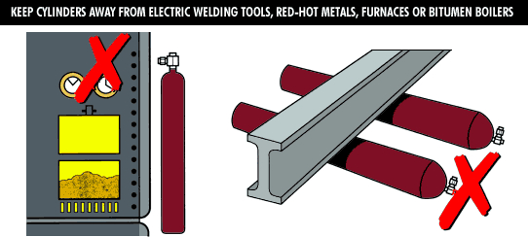
SWP-10

Precautions when maintaining the cylinder and fittings
- Never let oil or grease touch your cylinder or fittings. Never use jointing compounds.
- Lubrication of cylinder valves and fittings is highly dangerous as well as being unnecessary. High pressure oxygen will react violently with oils and grease, which may explode or ignite violently. Do not apply white or red lead, jointing compounds or jointing tape to any cylinders, valves or fittings.
- Oxygen equipment is at most risk from oil and grease so keep greasy hands, rags and gloves away from any part of the cylinder and fittings.
- Normal body oils do not usually affect the cylinder, though it is a sensible precaution never to touch any surface that is subject to oxygen under pressure.
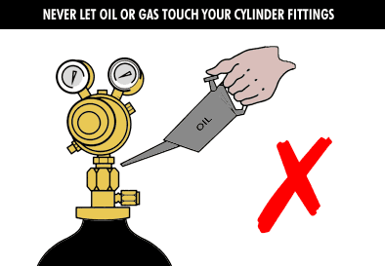

How do I keep cylinder valves clean? (Cracking or snifting of cylinders)
- Before assembling regulators and fittings make sure there are no particles of dirt in the cylinder outlet. If a supply of clean compressed air or nitrogen is available use this to blow out any loose particles of dirt from the valve sockets: NB eye protection must be worn during this operation. Where clean compressed air or nitrogen is not available, particles of dirt and residual moisture can be removed by “cracking” open and immediately closing the valve (otherwise known as “snifting”).
- Snifting means venting the cylinder momentarily to blow any debris from the cylinder valve outlet. If grit, dirt, oil or dirty water get into the cylinder valve sockets, leakage may occur.
- When snifting you should take the following precautions:
  - Wear eye protection
  - Be sure there is no possible source of ignition in vicinity; stand clear of the gas stream and on no account deflect the gas stream with the hand or the face.
  - In the case of the high purity gas such as argon, dry the outlet of the cylinder valve with a clean cloth before “snifting”.

SWP-Gas Cylinders Authorised & Approved by Management Page 2 of 8
This SWP does not necessarily cover all possible hazards associated with the machine/equipment.
It is designed to act as a reminder to users/operators prior to machine/equipment use.


PANELTEC PTY LTD
A.B.N. 12 128 689 412

SWP-10
- Never snift hydrogen or acetylene as it may ignite spontaneously and never snif toxic gases. Instead, carefully inspect the outlet and if there are any signs of dirt, blow it out with a jet of clean compressed air or nitrogen.

What are the requirements of testing cylinders?
- The owner of a cylinder is responsible for complying with the legislation in regard to maintenance and testing of cylinders.
- Owner of the cylinder needs to ensure that the requirements of Australian Standard 2030, SAA Gas Cylinders Code in respect to testing are met.

What do you need to know about cylinder connections?
- To prevent the interchange of fittings between cylinders containing combustible gases and noncombustible gases the cylinder valve outlets are threaded to opposite hands.
- Non-combustible gases, like oxygen, nitrogen, argon and air, all have conventional right-hand threads.
- Combustible gases like acetylene, hydrogen, propane and mixtures containing fuel gas all have left hand threads.
- These precautions ensure that oxygen and fuel gas pressure regulators are not interchangeable.
- Never use anything but the recommended cylinder valve keys.
- Never use spanners with long handles or the correct key if it is badly worn.
- These could damage the valve seat or spindle square.
- Always check the regulator threads to ensure that they correspond with the cylinder valve outlet.
- Never force the connections.

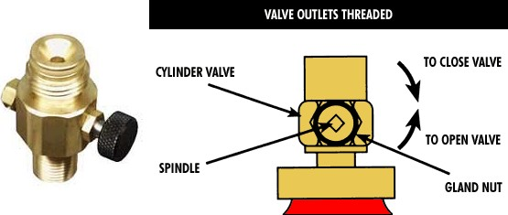

SWP-Gas Cylinders Authorised & Approved by Management Page 3 of 8
This SWP does not necessarily cover all possible hazards associated with the machine/equipment.
It is designed to act as a reminder to users/operators prior to machine/equipment use.



PANELTEC PTY LTD
A.B.N. 12 128 689 412

SWP-10

What do you need to know about pressure regulators?
- Regulators are fitted to cylinders to reduce the gas pressure in the cylinder to the working pressure of the torch.
- The regulator has two gauges - a high-pressure gauge for the gas in the cylinder and low pressure for the gas being fed to the torch.
- The gas cylinder and outlet valve are designed to supply gas through an approved pressure regulator.
- The pressure regulator screws into the valve outlet.
- Make sure the pressure regulator is designed for use with high pressure gas cylinders and the threads are the same as on the valve outlet.
- Never force a connection that does not fit.
- Do not attempt to repair or modify a regulator.
- Do not attempt to stop leaks between the regulator and cylinders by tightening the adjusting valve until the cylinder valve has first been closed tightly.
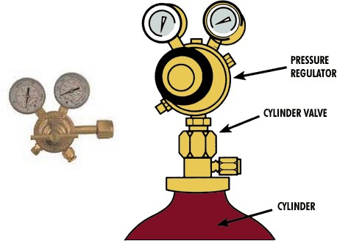
- Use regulators and pressure gauges for the gases for which they are designed and intended for use.

What do you need to know about flashback arrestors?
- To prevent flames travelling back into cylinders, safety devices known as flashback arrestors are strongly recommended and should be fitted downstream of pressure regulators in oxygen and fuel gas where gas mixtures can occur.
- Flashback arrestors should be fitted to all fuel gas supply lines and to oxygen supply lines when they are used in conjunction with fuel gases.
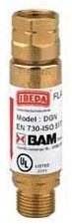

SWP-Gas Cylinders Authorised & Approved by Management Page 4 of 8
This SWP does not necessarily cover all possible hazards associated with the machine/equipment.
It is designed to act as a reminder to users/operators prior to machine/equipment use.



PANELTEC PTY LTD
A.B.N. 12 128 689 412

SWP-10

What do you need to know about hoses?
- Use only the approved hose material: blue for oxygen, red for acetylene and orange for propane.
- Never use a water hose.
- Replace hoses that are hardened, cracked or leaking.
- Do not use longer hoses than is necessary.
- The user must always have the cylinders and regulators within their sight whilst in use.
- It is important that each hose is long enough to allow cylinders to be safely positioned from flying sparks and hot metal.
- Repaired hoses must be professionally re-tested before use.
- Do not use hoses coiled, ensure that both hoses are of equal length and do not coil surplus hose around the cylinder or regulator or on the floor next to the cylinder in storage or in use. A fire in a coiled hose is very difficult to extinguish.
- If there is surplus hose, position the hose behind you and keep it clear of sparks.
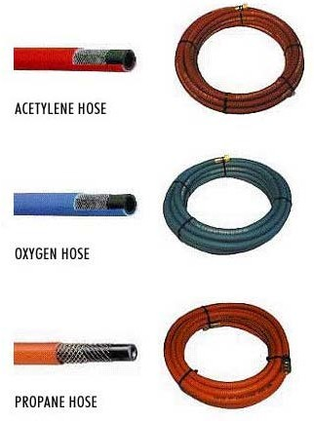

How do you test for leaks?
- Leaks may develop in any part of a gas system, but usually at joints.
- It is important that all equipment is regularly checked, and before each use.
- After connecting your welding or cutting plant to a full cylinder, it is recommended that the following test procedure be adopted in a well-ventilated area: -
  - Attach the regulator, hose and equipment to a full cylinder.
  - Shut off the control valve on the equipment.
  - Slowly open the cylinder valve, then screw in the regulator control knob to pressurise the system.
  - Close the cylinder valve and watch the regulator gauges.
  - If the pressure is retained there is no leak in the system.
  - If pressure drops, then a leak is present.
  - Conduct similar tests on the fuel gas system.

- To locate the leaks, apply a leak detection solution on to hoses and fittings and watch for bubbles.
- Some soaps contain oils, oil and oxygen do not mix, therefore avoid soapy water solution.

SWP-Gas Cylinders Authorised & Approved by Management Page 5 of 8
This SWP does not necessarily cover all possible hazards associated with the machine/equipment.
It is designed to act as a reminder to users/operators prior to machine/equipment use.



PANELTEC PTY LTD
A.B.N. 12 128 689 412

SWP-10
- Some regulators do not have gauges to indicate cylinder or working pressures therefore check all connections using a leak detector solution once lines are pressurised.
- Should a leak be detected and cannot be arrested, the defective equipment should be tagged with suitable warning notices and returned to the supplier.
- Ensure the leak detection solution is also used on cylinder valve gland, cylinder safety device and cylinder neck thread.

What is the procedure for handling gas cylinders in which leaks occur?
- Isolate the gas supply by turning off the gas cylinder valve, only if safe to do so.
- Isolate or remove the cylinder.
- Place it out of doors away from flames or sparks or any other sources of ignition.
- Evacuate the area.
- Ensure maximum ventilation.
- Post warning notices concerning dangerous conditions existing in the area.
- Contact the fire department and manufacturer.
- If an acetylene cylinder is heated accidentally or becomes hot through severe flashback or other cause, action should be taken promptly in the following manner: -
  - Shut the cylinder valve if safe to do so.
  - Clear all personnel from the area.
  - Cool the cylinder with supply of water from a fire hydrant. Do not extinguish any visible flame related to the leak.
  - Continue cooling the cylinder until it is cool, this may be determined by at intervals watching whether the water on the cylinder dries off or whether it remains wet.

Gases & Cylinder Contents
A summary of the characteristics of gases commonly used in welding are listed below. Users should always request a safety data sheet for each gas stored and used in the workplace. Cylinders shall be labelled and colour coded in accordance with Australian Standard 4484.
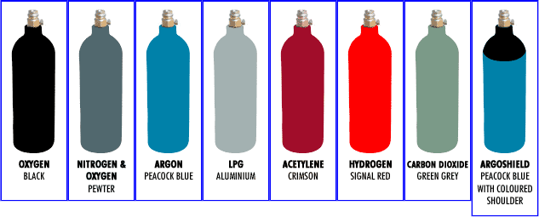

SWP-Gas Cylinders Authorised & Approved by Management Page 6 of 8
This SWP does not necessarily cover all possible hazards associated with the machine/equipment.
It is designed to act as a reminder to users/operators prior to machine/equipment use.


PANELTEC PTY LTD
A.B.N. 12 128 689 412

SWP-10
Gas Cylinder Colour Characteristics

Oxygen
Black- No smell. Generally considered non-toxic at atmospheric pressure. Will not burn, but supports and accelerates combustion. Materials not normally considered combustible may be ignited by sparks in oxygen rich atmospheres.

Nitrogen & oxygen – free nitrogen
Pewter- No smell, does not burn. Inert, except at high temperatures, but does not support life so will cause asphyxiation if insufficient oxygen is present. At high concentrations almost instant unconsciousness may occur followed by death. The prime danger is that there are no warning signs before unconsciousness occurs.

Argon
Peacock Blue- No smell. Heavier than air. Does not burn. Inert. Will cause asphyxiation in absence of sufficient oxygen to support life. Will readily collect in the bottom of a confined area. At high concentrations almost instant unconsciousness may occur followed by death. The prime danger is that there will be no warning signs before unconsciousness occurs.

LPG
LPG is odourised and has a fish-like smell. Will ignite and burn instantly from a spark or piece of hot metal. Is heavier than air and will collect in ducts, drains etc, and low lying areas. Fire and explosion hazard. Requires minimum energy to ignite oxygen.

Acetylene
Crimson- Distinctive garlic smell (sweet pungent). Fire and explosion hazards are similar to those of LPG. However, it is lighter than air and less likely to collect in ducts and drains. Requires minimum energy to ignite in air or oxygen. Never use copper or alloys containing more than 70 per cent copper or 43 per cent silver with acetylene.

Hydrogen
Signal Red- No smell. Non-toxic. Much lighter than air. Will collect at the highest point in any enclosed space unless ventilated at a high level. Fire and explosion hazard. Very low ignition energy.

Carbon dioxide
Green Grey- (French grey) No smell, but can cause the nose to sting. Toxic. Will cause asphyxiation. Much heavier than air. Will collect in ducts, drains and low lying areas.

Argoshield
Peacock Blue with coloured shoulder. No smell. Heavier than air. Does not burn. Will cause asphyxiation in absence of sufficient oxygen to support life. Will readily collect in the bottom of a confined area.

Safe Use & Handling
- When in doubt about the handling of a compressed cylinder or its contents, see that the manufacturer or supplier is consulted.

SWP-Gas Cylinders Authorised & Approved by Management Page 7 of 8
This SWP does not necessarily cover all possible hazards associated with the machine/equipment.
It is designed to act as a reminder to users/operators prior to machine/equipment use.


PANELTEC PTY LTD
A.B.N 12 128 689 412

SWP-10

What is needed to safely lift a cylinder?
- Always ensure that the cylinder is secure during the lift.
- Never lift a cylinder with magnets, chains or slings.
- Cylinders may be rolled on the bottom edge but do not drag them.
- Extra care is required for handling large cylinders.
- Do not attempt to catch a falling cylinder - let it fall and get out of the way.
- When moving cylinders about the workshop use a cylinder hand-truck.
- Never roll a cylinder flat on its side. Rolling cylinders along the ground damages the identification of the cylinder and may also damage the valve or cause it to open.
- Use a cylinder trolley to transport gas cylinders.
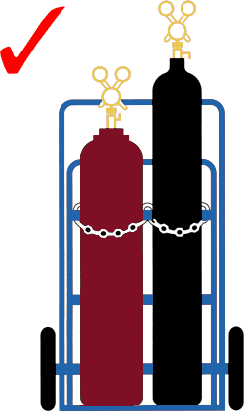
- Consider all cylinders as full and handle them with corresponding care.

Is protective clothing required to move cylinders?
- Protective clothing is required to move gas cylinders.
- All persons handling gas cylinders should wear protective footwear and industrial gloves
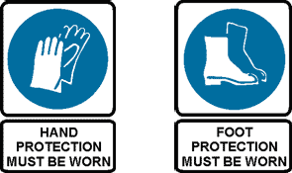
- Avoid loose clothing which may catch on cylinder valves.

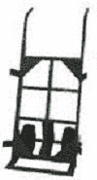
What is required to move a cylinder on a trolley?
- Make sure cylinders are properly located and effectively always secured, and cylinder valves are shut.
- Never transport or lift cylinders with pressure regulator and hose attached unless on a purpose designed trolley.
- General hand trucks and wheelbarrows are not ideal for carrying cylinders.

SWP-Gas Cylinders Authorised & Approved by Management Page 8 of 8
This SWP does not necessarily cover all possible hazards associated with the machine/equipment.
It is designed to act as a reminder to users/operators prior to machine/equipment use.

