WorkSafe Tasmania have investigated incidents over recent years where civil workers have been exposed to harmful gases and Volatile Organic Compounds (VOCs) whilst excavating beneath traffic easements in Tasmania. The sources of the contaminants are mostly related to the old town gas (coal gas) pipes that were made redundant in Hobart in 1978 and decommissioned in Launceston in 1995.

The main hazards with conducting excavation in and around soils contaminated by Historical Town Gas Infrastructure is the potential presence of VOC’s within the soil and or pipe. There is also potential for the presence of Hydrogen Cyanide to be released from the soils surrounding the pipe and or from the pipe contents.

Hydrogen cyanide usually creates a purple colour within soils but not always.

This procedure is designed to be used in conjunction with Paneltec Safe Work Method Statements (SWMS) No:54 Water Jetting-Safe Operation and No:57 Vacuum Truck. This procedure outlines the bare minimum safety procedures to be implemented by Paneltec operatives when working in a known location where soils are contaminated with VOC’s and other historical Town Gas by-products.
Personal Protective Equipment (PPE)

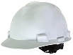
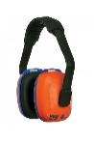


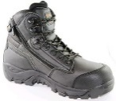
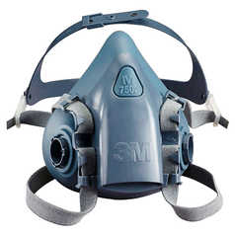
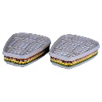
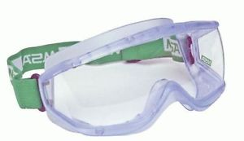

- Gloves (Viton/nitrile/PVC)
- Chemical goggles
- Disposable Coveralls (ensure hair and body is completely covered)
- Protective footwear & hardhat
- Half-face respirator, (VOC -3M 6057- cartridges for chemical exposure) if cyanide is not present
- Hearing Protection
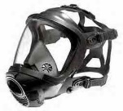
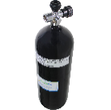

- Full SCBA is required if cyanide alarms are high and work must continue
Gas Alarms, Analysers & Detectors

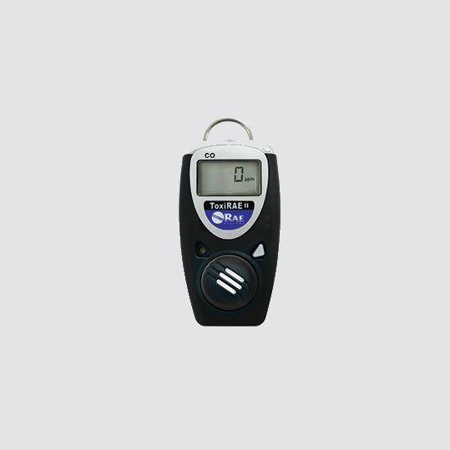
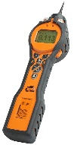
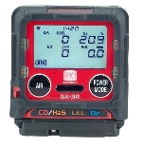
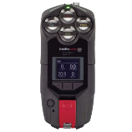
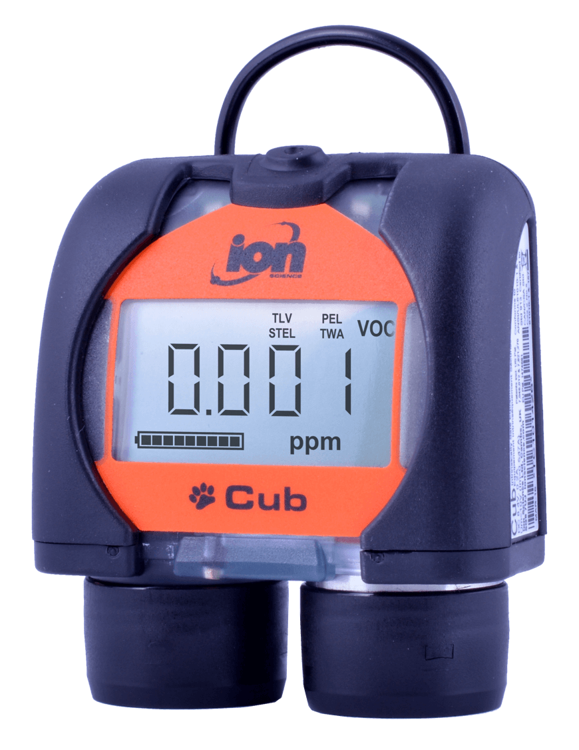
Cub Alarm 50ppm Tiger Analyser Toxi Ray II RKI GX-R3 Blackline G7c
VOC’s Only VOC & Cyanide Hydrogen Cyanide Hydrocarbons LEL Hydrogen Cyanide & Toluene
Does not analyse! CO, O2, & H2S (HCN) CO, O2, & H2S (VOC) & (HCN)

ANALYSER, DETECTOR, GAS & ACRONYM LEGEND

HCN = Hydrogen Cyanide

CO = Carbon Monoxide VOC = Volatile Organic Compound LEL = Lower Explosive Limit (Hydrocarbons - NG & LPG)

O2 = Oxygen H2S = Hydrogen Sulphide (Sewer) HEL = Higher Explosive Limit (Hydrocarbons - NG & LPG)

STEL = Short Term Exposure Level TWA = Time Weighted Average PEL = Permissible Exposure Limit

Safe Work Procedure (SWP)

- Set up Vacuum Truck as per Paneltec SWMS 54 & Water Jetting Safe Operation SWMS 57

- Check the wind direction and designate an area upwind as an emergency evacuation zone, make this area clear to all site personnel

- Complete a Paneltec SSRA in Lucidity and take pictures of the proposed excavation site

- Check that all Traffic Management is in Place and in accordance with the Traffic Management Plan (TMP)

- Verify vacuum truck hose and hydro excavation lance are in safe working order prior to excavation

- Ensure you and all your work crews have the skills, training and knowledge appropriate for the hazards/dangers involved when excavating near abandoned town gas pipes

- Check that all gas alarms, analysers and detectors (devices) are working and suitable for the detection of VOC’s/ and or cyanide (as above section)

- Check the devices are within their calibration dates (refer to the sticker on the device)

- The devices need to be turned on in fresh air and in place adjacent to all excavations and within truck/excavator cabins when excavation work is undertaken within the desired area of known Town Gas Infrastructure or contaminated soil

- Make sure all PPE as detailed in the above section is in place and adorned by all operatives involved within the proposed excavation areas circumference (above PPE to be adorned if within 10 Metres from centre of the closest part of the excavation, unless alarms sound then the distance should be increased to 25 Metres)

- Triple check that all half face respirators are fitted with the correct chemical/gas cartridges as per the table above, triple check that all other PPE is properly fitted and that the coverall’s hood is covering the head adequately

- If unusual ‘tar/bituminous like’ odours are noticed whilst excavating, work must cease immediately and the trained persons using the analysers should take air quality samples, all exposed operatives are to relocate to a safe distance away from the excavation (upwind) as item 10 above
- Once all elements from the SSRA, SWMS and the above SWP are satisfied excavation can begin and regular safe monitoring can be conducted

- If levels of VOC’s or Cyanide rise above the allowable threshold as outlined in the table below, cease excavation, liaise with the Customers Supervisor and contact WorkSafe Tasmania on 1300 366 322, do not re-enter the work area until the excessive levels fall below the exposure threshold, emergency services should be contacted on advice from WorkSafe Tasmania

- Contaminated soil should not be backed filled into the hole it came from, fresh FCR or road base should be used (monitoring is still to continue at this stage of backfilling)

- Prior to leaving site the spoils contained within the Vacuum Truck should be tested for contamination if possible (if alarms sounded during in excavation then it is safe to presume the spoils are contaminated). If the spoils are determined to be contaminated with VOC’s or Cyanide they will need to be promptly disposed of at the approved contaminated soil disposal area at Dulverton

- The Vacuum Truck should be washed thoroughly at the approved area utilising PPE and Paneltec’s Environmental Management Plan and associated Procedures

Record of VOC/Cyanide Readings Throughout the Job

Highest  Reading | Hole  1 | Hole  2 | Hole  3 | Hole  4 | Hole 5 | Hole  6 | Hole  7 | Hole  8 | Hole  9 | Hole  10 | Hole  11 | Hole  12 | Hole  13 | Hole  14 | Hole  15
HCN
VOC
O2
CO
LEL
H2S

Please refer to allowable exposure level table in conjunction with this SWP and throughout all testing process’s

Chemical name | Synonym | CAS No. | TWA |  | STEL |  | Peak limit
 |  |  | ppm | mg/m³
Carbon Monoxide | CO | 630-08-0 | 30 | 34 | - | -
Hydrogen Cyanide | HCN | 74-90-8 | 10 | 11 | - | - | 10
VOC (Toluene) | VOC | 108-88-3 | 50 | 191 | 150 | 574
Hydrogen Sulphide | H₂S | 7783-06-4 | 10 | 14 | 15 | 21

