

PANELTEC PTY LTD
A.B.N. 12 128 689 412

SWP-11
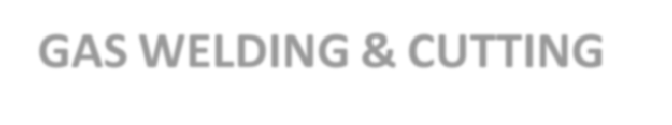
SAFE WORK PROCEDURE
GAS WELDING & CUTTING

2025 - 2027
DO NOT use this machine unless you have been instructed in its safe use and operation.

Personal Protective Equipment



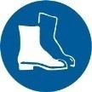

Put on PPE before you start welding. Welding Helmet/Face shield,
Welding Sleeves, Welding Gaiters, Welding Apron, Welding Gloves,
Safety Boots Hearing Protection
Only one person may operate this machine at any one time.

WELDING can cause fire or explosion. Sparks can fly off from the welding arc. The flying sparks, hot workpiece, and hot equipment can cause fires and burns. Accidental contact of electrode to metal objects can cause sparks, explosion, overheating, or fire.

General
- Supervisors must ensure that only employees holding a Certificate of Competency are allowed to use welding equipment.
- Approved personal protective equipment must always be used when welding or cutting.
- Approved welding screens must always be used.
- All equipment must be checked for damage. Damaged equipment must be tagged out, reported and not used.
- Know the position of the closest fire extinguisher.

Gas Cylinders
- Compressed gas cylinders must be only handled by personnel who fully understand the hazards involved with the use, movement and storage of gas cylinders.
- There are many different types of gas regulators, each designed for a specific use and a specific gas. Do not interchange fittings or regulators or try to adapt them to gases which they are not designed to handle.
- Never by-pass the regulator when discharging gas from a compressed gas cylinder.
- Do not use adaptors to connect regulators to gas cylinders.
- Always open cylinder valves slowly, using the standard wrench designed for the valve.
- Both full and empty cylinders shall be secured by chains, straps or other devices to a work bench, wall or other stationary object, or purpose-built transporting trolley or hand cart so as to prevent falling or rolling.
- Never drop cylinders or allow them to strike each other.
- Keep the valve protection cap securely in place whenever the cylinder is not connected for use.
- Cylinders should not be transported by hand. Use a proper hand cart to transport them.
- Never move cylinders by dragging, sliding or rolling on their sides.
- Cylinders should have signs indicating the name of the gas contained in them.

SWP-Gas Welding & Cutting V10- 31.08.2025 Authorised & Approved by Management Page 1 of 4
This SWP does not necessarily cover all possible hazards associated with the machine/equipment.
It is designed to act as a reminder to users/operators prior to machine/equipment use.



PANELTEC PTY LTD
A.B.N. 12 128 689 412

SWP-11
- Rooms or cabinets where the cylinders are stored should have signs indicating the hazards, i.e. poison, flammable, etc.
- Do not allow cylinders to lie in a horizontal position.
- Cylinders must not be moved with a regulator attached, unless in a purpose built gas trolley.
- Empty and full cylinders should be stored separately, with the empties clearly marked with white chalk.
- Remove empty cylinders from the area as soon as possible.
- Cylinders should not be exposed to excess heating. They should not be stored in direct sunlight or near sources of heat.

Burn Prevention when gas cutting or welding.
1. Wear proper protective clothing: gloves, safety shoes, long-sleeve shirt, and pants without cuffs.
- Do not wear synthetic clothing material.
- Wear goggles with filter lenses and clear protective cover glass.
- Do not wear oily or greasy clothes.
- Ensure that a correctly stocked First Aid Kit is available.

Fume accumulation prevention
- Provide adequate ventilation.
- Toxic fumes are produced during welding. Wear the appropriate respirator and ventilate or exhaust the fumes from the area.
- Do not cut or weld in a confined space unless that space can be ventilated or fumes exhausted.
- Never use oxygen for ventilation or purging.
- Do not take gas cylinders into a confined space.

Fire and explosion prevention
- Keep combustibles away from flame, slag, sparks, heated metal or arc. A distance of 5 metres is recommended.
- Use compressed gases only for the purpose they were designed for.
- Never attempt to weld, grind or cut any vessel or container if you do not know what it contained.
- Keep oil and grease away from all parts of an oxygen cylinder.
- Locate cylinders so that they will not be exposed to naked flames, cutting, grinding or welding sparks, slag, molten metal, etc.

Equipment care and use
- Check torches, hoses and connections for damage. Replace if in doubt.
- Do not use equipment that shows signs of obvious physical damage.
- See the preceding section on compressed gases for safe handling of gas cylinders.
- Never wrap hose or hang torch around cylinder valves or regulators.

Pressure Regulators
- Use only approved regulators.
- Never use a damaged or faulty regulator, immediately remove it from service. Do not attempt to repair regulators.
- When you are transporting a cylinder, remove the regulator and secure the cylinder cap.

Hoses
- Examine hoses for leaks, kinks, and wear.
- Only use hoses for their specified gas. Red is for fuel gas, green for oxygen, and black for inert gases. Replace any hose or fitting that is faulty

SWP-Gas Welding & Cutting Authorised & Approved by Management Page 2 of 4
This SWP does not necessarily cover all possible hazards associated with the machine/equipment.
It is designed to act as a reminder to users/operators prior to machine/equipment use.



Connections
PANELTEC PTY LTD
A.B.N. 12 128 689 412
SWP-11

- Make sure your regulator matches your cylinder.
- Clean cylinder valve outlets.
- Regulator outlet threads are right hand for oxygen, left hand for fuel gases.
- Tighten connections, but do not force.
- Incorrectly seated regulators can let gas escape from around the regulator base.

Torches
- Examine torch surfaces and connections.
- Clean torch tips with appropriate cleaners.
- Never use a torch with a valve stem leak.
- Do not use a faulty torch.

Pressurizing procedures
- Drain regulator of residual gas.
- Always stand to the side of regulator before opening cylinder valve.
- Always open cylinder valve very slowly.
- After cylinder pressure has registered on regulator high pressure gauge at cylinder valve should be in following position: Oxygen and Inert Gases - open fully to seal stem against possible leak. Fuel Gases - open to less than one turn to allow for quick emergency shutoff.
- Use only manufacturer's recommended pressures.
- Check for leaks regularly. Brush with an appropriate commercial solution and check for bubbles.

Lighting torch procedures
- Purge lines before lighting.
- Point torch tip away from people and combustibles.
- If outside, never light against the wind.
- Light as follows:
  - Open fuel valve and ignite gases flowing from tip with sparklighter. Do not use matches or hot metal.
  - Adjust fuel valve for full flow without popping the flame.
  - Adjust oxygen valve to desired flame intensity.

Shutdown procedure
- Extinguish the flame as follows:
  - Close oxygen and (without delay) fuel torch valves tightly.
  - Check for gas leak from tip or valves.
  - Place torch in safe position to prevent accidental opening of valves or damage.

Leaving equipment unattended
- Extinguish flame, close cylinder valves and any bleed hoses.
- Do not leave cylinders in unventilated cabinets, inside vehicles, or other confined spaces.

SWP-Gas Welding & Cutting Authorised & Approved by Management Page 3 of 4
This SWP does not necessarily cover all possible hazards associated with the machine/equipment.
It is designed to act as a reminder to users/operators prior to machine/equipment use.



Potential Hazards
- Burns
- Welding Flash/Eye Injury
- Flying Slag
- Hot Materials

PANELTEC PTY LTD

A.B.N. 12 128 689 412
SWP-11

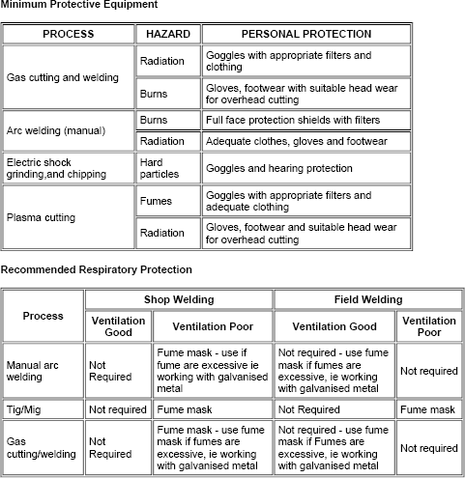
- Damage to Electrical Cables/Electrocution
- Inhaling Poisonous Gas
- Gas explosion / Fire
- Manual Handling problems

DO NOT Use the welder for:
1. Use other than recommended tasks

SWP-Gas Welding & Cutting Authorised & Approved by Management Page 4 of 4
This SWP does not necessarily cover all possible hazards associated with the machine/equipment.
It is designed to act as a reminder to users/operators prior to machine/equipment use.

