SAFE WORK PROCEDURE – SWP 31
Personal Protective Equipment (PPE)




Highly Visible Workwear – Long Pants
Safety Glasses to AS/NZS:1337 must be worn at all times |     and Shirt (Sleeves Down)
Safety Boots must be worn at all times. | Hearing protection  (where required)
Hard Hat (No caps underneath) |   Electrically rated Safety Gloves.>500V  Inspected Prior to each use

Respiratory protection (Where dust & particles are generated)
Electrical Safety Equipment
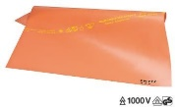
Adequately sized and rated (min 500V) insulated mats.

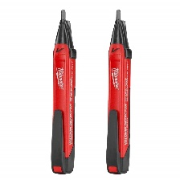

Non – contact voltage detector (Volt Stick)
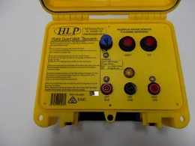

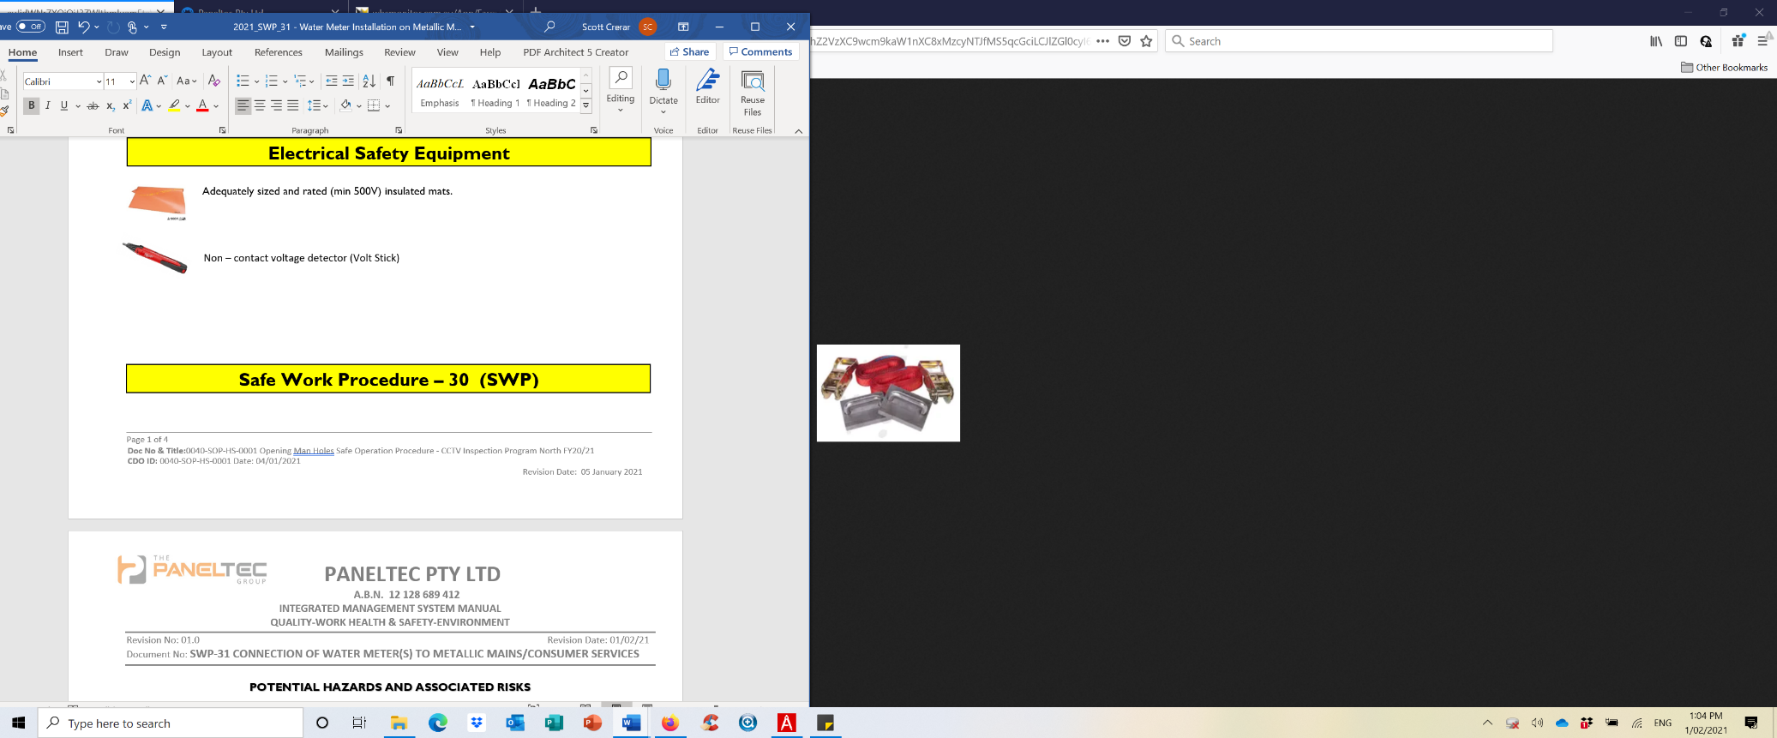
Safety Meter Bridging Plate Set OR Safety Meter Plumb Guard

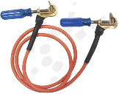
Safety meter lead and clips

Safe Work Procedure – 31 (SWP)

POTENTIAL HAZARDS AND ASSOCIATED RISKS

Slip, Trips, Falls

- Slip, trip, fall due to cluttered, uneven or slippery work surfaces
- Slip, trip, fall due to steep working surfaces

Manual Task Injury

- Manual task/musculoskeletal injury from incorrect manual handling
- Insect Bite (Spider or Snake)

Electricity

- Risk of Electrocution through earth leakage or stray currents

PRE-OPERATIONAL SAFETY CHECKS

- Complete, Site Specific Risk Assessment (SSRA)
- Discuss any site-specific hazards that may be on-site with your team (boggy area’s, slips & trips, pets ect)
- Ensure appropriate delineation of the work zone and traffic management is in place where required.
- Ensure all workers are trained in fitting water meters
- All workers to be familiar with Manual Handling techniques

PLANNING & SETUP PROCEDURES

- Is the pipework adjacent to the works metallic? (GI, Copper, Steel etc) If yes, proceed with this SWP, If no proceed under the SSRA
- Review Job Pack and ensure Dial before You Dig (DBYD’s) have been reviewed if excavating.

EQUIPMENT INSPECTION IF METALLIC CONNECTIONS ARE PRESENT

- Check your electrical gloves by taking them out of the bag and visually checking for any holes or tears
- Check bridging conductors for wear and tear, check for obvious defects such as cuts, crushing, burns etc
- Ensure bridging jaws are free from mud and corrosion, clean or shine with wire wool where necessary
- Test the bridging conductor is working by using your vault stick to ensure a continuous circuit

TEST THE PIPEWORK/WATER METER FOR POTENTIAL ELECTRICAL CURRENTS

- Wear electrically rated gloves and other PPE as required
- Using the volt stick place the probe on a metallic component of the water meter/pipework sections

VOLTAGE DETECTION PROCEDURE (VDP)
- If a voltage is detected at any point during this SWP, all work must cease immediately.
- Notify the resident (if they are home).
- Notify the Project Supervisor or TasWater Representaive who will notify TasNetworks.
- Remain on-site in a safe location until TasNetworks have made the site safe.

- If no voltage is detected, then work can continue to clear around the water meter/pipework sections
- Roll out and position your insulating ground matt on the standing/kneeling work area
- Whilst still wearing the electrically rated gloves begin clear around the water meter
- Once metallic pipes have been verified on either side of the meter proceed to bridge the connection with bonding straps (18-23) or the plumb guard (24-30) – select either option below:

SETTING UP THE BRIDGING/BONDING STRAPS & WORKS (Without Plumb Guard)
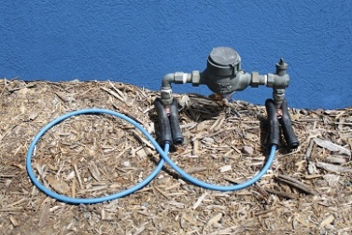
- Figure 1 -
- Whilst still wearing the electrically rated gloves and positioned on your Matt, clean the metallic surfaces of the pipe back to bare metal adjacent to the meter or pipework sections with emery cloth or wire wool.

- Connect bonding strap to cleaned surfaces either side of meter or pipe component NOTE: Always connect straps to bare pipe and not the fittings see Figure 1

- If leads, clamps or pipework sparks, cease work and follow the VDP above

- Be cautious not to touch exposed parts of the bonding clamps and work only with in the zone of the clamps

- Replace component, pipe section or meter assembly.

- Remove clamps and Matt(s) only after all final connections have been made

SETTING UP THE BRIDGING/BONDING STRAPS & WORKS (With the Plumb Guard)
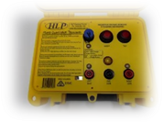
- Ensure the Plumb Guard is in calibration date, turn it on and hold down the test button, if left
and right lights flash, the alarms sound it is in safe working order and the test button can be
released. Leave the unit turned on.

- Whilst still wearing the electrically rated gloves and positioned on your Matt, clean the metallic surfaces of the pipe back to bare metal adjacent to the meter or pipework sections with emery cloth or wire wool.

- Insert the Plumb Guard ground stake as far as possible into the surrounding soil (not gravel)

- Connect the green ground (GND) lead from the Plumb Guard to the ground stake

- Connect the left (red) bonding lead to the LHS of the pipe section proceeding the component or meter assembly to the cleaned surface, do the same with the right bonding lead and connect to RHS pipe section
NOTE: Always connect straps to bare pipe and not the fittings see Figure 1: (Previous Page)

- Replace component, pipe section or meter assembly and co.

- If the alarm sounds at any point in the pipework replacement procedure, follow the VDP on page 3

COMPLETE JOB AND PACK UP

- Reinstate site to the previous condition

- Check condition of all leads, matts, gloves and PPE and report any faults on return to the depot

- Pack away all items in there containers carefully

- Complete all relevant paperwork and take all necessary photos of works completed

