SAFE WORK PROCEDURE – SWP 33
Personal Protective Equipment (PPE)

Mandatory Task Specific PPE
  Eye Protection |   Minimum P2 Respiratory Protection |   Disposable Coverall Protection |   Foot Protection with over boot disposable cover |   Disposable Hand Protection
Purpose

The intent of this procedure is to provide clear instructions relating to the cutting of asbestos cement pipes and PPE requirements associated with it. It details the additional requirements when using a reciprocating saw. All operators working on ACM pipes shall be trained and understand the requirements of these procedures prior to conducting any work on AC pipes.
Scope

This document specifically relates to cutting asbestos cement pipework.
Equipment List

Storage Container  labelled in accordance with the GHS to indicate the presence of asbestos | Variable speed reciprocating saw (locked at 1500rpm)
Asbestos waste bags | Carbide teeth blades  3-5 TPI blades must be used
Roll of duct tape | Reciprocating Saw battery
Geofabric | Hand Saw
Foricon plastic wrap | Industrial wet wipes
Asbestos warning signs | Chemical Sprayer (Surfactant)
Caution Asbestos barricading tape and fixtures | Bondcrete (PVA)
Water spray bottle | Dedicated reciprocating saw case
Personnel List

Position | Quantity | Qualification
Operator | 2 | CPCCDE3014A Remove non-friable asbestos (under 10sqm)
Safe Work Procedure – 33 (SWP)

No. | Step | Photo

Preparation
 | Check vehicle/trailer before leaving the depot to ensure all listed equipment and PPE are on hand.
 | A SWMS must be prepared before commencing the job and must include details on the controls that are to be implemented to eliminate or minimise the risk of asbestos exposure.
 | Review Geographic Information Systems (GIS) layers/ asset database to identify the location of the AC pipe and any other hazardous material.
Determine the area of AC pipework to be removed using the table below.
If greater than 10m2 a licenced contractor MUST complete the task. If under 10m2 only trained and competent persons to remove the asbestos containing material
 | Ensure barricades are erected to delineate the asbestos area and asbestos danger signage indicates where the asbestos removal work is being carried out.  See photo 1 for example of required delineation | 1
Lay large piece of foricon plastic on the ground and secure to ground with duct tape or heavy objects; to be the used as the decontamination zone.
See photo 1 for example of decontamination zone
 | Ensure wet wipes and water misting spray is located within decontamination zone.
 | Prepare a surfactant solution in a chemical sprayer using the bondcrete adhesive solution (with 9:1 ratio) to encapsulate the airborne asbestos fibres during the cutting process.
 | Workers must fit their respirator, perform positive fit check, and ensure all other listed PPE is worn prior to performing work that disturbs asbestos.  Use duct tape to assure that the coveralls fit snugly to the contours of the wearer and will not tear when the worker bends or turns.  Ensure the elastic seals where the coveralls meet with the boot covers and gloves are sealed with the duct tape.  See Photo 2 for example of full PPE requirement  If gumboots are worn, these must be decontaminated with wet wipes and remain sealed in double asbestos bagging until the next removal task | 2

Cutting Procedure
 | Ensure adequate clearance around AC pipe to allow for placement of the geofabric and safe use of reciprocating saw. | 3
 | The section of AC pipe, that is subject to cut, must be thoroughly coated with surfactant solution prior to commencing the cutting process.
 | Ensure the continuous application of surfactant solution from the commencement of the cutting process until completion.  Operate the reciprocating saw in accordance with manufacturer’s instruction, using a soft start and increasing saw speed as required.  Note: Only blades with carbide teeth (3-5 TPI) are to be used. | 4
The cut section of AC pipe shall be wrapped in the geofabric located underneath the pipe, by wrapping the fabric edges in on itself, ensuring all AC particles remain contained.
Place wrapped pipe section in an asbestos labelled plastic bag.
Bag sealing steps:

- Make sure the bag is no more than half filled and remove excess air to reduce the risk of handlers inhaling dust.
- Once you’ve filled the bag, twist the top of it tightly and fold the neck over in a gooseneck twist.
- Seal the bag with duct tape to fully enclose the ACM inside.
- Place the first bag into the second bag and repeat the sealing procedure

If bag size is inadequate for the length of cut pipe, triple wrap the section of pipe in foricon plastic, seal with duct tape and tape asbestos waste bag to each end of wrapped pipe.

Post Cutting Decontamination Procedure
Decontamination of tools and equipment
At the end of the asbestos removal work, all tools and equipment must be fully dismantled and cleaned (wiped down) using the industrial wet wipes
Using 1 surface of the wet wipe; refolded to expose a clean surface with each wipe to prevent recontamination.
Ensure PPE is worn for this process
Once cleaned and decontaminated, all tools and equipment used must be stored in an asbestos labelled storage container (labelled) or double bagged in asbestos bags before removing from the asbestos removal work area.
Ensure exterior of the container is fully decontaminated using industrial wet wipes before removing from work area
Note: rechargeable batteries can be returned to service once thoroughly wiped down using the abovementioned process
The bags/containers used for storing the tools and equipment must remain sealed until the commencement of the next asbestos removal task
PPE must be worn when opening the bag to re-use the equipment or tools, performed in a controlled environment
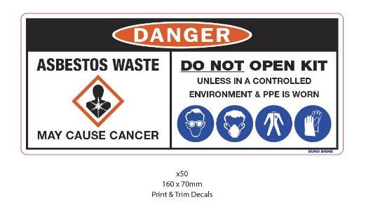

Any asbestos waste is to be disposed of in the approved Paneltec Asbestos waste bins.
Removal and disposal of PPE
Personal decontamination must be done within the designated decontamination area to avoid the worker re-contaminating themselves or contaminating outside of the asbestos work area.
Before removing contaminated PPE, stand on foricon plastic (designated decontamination zone) and wipe down all PPE surfaces, assisting colleagues where required, spray all PPE surfaces with water mist before commencing the safe PPE removal process.

 | Safe PPE removal steps:  - Remove coveralls by rolling inside out from the top down  - Place coveralls on foricon plastic  - Remove your shoe covers and clean your boots with a wet wipe. Place shoe covers and wet wipes on foricon plastic  - Remove your face mask and put on foricon plastic. If using reusable respiratory protection, ensure mask is thoroughly decontaminated using wet wipes.  - Place wet wipes on foricon plastic and place respirator in a sealed asbestos bag for reuse  - Wrap all contaminated disposable PPE and equipment in the foricon plastic on ground, folding the edges of the plastic inwards to contain all hazardous materials inside the plastic  - Place folded foricon into an asbestos waste bag and seal securely with duct tape  - Place bagged items into a second asbestos waste bag and seal securely with duct tape, leaving a section at the top to place used wet wipes  - Use a wet wipe to decontaminate the outside of the asbestos waste bag  - Place wet wipes used in the top of asbestos waste bag  - Wipe your hands, nails and face thoroughly with a wet wipe and place in the top of the asbestos waste bag and seal with duct tape  All decontaminated PPE is to be treated as asbestos waste and disposed of accordingly. | 2
Disposal of asbestos waste
 | All double wrapped asbestos waste shall be securely and safely loaded onto a Paneltec vehicle and transported directly from the worksite to be disposed of in an asbestos waste bin or approved receival station.
AC Pipe length equivalent to 10m2

Dimensions of AC Pipe equiavent to 10m²
Nominal Diameter | Outside Diameter | Length of pipe equivalent to 10m²
DN100 | 122 mm | 26.1m
DN150 | 177 mm | 18.0m
DN200 | 232 mm | 13.7m
DN225 | 259 mm | 12.3m
DN300 | 344 mm | 9.25m
DN375 | 425 mm | 7.5m
DN450 | 505 mm | 6.2m
DN525 | 587 mm | 5.5m
DN600 | 664 mm | 4.7m
Site & Procedure Photo Examples
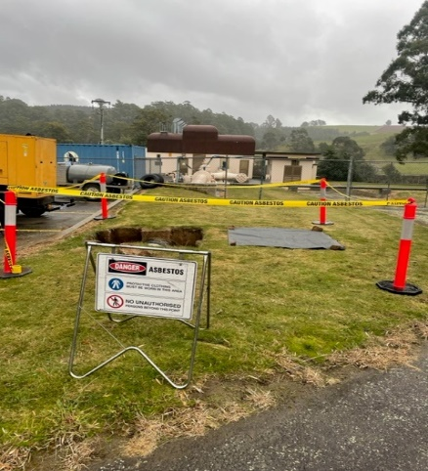 | 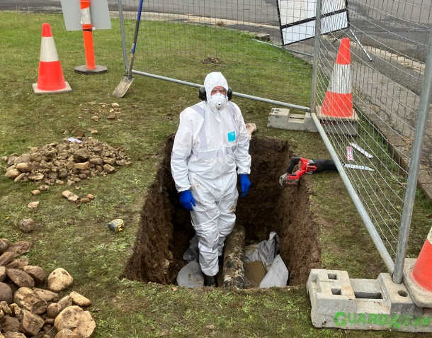
- Worksite barricading and signage | - Operators wearing the appropriate PPE before commencing the job
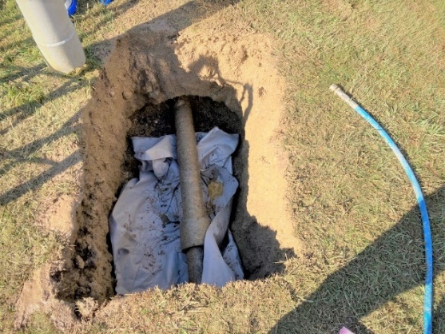 | 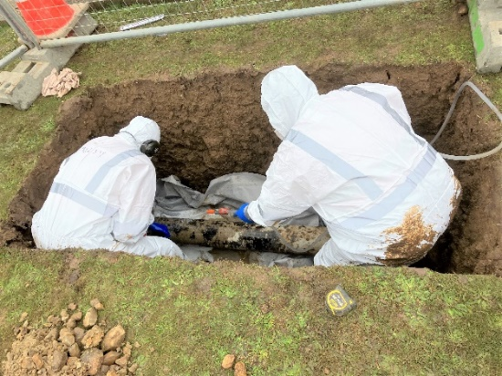
- Place geofabric underneath the section of pipe | - Ensure continuous application of surfactant solution during the cutting process
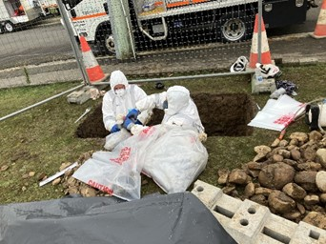

- Ensure asbestos waste must be double bagged for tagging and secure disposal
References

This work instruction was prepared in compliance with the noted Tasmanian legislation and the guidelines stipulated in the following Paneltec IMS documents:

Tasmanian WHS Regulation 2022 - CHAPTER 8 – ASBESTOS
SWMS-063 – Removal of Asbestos Pipe
WHS18 – Personal Protective Equipment Procedure
WHS 28c – Asbestos Exposure

