

SWP 28 - Testing Procedure for Live Tap on Polyethylene Gas Pipe
Natural Gas <500KPA

Who: | Natural Gas Distribution Team – Operative with Cert III in Gas Industry Operations  Certifying Gasfitter -If Standard/Complex Gas Installations (MUST SUPERVISE & CERTIFY ALL WORK)
When: | On receipt of a Work Order
Why: | To ensure a common standard is applied when pressure testing polyethylene (PE) gas pipes
You Need: | - Either a certified Bourdon-type gauge with a 150 mm dial face or an electronic pressure gauge  - Air compressor capable of reaching pressures of 1.4 MAOP, or nitrogen bottle, hose and regulator  - Test head  - Soapy water  - Appropriately calibrated gas detector  - Personal Protective Equipment (PPE)
Information: | Test pressure shall be in the second half of the range of the test gauge
NOTE: | Do not pressure test against a squeeze-off clamp

1. PRESSURE TESTING

Step No. | Task Description | Reference
1.1 | Ensure all valves on test head are closed.
1.2 | Fit gauge to test head.
1.3 | Remove any downstream meter assembly from the service valve if applicable.
1.4 | Attach test head to service either at the meter inlet valve or at the tapping tee.
1.5 | Attach nitrogen hose or compressor air hose to test head.
1.6 | Open valve on nitrogen cylinder and control pressure by regulator on nitrogen bottle or start compressor and open compressor valve.

1.7 | Gently open inlet valve on test head.
1.8 | When planned test pressure is reached close the inlet valve on the test head.
1.9 | Close valve on nitrogen cylinder or turn off compressor.
1.10 | Disconnect nitrogen hose or compressor hose from inlet valve on the test head.
1.11 | Soap test the test head for leaks.
1.12 | Allow pressure to stand for a 10-minute settling period.
1.13 | Check that the pressure is the same as at the start of the settling period.

- PRESSURE TESTING

NOTE: | If the pressure has dropped below the required test pressure, reconnect pressurising equipment and boost the pressure back to the required test pressure.  Only when pressure has stabilised proceed with the following steps.
1.14 | When pressure testing from the tapping tee:  Pressure test the service for 10 minutes with the meter inlet valve CLOSED but capped and a further 5 minutes with the meter inlet valve OPEN but capped.
1.15 | When pressure testing from the meter inlet valve:  Pressure test the service for 10 minutes and close the meter inlet valve, disconnect the test head and soap test the valve to ensure that it is not passing. Maintain this test for a minimum of 5 minutes.
1.16 | Monitor pressure; any drop in pressure indicates a leak.
1.17 | Following a satisfactory test, purge the nitrogen or air from the service.
1.18 | Ensure pressure test part of Service Completion Record As-built Info Page is completed or details are recorded by the Certifying Gasfitter if the underground pipework will be intended to form part of a consumer gas installation.

APPENDIX A – Test Durations

Duration of Pneumatic Pressure Tests for 35-500 kPa PE100 mains (Hrs)

Pipe Length (m) | PE Pipe Diameter (mm)
 | 63 mm | 90 mm | 125 mm | 160 mm | 200 mm | 250 mm | 315 mm
50 | 0.50 | 0.50 | 1.00 | 2.00 | 3.00 | 5.00 | 8.00
100 | 1.00 | 1.00 | 1.50 | 3.00 | 6.00 | 10.00 | 11.00
150 | 1.25 | 1.25 | 2.00 | 5.00 | 9.00 | 15.00 | 18.00
200 | 1.75 | 1.75 | 3.00 | 6.00 | 12.00 | 20.00 | 22.00
250 | 2.00 | 2.00 | 3.50 | 8.00 | 14.00 | 24.00 | 24.00
300 | 2.50 | 2.50 | 4.50 | 10.00 | 17.00 | 24.00 | 24.00
350 | 3.00 | 3.00 | 5.00 | 11.00 | 20.00 | 24.00 | 24.00
400 | 3.25 | 3.25 | 6.00 | 13.00 | 23.00 | 24.00 | 24.00
450 | 3.75 | 3.75 | 6.50 | 15.00 | 24.00 | 24.00 | 24.00
500 | 4.00 | 4.00 | 7.00 | 16.00 | 24.00 | 24.00 | 24.00

Calculating the Test Duration for a Set Maximum Drop in Test Pressure

Diameter | 63 mm | 90 mm | 125 mm |  | 160 mm | 200 mm | 250 mm | 315 mm
Test period multiplier | 0.0018 | 0.0037 | 0.0072 |  | 0.0118 | 0.0185 | 0.0289 | 0.0459
Multiply the above corresponding Test Period Multiplier number with the diameter of pipe being tested by the length of the test section in metres.
The result is the duration of the test in HOURS with an allowable pressure drop of 3mBar or approximately 0.3 kPa
Example:
A 250M length of 125mm PE main is to be tested
 | 250 x 0.0072 = |  | 1.8 | Hrs.
 | 1.8Hrs x 60 = |  | 108 | Mins.
Therefore, if after a settling period the main is tested for 108 minutes and the pressure does not drop by more than 3mBar the test has Passed.

Volumes of PE Pipe in Cubic Metres (M³) - SDR 11

Pipe Length (m) | PE Pipe Diameter (mm)
 | 20 mm | 32 mm | 63 mm | 90 mm | 125 mm | 160 mm | 200 mm | 250 mm | 315 mm
1 | 0.00 | 0.00 | 0.00 | 0.00 | 0.01 | 0.01 | 0.02 | 0.03 | 0.05
2 | 0.00 | 0.00 | 0.00 | 0.01 | 0.02 | 0.03 | 0.04 | 0.07 | 0.10
3 | 0.00 | 0.00 | 0.01 | 0.01 | 0.02 | 0.04 | 0.06 | 0.10 | 0.16
4 | 0.00 | 0.00 | 0.01 | 0.02 | 0.03 | 0.05 | 0.08 | 0.13 | 0.21
5 | 0.00 | 0.00 | 0.01 | 0.02 | 0.04 | 0.07 | 0.11 | 0.16 | 0.26
6 | 0.00 | 0.00 | 0.01 | 0.03 | 0.05 | 0.08 | 0.13 | 0.20 | 0.31
7 | 0.00 | 0.00 | 0.01 | 0.03 | 0.06 | 0.09 | 0.15 | 0.23 | 0.37
8 | 0.00 | 0.00 | 0.02 | 0.03 | 0.07 | 0.11 | 0.17 | 0.26 | 0.42
9 | 0.00 | 0.00 | 0.02 | 0.04 | 0.07 | 0.12 | 0.19 | 0.30 | 0.47
10 | 0.00 | 0.01 | 0.02 | 0.04 | 0.08 | 0.13 | 0.21 | 0.33 | 0.52
20 | 0.00 | 0.01 | 0.04 | 0.09 | 0.16 | 0.27 | 0.42 | 0.66 | 1.04
30 | 0.01 | 0.02 | 0.06 | 0.13 | 0.25 | 0.40 | 0.63 | 0.99 | 1.57
40 | 0.01 | 0.02 | 0.08 | 0.17 | 0.33 | 0.54 | 0.84 | 1.31 | 2.09
50 | 0.01 | 0.03 | 0.10 | 0.21 | 0.41 | 0.67 | 1.05 | 1.64 | 2.61
100 | 0.02 | 0.05 | 0.21 | 0.43 | 0.82 | 1.35 | 2.10 | 3.29 | 5.22
200 | 0.04 | 0.11 | 0.42 | 0.85 | 1.64 | 2.69 | 4.21 | 6.57 | 10.44
300 | 0.06 | 0.16 | 0.63 | 1.28 | 2.46 | 4.04 | 6.31 | 9.86 | 15.65
400 | 0.08 | 0.22 | 0.83 | 1.70 | 3.29 | 5.38 | 8.41 | 13.15 | 20.87
500 | 0.11 | 0.27 | 1.04 | 2.13 | 4.11 | 6.73 | 10.52 | 16.43 | 26.09
1000 | 0.21 | 0.54 | 2.09 | 4.26 | 8.22 | 13.46 | 21.03 | 32.86 | 52.18

Volumes of PE Pipe in Cubic Metres (M³) – SDR 9

Pipe Length (m) | PE Pipe Diameter (mm)
 | 20 mm | 32 mm | 63 mm | 90 mm | 125 mm | 160 mm | 200 mm | 250 mm | 315 mm
1 | - | - | 0.00 | 0.00 | 0.01 | 0.01 | 0.02 | 0.03 | 0.05
2 | - | - | 0.00 | 0.01 | 0.01 | 0.02 | 0.04 | 0.06 | 0.09
3 | - | - | 0.01 | 0.01 | 0.02 | 0.04 | 0.06 | 0.09 | 0.14
4 | - | - | 0.01 | 0.02 | 0.03 | 0.05 | 0.08 | 0.12 | 0.19
5 | - | - | 0.01 | 0.02 | 0.04 | 0.06 | 0.10 | 0.15 | 0.24
6 | - | - | 0.01 | 0.02 | 0.04 | 0.07 | 0.11 | 0.18 | 0.28
7 | - | - | 0.01 | 0.03 | 0.05 | 0.09 | 0.13 | 0.21 | 0.33
8 | - | - | 0.02 | 0.03 | 0.06 | 0.10 | 0.15 | 0.24 | 0.38
9 | - | - | 0.02 | 0.03 | 0.07 | 0.11 | 0.17 | 0.27 | 0.42
10 | - | - | 0.02 | 0.04 | 0.07 | 0.12 | 0.19 | 0.30 | 0.47
20 | - | - | 0.04 | 0.08 | 0.15 | 0.24 | 0.38 | 0.59 | 0.94
30 | - | - | 0.06 | 0.12 | 0.22 | 0.36 | 0.57 | 0.89 | 1.41
40 | - | - | 0.08 | 0.15 | 0.30 | 0.49 | 0.76 | 1.19 | 1.89
50 | - | - | 0.09 | 0.19 | 0.37 | 0.61 | 0.95 | 1.48 | 2.36
100 | - | - | 0.19 | 0.38 | 0.74 | 1.22 | 1.90 | 2.97 | 4.71
200 | - | - | 0.38 | 0.77 | 1.48 | 2.43 | 3.80 | 5.94 | 9.43
300 | - | - | 0.57 | 1.15 | 2.23 | 3.65 | 5.70 | 8.91 | 14.14
400 | - | - | 0.75 | 1.54 | 2.97 | 4.87 | 7.60 | 11.88 | 18.86
500 | - | - | 0.94 | 1.92 | 3.71 | 6.08 | 9.50 | 14.85 | 23.57
1000 | - | - | 1.89 | 3.85 | 7.42 | 12.16 | 19.01 | 29.70 | 47.15

APPENDIX B – Reference Installation of Plasson Tapping Saddles
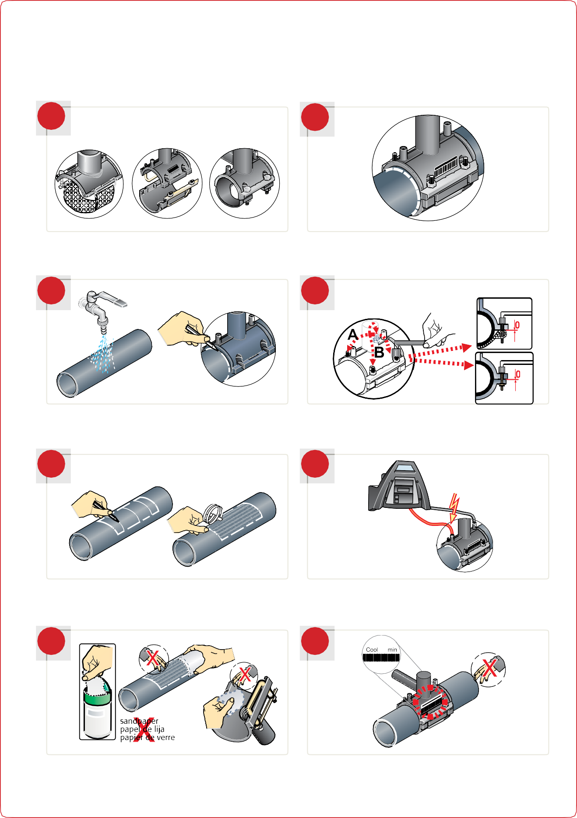

EF Installation Instructions
ElectroFusion procedure - all saddles

1 5

Welding instructions for all Plasson ElectroFusion saddles.

2
Assemble saddle on scraped pipe and tighten nuts and bolts crosswise.

6

Clean pipe then draw saddle boundaries on pipe.

3
Tighten until upper and lower saddle parts are mated (zero gap).

7

Add marks on pipe inside boundaries and scrape pipe fully inside perimeter.

4
Fuse fitting.

8

Degrease saddle surface and scraped pipe with appropriate cleaning agent.
Allow to cool. Cool additional 30 minutes prior to tapping and pressure testing.

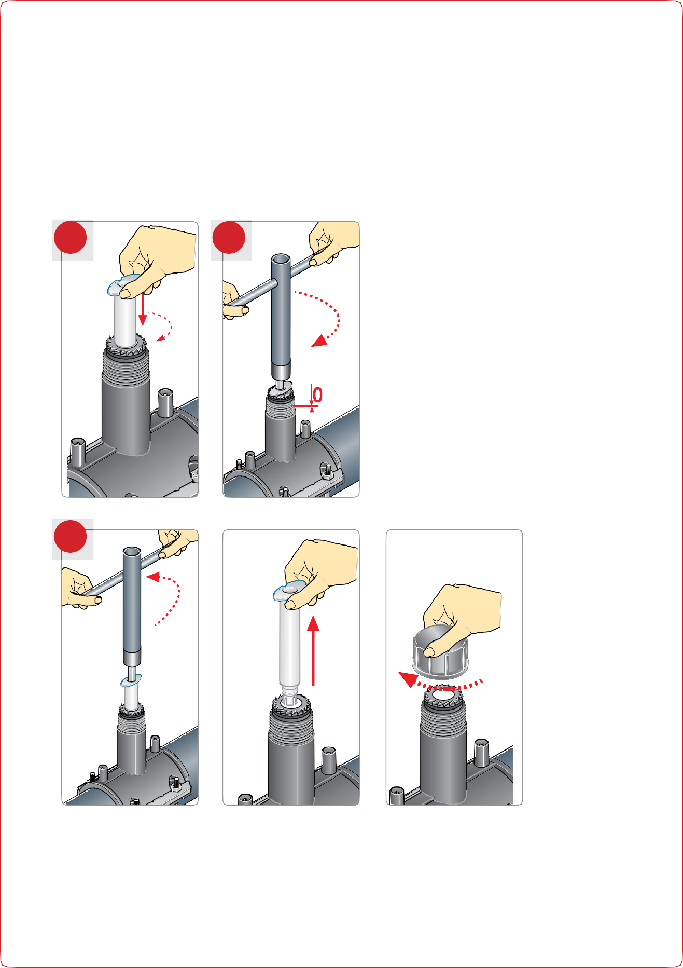

EF Installation Instructions

Tapping instructions for Tapping Saddle

- Push down on sleeve to ensure correct starting position.
- Tap pipe by turning wrench clockwise to lowermost position of the sleeve.

1 2

3

- Unscrew to uppermost position (resistance increases significantly). Then add ½ turn, not more, to tighten firmly for good seal. Remove sleeve, then screw on cap and tighten firmly.

