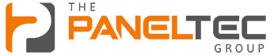
PANELTEC PTY LTD
A.B.N. 12 128 689 412

INTEGRATED MANAGEMENT SYSTEM MANUAL QUALITY-WORK HEALTH & SAFETY-ENVIRONMENT
Revision No: 010 Revision Date: 31/08/25
Document No: IMS-05.14

SOCIAL MEDIA POLICY

Social Media Management
This policy supports Paneltec Pty Ltd’s (Paneltec) commitment to embrace the spirit and intent of our statutory obligations as a PCBU.

Policy Objective

This policy is intended to help staff make appropriate decisions about the use of social media such as (but not limited to) blogs, wikis, social networking websites, podcasts, forums, message boards, or comments on web-articles, such as Twitter, Facebook, LinkedIn, Instagram, Snapchat and other relevant social media websites whilst being employed by Paneltec. This policy outlines the standards we require staff to observe when using social media, the circumstances in which we will monitor your use of social media and the action we will take in respect of breaches of this policy

Policy Statement

Paneltec Pty Ltd’s request that all employees:

- Do not upload, post, forward or post a link to any abusive, obscene, discriminatory, harassing, derogatory or defamatory content on our own social media sites or the employees own account.
- Never disclose commercially sensitive, anti-competitive, private or confidential information. If you are unsure whether the information you wish to share falls within one of these categories, you should discuss this with the Compliance Manager.
- Any member of staff who feels that they have been harassed or bullied, or are offended by material posted or uploaded by a colleague onto a social media website either directly or indirectly, should inform the Compliance Manager immediately.
- Be honest and open, but be mindful of the impact your contribution might make to people’s perceptions of us as a company. If you make a mistake in a contribution, be prompt in admitting and correcting/deleting it.
- You are personally responsible for content you publish into social media tools – be aware that what you publish will be public for many years.
- Don’t discuss colleagues, competitors, customers or suppliers without our prior approval.
- If you notice any content posted on social media about us (whether complementary or critical) please report it to the Compliance Manager immediately.
- Any false and or defamatory statements about any person within the company, or the company itself, either directly or indirectly, published on social media will result in a formal meeting with management for gross misconduct.
This can result in your instant dismissal.
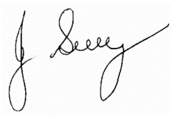

Signed by Director: John Guy
(Name)

31/08/25
(Date)

Signature
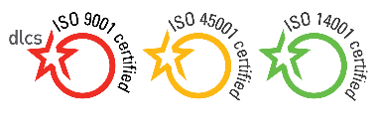

Policy Review Date: August 2028
Controlled Document Authorised & Approved by Management Page 1 of 1

