Revision No: 010 Revision Date: 31/08/25
Document No: IMS-05.08

VEHICLE POLICY

The safe operation of Paneltec Pty Ltd company vehicles is the prime responsibility of the driver. It is policy, that where fitted seat belts must be worn and traffic laws followed at all times.

Driver’s License
- You must hold a valid driver’s licence of the appropriate type for the vehicles you drive and produce it on request
- Should you at any time have your licence amended/endorsed, you must immediately advise your Supervisor, in order that your personal file can be updated
- Your Supervisor may request to sight your licence periodically and may also carry out a license search with the Police to verify its validity

Traffic Offences
- If you receive a Traffic Offence or other infringement notice in respect of your vehicle, you must make a written report to your Supervisor as soon as is practicable
- The driver is responsible for the manner in which the vehicle is driven. As such the driver is responsible for any driver-responsible fines imposed as a result of any traffic offence, including parking, committed while in charge of the vehicle
- Compliance & Enforcement laws also apply to drivers

Reporting of Accidents, Incidents or a Near Miss
Vehicle Accidents must be reported to your Supervisor as soon as practicable after the site has been made safe, with a full personal description given on return to work where the required paperwork is to be completed.
Incidents or a Near Miss must be reported to your Supervisor as soon as practicable, and in any case within 48 hours using the incident/hazard report form.

Security
- Security, of vehicles particularly outside the premises itself, are of the utmost importance
- You are prohibited from carrying unauthorised persons, loads or animals in or on your vehicle. (Carriage of Passengers can only be authorised by your Supervisor)
- The use of company vehicles for other than company business is prohibited unless authorised by your Supervisor
- You must not leave your vehicle unattended except for work purposes and when you are required to do so for immediate personal needs, in this event your vehicle must be parked safely, with your motor off and the vehicle secured

Revision No: 010 Revision Date: 31/08/25
Document No: IMS-05.08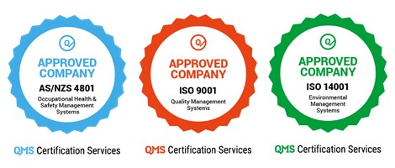

Mobile phones & other equipment
- The operation of mobile phones, radio telephones, and CB sets in vehicles whilst the vehicle is in motion is not permitted (except where a hands free kit is used)
- Additional rules can be found in the mobile phone use policy

Plant & Equipment Daily Checks
- Drivers will complete daily pre-start plant checks on equipment using the appropriate forms supplied

Vehicle Operation
- At all times drive safely, obey all road laws and consider the safety of all road users
- Drivers of heavy vehicles must have a zero blood alcohol level (0.00) and not under the influence of any drugs that may affect their ability to driver or operate the vehicle safely
- Company vehicles are only to be used for work activities unless otherwise arranged
- Company vehicles are permitted to carry only people and goods associated with company activities unless otherwise arranged
- Vehicles parked overnight away from the depot must be securely parked with tools and equipment locked away or covered up
- Smoking or Vaping is not permitted in company vehicles or plant
- Drivers are expected to display good driving habits and road courtesy when driving company vehicles
- Seat belts where fitted must be used at all times in accordance with the Road Safety Act
- Ignition keys must not be left in the vehicle when parked or unattended. Keys are to be kept in a secure location
- It is the driver’s responsibility to comply with any local government (council) regulations and by-laws controlling use and parking vehicles within council areas

Fatigue Management
- Vehicle drivers must follow the fatigue management rules set down in the company fatigue management plan

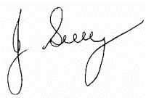

Signed by Director: John Guy
(Name)
31/08/25
(Date)

 Signature

Policy Review Date: July 2028

