
PANELTEC PTY LTD
A.B.N. 12 128 689 412

INTEGRATED MANAGEMENT SYSTEM MANUAL QUALITY-WORK HEALTH & SAFETY-ENVIRONMENT
Revision No: 010 Revision Date: 31/08/25
Document No: IMS-05.07
SMOKE FREE WORKPLACE POLICY

Passive smoking (the inhalation of environmental tobacco smoke [ETS]) increases risks to health.

For the requirements surrounding inhalation of tobacco products via vapor dispensing pipes or e-cigarettes the requirements for smoking and vaping are the same as outlined below.

Paneltec Pty Ltd has a duty of care under Work Health and Safety legislation to provide a safe and healthy work environment for all workers and others who enter the workplace.

Paneltec Pty Ltd has therefore adopted a Smoke-free Workplace Policy. This policy intends to eliminate smoking in the workplace and prevent exposure of workers to environmental tobacco smoke.

Objective
To achieve a smoke-free workplace, to protect all workers and visitors from the effects of environmental tobacco smoke and reduce the fire risk.

Implementation
Smoking will not be permitted in any enclosed areas, including meeting rooms, staff rooms, display homes and company motor vehicles.

Smoking will not be permitted within three metres of access points to buildings such as doors, and open windows. Smoking will not be permitted in other areas designated as ‘No Smoking’ areas by signage.
Smoking is not permitted on any site and or client premises deemed a non-smoking area.

Workers who wish to smoke must do so within designated areas only. Workers who do smoke are requested to dispose of their litter in the correct manner and leave the smoking area neat and tidy.

The responsibility for enforcing this policy rests with managers and workers. All are obliged under Work Health and safety legislation to protect the health of their fellow workmates and members of the public while at the workplace.

Any person who breaches this policy may face disciplinary measures.

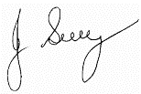

Signed by Director: John Guy
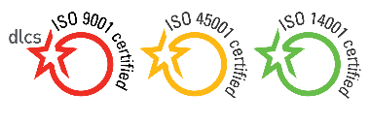 (Name)
31/08/25
(Date)
Signature

Policy Review Date: July 2028

Controlled Document Authorised & Approved by Management Page 1 of 1

