
PANELTEC PTY LTD
A.B.N. 12 128 689 412

INTEGRATED MANAGEMENT SYSTEM MANUAL QUALITY-WORK HEALTH & SAFETY-ENVIRONMENT
Revision No: 010 Revision Date: 31/08/25
Document No: IMS-05.04

ENVIRONMENT POLICY

Paneltec Pty Ltd is committed to achieving compatibility between economic development and the maintenance of the environment whilst complying with AS/NZS ISO 14001.

To fulfil this commitment, we the PCBU and our workers will observe all environmental laws by:

- Ensuring compliance with environmental legal requirements including the EPA Regulations, AS/NZS Standards and industry best practice as a minimum level within all of its activities.

- Integrating environmental factors into planning and operational decisions and processes.

- Assessing environmental effects of our activities and regularly monitor and audit our environmental performance.

- Continually improve our environmental performance.

- Promote environmental awareness among our workers to increase understanding of environmental matters.

- Use of innovations and technologies to minimise atmospheric emissions and noises.

- Minimise the generation of waste products.

- Being an industry leader in Environmental Management.

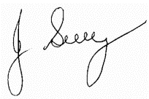

Signed by Manager: John Guy
(Name)
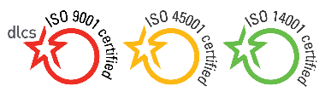
31/08/25
Signature

Policy Review Date: July 2028

Controlled Document Authorised & Approved by Management Page 1 of 1

