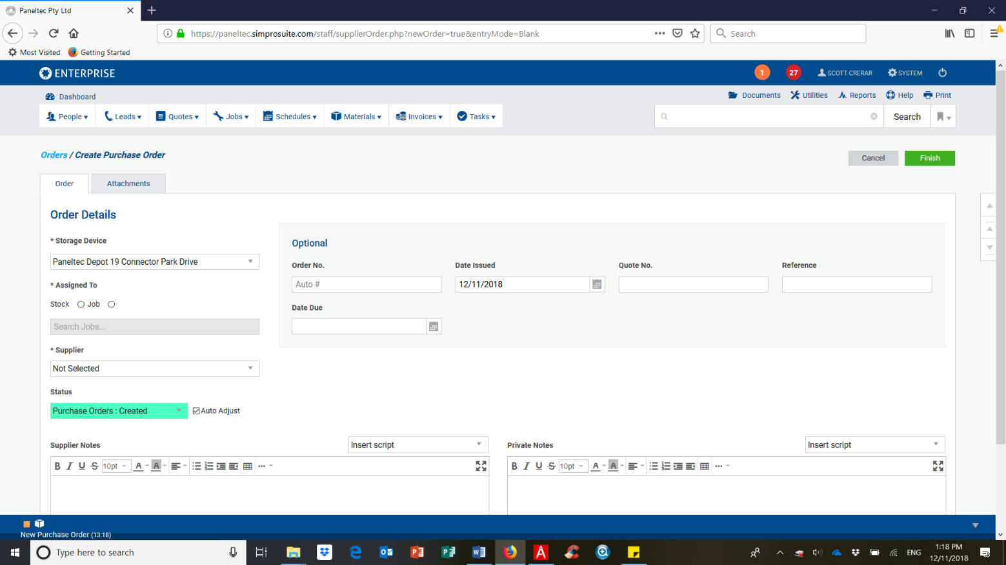
REFER TO SIMPRO ENTERPRISE PC PROGRAM – PURCHASE ORDERS

