PROJECT DETAILS
Project No. |  | Project Title: | Construction Project: | Project Address:
PROJECT CONTACTS |  |  | PROJECT SCOPE OF WORKS | SITE ENVIRONMENTAL CONDITIONS
Position | Name | Contact
TW Project Manager |  |  |  | - If contaminated soil is found during excavation, then the Environmental Advisor/Project Manager must be notified immediately. With the soil disposed of accordingly.  - Paneltec agree that any suspected or identified contaminated soil will be immediately brought to the attention of the TasWater Project Supervisor and or TasWater Environmental Advisor
TW Project Supervisor
TW Environmental Advisor
TW Community Engagement Officer
Contractor Details | Paneltec | 6343 2026
TW Community Hotline - Available 24/7 |  | 13 69 92
PROJECT SITE HOURS OF WORK
Standard Construction Works:
Monday to Friday 7:00 am to 5:00 pm
Saturday No work
Sunday No work
No works to be carried out on weekends or public holidays unless a permit has been accepted.
 |  |  |  | ENVIRONMENTAL APPROVALS AND PERMITS
- PDGTOL36 Out of Hours Work Permit (as required)
- PDGTOL38 Disturb Land or Vegetation Permit (completed prior to excavation)
- PDGTOL84 Permit to Dewater (as required)
SEDIMENT AND EROSION CONTROL |  |  | FLORA AND FAUNA | WEED, PEST AND DISEASE
Management Measures [PDG EMP Standard Sub-plan 1] |  |  | Management Measures [PDG EMP Standard Sub-plan 2] | Management Measures [PDG EMP Standard Sub-plan 3]
- Erosion and sediment controls, including clean water diversions, must be installed prior to commencement of ground disturbance. These controls must be maintained and remain in place until ground stabilisation has occurred.  - Cleared areas must be kept to a minimum.  - Topsoil must be retained where possible and stockpiled separately from all other materials.  - Topsoil stockpiles not to be compacted or have any materials stored on them.  - Mud and soil not to be tracked offsite onto public roads.  - If concrete washout is required, an adequate number of concrete washout facilities must be installed and maintained. The washout facilities will be isolated from surface water flows and will be lined to prevent contamination of soil, ground and river water.  - Excess concrete (including washout) must not be discharged to stormwater or to the ground, excess concrete to be disposed of to an appropriate facility.  - Site affected water not to be discharged from site without a Permit to Dewater.  - Existing ground conditions and weather forecasts will be taken into consideration prior to conducting civil works. Excavation works will not be conducted if ground conditions are unsuitable or pose environmental risk.  - Paneltec will abide by the above measures and will implement controls. |  |  | - Prior to any grubbing, clearing or disturbance to vegetation on site a Permit to Disturb Land must be in place.  - Paneltec to liaise with TW Project Supervisor prior to excavation and complete permit  - Site speed limits must be obeyed at all times.  - All vehicles must use formed access tracks and laydown areas as designated.  - Trenches, HDD entry and exit pits shall be covered and/or fenced at the end of a shift, or fauna egress provided, to prevent animals becoming trapped.  - Paneltec will abide by the above measures and will implement controls. | - All ground engaging plant and equipment shall be cleaned down of all soil and vegetation material in accordance with the washdown procedures outlined in the Weed and Disease Planning and Hygiene Guidelines – Preventing the spread of weeds and diseases in Tasmania (DPIPWE, 2015); a documented inspection of the plant and/or equipment must be completed:  - Prior to arrival on site.  - All Paneltec plant, vehicles and equipment will arrive on-site cleaned of soil and vegetation material  - All soils or mulch materials bought to the project site must be certified (including documentation) by the supplier as weed-free.  - Gravel base will be the only fill medium brought to site  - Paneltec will endeavour to reuse excavated material where appropriate.
NOISE AND VIBRATION | AIR QUALITY | HERITAGE
Management Measures [PDG EMP Standard Sub-plan 4] | Management Measures [PDG EMP Standard Sub-plan 5] | Management Measures [PDG EMP Standard Sub-plan 6]
- Undertake construction activities within the nominated hours of work to comply with contractual and legal requirements. An Out of Hours Work Permit must be in place prior to commencing work outside of the allowable working hours for the site.  - All equipment must be serviced and maintained according to manufacturer’s recommendations, or more frequently if required to minimise noise generated.  - The Australian Standard AS 2436-2010 shall be used to guide appropriate measures for mitigating construction and demolition noise.  - Where fitted, engine covers must remain closed when machinery is in use.  - Construction machinery, plant and equipment shall be switched off or throttled down to a minimum when not in use.  - Consider neighbours and minimise noise when packing up plant and equipment and/or departing from site.  - Paneltec will abide by the above measures and will implement controls. | - All construction plant and equipment must be maintained in accordance with manufactures specifications to minimise fugitive exhaust emissions.  - Loads must be covered where practicable when hauling dust-generating material to or from site.  - Burning of any materials is prohibited onsite.  - Paneltec will abide by the above measures and will implement controls. | - In the event a suspected heritage artefact or area is uncovered during construction, work must cease, and the Unanticipated Discovery Plan, as identified in the Heritage Management Procedure, must be adhered to.  - Paneltec will abide by the above measures and will implement controls.
ENVIRONMENTALLY HAZARDOUS MATERIALS | BUSHFIRE RISK | WASTE
Management Measures [PDG EMP Standard Sub-plan 7] | Management Measures [PDG EMP Standard Sub-plan 8] | Management Measures [PDG EMP Standard Sub-plan 9]
- An Emergency Response Plan which incorporates a spill response procedure shall be maintained for the project.  - All refuelling points and refuelling/service vehicles must have fully stocked hydrocarbon spill kits.  - Storage and handling of environmentally hazardous materials must be in strict accordance with the applicable standards and MSDS for the substance.  - Environmentally hazardous substances must be stored in a bunded area with a minimum holding capacity of 110% of the largest container within the bund or 25% of the total capacity of all containers within it, whichever is the greater.  - The types and sizes of spill kits on site must be selected based on the types and volumes of materials stored.  - Training in the use of spill kits must be provided to relevant construction staff.  - Management of environmentally hazardous materials must be covered in the site induction. Relevant construction staff will undergo spill response training, as well as safe handling and storage training.  - Undertake routine maintenance of plant and equipment for prevention of leaks of hazardous substances, such as fuel and hydraulic fluid.  - Paneltec will abide by the above measures and will implement controls. | - Smoking must only be permitted in designated areas. These shall be clearly marked, communicated to site personnel, and their locations shown on the Site Environment Plan (SEP).  - No open fires shall be permitted on the project site at any time.  - Paneltec will abide by the above measures and will only be in designated areas. | - All wastes streams must be classified, stored, tracked, transported and treated in accordance with contractual and regulatory requirements, including the use of licensed transport and treatment facilities.  - Adequate and appropriate waste storage must be present onsite at all times for all waste streams present.  - Waste Classification and Management table in the PDG EMP to be used to manage waste streams  - Waste storage must be clearly sign posted to inform all project personnel of the correct material to be placed within each storage type. Containers must be emptied at a frequency that is sufficient to ensure their correct use.  - Excess concrete and concrete washout is not to be discharged to land or stormwater; a concrete washout facility must always be used.  - All waste stream volumes must be recorded and provided to TasWater.  - Burial or burning of waste is not permitted on project sites.  - Paneltec will abide by the above measures and will implement controls.

TRAFFIC | CONTAMINATED LAND | ACID SULFATE SOILS
Management Measures [PDG EMP Standard Sub-plan 10] | Management Measures [PDG EMP Standard Sub-plan 11] | Management Measures [PDG EMP Standard Sub-plan 12]
- All traffic will adhere to designated roads and associated speed limits.  - Paneltec will abide by the above measures and will implement controls. | - In the event unanticipated contaminated materials are discovered or suspected, works must cease, and the EA notified immediately.  - Disposal (and transport) of contaminated soil must be undertaken in accordance with the requirements of EPA Tas IB 105 and relevant legislation.  - Existing abandoned rising main to be left untouched.  - Paneltec agree that any suspected or identified contaminated soil will be immediately brought to the attention of the TasWater Project Supervisor and or TasWater Environmental Advisor | - In the event unanticipated ASS materials are discovered or suspected, the following must be undertaken:  - No Acid Sulphate Soils anticipated at this location As per “The List”  - Acid Sulphate Soils to be managed in accordance with the “Tasmanian Acid Sulphate Soil Management Guidelines”.  - Less than 100m³ of excavation during project and no filling of land. Current project construction methodology (Horizontal Directional Drill of proposed pipeline).  - No further consideration of ASS required.  - If construction method or excavated quantities over 100m³ the following will occur.  - Works must cease, and the EA notified immediately, with works to remain ceased until the all clear to proceed has been given.  - Field screening tests must be conducted in accordance with the Tasmanian Acid Sulfate Soil Management Guidelines (DPIPWE 2015) by a suitably qualified person.  - Laboratory testing must be undertaken in the event PASS are identified from the screening test.  - Paneltec agree that any ASS will be immediately brought to the attention of the TasWater Project Supervisor (DV) and or TasWater Environmental Advisor (JT)  - ASS (Acid Sulphate Soil)
GHG & ENERGY | WATER MANAGEMENT
Management Measures [PDG EMP Standard Sub-plan 13] | Management Measures [PDG EMP Standard Sub-plan 14]
- Project fuel consumption to be recorded and reported through to TasWater on a monthly basis.  - Construction machinery, plant and equipment shall be switched off when not in use.  - Construction machinery, plant and equipment shall be modern to maximise efficient use of fuel.  - Paneltec will abide by the above measures | - All Vacuum Truck, Drill and Consumable Water shall be filled and loaded at the Paneltec Depot

Project/Site Specific Monitoring Requirements
as per PDG EMP [0001-PLN-EN-0002], Environmental Monitoring Procedure [0001-PRO-EN-0009]
Location | Parameter | Acceptance Criteria | Frequency | Equipment / Methodology | Record | Responsibility
Site wide | Inspection Score | 100% | Weekly or one per project if works are under a week. |  | - PDGTOL76 HSE Site Inspection Checklist – (Environmental section) | Supervisor / EA

SITE PLAN(S) SHOWING DETAILS OF ENVIRONMENTAL MANAGEMENT AND MITIGATION FEATURES
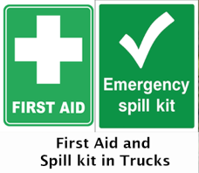
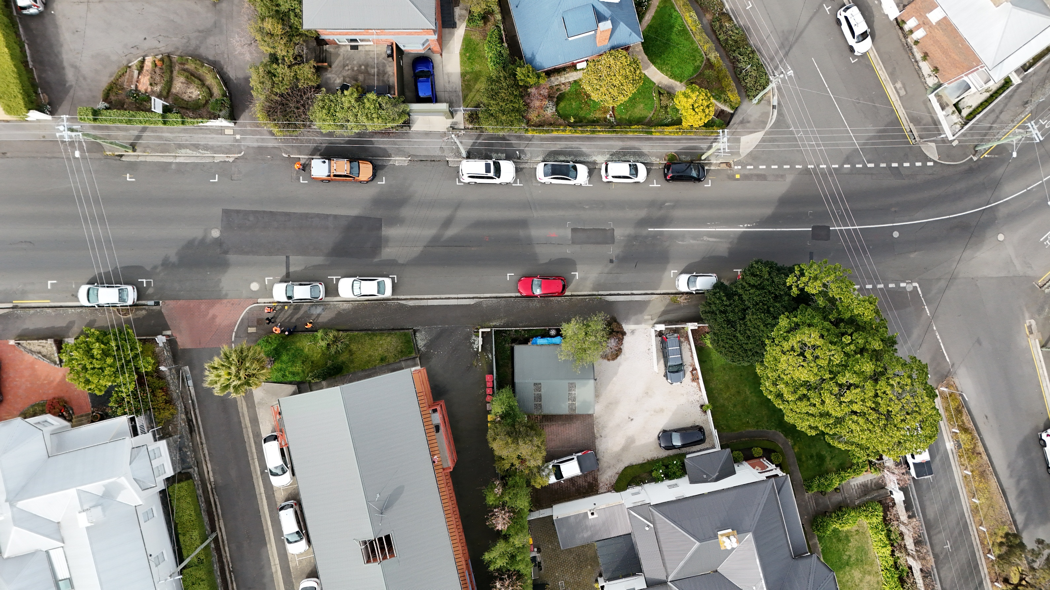
EXAMPLE
Primary Excavation zone
LV Power (overhead)
Gas Main
Sediment Control
Water Main
Site Office

