  - Viatec Traffic Solutions/THE PANELTEC GRoup

INCIDENT Investigation

August 2024
Private & Confidential
INSERT NAME OF LEAD INVESTIGATOR / PERSON THAT PREPARED THE REPORT

[Choose date]
Contents
1 Overview 4
1.1 Investigation Trigger 4
1.2 Brief Incident Overview 4
1.3 Key Findings 4
1.4 Key Contributing Factors 4
1.5 Suspected Cause(s) 4
1.6 Actions required 4
2 Incident Summary 5
2.1 Incident Details 5
2.2 Photos 5
2.3 Details of Person(s) Involved / affected 5
2.4 Consequences (tick all that apply) 5
3 Attachments and Tools Used 6
3.1 Summary of Events 7
3.2 Data Collection (PEEPO) 8
3.3 Critical Risk Control Protocol – Evaluation 10
3.4 ICAM Chart 13
3.5 Root Tree Analysis – 5 Whys 15
3.6 Alternative “5 Why” Tool 16
3.7 Witness Statement(s) 17

Executive Summary
(Provide a high-level summary of the investigation, including any substantial recommendations)

INVESTIGATION TEAM:
Lead Investigator Name / Position |  |  |  | Click or tap to enter a date.
Lead Investigator |  | SIGNATURE (CAN BE DIGITAL) |  | DATE
Investigator Name / Position |  |  |  | Click or tap to enter a date.
Investigator |  | SIGNATURE (CAN BE DIGITAL) |  | DATE
Investigator Name / Position |  |  |  | Click or tap to enter a date.
Investigator |  | SIGNATURE (CAN BE DIGITAL) |  | DATE
Investigator Name / Position |  |  |  | Click or tap to enter a date.
Investigator |  | SIGNATURE (CAN BE DIGITAL) |  | DATE

APPROVED BY:
Name/Position of Division Approver |  |  |  | Click or tap to enter a date.
DIVISION |  | SIGNATURE (CAN BE DIGITAL) |  | DATE
Name / Position of HSEQ Approver |  |  |  | Click or tap to enter a date.
HSE TEAM |  | SIGNATURE (CAN BE DIGITAL) |  | DATE

INITIAL DISTRIBUTION TO:
Name / Position | Name / Position

- Overview
  - Investigation Trigger
☐ | Severity 1 Event | ☐ | Potential Class 1 Event (PC1) | ☐ | Regulator Notifiable
☐ | Workers Comp Claim | ☐ | Lost Time Injury (LTI) | ☐ | Other:
  - Brief Incident Overview

  - Key Findings

  - Key Contributing Factors

  - Suspected Cause(s)

  - Actions required
Actions must address the causes / contributing factors identified throughout the incident.
Item | Corrective Actions | Responsible Person | Due Date
1
2
3
4
5
6

- Incident Summary
  - Incident Details
Date of Incident: | Click here to enter a date.
Date of Investigation: | Start: Click here to enter start date  End: Click here to enter end date
Synergy Incident Number: | Click here to enter incident number.
Site/ Location: | Click here to enter site / location where incident occurred.
Reported to: | Click here to enter who the incident was reported to
Activity being completed: | Click here to enter details of the activity being completed at the time of incident
  - Photos
(INSERT RELEVANT PHOTOS / ANNOTATION)
  - Details of Person(s) Involved / affected
Name/Position | Involvement /Impact
  - Consequences (tick all that apply)
Y/N | Outcome | Actual Consequences from the Incident
☐ | Injuries | provide details of the injuries that occurred as a result of the incident
☐ | Medical Treatment | provide details of any medical treatment provided
☐ | Lost Time | Provide details of time lost / suspected duration
☐ | Fatality/s: | Provide details of the number of fatalities
☐ | Environmental Harm: | Provide details of Environmental Harm
☐ | Dangerous Incident | Provide details on whether the incident was a dangerous occurrence (near miss/hit requiring regulator notification)
☐ | Financial Impacts | Provide details of any financial impacts
☐ | Property Damage: | Provide details of the extent of any property damage including structures, plant and equipment
Potential Consequences: |  | Provide details of the potential consequences based on the most likely outcome had the event been fully realised.

- Attachments and Tools Used
Select the relevant tools that will be completed for this investigation. Not all tools need to be used for all investigations.

Y/N | Attachment / Tool | Mandatory For
☐ | Summary of Events | All Investigations
☐ | Data Collection (PEEPO) | Severity 1&2 Events
☐ | Critical Risk Control Protocol – Evaluation | Events involving critical risks
☐ | ICAM Chart | Severity 1&2 Events
☐ | Root Tree Analysis – 5 Whys | As needed - Optional
☐ | Alternative “5 Why” Tool | As needed – Optional
☐ | Witness Statement(s) | As needed - Optional

  - Summary of Events
DATE | TIME | DETAILS
 |  | PRE INCIDENT – What occurred leading up to the incident (go as far back as relevant, e.g. 72hrs prior to the event)
 |  | INCIDENT OCCURRED
 |  | POST INCIDENT – What initial action was taken post incident?

  - Data Collection (PEEPO)
Select relevant pieces of evidence that has/needs to be collected and provide summary details for each. This should be completed as a planning activity at the early stages of the investigation.
People | Environment | Equipment | Procedures | Organisational
Psychology - Assessment of personality, safety attitude, motivation, conflict, stress, external influences, i.e. social and domestic pressures | Select Environment Data to be Collected | Select Equipment Data to be Collected | Select Procedure Data to be Collected | Select Organisational Data to be Collected
Details of data collected/to be collected | Details of data collected/to be collected | Details of data collected/to be collected | Details of data collected/to be collected | Details of data collected/to be collected
Select People Data to be Collected | Select Environment Data to be Collected | Select Equipment Data to be Collected | Select Procedure Data to be Collected | Select Organisational Data to be Collected
Details of data collected/to be collected | Details of data collected/to be collected | Details of data collected/to be collected | Details of data collected/to be collected | Details of data collected/to be collected
Select People Data to be Collected | Select Environment Data to be Collected | Select Equipment Data to be Collected | Select Procedure Data to be Collected | Select Organisational Data to be Collected
Details of data collected/to be collected | Details of data collected/to be collected | Details of data collected/to be collected | Details of data collected/to be collected | Details of data collected/to be collected
Select People Data to be Collected | Select Environment Data to be Collected | Select Equipment Data to be Collected | Select Procedure Data to be Collected | Select Organisational Data to be Collected
Details of data collected/to be collected | Details of data collected/to be collected | Details of data collected/to be collected | Details of data collected/to be collected | Details of data collected/to be collected
Select People Data to be Collected | Select Environment Data to be Collected | Select Equipment Data to be Collected | Select Procedure Data to be Collected | Select Organisational Data to be Collected
Details of data collected/to be collected | Details of data collected/to be collected | Details of data collected/to be collected | Details of data collected/to be collected | Details of data collected/to be collected

  - Critical Risk Control Protocol – Evaluation
Use this tool to identify gaps in critical controls that were relevant to the Incident’s occurrence. Details of gaps should be incorporated into the ICAM Chart where relevant.
Critical Risk | Applicable | Details of any controls that were absent, or not effectively implemented | Additional Information
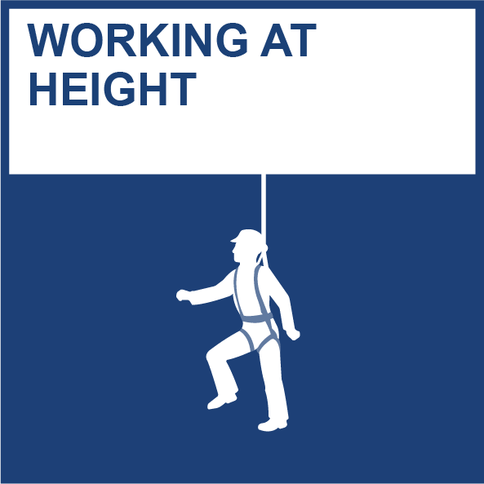 | ☐ | Select Control
 |  | Provide Details
 |  | Select Control
 |  | Provide Details
 | ☐ | Select Control
 |  | Provide Details
 |  | Select Control
 |  | Provide Details
 | ☐ | Select Control
 |  | Provide Details
 |  | Select Control
 |  | Provide Details
 | ☐ | Select Control
 |  | Provide Details
 |  | Select Control
 |  | Provide Details
 | ☐ | Select Control
 |  | Provide Details
 |  | Select Control
 |  | Provide Details

Critical Risk | Applicable | Details of any controls that were absent, or not effectively implemented | Additional Information
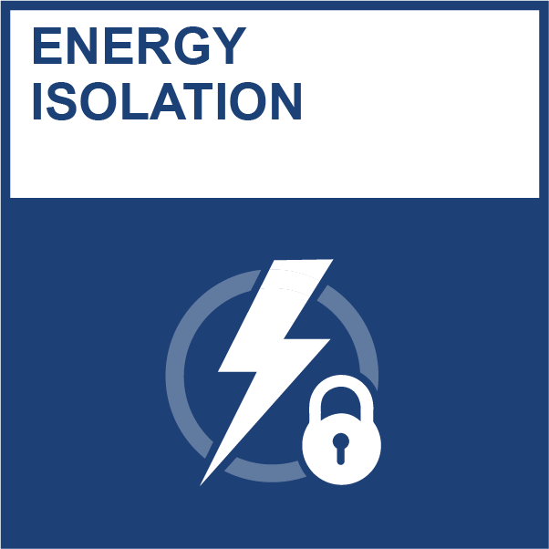 | ☐ | Select Control
 |  | Provide Details
 |  | Select Control
 |  | Provide Details
 | ☐ | Select Control
 |  | Provide Details
 |  | Select Control
 |  | Provide Details
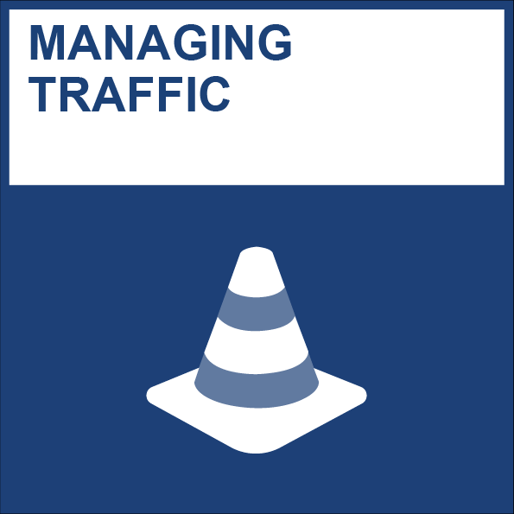 | ☐ | Select Control
 |  | Provide Details
 |  | Select Control
 |  | Provide Details
 | ☐ | Select Control
 |  | Provide Details
 |  | Select Control
 |  | Provide Details
 | ☐ | Select Control
 |  | Provide Details
 |  | Select Control
 |  | Provide Details
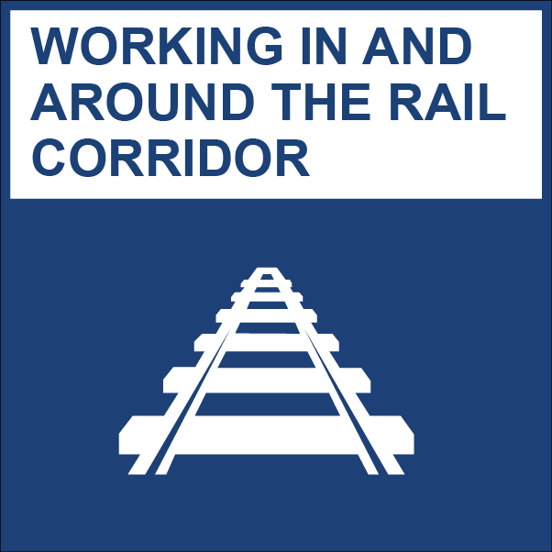 | ☐ | Select Control
 |  | Provide Details
 |  | Select Control
 |  | Provide Details
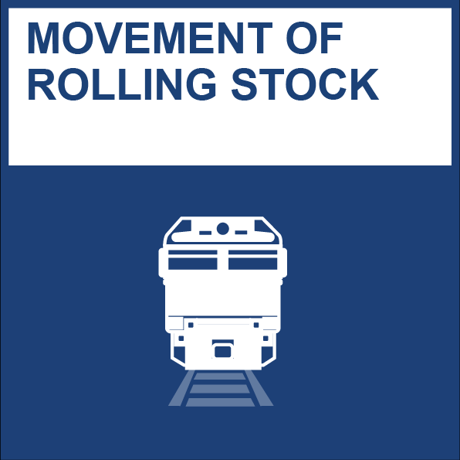 | ☒ | Select Control
 |  | Provide Details
 |  | Select Control
 |  | Provide Details

  - ICAM Chart
Select relevant contributing factors starting from the absent and failed defences, working backwards and provide comments in the cell bellow

Organisational Factors | Task / Environmental Conditions | Individual / Team Actions | Absent or Failed Defences | Incident
Select organisational factors | Select task/environmental conditions | IT04 Equipment Use Error or Violation | DF12 Hazard Awareness | INCIDENT
Details for OF Selected | Details for TE Selected | Details for ITA Selected | Details for AFD Selected
Select organisational factors | Select task/environmental conditions | Select individual/team actions | DF08 Rescue
Details for OF Selected | Details for TE Selected | Details for ITA Selected | Details for AFD Selected
Select organisational factors | Select task/environmental conditions | Select individual/team actions | Select absent or failed defences
Details for OF Selected | Details for TE Selected | Details for ITA Selected | Details for AFD Selected
Select organisational factors | Select task/environmental conditions | Select individual/team actions | Select absent or failed defences
Details for OF Selected | Details for TE Selected | Details for ITA Selected | Details for AFD Selected
Select organisational factors | Select task/environmental conditions | Select individual/team actions | Select absent or failed defences
Details for OF Selected | Details for TE Selected | Details for ITA Selected | Details for AFD Selected
Select organisational factors | Select task/environmental conditions | Select individual/team actions | Select absent or failed defences
Details for OF Selected | Details for TE Selected | Details for ITA Selected | Details for AFD Selected
Select organisational factors | Select task/environmental conditions | Select individual/team actions | Select absent or failed defences
Details for OF Selected | Details for TE Selected | Details for ITA Selected | Details for AFD Selected

  - Root Tree Analysis – 5 Whys
Visual representation of why the incident occurred.

  - Alternative “5 Why” Tool
Brief description of the incident:
Provide a brief description of the incident:
 | What were the immediate cause(s) of the incident? | Cause 1 Details | Cause 2 Details | Cause 3 Details
 | Why 1? | Cause 1 -Why 1 Details | Cause 2 -Why 1 Details | Cause 3 -Why 1 Details
 | Why 2? | Cause 1 -Why 2 Details | Cause 2 -Why 2 Details | Cause 3 -Why 2 Details
 | Why 3? | Cause 1 -Why 3 Details | Cause 2 -Why 3 Details | Cause 3 -Why 3 Details
 | Why 4? | Cause 1 -Why 4 Details | Cause 2 -Why 4 Details | Cause 3 -Why 4 Details
 | Why 5? | Cause 1 -Why 5 Details | Cause 2 -Why 5 Details | Cause 3 -Why 5 Details

  - Witness Statement(s)

Name of Witness: | Include full name of the witness.
Position/Employer: | Provide details of employer and position held with employer.
Contact Details: | Include contact number, email and/or work address.
Statement taken by: | Enter the name of the person taking the statement, or state “Self” if applicable
Date of Statement: | Click here to enter a date.
Method of collection: | ☐ Phone ☐ Email ☐ Face to face ☐ Written by witness
Statement: | Provide details of what was observed leading up to the incident, during the incident and post incident. – Should be written in the witnesses own words

