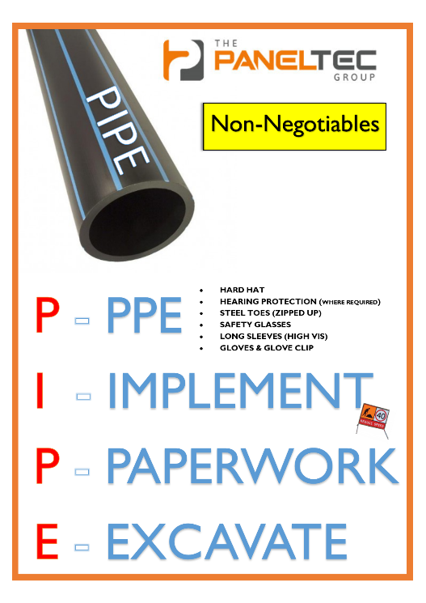
As an employee of Paneltec Pty Ltd (Paneltec) I understand that the following Items of Personal Protective Equipment (PPE) are mandatory to wear on all Paneltec Work Sites and at the depot where necessary.

- Hard Hat
- Hearing Protection (In all environments >75DB)
- Steel Capped Safety Boots (Zipped up & Laced)
- Safety Glasses and; or Face Shield (where double protection is required)
- Long Sleeved Highly Visible Work Wear
- Gloves & Glove Clip on Person or in PPE Bag

I understand that it is a requirement of Regulation 46(2) of the Work Health and Safety Regulations 2012 Duties of worker, which states; that a worker shall use or wear PPE in accordance with any information, training or reasonable instruction by the person conducting the business or undertaking, and any non-compliance may result in a personal fine of up to $3600.00 being issued by the Regulator.

I hereby confirm that I will wear the above PPE in the term of my employment with Paneltec and advise management immediately if the PPE is damaged, broken or missing. Lost PPE or intentionally damaged PPE will be replaced at the Employees own cost.

Worker’s Name: ____________________

Signature: _________________________

Management Representative: ___________________

Management Signature: _______________________ Date: _____________

