Procedure
This procedure is to be used as a guide to ensure underground assets eg sewer, electrical, gas, telephone etc are not disturbed or damaged during excavation works.

Process
- All service utilities are required to maintain records of their underground services.
- When planning a job requiring drilling or ripping, a complete record search must be undertaken by lodging an enquiry with ‘Before You Dig Australia’.
- Lodging an enquiry with ‘Before You Dig Australia’ is as simple as making a free request via
https://www.byda.com.au/
- Asset owners who are not members of this service must also be contacted directly.
- Many risks associated with working near existing underground services can be minimised at the project planning stage.
- Tas Gas will contact the request applicant if the proposed excavation site is within striking distance of their strategic supply services (and will sometimes meet on site to markup their assets).
- Once the records are obtained, they should remain in the work area and be accessible to all.
- When carrying out emergency work, every effort should be made to obtain records as soon as possible. If work must commence prior to the records being obtained, it should be carried out on the basis that underground services are present. When an asset location is requested, asset owners may provide information on the recommended practices for work near that location or service.
- Before undertaking an excavation in any street or footway, approval from the authorities and asset owners involved must be obtained.
- For works on public lands, some utility/service providers, e.g. the Roads Authority (i.e. the Local Council, or State Roads.) may have approval processes in place as a result of legislation or established agreements. Where any exemptions apply, the Roads Authority, State Growth, the local Council or other entities may still require notification of the works.
- A critical part of planning safe systems of work is the validation of records at the work site - With some services installed over 60 years ago, it is likely that changes would have been made to the surface of the land at some stage. Road widening and regrading of surfaces are common causes for inaccuracies in records. For this reason, when working from old records, pipe and cable locating devices or third-party locating services should be used. Any inaccuracies in records should be notified to the relevant authority.
- Utility companies typically require notification and approval of a major project or where the project may require supply of a service or product outside normal residential demand.
- At the project planning stage, it is important to consider minimising damage to surface infrastructure and disruption of services to residents, pedestrians and traffic.
- Any construction or maintenance technique should ensure adequate clearances are maintained between services and that other services crossings are identified.
- Consideration should also be given to the appropriate level of supervision and training, including specific industry awareness training, for an individual undertaking work near any gas or electrical assets.

Working near TasNetworks’ ground mounted infrastructure and underground power cables
TasNetworks’ electricity network also uses ‘ground mounted’ assets, including high voltage substations, electrical cabinets and electrical turrets (photographs of typical examples of these assets are provided in Appendix A).
TasNetworks also has an extensive underground distribution network of cables operating at both high voltage and low voltage.
Contractors planning underground work must contact ‘Before You Dig Australia’ at https://www.byda.com.au before commencing work. A response will be provided on whether TasNetworks ‘Does’ or ‘Does NOT’ have a record of infrastructure in the location of the proposed works provided by the Contractor.
If TasNetworks does have a record of infrastructure at the location of the proposed works, then the Contractor should use a cable location service to accurately identify the location of the infrastructure.
TasNetworks must be notified by contacting 1300 137 008 at least 7 days in prior to the commencement of the works if:
- The proposed work is within 2 m of TasNetworks’ ground mounted assets (refer Appendix A);
or
- The proposed work is within 1 m of TasNetworks’ underground assets, e.g. cables. The notification must provide details of the proposed work and the location.

TasNetworks will provide a response as to whether the work can be undertaken and any requirements that must be adhered to when undertaking the work.

Without prior written authorisation from TasNetworks the Contractor is not authorised to undertake the proposed work. Failure to comply with this requirement can lead to prosecution under the Electrical Supply Industry Act.

The Guidelines When Working near TasNetworks Electrical Assets (NW30394588) referenced below set out the requirements for working near Underground Powerlines.

About TasNetworks
Tasmanian Networks Pty Ltd (ACN 167 357 299) (‘TasNetworks’) is the owner and operator of the regulated electricity network in Tasmania, with the exception of the Bass Strait Islands.

Who these guidelines apply to
These guidelines are TasNetworks’ minimum requirements for when work is to be performed near TasNetworks’ electricity network by third parties (persons not working for TasNetworks), such as:
- Councils;
- Contractors to third parties;
- Other Infrastructure Owners;
- Land owners where TasNetworks’ electrical assets cross their property; and
- Any other persons who work in the vicinity of TasNetworks’ electrical assets as or on behalf of a third party.
For simplicity, councils, contractors to third parties, other infrastructure owners and other third parties working near TasNetworks’ electrical assets are referred to as ‘Contractors’ in this document.

Identification
To ensure the safe operation of its distribution network, TasNetworks should be informed of any activity that may have an impact upon the electricity network.

Contractors planning underground work must contact ‘Before You Dig Australia’ at https://www.byda.com.au before commencing work.

Hydro Tasmania, councils and property owners also own and manage electrical infrastructure. These organisations (or persons) should also be contacted during the work planning phase to determine if they have infrastructure near planned excavations and their requirements.

Notification
In accordance with The Tasmanian Electricity Supply Industry Act 1995, a person who proposes to do work near electrical infrastructure must give the appropriate electricity entity at least 7 days notice of the proposed work if:
- There is a risk of equipment or a structure coming into dangerous proximity to the electrical conductors; or
- The work may affect the support for any part of the electricity infrastructure; or
- The work may interfere with electricity infrastructure in some other way.

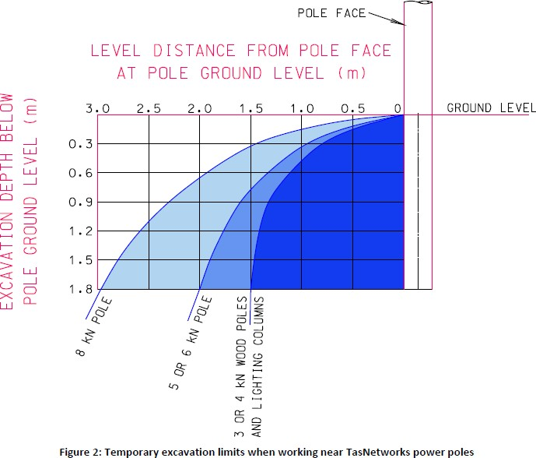
Figure 2 applies to TasNetworks’ timber poles and lighting columns with a length between 9 m and 12 m, strength of 3

kN to 8 kN and assumes that the excavation is open for no more than one week. (Information on identifying the length and strength of poles from the pole tag is given above).

If the pole is made from a material other than timber, then:
- If the pole is 125 mm rectangular hollow section (RHS), it should be treated like a 4 kN timber pole when using Figure 2.
- Any other pole type should be treated like an 8 kN timber pole when using Figure 2.
If excavations are located outside of the limit curves in Figure 2 or do not exceed 300 mm in depth, then work may proceed without notifying TasNetworks.

If the excavation falls within the limit curves (the shaded area) in Figure 2 and exceeds 300 mm in depth this will affect electrical infrastructure and the Contractor shall obtain written advice from a suitably qualified and experienced engineer detailing:
  - How the pole is to be kept safe during the excavation; and
  - How the ground around the structure should be reinstated.
A copy of the engineer’s advice along with the name, qualifications and contact details of the advising engineer shall to be emailed to structureandoverhead@tasnetworks.com.au at least 7 days in advance of the commencement of works. The Contractor must ensure the advising engineer’s advice is fully implemented.
If the engineering advice requires that the pole be physically supported, then this should be undertaken by TasNetworks.

Trenchless Techniques
- Before commencing trenchless techniques, the location of other services and survey marks is required. Positive locating of underground assets is achieved by either hand Pot-holing or water jetting and vacuum method (or equivalent asset location techniques) must be used to locate existing underground services to ensure adequate clearances are maintained between services and to locate other service crossings. Potholing at each service crossing and at regular spacing along services is recommended.
- Where high risk services are identified, consultation with the utility/service provider may be required. Where clearances required by other services cannot be achieved at the proposed depth of service installation, alternative solutions should be sought in consultation with the relevant parties, which may include the regulatory authority. Alternative solutions may include seeking alternative routes, relocation of existing assets, installing the new asset with reduced clearances, or installing the new asset well below the existing services.

Damage to TasNetworks’ assets – Stop Work Immediately and phone 13 2004

 Refer to Emergency Procedures – Underground Assets Gas/Electricity (A5 ‘Emergency Procedure’ cards in Excavators etc).

PROCEDURE RECORDS
Number | Detail
- | Dial B4 U Dig Information

