Procedure
The objective of the Code of Practice on How to Manage the Risk of Falls in the Workplace is to prevent incidents at workplaces involving falling from one level to another and to prevent or reduce injury resulting from those falls.

Process
To comply with the Code of Practice, the PCBU must identify all tasks that involve the possibility of someone falling. Tasks may include:
- Climbing up and down from machinery.
- Repairs or maintenance on any plant or structure.
- Working on fragile or unstable surfaces.
- The need for equipment to gain access.
- Working on sloping or slippery surfaces; and
- Working near an edge, hole, pit or shaft.
Using the processes outlined in the safety procedure “Hazard Identification Risk Assessment & Risk Control’ the incidents of ‘fall’ should be minimised.

When considering what safety measures need to be taken ask these questions.
- Can the work or some of the work be done from the ground or a solid construction?

- Can a passive fall prevention device be used? (Note: a passive fall prevention device is material or equipment or a combination thereof that is designed for preventing falls and, after initial installation, does not require any ongoing adjustment, alteration or operation by any person to ensure the device’s integrity.) (Example: elevated work platforms – fixed work platforms, cherry pickers, step platforms, building maintenance units; scaffolding; guard railing; safety mesh.

Can a work positioning system be used?
E.g. industrial rope access system or travel restraint system.

Can a fall injury prevention system be used?
E.g. safety net, catch platform or fall arrest harness system.

If none of the above measures are reasonably practicable or do not minimise the risk of a fall then a fixed or portable ladder or administrative control must be used.
In many cases a number of measures will be required to eliminate or reduce the risk of a fall.

Safety of Fall Prevention measures:
Ladders & Step Ladders
General - Ladders are primarily a means of access, not a work platform, and should only be used for light work where hand hold and stability can be maintained and only if it is not practicable to use other temporary work platforms such as trestles, scaffolds and EWP’s.
Portable ladders and step ladders should comply with the appropriate Australian Standard and be used in accordance with the manufacturer’s instructions. Ladders should have a load rating of at least 120kg, be of correct size and length for the associated work and provided with anti-slip feet where practicable. Only one person should work from a ladder at any one time. Persons should not over-reach when using a ladder.
Positioning & Securing - Ladders must be located and positioned to provide a safe and secure working medium. Extended ladders should be secured top and bottom, by securing at the ladder head, or held secure by other means, e.g. held securely at the base by an assistant.
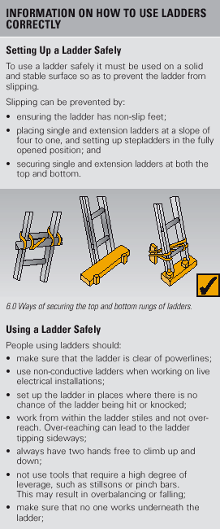
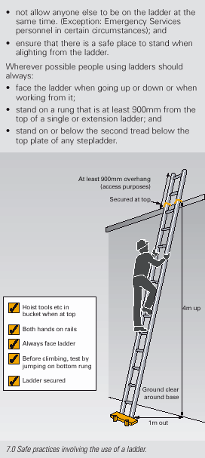
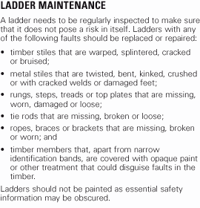

Ladder maintenance
Ladders should be regularly inspected by a competent person in accordance with the manufacturer’s recommendations. Ladders with any of the following faults must be replaced or repaired:
  - fibreglass stiles cracked, chipped or severely faded with fibres exposed
  - timber stiles warped, splintered, cracked or bruised
  - metal stiles twisted, bent, kinked, crushed or with cracked welds or damaged feet
  - rungs, steps, treads or top plates that are missing, worn, damaged or loose
  - tie rods missing, broken or loose
  - ropes, braces, or brackets that are missing, broken or worn
  - timber members that are covered with opaque paint or other treatment that could disguise faults in the timber
  - missing, loose, bent or worn fasteners, i.e. rivets, bolts and pins
  - worn or damaged feet, including non-slip material.

Temporary work platforms
A ‘temporary work platform’ is a working platform, other than a permanently installed fixed platform, used to provide a working area for the duration of the job. The design of the platform prevents workers from falling. Temporary work platforms include scaffolds, elevating work platforms, mast climbers, workboxes, building maintenance units, portable or mobile fabricated platforms or any other platform that provides a working area and is designed to prevent a fall.

Elevating work platforms
Elevating Work Platforms (EWPs) include scissor lifts, cherry pickers, boom lifts and travel towers. There are battery powered and internal combustion engine types. Some are designed for hard flat surfaces only, while others are designed to be operated on rough terrain.
Safety considerations include that:
- workers operating the platform are trained and instructed in safe operating procedures for the particular brand and type of equipment, as well as the safe use of fall-arrest equipment and emergency rescue procedures
- the platforms are only used as working platforms and not as a means of entering and exiting a work area unless the conditions set out in AS 2550.10 Cranes, hoists and winches - Safe use - Mobile elevating work platforms are met
- unless designed for rough terrain, the platforms are used only on a solid level surface
- the surface area is checked to make sure that there are no penetrations or obstructions that could cause uncontrolled movement or overturning of the platform
- the manufacturer’s or supplier’s instructions are consulted for information on safe operation
- persons working in travel towers, boom lifts or cherry pickers wear a properly anchored safety harness
- workers are licensed when operating boom-type elevating work platforms with a boom length of 11 metres or more.

Safe work procedures
An administrative control can be as simple as a safe work procedure that describes the steps involved in safely undertaking a task. It may also include any particular training, instruction and the level of supervision required. For example, a safe work procedure to reduce the risk of falls when entering or exiting vehicles may include instructing drivers to not jump down from the cab and always maintain three points of contact when climbing into or out of the cab.


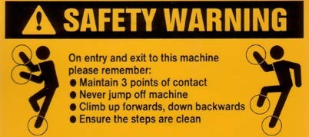
User friendly ‘3 points of contact stickers’ should be mounted at access points to plant & equipment.

These diagrams show the correct procedure for climbing in and out of trucks
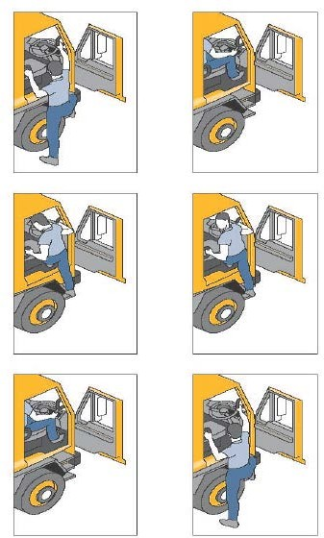

Reference:
Code of Practice on How to Manage the Risk of Falls in the Workplace

