General Guidelines
The Code of Practice for Confined Spaces notes that a confined space is determined by the hazards associated with a set of specific circumstances and not just because work is performed in a small space.
Regulation 5: A confined space means an enclosed or partially enclosed space that:
- Is not designed or intended primarily to be occupied by a person: and
- Is, or is designed or intended to be, at normal atmospheric pressure while any person is in the space: and
- Is or is likely to be a rick to health and safety from:
  - An atmosphere that does not have a safe oxygen level, or
  - Contaminants, including airborne gases, vapours and dusts, that may cause injury from fire or explosion, or
  - Harmful concentrations of any airborne contaminants, or
  - Engulfment.
Confined spaces are commonly found in vats, tanks, pits, pipes, ducts, flues, chimneys, silos, containers, pressure vessels, underground sewers, wet or dry wells, shafts, trenches, tunnels or other similar enclosed or partially enclosed structures, when these examples meet the definition of a confined space in the WHS Regulations.

Trenches are not considered confined spaces based on the risk of structural collapse alone, but will be confined spaces if they potentially contain concentrations of airborne contaminants that may cause impairment, loss of consciousness or asphyxiation.

If the space to be entered into falls within the above definition then the procedure for entering into the confined space must be followed.
All workers who are required to work in a confined space should receive full information, instruction and training in relation to hazards and risks and be made aware of the relevant risk assessment for the confined space work.

Consultation
You must consult your workers who are involved in carrying out work in or near a confined space during the process of identifying hazards, assessing risks and implementing control measures.

It is often more effective to involve a team of people in the risk management process to draw on a range of knowledge and experience, for example knowledge of:
- the particular confined space under assessment
- any work methods that will be used in or near the confined space
- confined space hazards and control measures.

The following flowchart will help to determine whether a space is a ‘confined space’ for purposes of the WHS Regulations.
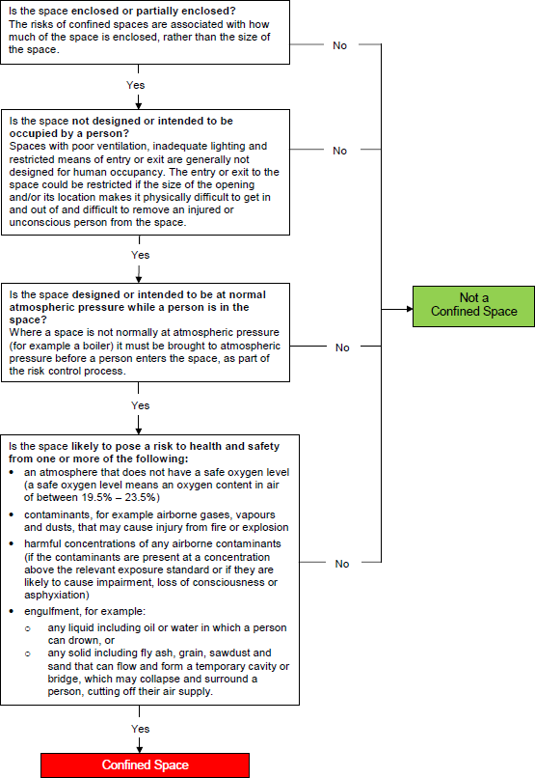

What hazards are associated with a confined space?

Restricted entry or exit
Small entrances and exits make it difficult to rescue injured workers or to get equipment in or out of the confined space. In some cases, entrances and exits may be very large but their location can make them difficult to access. For example, accessing pits or openings high up in silos may require the use of ladders, hoists or other devices, and escape and rescue from such spaces may be difficult in emergency situations.

Harmful airborne contaminants
The following table illustrates the kinds of harmful atmospheres that may be present in a confined space, and how they may be created.
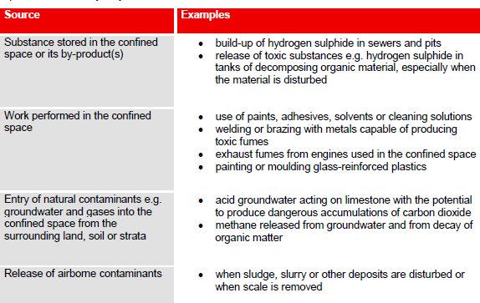

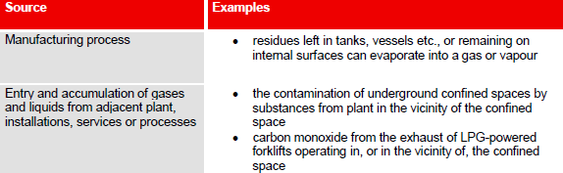

Unsafe oxygen level
Air normally contains 21% oxygen by volume, although oxygen levels of 19.5% — 23.5% by volume are considered to be safe.

Some situations can cause the level of oxygen to dramatically decrease, leading to an oxygen- deficient atmosphere and possible asphyxiation. This may occur, for example, if oxygen in the atmosphere is:
  - displaced by gases produced during biological processes, for example, methane in a sewer
  - displaced during purging of a confined space with an inert gas to remove flammable or toxic fumes
  - depleted inside metal tanks and vessels through surface oxidation (for example, when rust forms)
  - consumed during combustion of flammable substances
  - absorbed or reacts with grains, wood chips, soil or chemicals in sealed silos.

Too much oxygen can increase the risk of fire or explosion. Oxygen-enriched atmospheres may occur if:
  - chemical reactions cause the production of oxygen, for example certain reactions with hydrogen peroxide
  - there is a leak of oxygen from an oxygen tank or fitting while using oxy-acetylene equipment.

Fire and explosion
A fire or explosion requires the presence of three elements: an ignition source, air and a fuel (gas, vapour or mist) capable of igniting. A flammable atmosphere is one in which the flammable gas, vapour or mist is likely to exceed 5% of its lower explosive limit (LEL).

Flammable atmospheres in confined spaces may result from the evaporation of a flammable residue, flammable materials used in the space, a chemical reaction (such as the formation of methane in sewers), or from the presence of combustible dust (such as that in flour silos).

If an ignition source, such as a sparking electrical tool or static on a person, is introduced into a space containing a flammable atmosphere, an explosion is likely to result

Engulfment
Engulfment means to be swallowed up in or be immersed by material, which may result in asphyxiation. Examples of materials that may pose a risk of engulfment include plastics, sand, liquids, fertiliser, grain, coal, coal products, fly ash, animal feed and sewage. Stored materials such as sand and grain can form a crust or bridge when a container is emptied from below, leaving the top layer in place. Workers walking on the bridge or working below the bridge on the floor of the container may be engulfed if a bridge collapses.

Other hazards
Uncontrolled introduction of substances
The uncontrolled introduction of substances such as steam, water or other liquids, gases or solids may result in drowning, being overcome by fumes or other harm depending on the nature of the substance.

Vehicles and LPG forklifts operating close to the opening of the confined space can cause a build- up of exhaust gases, including carbon monoxide, in the space.

Biological hazards
Contact with micro-organisms, such as viruses, bacteria or fungi, may result in infectious diseases, dermatitis or lung conditions such as hypersensitivity pneumonitis. Sewers, grain silos and manure pits are examples of confined spaces where biological hazards may be present.

Mechanical hazards
Exposure to mechanical hazards associated with plant may result in entanglement, crushing, cutting, piercing or shearing of parts of a person’s body. Sources of mechanical hazards include plant such as augers, agitators, blenders, mixers and stirrers.

Electrical hazards
Electrical hazards may cause electrocution, shocks or burns, and can arise from cables, transformers, capacitors, relays, exposed terminals and wet surfaces where electrical circuit and electrically powered plant are used.

Skin contact with hazardous substances
The nature of a confined space could give rise to an increased likelihood of skin contact with surface contaminants. Skin contact with hazardous substances may result in immediate health effects such as burns, irritation or allergic dermatitis, or longer-term systemic effects

Noise
Noise generated in a confined space from the use of plant, the work method or process may be amplified due to reflections off hard surfaces. Exposure to hazardous noise may result in hearing loss, tinnitus and other non- auditory health effects. Hazardous noise may also prevent workers hearing warning signals and distract workers from their work.
Further guidance is available in the Code of Practice: Managing Noise and Preventing Hearing Loss at Work.

Manual tasks
Hazards arising from manual tasks may be exacerbated by physical constraints associated with working in a confined space. Additional hazards may arise from the use of personal protective equipment that restricts movement, grip and mobility.
Further guidance is available in the Code of Practice: Hazardous Manual Tasks.

Radiation
The health effects associated with radiation depend on the type of radiation involved. Sources of radiation include radioactive sources, x-rays, lasers, welding flash, radio frequency and microwaves.

Environmental hazards
Environmental hazards associated with work in a confined space may cause or contribute to harm. Examples of environmental hazards include:
- heat or cold stress arising from the work, process or conditions
- slips, trips and falls arising from slippery surfaces or obstacles
- inadequate lighting.

Further guidance is available in the Code of Practice: Managing the Work Environment and Facilities.

Hazards outside the confined space
Where the confined space has a vertical opening, there is a risk that people could fall in.

Traffic hazards are a concern where confined space entrances or exits are located on footpaths or roads. There is the potential for workers entering or exiting the space to be struck and injured by vehicle traffic.

Work done outside the space, but near openings to it, can contaminate the atmosphere inside the space. A common example is the exhaust gases from an internal combustion engine. There may also be potential for fire or explosion where hot work is done in areas next to confined spaces that contain flammable atmospheres.

Additional physiological and psychological demands
Working in a confined space may impose additional physiological and psychological demands over and above those encountered in a normal working environment. Consideration should be given to a worker’s:
  - physical ability
  - ability to work in a restrictive space (for example claustrophobia
  - ability to wear the personal protective equipment required to do the work (for example respirators)

Risk Assessment required prior to Entering a Confined Space
When undertaking a risk assessment to determine the risks requiring control the following factors should be considered:
  - the atmosphere in the confined space, including whether testing or monitoring is to be undertaken
  - the risk of engulfment of a person
  - all proposed work activities, particularly those that may cause a change to the conditions in the confined space.
  - the number of persons occupying the space
  - the soundness and security of the overall structure and the need for lighting and visibility
  - the identity and nature of the substances last contained in the confined space
  - any risk control measures needed to bring the confined space to atmospheric pressure
  - the number of persons required outside the space:
    - to maintain equipment essential for the task being undertaken within the confined space
    - to provide continuous communication with the persons within the confined space, and
    - to properly initiate emergency response procedures
  - risks associated with other hazards, such as noise or electricity
  - arrangements for emergency response, for example first aid and resuscitation
  - the physiological and psychological demands of the task and the competency of persons involved in the tasks or emergency response duties
  - the adequate instruction of persons in any required procedure, particularly those that are unusual or non- typical, including the use and limitations of any personal protective equipment and other equipment to be used
  - the availability and adequacy of appropriate personal protective equipment and emergency equipment for all persons likely to enter the confined space.
  - the need for additional risk control measures, including:
    - prohibiting hot work in adjacent areas
    - prohibiting smoking and naked flames within the confined space and adjacent areas

    - avoiding contamination of breathing air from operations or sources outside the confined space, for example, from the exhaust of an internal combustion engine
    - prohibiting movement of equipment in adjacent areas, for example forklifts
    - prohibiting spark-generating equipment, clothing and footwear
  - whether purging or cleaning in the confined space is necessary
  - whether hot work is necessary
  - conditions that could impede entry and exit or the conduct of the tasks in the confined space, for example, plant layout, dimensions, manual handling and ergonomic aspects of the task activity.

Atmospheric testing and monitoring
Testing and monitoring the atmosphere in a confined space is a routine part of determining appropriate control measures.
Any air monitoring in a confined space should be carried out by a competent person using a suitable, correctly calibrated gas detector. It may be necessary to test the atmosphere for:
  - oxygen content
  - airborne concentration of flammable contaminants
  - airborne concentration of potentially harmful contaminants (for example, hydrogen sulphide and carbon monoxide).

A confined space entry permit may be used as a record of the risk assessment

How to Control the Risks
The most important step in the risk management process involves controlling risks by eliminating them so far as is reasonably practicable, or if that is not possible, by minimising the risks so far as is reasonably practicable.

The hierarchy of control
The ways of controlling risks are ranked from the highest level of protection and reliability to the lowest. This ranking is known as the hierarchy of control. The WHS Regulations require duty holders to work through this hierarchy to achieve the highest level of protection that is reasonably practicable in the circumstances.

Please refer to WH&S procedure WHS-10 Hazard Identification, Risk Assessment & Control Procedure

Entry permits
A confined space entry permit provides a formal check to ensure all elements of a safe system of work are in place before people are allowed to enter the confined space. It also provides a means of communication between site management, supervisors and those carrying out the work and ensures that the person conducting the business or undertaking has checked and authorised the entry to the confined space and it is safe to proceed.

The permit must be completed in writing by a competent person who holds a CSE certificate and:
  - specify the confined space to which the permit relates
  - record the names of persons permitted to enter the confined space and the period of time that the work will be carried out
  - set out risk control measures based on the risk assessment, and
  - contain space for an acknowledgement that work in the confined space has been completed and all persons have left the space.
Regulation 77: The permit must be kept until the work is completed, or if a notifiable incident occurs, for at least 2 years after the confined space work to which the permit relates is completed.

A competent person is one who has acquired through training, qualification or experience, the knowledge and skills to carry out this task.

A confined space entry permit must be issued for each entry into the confined space. Each permit only applies to one confined space and allows one or more workers to enter that space. A competent person who directs and supervises the work should be nominated and authorised to issue the permit on behalf of the business or undertaking.
The entry permit must be used as a written record that all workers have exited the confined space on completion of the work. It should be displayed in a prominent place to facilitate signing and clearance. Each worker must be able to understand the entry permit.
The information on the entry permit may be used as a suitable record of the risk assessment that has been carried out.

Isolation
All potentially hazardous services should be isolated prior to any person entering the confined space Lock Out & Tag Procedure WHS-14

Ventilation in Confined Spaces
Where persons entering a confined space are not wearing approved air respiratory protective devices, the confined space shall be ventilated, by natural, forced or mechanical means, to establish and maintain a safe work environment. The ventilation must be continued for the duration of the task as a safeguard against the unexpected release of contaminants or lack of oxygen. When a fan or other mechanical device is used to ventilate the confined space the following precautions must be followed.
  - Ventilate confined space for at least 1 hour before entry.
  - Check contaminant levels before entry into confined space, use a monitor as appropriate. Ensure that any monitors have been tested to the required level.
  - Continuously monitor the ventilation equipment to ensure proper function.
  - Clearly identify and danger tag controls and power supply to guard against unauthorised interference.
  - Ensure contaminated air exhausted from confined space does not present a hazard to other people.

Entering Confined Spaces
Entry into a Confined Space must not take place unless authorised by the Site Manager and a Confined Spaces Entry Permit (SF-45 sample) has been issued by the Site Manager. Some sites/clients may require you to use their Confined Space Permit.
In addition to completing the Confined Spaces Entry Permit you must ensure:
  - That the workplace is safe
  - That appropriate signs are displayed
  - That appropriate Barriers are erected to ensure that no person can fall into the confined space
  - That all safety equipment is in place and safety personnel are present.

Communication and safety monitoring
A communication system is needed to enable communication between people inside and outside the confined space and to summon help in an emergency.
Depending on the conditions in the confined space, communication can be achieved by voice, radio, hand signals or other suitable methods.
Before a worker enters a confined space, a standby person must be assigned to continuously monitor the wellbeing of those inside the space, if practicable observe the work being carried out and initiate appropriate emergency procedures when necessary

The standby person should:
  - understand the nature of the hazards inside the particular confined space and be able to recognise signs and symptoms that workers in the confined space may experience
  - remain outside the confined space and do no other work which may interfere with their primary role of monitoring the workers inside the space
  - have all required rescue equipment (for example, safety harnesses, lifting equipment, a lifeline) immediately available
  - have the authority to order workers to exit the space if any hazardous situation arises
  - never enter the space to attempt rescue

Entry and exit procedures
For the entire period the confined space entry permit is valid, procedures should be in place to indicate when any worker is in the space, for example by using tags, a system of signing in and out on the entry permit, or having a standby person record who is in the space

Signs and barricades
Before any work in relation to a confined space starts, signs must be erected to prevent entry of persons not involved in the work

Training
All persons signing off on an entry permit, entering a confined space or acting as stand-by persons must be fully trained and competent.
Workers and their supervisors must have the skills and knowledge to understand the hazards associated with working in the confined space, the contents of any confined space entry permit, and the control measures implemented for their protection.
Training should be provided to workers who:
- enter or work in confined spaces
- undertake hazard identification or risk assessment in relation to a confined space
- implement risk control measures
- issue entry permits
- act as a standby person or communicate with workers in a confined space
- monitor conditions while work is being carried out
- purchase equipment for confined space work
- design or lay out a work area that includes a confined space.

Re-training or refresher training should be provided as appropriate for a particular workplace. The frequency of this training should depend on how often workers are required to carry out tasks associated with entry to or work in confined spaces.

Records of all training provided to workers in relation to confined space work must be kept for 2 years.

Maintenance of control measures
Proper maintenance of control measures is an integral part of any safe system of work. Maintenance may involve visual checks, inspections, testing of equipment, preventative maintenance and remedial work. Equipment that should be regularly inspected includes:
- atmospheric testing and sampling equipment
- personal protective equipment including respirators
- ventilation equipment
- safety harness and lines
- emergency rescue equipment.

Emergency Procedures
When establishing emergency procedures, the following factors must be taken into account to manage risks associated with confined spaces:
- whether the work can be carried out without the need to enter the confined space
- the nature of the confined space
- any changes in hazards associated with the concentration of oxygen or the concentration of airborne contaminants in the confined space
- the work to be carried out in the confined space, the range of methods by which the work can be carried out and the proposed method of working
- the type of emergency and rescue procedures required

For further information refer to our reference – Code of Practice Confined Spaces.

PROCEDURE RECORDS
Number | Detail
SF-45 | Confined Space Entry Permit (Sample)
Skills Register | Excel spreadsheet

